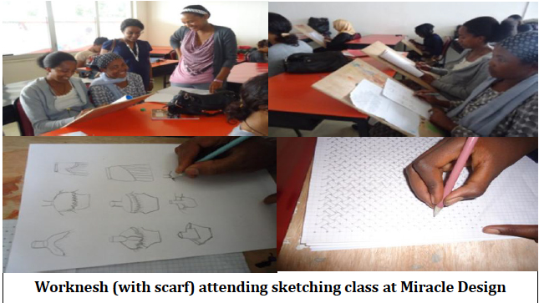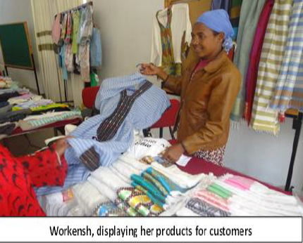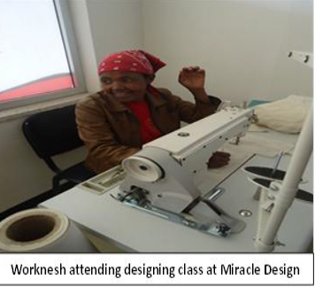

**Worknesh (with scarf) attending sketching class at Miracle Design**

**Worknesh displays her products for customers**

**Worknesh in a designing class at Miracle Design**

**How she became a Successful Businesswoman in a Male-dominated Industry**

Since 2011, when Worknesh applied to EDGET for support, she has received training and many other benefits from the project:

1. Training on weaving design, costing and pricing
2. Financial literacy training – saving, credit and budgeting
3. Access to new markets, including product orders from two designers in Addis Ababa
4. Participation in three textile exhibitions and bazaars facilitated by EDGET

Miracle Fashion Design School also offered Worknesh a scholarship worth 15,000 ETB through its association with EDGET.

**Meet Worknesh Wade…**