Ecumenical Church Loan Fund

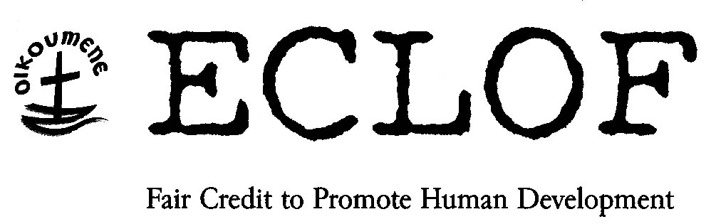

PHILIPPINES
SRW

LOANS RATIFIED UNDER DEVOLUTION OF AUTHORITY TO DIRECTOR
Applicant : 11 Rice Farmers’ Solidarity Groups of Palawan branch of ECLOF Philippines
Project : Funding for 11 Solidarity groups
Loan Product : Solidarity loans
Beneficiaries : As per schedule:
_________________________________________________________________________________

PROJECT BACKGROUND
Palawan is a narrow archipelago on the western border of the Philippines approximately 240 kms from Manila. Its geographical location makes it seem remote from the rest of the country. The waters of the South China Sea lap the western shores of Palawan, while the Sulu sea hugs its eastern coast. With a land area of nearly 1.5 million hectares, Palawan is the country’s largest province and the fifth largest island in the archipelago. Its irregular coastline stretches almost 2,000 kilometers long, indented by numerous coves and bays.

The poverty situation in the Province of Palawan is continually getting worse over the years. A 25% increase in the poverty incidence was recorded during the period 1994 – 2000. Limited job opportunities, high cost of farm and non-farm inputs and unqualified labor force due to low educational outreach triggered the increase of number of poor families in the Province.

For the past years, agriculture has remained the mainstay of Palawan’s economy. The vast area of land devoted to agriculture, favorable climate and good soil condition partially explains the situation. The agricultural sector, particularly rice production, is able to supply the need of the Palawan’s population. The province also exports rice to other provinces.

While the sector of agriculture registered an annual contribution of 47% to the economy, its trend is not too impressive. The low level of farm mechanization, inadequate farm-to-market roads, poor access to post harvest facilities, high cost of farm inputs, and access to credit facilities are among the factors which contributed to its low average annual growth.

A vital aspect of poverty alleviation is the support given to the producers i.e. farmers and fishermen. ECLOF Philippines – Palawan Branch believes that supporting the agricultural sector by providing fair credit will help the farmers improve their lot. Aside from providing access to fair credit, the branch will also tie up with different suppliers of farm inputs thereby helping the farmers to access cheaper sources of farm inputs.

ECLOF PHILIPPINES
The Palawan branch of ECLO Philippines opened its doors to the public in 2004. As can be seen from the below graph, the branch is rapidly expanding, increasing its operations and adding new products to its portfolio.

APPLICANTS
The rice farmers are one of the main target beneficiaries of ECLOF loan program in Palawan province. These farmers belong to different regions in the Philippines, they migrated to Palawan in order to find a better living.

PROJECT
The project site is in four different rice producing areas in Palawan: Narra, Roxas, Bataraza and Quezon.
Narra is an agricultural town 96kms. south of Puerto Princesa City. It has an area of 10,515 hectares of potential irrigable land. At present it has 3,058 hectares of national irrigation system with 2,100 farmers beneficiaries. Roxas is located in the northern portion of mainland Palawan. It has a total agricultural area of 4,722.23 hectares for rice production and has an estimated total of 1,400 farmers. It has 1,600 hectares of irrigated land. Bataraza lies on the southern portion of Puerto Princesa which is about 218 kilometers. It has a total of 10,000 hectares of agricultural land area and has 5,000 hectares of cultivated land. At present, there are four Communal Irrigation Systems in the area, located in Barangay of Marangas, Bono-bono, Bulalacao and Tarusan. The beneficiary area will be on Barangay Marangas.
Quezon is 130 kilometers away from the mainland (Puerto Princesa), it has a total land area of 1,400 hectares for rice farming. It has a total estimate of 721 farmers.

Proceeds of the loan will be used to pay for the inputs, such as certified seeds, labor cost and fertilizers. Some of these farmers own titled land and cannot access loans from Rural Banks, so they borrow from money lenders at an interest of 10-25% for every 120-200 days. Thus, they have applied for this loan with ECLOF.

Farmers of Palawan mostly sell their produce directly to Rice Mill owners. Some of them through the cooperatives in their area, were able to sell to the National Food Authority. However, this transactions usually take too long before they can realize the fruits of their labor. Since the rice mill is present in the whole area of Palawan, selling this harvest will not be a problem.

Project financing:
Farmers’ contributions Php 212,169.50
ECLOF Philippines Php 579,503.50
Total Project Cost Php 791,673.00

The project cost is made up of expenses the rice farmers incur during the production cycle: land preparation, purchase of seeds, fertilizers, crop protection, harvesting and marketing.

Reimbursement capacity:
- Rice Farming:
Estimated harvest in kilos per area 3,200 kg/hectar
Total area for the project 56 hectares
Projected price/kilo Php 6.50 (lowest)
Total Projected Sales Php 1,164,800.00
Less: Total Cost (share) Php 791,673.00
Expenses Php 127,152.69
Net Profit Php 245,974.31
Average profit per farmer PhP 4,392.40 (US$ 79)

Previous Loan history and reason for choosing ECLOF
This is the first batch of the pilot project which the Palawan branch of ECLOF Philippines is launching to serve the rice farmers of the area. The farmers association of different areas requested for an orientation from ECLOF after learning from the Solidarity groups of other program. They used to borrow capital from individual lenders at 15-25% interest every 100-200 days, leaving them with very small profit that sometimes was not sufficient for their daily needs. ECLOF Philippines will return each farmer 1% of the borrowed amount when the loan is repaid as a form of savings to the farmer.

