Magaya Primary School Project Proposal
Project Proposal for Funding
Name of organization | Rozaria Memorial Trust and Magaya Old Students Association
Title of Proposed Project | Magaya Primary School Project proposal for funding
Amount Needed | US$7,250* *
Location of Implementation | Magaya Village, Murewa, Zimbabwe
Point of Contact, Phone, Address | The Head : Mrs Wachipa or S.Mapiki  Tel: +263772259585/+263773434226  Email: shepherd@cipf.co.zw
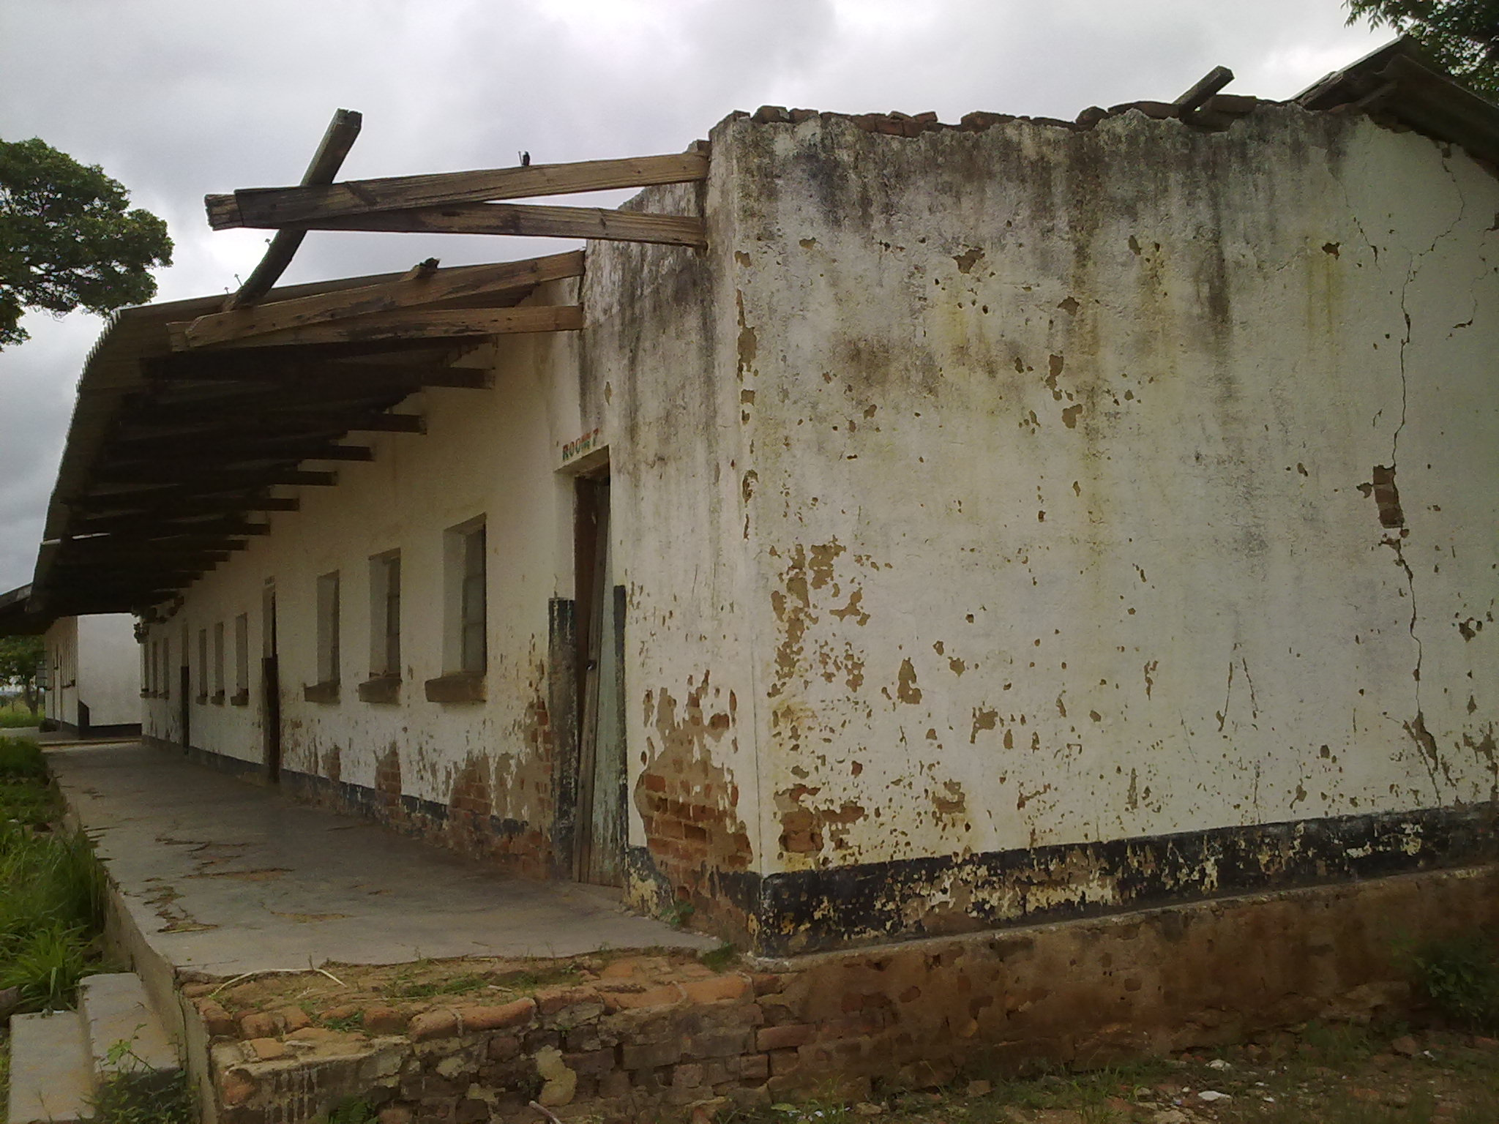
The dilapidated block currently being used by pupils. Clear signs of old age and effects of storm damage are visible. The children urgently require safe learning environment and desire quality education.

Executive Summary
Magaya Primary School Education project proposal is a project in association with Rozaria Memorial Trust and Magaya Old Students Association (MOSA). MOSA is an association of former students of Magaya Primary and Secondary schools of Murewa. The thrust of MOSA is to assist the two schools in rehabilitating infrastructure and learning materials. RMT is an organization founded in 2006 to support innovative community initiatives that promote education, health and entrepreneurship especially among you people.
RMT and MOSA’s main concern is the realization of sustainable development in which the children, teachers and the community are involved in positive activities that will ensure socio-economic welfare in the entire locality and ensure proper learning environment by providing habitable accommodation. It is also in a way assisting Government attain the Millennium Development Goal (MDG) by providing ablution facilities at the school. The vision of MOSA is peaceful co-existence and development in which everyone participate equally and effectively in problem and solution identification and where local communities, governments and other developmental bodies facilitate and carry out skills transfer to the younger generation who are not fortunate enough to be afforded or even to go to school.
MOSA has furthermore succeeded to hold three successful meetings with the School Development Committee (SDC) and community Heads to forge an understanding of our vision and goals. We made sure that there is community ownership of the project. There is need to involve everyone and have a buy in of the project. The local community and leadership have been very supportive and are doing their part by moulding bricks, providing other materials like river sand, stones and labour.
In order to realize its goals, MOSA has agreed to assist in mobilising resources to build four class rooms to replace the ones which were destroyed by a hail storm. The construction cost will require USD8,000.00 for labour costs as materials worth $22360.00 were kindly donated by the Australian Embassy in January 2012 and work has started although builders are working with the assumption that MOSA will eventually get funding.
Rozaria Memorial Trust’s main objective is to create community capacity to provide education and health infrastructure, and with a particular outreach to the most vulnerable in communities. Since 2006, RMT has been supporting children living with HIV working collaboratively with 9 schools in Murewa District, including at Magaya primary and secondary school, through which it has a long standing collaboration with MOSA. RMT Founder and Chairperson is also the current MOSA Patron.
Project rationale
Developments do not come to these remote parts of Murewa easily. As an example since 2008 when the school was destroyed by a storm, the school has been using dilapidated classrooms, the school enrolment has since gone down from 600 students to about 250 currently. The major constraint for children and parents is that the most nearby primary schools are between the walking distances of 5 and 10 kms or 2 and 4 hours respectively. The school pass rate has been unsatisfactory due various reasons.
MOSA has taken the initiative to change this situation and is now approaching organizations in order to improve the conditions for children who are joining primary schools in the nearby villages.
The MOSA’s strategy is to construct a BLOCK consisting four classes for the primary School in Murewa for boys and girls respectively. Implementation will include construction, provision of teaching materials, such as text books for all subjects, and clean and safe drinking water and there will be two phases of the project.
In phase (1) of the project, MOSA will construct 4 classrooms which will have one door and eight windows each and will be 27 metres long and six metres wide. The walls and the floor will be made from locally baked bricks; the doors and windows of metal and the roof of asbestos sheets. There will also be need to construct staff houses comprising of head master’s, her deputy and a staff rooms, six toilets and two staff houses. Once construction work is completed, classrooms will be fitted with chairs in phase two of the project to prepare the school to start operating learning and teaching activities in 2012. The classrooms will be used to teach the pupils in the morning and avoid hot sitting which inconveniences both school children and teachers. The MOSA executive mobilized parents and local community members to make bricks for the buildings and contribute other locally available materials towards this project.
This project will also provide the community in appreciating the importance of sending their children to school. MOSA being former students should motivate the young boys and girls to emulate and believe that nothing is impossible if they work hard.
Problem Statement
The school is located 104km from Harare and 3.5km from Harare – Nyamapanda highway. There is a good gravel road linking it to the tarred main road, the problem is the economic problems bedevilling the community which has not been spared the scourge of the HIV/AIDS. There are orphans learning at the school and small percentage get assistance from the Basic Education Assistance Module (BEAM). UNICEF has been supporting 400 000 disadvantaged primary school pupils in Zimbabwe for the past three years and indications are that it is pulling out thereby exposing the pupils .The community which is predominantly peasantry therefore finds it extremely difficult to pay the school levy per term. In essence, it means the little levies paid cannot sustain capital projects as even Government is failing to give infrastructure grants due to liquidity problems in the economy.
The objectives:
To construct one block for primary school for Magaya Primary school, Murewa, Zimbabwe with a population of about 1,000 primary school going children to provide quality education in six months.
Strategies of Implementation
The project was proposed by a series of discussion with the local communities, review of baseline data, and also minutes of the MOSA meetings.
At the initial start of the school project, MOSA will construct 4- class rooms, 12- toilets, and staff houses, and also equip the school gradually with teaching materials, such as text books and the supply of water. It should be noted that the school has now been electrified and that a borehole has now been sunk for the teachers as donation by one former student who is a member of MOSA.
Phase 1
Construction of 4 classrooms has started but staff houses will start as soon as funds are availed. This will be followed by construction of storage tanks for rainwater collection. At the end of the project, the last act will be the buying of desks as Government has provided almost all the essential text books.

Installation of a 5,000 litre borehole water collection plastic tank is at an advanced stage and purchase of desks will be done to enable the school to start operating in the second budget of phase two of the project. The school will admit 200 students over four classes
MOSA has engaged the expertise of local builders and other labourers to carry out the actual work. The material donated by the Embassy was delivered and is at the school, well secured. The Head and her Deputy will prepare all the necessary reports including the financial reports and submit them to the Executive Committee of MOSA as was agreed upon.
MOSA will invite the donor representatives and members of the government to carry out their own independent evaluation after the completion of the project. Continuous monitoring of the project will be conducted by the MOSA executive and representatives from the Embassy or potential sponsor to ensure that the project achieves its goals and objectives as set out in this proposal.
Expected Results
- Quality education for 300 students delivered through creation of students friendly
- learning spaces;
- Improved standards of life among teaching staff at Magaya school.
- Increased enrolments up to 500 students and enhancement of habitable classrooms.
- 7. Deliverable
- Secretary of MOSA will deliver both technical and financial reports each month to the funding agency. This will include details of the class attendance by learners and teachers, lessons taught, materials purchased, challenges faced, achievements realized, money spent and the community support.
- Project Beneficiaries
- The school facilities aim to give services to 300 primary school students from Magaya and surrounding villages such as Jakopo, Chimusoro, Marumisa, Dizha, Nyazema, Nhende etc.
- Monitoring and Evaluation
- A variety of formal and informal Monitoring and Evaluation mechanisms will be central to ensuring the appropriate delivery of effective and sustainable services. These will include: Multi Indicator Cluster Surveys, class performance surveys, class attendance data, girl-boy retention data and exit surveys.

- Project sustainability
- MOSA will continue to work with the local Council and Ministry of education on this capacity while also working closely with local NGO working on education programmes in the area. MOSA will develop a Memorandum of Understanding with the Ministry of Education which will clarify each partners’ roles and responsibilities both short and long term. The Ministry of education will be encouraged to provide staff for the facilities, facilitate the UNICEF supported school supply and MOSA will invest heavily in staff training at all levels. In this way sustainable structures for primary school education delivery will be developed in Magaya village, Murewa.
- MOSA will work with local communities to develop the capacity of individuals to play an active role in governance and delivery of education in primary school. Parents Teachers Association (PTA) will be formed to ensure the school’s future sustainability. MOSA’s annual sustainability assessment will be used to review the capacity of both local communities and school to take on further aspects of supporting the school after the donor phase. RMT will continue to provide its technical support and facilitation.
- 9. Collaboration
- RMT and MOSA will collaborate and network with the local community, community leaders, Development partners and Government of Zimbabwe.
- 10. Community Contribution
- The local Community will contribute labour and local materials such as water and sand that will be used to construct the four classrooms and provide security for the materials.
- 11. RMT & MOSA Capacity
- RMT and MOSA has the required capacity necessary to design interventions and at the same time give impetus to the program’s management. The organization constantly plans before engaging in project activities and other interventions. It’s recognition by the local communities and School authorities have further placed us in a strategic footing to replicate ourselves in the affairs of the school. We have a policy of non interference in the school administration and our role is to assist where possible. MOSA has a rare unity of purpose amongst its members and the feeling of serving one’s former school bonds us further. This has in turn ensured solidarity and hence it’s stability. There is high potential that this achievement will be replicated in the community and Murewa district as a whole.
- 12. BUDGET PROPOSAL
- Our budget proposal is based on materials donated by the Embassy as well as personal cash donations by members of MOSA. Each pupil has been levied $5.00 each and there is a budget deficit which MOSA need to cover mostly for labour.
- MOSA has an existing FCA with METBANK Murewa and details are available on request.
- RMT has the systems in place for governance and financial accountability and has gone through the due diligence review by Global Giving Foundation.
MAGAYA PRIMARY SCHOOL CONSTRUCTION PROJECT
BUDGET
ITEMS |  | INCOME
Donations |  | $ 22,360.67
Project levy |  | $ 1,500.00
other donations |  | $ 350.00
 |  | $ 24,210.67
 |  | Expenses
Building materials |  | $ 22,360.84
600 bags cement
Door frames
Window frames
Asbestos sheets
Roof traces
Paint
Labour - builders |  | $ 8,000.00
Security | [6 months] | $ 600.00
Misc |  | $ 500.00
 |  | $ 31,460.84
Deficit |  | $ (7,250.17)
- Conclusion
- MOSA will adopt the policy of corporate good governance throughout the implementation process of this project. This will ensure accountability and transparency in the management of resources.

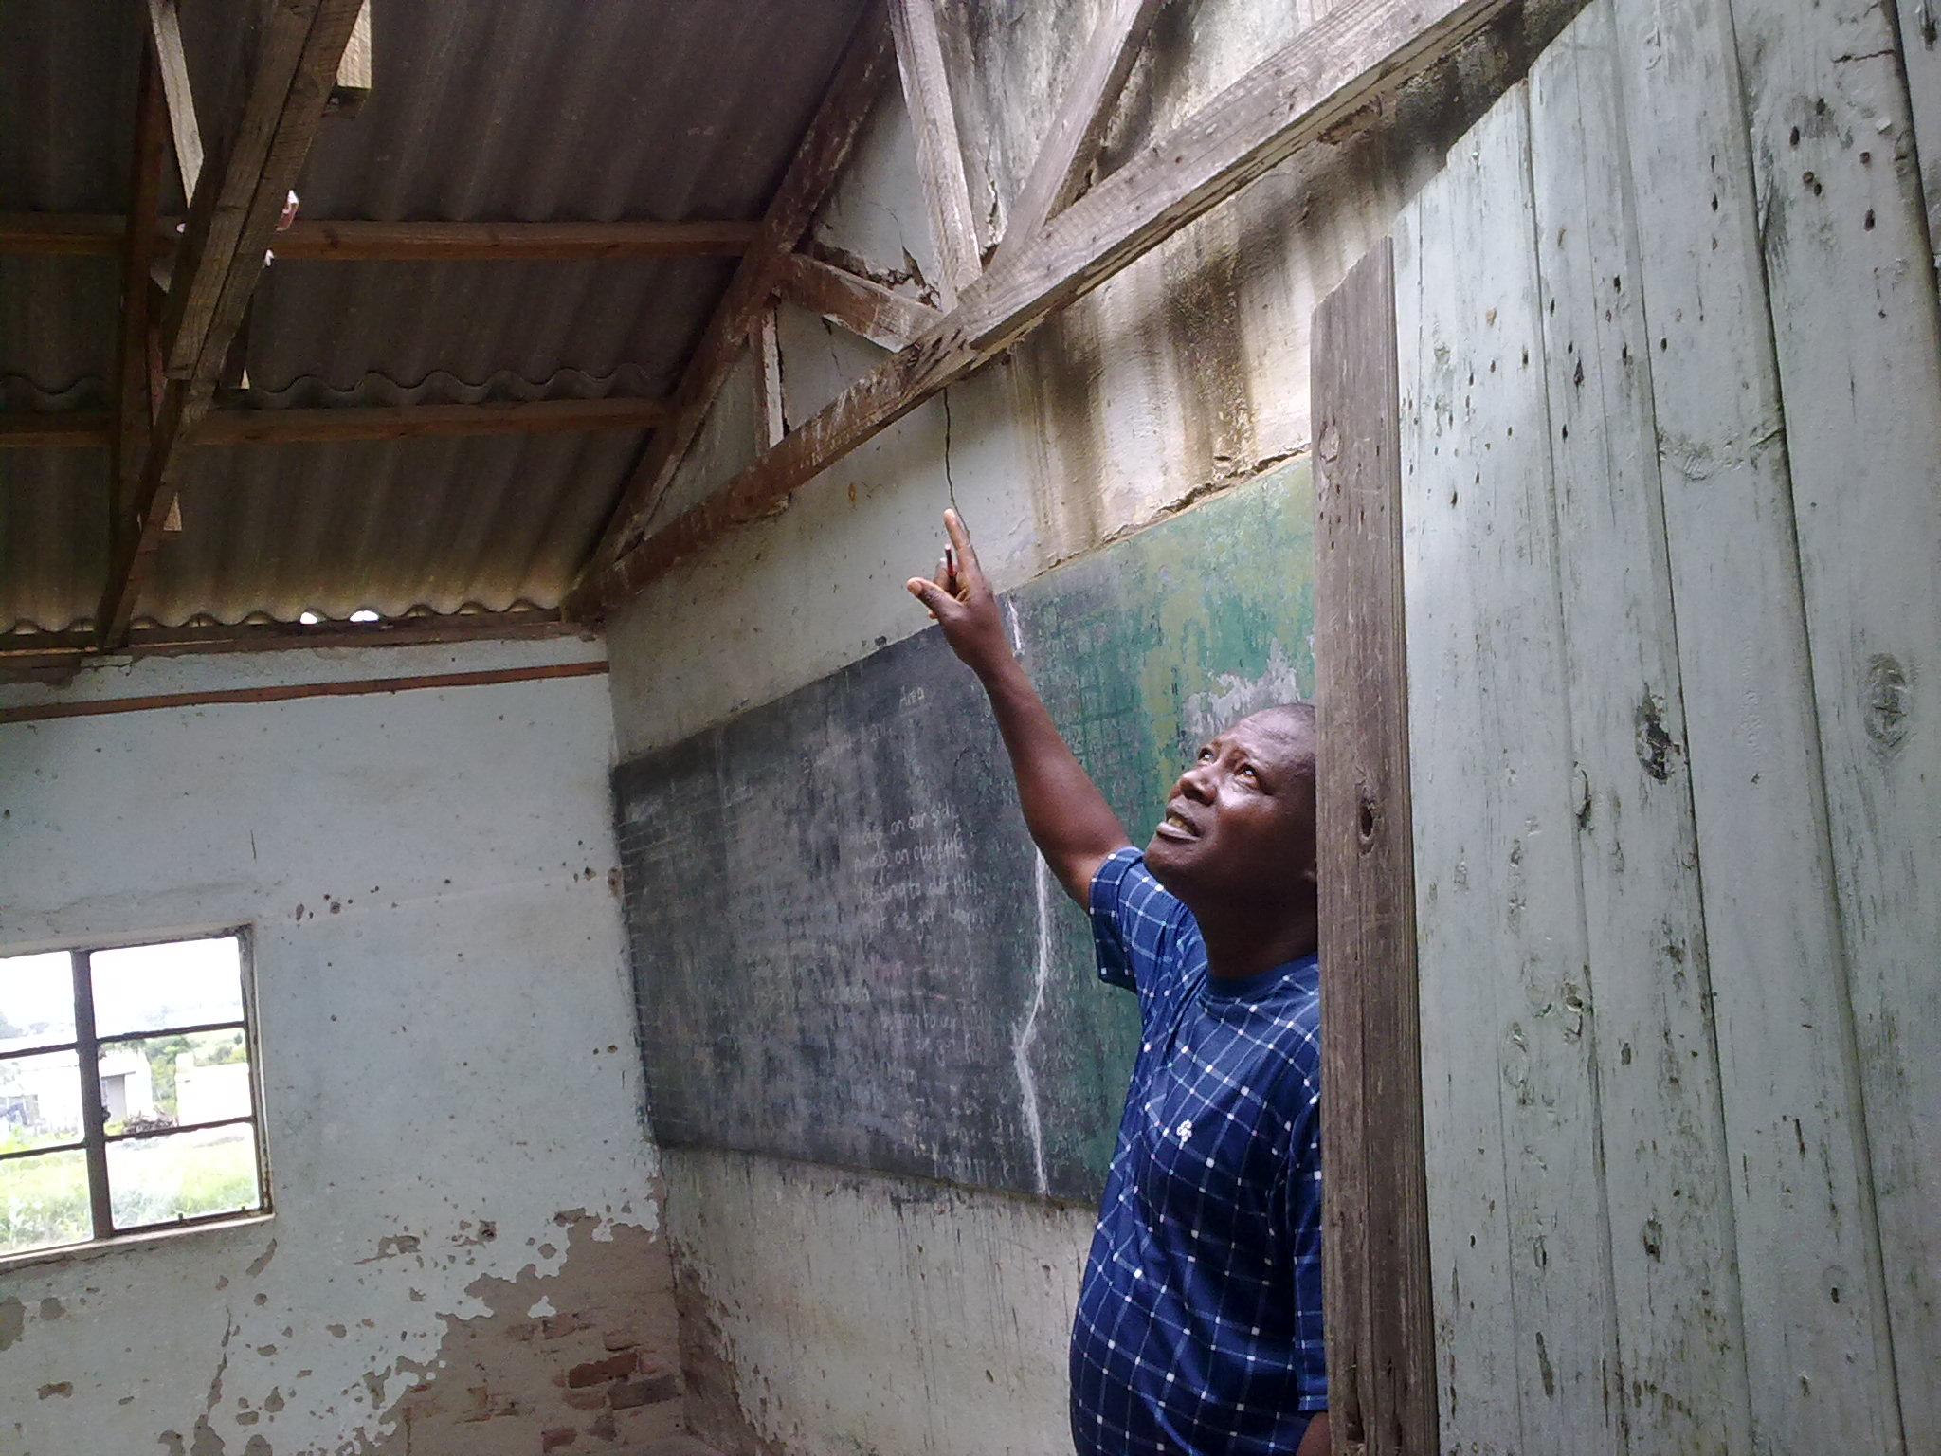

The Deputy Headmaster indicating the blown and cracked asbestos. You may also appreciate the crack on the board and peeling wall plaster. We need your financial support to restore the school to its former glory.

Shepherd Mapiki – Secretary MOSA
5th July 2012

