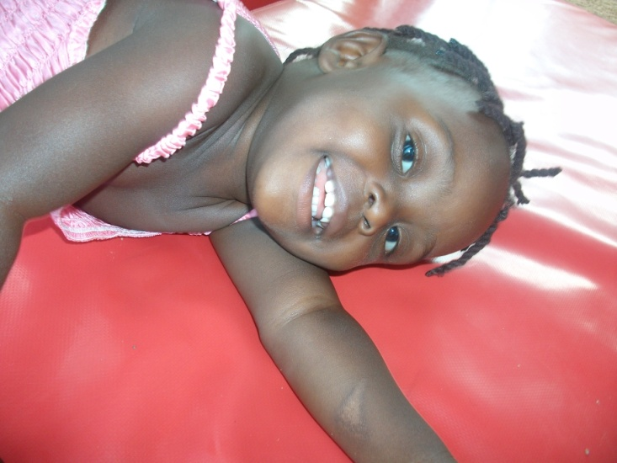
The orphanage building construction is yet to begin.
The new orphanage is in a beautiful rural area, away from the filth and congestion of the city area, with plenty of clean air and fields will be surrounding the building site. Here’s the proposed boys and girls dormitory to be constructed
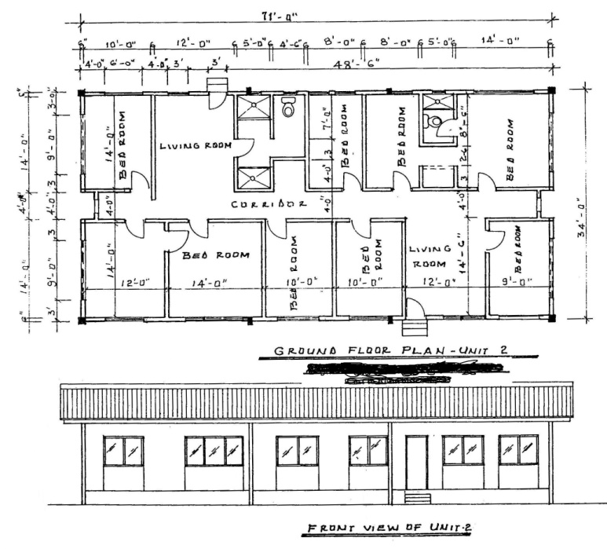It is anticipated that each building will accommodate 15 children with a separate room for the house mother, 30000 bricks have been made and baked in preparation to start construction. We are employing employ the services of local people to assist in the building program; however the buildings will be constructed under the instruction and design criteria of the district planner.
As part of the move to self-sufficiency in future it will be essential to develop areas for the growing of food crops, 01 acre of land is going to be for farming. It is anticipated that this will commence once the orphans have relocated to the property. Other areas will be set aside for recreational activities; however this too will be developed following the transfer of the orphans to the property. Such areas will be required to service both the school and the orphanage.
This is, of course, a huge project and donations are urgently needed to help see this amazing project through to completion. Your recent gifts will help us do construction of one dormitory to accommodate girls, surely this accommodation will provide these kids with a new home. Thanks for being part of us in helping us make their dream come true. Construction progress report will be sent to you by 30th November 2012.
