GLAD TO REPORT THAT THABO IS NOW REVOVERED BACK AT SCHOOL THIS YEAR AND WILL WRITE HIS A-LEVEL EXAMS WHICH HED MISSED THIS JUNE
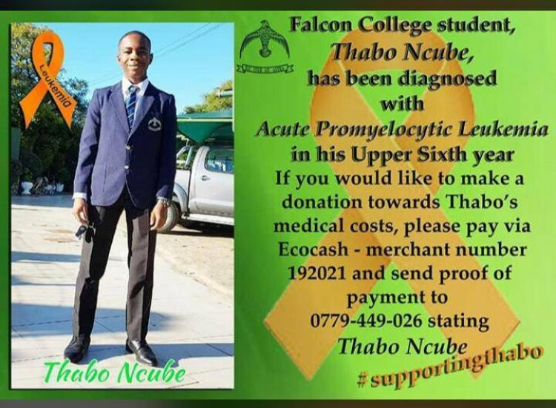
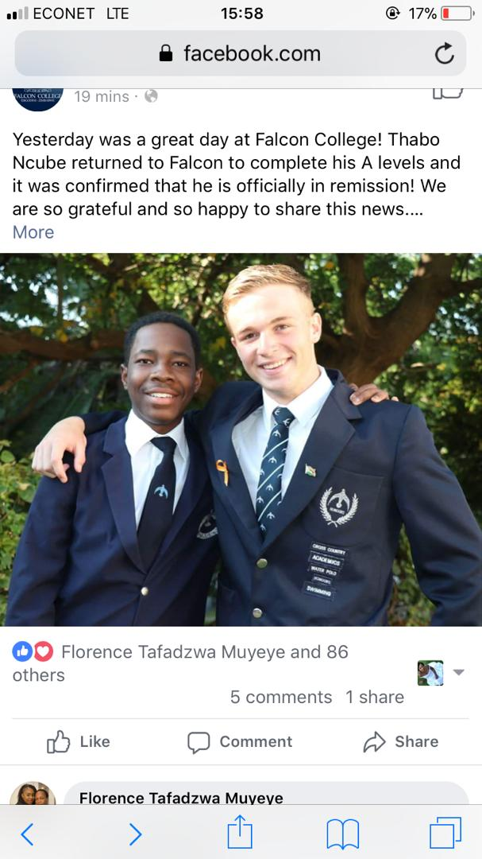
Thank you all for support through Global Giving

