|  |  |
| --- | --- |
| C:\Users\Daniel Mckenzie\Pictures\Kidzcan food distribution to parents.jpg  Covid-19food hamper distribution | C:\Users\Daniel Mckenzie\Pictures\BYO Handover 2.jpg  Covid-19 Mpilo ward donation |
| C:\Users\Daniel Mckenzie\Pictures\Pari A4 Project donation 1.jpg  Ward covid-19 donation | C:\Users\Daniel Mckenzie\Pictures\SKH PPE donation.jpg  SKH Covid-19 donation |
| C:\Users\Daniel Mckenzie\Pictures\Transportation form Nyabira.jpg  Patient transport assistance | C:\Users\Daniel Mckenzie\Pictures\BYO Handover.jpg  Sanitisation ward project |
| C:\Users\Daniel Mckenzie\Pictures\Pari A4 ward project.jpg  Sanitisation ward project | C:\Users\Daniel Mckenzie\Pictures\Chemotherapy drugs collection.jpg  Procurement of chemotherapy drugs |

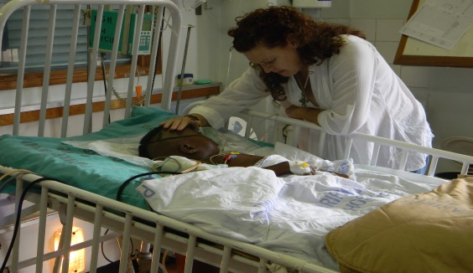

Andrea Whatman-founder of Kidzcan with a patient at A4 Ward Parirenyatwa Hospital