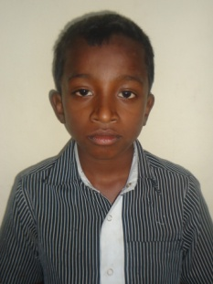

Sandeep ,newly admitted HIV child with healthy status at present