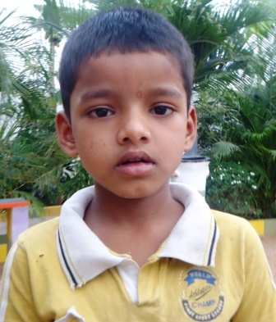

**Success Story Of Aslam ---- HIV boy to lead an extendable potential life span**

Ismail and Rehmat were HIV parents of Aslam [ 7 Years of HIV boy]. Ismail, a painter by profession , was getting sick quite often which led him to go for HIV testing.With testing not only he but entire family including children turned out to be positive cases.

Aslam lost her mother few years back. At that moment , her father started looking for HIV children’s care home as he was unable to feed them also. With the help of DESIRE Society health worker in community, he brought both children to DESIRE Care home at IDA Bollaram.Again , he took both of them back for a while for celebrating their religious function at home. Unfortunately, they lost father this year and relatives brought them back to DESIRE care home.

Aslam is improving upon the physical and health status. He is cooperative with other inmates. He is enrolled for in campus schooling in UKG standard. Nutritional and medical balance will secure his potential life span which in turn depends upon like minded platforms to continue sharing contributions.

Hope , it is reunited efforts of DESIRE donors to take up challenge of serving such HIV children at Hyderabad Care Home level in future too.