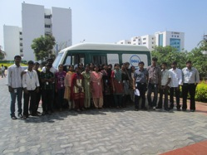

Science Fair

A Volunteer Led Success!
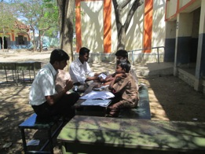
iMobile Lab
Sponsored by Dell Global Giving

Agastya is on a mission to "spark curiosity" in children. The iMobile Lab's child-centric learning approach blends digital technology and multisensory, hands-on science to provide a rich learning environment for rural and disadvantaged children.
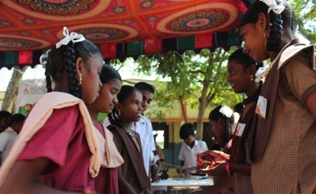
Agastya Science Fairs
When Dell employees Adhitya and Mohamed Iliyas finished their night-shift on 25th February, little did they know that their unflinching willingness to spend the immediate morning with Bharathi, Mouli, Madhan Kumar, Lakshminarayanan, Sundaresan and Nandhakumar - children of Vilankurichi school would make such a difference.

On 26th February, Adhitya and Mohd. Iliyas, with great willingness and gusto trained the children how to explain biological principles during the Science Fair. On 28th, when they walked in, the eyes of the children lit up as they ran towards the volunteers screaming “Anna, anna, come see my model. See if I’m explaining it correctly. Will you stay with me again the whole day?”

And stay and support, they did. Yet again! And marked the beginning of a remarkable bonding. Only strangers yesterday, they had become older, caring brothers to those children today.

The power of peer to peer learning comes into play with students donning the role of teachers during Science Fairs. Realizing the positive impact they make on their peers and reflecting on their own innate ability, children emerge self-assured with renewed confdence.
Fair at Vilankurichi, CBE

Dell Employee Engagement
25 volunteers . 200 hours. Friendships for Life.
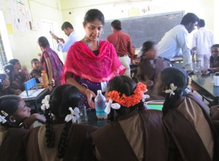
Dhivya, the 1st volunteer since the iMobile Project began, along with other volunteers training children of Vilankurichi school, CBE.
Agastya’s instructors trained Dell volunteers on hands-on science models . In turn, Dell volunteers enthusiastically trained children recruited for Dell’s iMobile Lab project.

Dell’s volunteering team, led by the energetic Praveen T
spent an entire day with the children, training them on models, encouraging questions and helping them practice for the event on Feb 28th. That they did all this with enthusiasm, patience and care, providing children with much-needed attention and support inspired these shy, tentative children to open-up.



A transformation had begun.
To the warm surprise of parents, teachers and the headmistress, on 28th February, 28 young children had become Young Instructors (YIs). YIs who found science interesting and who were confident and willing to spread and share the joy of learning to over 300 school-mates during the Science Fair.
www.agastya.org
www.facebook.com/Agastya.Foundation

