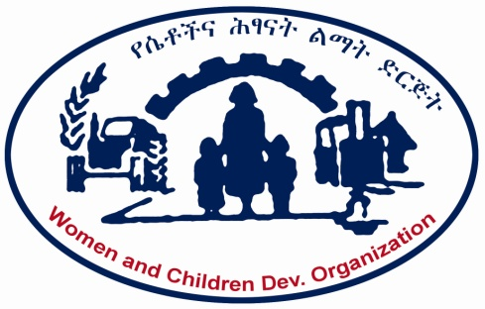

WOMEN AND CHILDREN DEVELOPMENT ORGANIZATION
(WCDO)

Improved fuel saving stove for poor female -headed households and Income generation, in Shashamane Town, Ethiopia

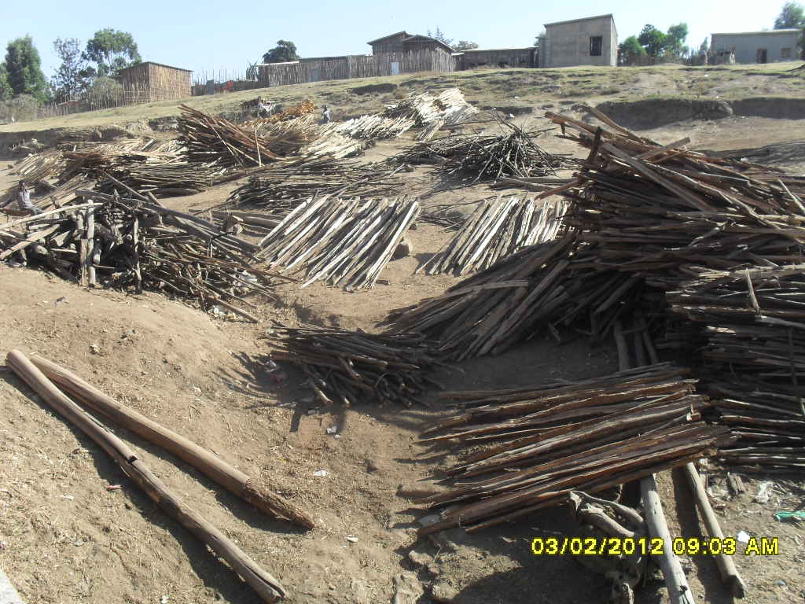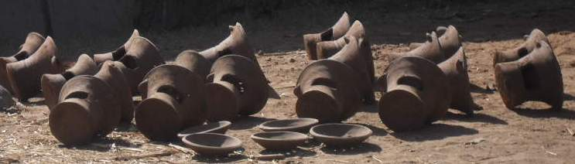

Executive Summary
- Project Title: Improved fuel saving stove for poor female headed households and income generation
- Project Location: Country Ethiopia :Region: Oromia Region, Shashamane town
- No. of Beneficiaries: - Poor 50 female headed households
- Type Of Beneficiaries: Women, Children and the Community in General
- Total project cost: : $ 189000

- Implementing Organization: Women and Children Development Organization WCDO
Contact Person: Ato Melaku Hailu, Executive Director
Address: Tel. 0116621351, Cell phone 0911607135
P.O.Box 12796
Email: wcdom_eth@yahoo.com, wcdo@telecom.net.et
Addis Ababa Ethiopia

Organizational Profile
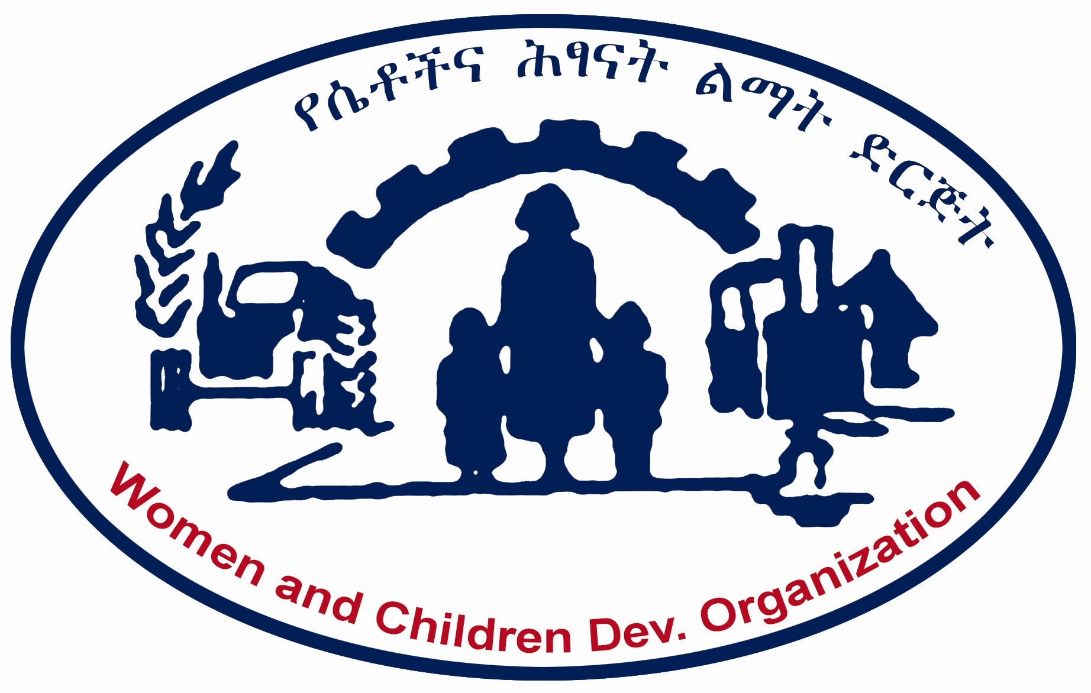
Women and Children Development Organization (WCDO), Ethiopia

Women and Children Development Organization (WCDO), is an Ethiopian, non-governmental and non-profit humanitarian organization established in 1995 by Ethiopian volunteers who were concerned about the devastating economic and social situation of the community caused by man-made and natural calamities.
Since July 1995, WCDO is legally registered with the Ethiopian Ministry of Justice (MoJ), Legal Certificate No. 183, and is permitted to operate in the whole of Ethiopia.
WCDO’s vision is to alleviate poverty in Ethiopia for the country to become prosperous. It is the organization’s mission to serve the impoverished communities and to contribute to a comprehensive and sustainable development. Particularly, WCDO aims to change the livelihood of women, children and of the community at large in Addis Ababa City and in the rural, urban and pastoral areas of SNNPRS, through comprehensive and sustainable community development programs and poverty reduction strategies which motivate for an active participation of a multitude of stakeholders.
WCDO’s strategic objectives’ focus is set on environmental sanitation & alternative and sustainable energy development community rehabilitation; reintegration and protection Education; dry land agriculture, environment and food security; health; income generation; livestock development; elderly care and support; water development; pastoral development; and women in development.
WCDO’s work prioritizes women, children, and marginalized and vulnerable community members who are living under the poverty threshold and are disadvantaged due to the fragile economic settings in remote rural areas and urban slums.
In its community development approach, WCDO has designed its program to positively contribute to the promotion of a better life for the disadvantaged and powerless target communities, particularly women and children. WCDO’s intervention is thus based on people priorities’ needs with the strong participation of the beneficiary communities.
With regards to previous experiences, WCDO has been implementing development activities for more than 14 years both in urban and rural areas of Ethiopia. As far as the capacity of the organization for implementation is concerned, WCDO has succeeded in implementing development projects such as environmental sanitation, biogas, pit latrines, water supply points’ development, shower installations, cloths washing stands, skips and extensive education on hygiene and health to the beneficiary communities.
WCDO has a rich experience in the areas of water and sanitation provision, biogas development and education, amongst other areas of expertise and activity.

Some of the achievements of WCDO, which benefited more than 770,000 people in the respective project areas, the vast majority of which women and children, are:

- Provision of loans for 300 poor women, for income generating activities;
- Provision of educational support and resources for 5,000 impoverished school children;
- Establishment of an income generating bakery project for impoverished women;
- Provision of tailor-made health and hygiene education to more than 9,000 community groups aged 10 and older;
- Renovation of 100 ruined houses owned by impoverished households, including female-headed households;
- Construction of 61 water supply points;
- Construction of 62 dry pit latrines each with four seats;
- Construction of 5 public showers (with ten rooms for men and women);
- Construction of 40 cloth-washing stands;
- Provision of 12 skips (for solid waste disposal);
- Construction and installation of 9 biogas facilities with communal pit latrines, and kitchens;
- Organisation of ten youth HIV/AIDS working groups;
- Conducting training workshops on HIV/AIDS for peer educators, counsellors, voluntary caretakers and members of organised working groups;
- Provision of marketable skill training for more than 200 youth;
- Construction and installation of one public library;
- Construction and establishment of two Alternative Basic Child Education Centres (ABECs) for 480 primary school-aged children.

WCDO has implemented many projects on environmental sanitation and biogas development in the country. However, the previous project that were implemented at community levels mainly focused on construction aspects, without integrating training or education related to the the provision of eco- and community development enhancing facilities. The project that is presented hereunder aims to link the development with the educational and awareness raising component.

For further information visit http://www.wcdo.org.et.
The Project:
Improved fuel saving stove for poor femal-Headed households and income generation
(Oomia Regional State, West Arsi Zone, Shashamane Town)
Background of the proposed Project
Notwithstanding the progress in critical aspects of human development, Ethiopia is a long way from achieving some of the Millennium Development Goals (MDGs) by 2015, given the country’s very low overall starting point. “The development challenge facing Ethiopia is immense. Its people are among the poorest in the world, the economy is growing too slowly, and population growth is alarmingly rapid”. The overall crisis in the region, the protracted border conflict with Eritrea, the deteriorating situation in Somalia and the violent conflicts in parts of Sudan all have a negative impact on Ethiopia. However, being one of the region’s most stable countries, the European Commission regards Ethiopia as a focal area for support, giving its relative stability and significant geopolitical position.
Climate change and its impact have severe consequences on large parts of Ethiopia’s population, the majority of which are small-scale farmers. This leads to a heavy rural-urban migration, with e.g. Ethiopia’s capital Addis Ababa growing rapidly and to a large extent uncontrolled.
Urbanization, both as a social phenomenon and a physical transformation of landscapes is one of the most powerful, irreversible and visible anthropogenic forces on earth (Masakazu, 2003; UN-HABITAT, 2008). Urbanization does not have only local environmental impacts but it also has a large ‘ecological footprint’ beyond its immediate vicinity. Intensive and extensive exploitation of natural resources to support the urban economy includes use of high amounts of energy resources (including fuel wood, charcoal), quarrying and excavation of sand, gravel and other building materials on large scales, and over extraction and inefficient delivery and use of water. These all contribute to degradation of the natural support systems and irreversible pollution that have impacts on human health as well as on vegetation and soils at considerable distances (Brooke et al, 2009).
One of the geographical areas heavily affected by the consequences of climate change is the Ethiopian Rift Valley, which stretches the whole length of the country from neighboring Eritrea in the northeast to Lake Turkana in the southwest, bordering Kenya. The Ethiopian Rift Valley Lakes Basin (RVLB) is one of the twelve Ethiopian river basin ecosystems which share a common geological structure, history and similar biological resources.

The Rift Valley Lakes are very important in terms of biological resources. In contrast, the overall ecosystem lies in a region of rainfall deficiency, with evapo-transpiration higher than the mean annual rainfall, making the area susceptible to drought and ecological degradation.
Common threats to the lakes include:
- Institutions for the management and proper use of fisheries are weak, as is law enforcement for resource and protected area conservation;
- Poverty, the lack of livelihood alternatives for farmers, poor agricultural technology and productivity;
- Associated low and erratic rainfall and the threat of high human population pressure;
- Illegal settlement in parks and conservation areas.
- Livestock pressure on conservation areas.

The Arsi Negele and Shala woredas are located in the Rift Valley area, around the southern-central regions where the fastest growing urban cities are located. The rapid urban development in these cities is putting added pressure on the nearby Arsi Negele and Shala woredas that are already ecologically sensitive. Even if the West Arsi is classified as a surplus-producing zone, some of its woredas and kebeles are situated in very drought-prone areas. Shala, one of its woredas, is the most drought-affected area. Consequently, Arsi Negele has kebeles that are chronically food insecure due to the recurrent drought.

Much of the woredas’ soil is sandy and not fertile. There is a large amount of area available for livestock free grazing. These areas are chronically susceptible to moisture stress that adversely affects water availability and pasture. The area is known as a food deficit zone. The woredas suffer from recurrent drought each year. Rain fed crop production is undertaken in the zone, however, poor soil fertility coupled with insufficient rainfall limits agricultural productivity. On their subsistence farming Maize is the major stable food crop grown while haricot beans are grown as cash crop. In their order of importance, haricot beans and maize are the main crops sold. Illegal fuel wood and charcoal selling is one of their income sources for their life subsistence. Land is prepared using plough-oxen. The middle class pay cash for agricultural labour - weeding, ploughing and harvest crops. Men usually do land preparation while both men and women do the weeding. The major types of pests and diseases are stalk borer, leaf spot and aphids. Maize is affected by stalk borer and aphids, haricot beans by leaf spot.
The main types of livestock are cattle and shoats. The method of feeding for the livestock is free grazing or browsing - there is no purchase of feed for livestock. The source of water in wet season are rivers, surface rainwater, seasonal ponds and community ponds while during the dry season it is rivers, community ponds and deep wells in far-flung areas. Human and natural factors are the cause for the degradation of the environment such as deforestation by the local community, over grazing, and chemical industry wastes (Soda ash chemical factory). All types of diseases affect cattle. Sheep, goats and horses are affected only by internal parasites.

Since the woredas are categorised under main part of the Rift Valley, there are a lot of ecological diversity in flora and fauna, especially the wild bird population including the migrants in Abijata Shala National Park. Although the degradation of the area is increasing, birds still migrate from different parts of the world especially from the Europe countries. If the problem continues at this pace, it will affect the Rift Valley system and the global environment.

There is urgent need to start sensitizing the community on climate change adaptation and mitigation measures which include Biogas development, water catchments, fuel saving stove and tree nursery establishment and management to selected women and youth groups in the area and later use the raised seedlings for reforestation of degraded hills and water valleys.
Oromia is one of the nine ethnic divisions (kililoch) of Ethiopia. Ethiopia’s largest state, both in terms of population and area, covers approximately 353,000 square kilometres, stretching from the western border in an arc to the south-western corner of the country. According to a 2007 census, its population stands at approximately 27 million, with a nearly equal male-female ratio.
It includes the former Arsi Province along with portions of the former Bale, Hararghe, Illubabor, Kaffa, Shewa, Sidamo, and Welega provinces.
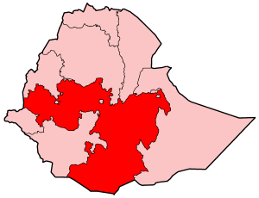
Its current capital is Adama; other important cities and towns include Ambo, Asella, Debre Zeit, Dembidolo, Fiche, Gimbi, Goba, Jimma, Metu, Negele Boran, Nekemte, Waliso and Shashemane.

Map drawn from http://en.wikipedia.org/wiki/File:Ethiopia-Oromia.png)
Shashemene (ሻሸመኔ) is located at almost 250km from Addis Ababa, on an area of approximately 18.6 square kilometres. The town is bordering with the Maja Dama and Bulchena Danaba kebeles to the west, the Alelu Elu kebele to the north, the Awash kebele to the east and the Burqa and Alalcha Harabate kebeles to the south. Most part the town has an elevation that ranges from 1500 to 2300m above sealevel, except the eastern section with an altitude of over 2300m.
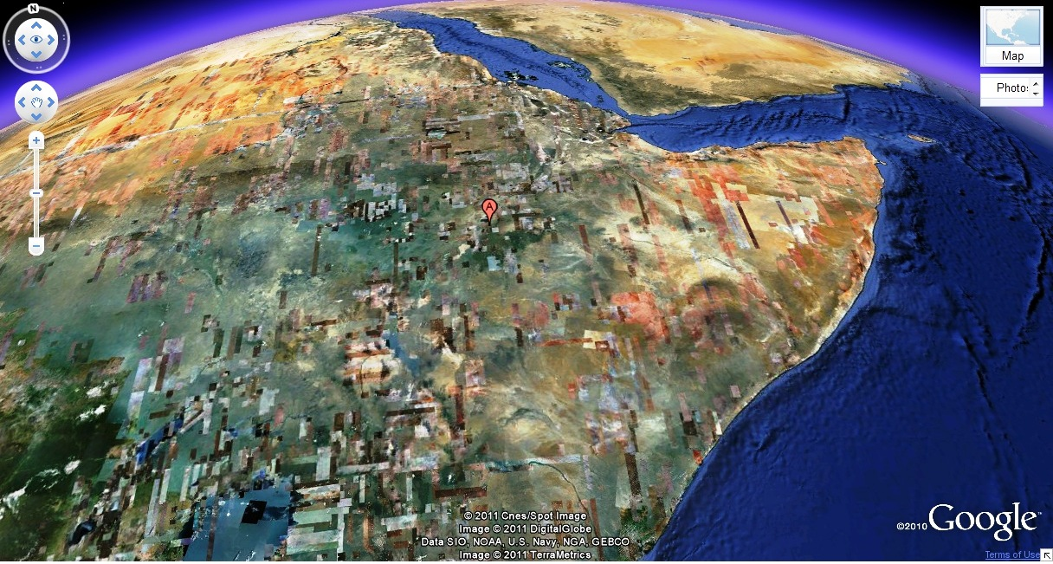

(Map drawn from http://maps.google.com/)
Shashemene finds itself currently under reform. It is one of the five first-grade towns in the Oromia National Regional State. It has its own administrative council and is administered by a mayor.
The town became the capital of the zone since the foundation of the West Arsi Zone. It is located at the road junction of Finfinne to Awassa and Bale to Arba Minch. In the region, Shashemene is well known as strategic knot for trade and services. In fact, the town’s main source of income is trade.
Shashemene is the largest town in the zone, almost located at its centre, and covers about 18.60km2. It is connected with all districts of the zone by asphalt or gravel roads. In the year 2000, it accounted for a total of 101,700 residents.

Description of the current Situation and the Problems to be addressed

Poor water access and lack of sanitation and energy sources are a major struggle of the town, which are predominantly affecting women, children and young people.
Due to a lack of awareness and capacity building activities on water, alterative energy, energy saving and sanitation related issues, hygiene related diseases within the town prove to have a great impact. Basic needs are not accounted for, which has strong repercussions on the communities. Particularly women and children are exposed to a number of diseases that can be directly linked to the lack of clean energy sanitation and clean water resources.
The conducted assessment in the project area indicates that wood and kerosene are the major sources of energy, which heavily affects the communities’ bio-systems, with a great impact on deforestation and air pollution. Moreover, women and children are forced to take the burden of wood collection and carrying at the cost of their physical health and time which in turn cannot be spent in generating income or in education.
Both in terms of economic and ecologic efficiency, kerosene and fuels cannot be regarded as affordable energy sources.
The community is affected by diseases related to insufficient or unclean water resources, the lack of sanitation and the lack of efficient energy resources. Besides the actual lack of resources, the lack of knowledge and awareness on sanitation, hygiene and energy is a prevalent problem. Particularly women and children, the most vulnerable community members, experience such problems.
Biomass is the single most resource meeting the energy needs of the Ethiopian households. It is used mainly for cooking applications on traditional three-stone open fires .About 50% of the country’s primary energy consumption is used for cooking mostly on traditional open fire stoves, wasting more than 90% of the fuel in an unsafe and unhealthy manner. The use of biomass for energy production is not only inefficient but can have negative effects on people’s health. Smoke emission resulting from indoor cooking can lead to various respiratory diseases in poorly ventilated kitchens and goes along with a high risk of fire. Access to biomass fuels is increasingly difficult. In rural areas, women and children spend an estimated 5 to 6 hours a day collecting fuel wood, which can result in physical impairments such as postural deformities. This time could otherwise be used for education or income-generating activities. Additionally the women are not only frequently harassed by border guards bribing them for money, but also they are prey to sexual assault which puts them at high HIV/AIDS risk. In urban areas where biofuels are purchased, the money spent on fuels - about 20% of household expenditure - could otherwise be used for education, health etc. These national figures disguise regional differences.
The growing demand for fuel wood resulting from the importance of biomass for energy supply and high population growth has serious impacts on natural resources. Even now the estimated demand for fuel wood is five to six times the sustainable supply. Most Ethiopian forests, including the Forest Priority Areas, are already highly degraded. Only 3.56% of Ethiopia’s natural forest cover still exists, the depletion rate is estimated at 150.000 to 200.000 ha per annum. Dense and homogeneous patches of forest cover remain only on steep slopes and in remote areas. The expansion of farmlands and pastures and the dense population heavily drain on the forest resources. The demand for wood products, especially fuel wood, is expected to increase at about the same rate as the population, around 3% annually. The destruction of natural vegetation due to wood based energy consumption can lead to soil degradation, erosion and thus to decreased water levels of rivers and reduced recharge rates of aquifers. Moreover, the use of animal dung for energy production leads to a removal of nutrients from cropland and thus to a decrease of agricultural productivity.
The target area of the project is Arada sub-city Ketena-1 and Ketena-3 in Shashamane town Administration has the largest number of female headed households compared to other sub-cities. The sub –city is divided in to 7 Ketene’s. Except from Ketena 6 others are known by their high population size and the dwellers are dependent on petty trade.
There are large number of women and children in the sub city engaged in provisional micro-business activities. Most orphan and vulnerable girls coming to the town expecting for a better life end up in falling into the social problems at Arada sub -city including prostitution, Child trafficking, child labor, rape, physical assault and the like. Orphaned and abandoned children in the sub- city are also exposed to all kinds of hazards. In the Sub -city there are more than 700 orphans because of HIV/AIDS. This number is shown to be the largest compared to those in the other sub cities of the town.
The Ketena’s of the sub city are in varying degrees under poor socio economic conditions. The needs assessment conducted with the stakeholders indicate that poor communities of the Ketena’s of Arada sub-city lead a life of extreme poverty: the majority of the households are living without regular and sustainable income, most of the women, including women that lead households, live depending on small petty trades without sufficient income for their subsistence. Most children are malnourished.
There is a pressing cooking energy need of the community. As the need assessment shows, fuel wood is the major source of energy for the majority of households in the area, which has a great impact on deforestation and in turn affects the environment.
The extent of the problem gets serious when we think of alternative means of energy for the poor community in the target areas. The increasing price of kerosene and electricity has made it difficult and unaffordable for the poor.
That is why WCDO needs to focus on improving the prevailing awful cooking energy shortage through designing appropriate and feasible strategies, which include promoting fuel saving stove and providing the targeted communities with necessary knowledge and skill on the construction and use of fuel saving stove.
Access to affordable, reliable and sustainable energy is though to be essential to sustainable development. An adequate solving of energy problems will contribute to achieving progress across all pillars of sustainable development: economic, social and environmental, therefore decreasing the level of poverty and in line with the UN Millennium Development Goals.
OBJECTIVES
Provision of fuel saving stove for 50 poor female headed households and Income generation
Beneficiaries
Direct-50 households and their families (estimated 300 people)
ACTIVITY
- Identification and selection of direct beneficiaries and organizing them.
- Establishing Community project Committee(CPC) and User project committee(UC)
- Establishing a Small Micro Enterprise/SME/ that will produce fuel saving stove,”Gonzeye”
- Purchase and prepare the necessary materials for production of fuel saving stove
- Provide training for the members of the enterprise on construction of fuel saving stove
- Facilitate and help the enterprise to be registered and legally licensed ,and get financial documents
- Help the enterprise to get market and link with other cooperatives
METHODOLOGY
Small Micro Enterprise (SME) will be organized by selecting one woman (the house head in this case) for each household. A total of 50 women will be organized and will given appropriate practical training on preparation/construction of fuel saving stove and initial capital with adequate production material will be provided to the women groups. Additional basic business skill training will be given communicating with concerned governmental bodies; WCDO will facilitate the legalization of the enterprise. After the women start producing the stove they will take one stove for their households at the first hand. This methodology will create sense of ownership make them the primary users of their products.
Annex I. Action Plan : Project Duration Three (3) Months
S.No | Activity | Quarter 1 | Quarter 2 | Quarter 3
 | Establishing Community project Committee/CPC and User project committee/UC/
 | Purchase required materials
 | Provide training for enterprise members
 | Facilitate and help the enterprise to be licensed and legally registered ,and get financial documents
 | Help the enterprise to get market and link with other cooperatives
 | Experience Sharing / Hand over and Inauguration

ANNEX II
Financial Plan
Activity List | Total Price in USD | Description
Material Cost | $14000 | Cement, sand, sieve, water etc
Training and Related | $4600 | Skill training( stationary,refreshement etc
Others | $300 | Experience sharing visit ,handover ceremony etc
Total | $18900.00

See http://www.entwicklung.at/uploads/media/Ethiopia_Country_Strategy_2008-2012_02.pdf, p.4.
For a photographic account of Shashamane, see: http://www.flickr.com/photos/86041724@N00/sets/72157608325118302/.
Kebele: A kebele (Amharic for "neighbourhood") is the smallest administrative unit similar to ward / a neighbourhood / a localised and delimited group of people. It is part of a woreda, which means district.

