Selected Gbowee Scholarship Recipients: Hear Her Story

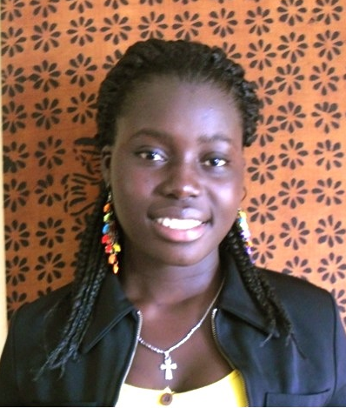
Josephine Gekpelee is 20 years old, and currently enrolled at Cuttington University in Bong County, the third most populous county in Liberia. Founded in 1889, CU is the oldest, private university in Liberia and is a top-ranked institution. Josephine has a wide smile and easy laugh, quiet nature, and firm opinions about how to improve the country. She lives with her brother and his wife. Her older sister attends university, and she is well aware of the opportunities higher education can bring. Josephine studies Agriculture & Rural Development to learn how “families like my own” can sustain themselves while helping Liberia develop. Liberia produces only about 40 percent of the rice, the country’s food staple, for a country of 3.5 million people. According to a 2010 United Nations Development Program report, 60 percent of the population was classified as “food insecure.” Josephine sees farming as way “to provide food for my country.” Josephine, whose hobbies include singing and sharing jokes, is serious about how GPFA will impact her future. “Seeing myself at university,” she explained “means a whole lot to me and my family, and I thank God for the Foundation. I hope and pray that the Foundation will still be by my side until my dreams come to reality.”

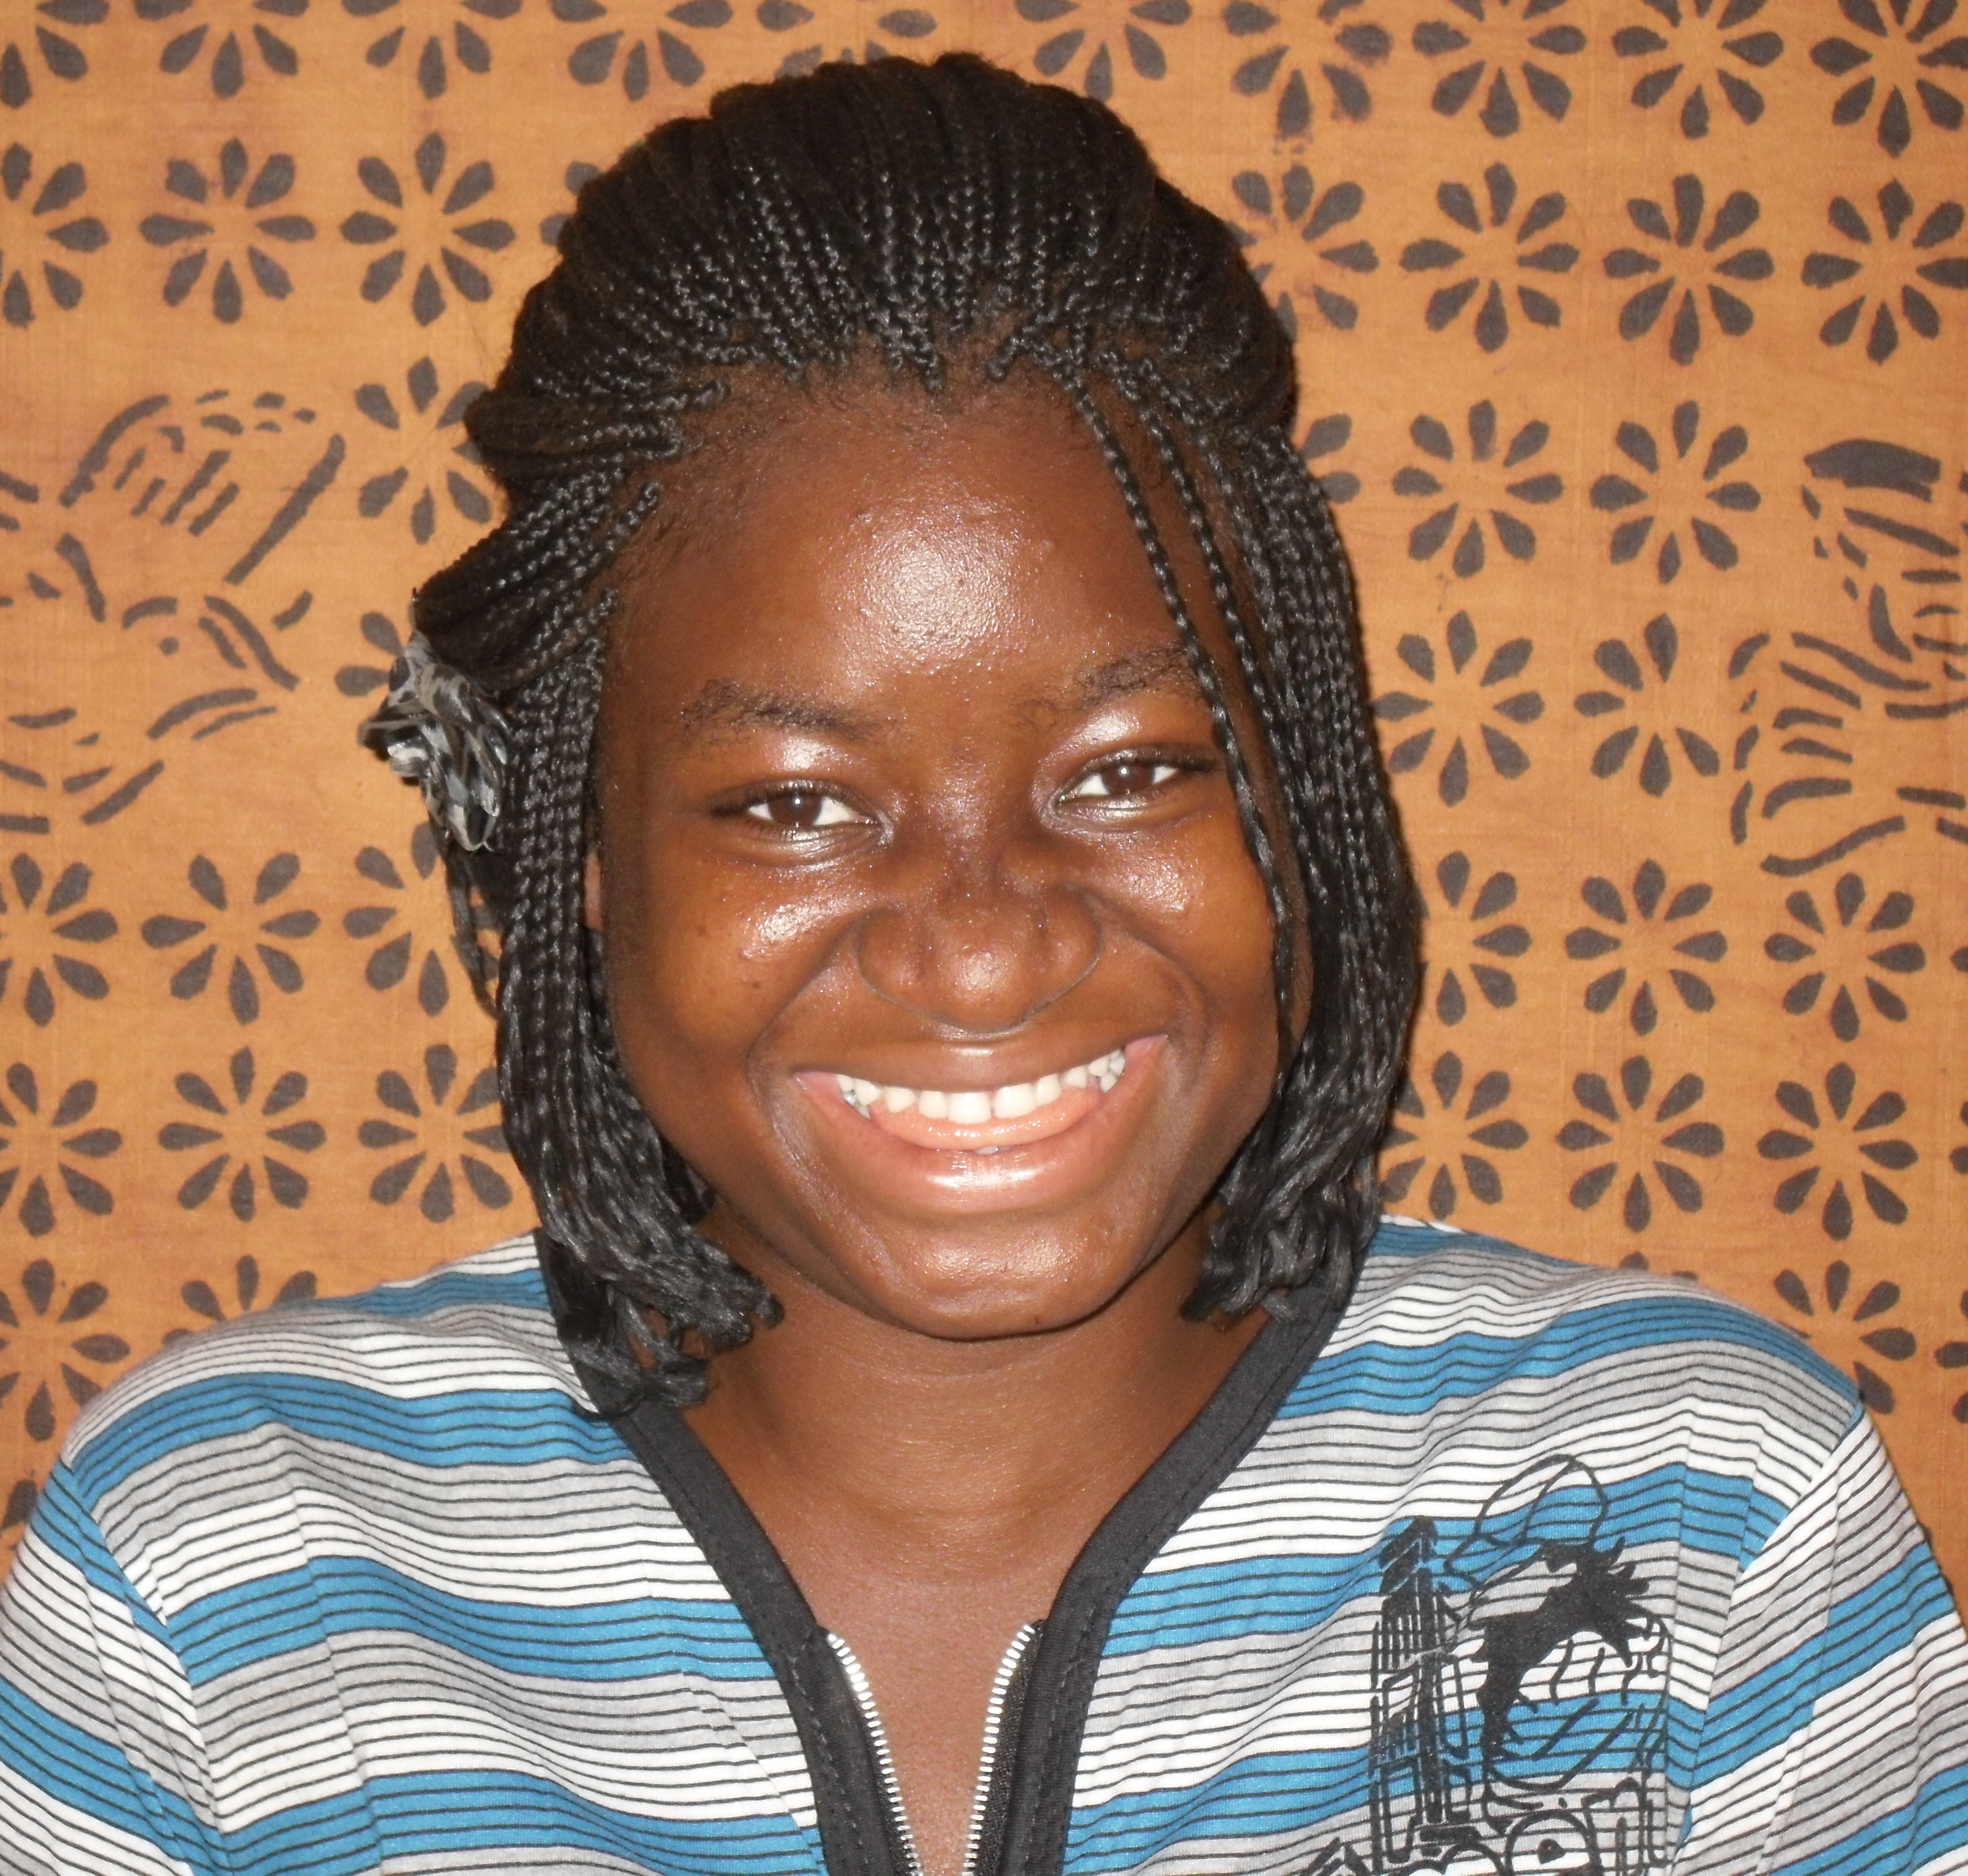
MaHawa Ngaima is 18 years old, and is named after her late grandmother. As the first and only member of her family to attend a college or university, MaHawa is enrolled at University of Liberia, one of the oldest public institutions of higher education in West Africa. MaHawa’s big cheeks and round eyes conceal a steely focus. She studies Biology & Chemistry at UL, and will use her education to treat children suffering from chronic diseases, which the World Health Organization predicts will account for “78 percent
of the global disease burden by 2020.” MaHawa is from Lofa County located about 6-7 hours drive north of Monrovia. The Lofa County Development Agenda (LCDA) cited the area as “arguably the most severely affected by the 14 years of [civil] war.” The LCDA cited in its 2008-2012 report that about a quarter of women 15 years and older were literate (compared to half of men) and just 14 percent of females aged 12-17 were enrolled in secondary school (compared to 39 percent of males). With her GPFA scholarship, MaHawa is now determined to continue her education to the master’s degree level because “I want to work for the interests of children.” With a last name that means “come back” in the Gbandi language, MaHawa intends to return to Lofa to use her education for the betterment of the community. MaHawa is grateful that “I don’t have to worry about school fees and transportation anymore. I am the most happiest child! I hope other girls are helped so that they too can tell that they have been cared for an not left behind; to make them feel important to society.”
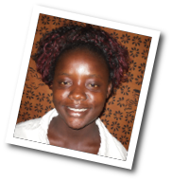
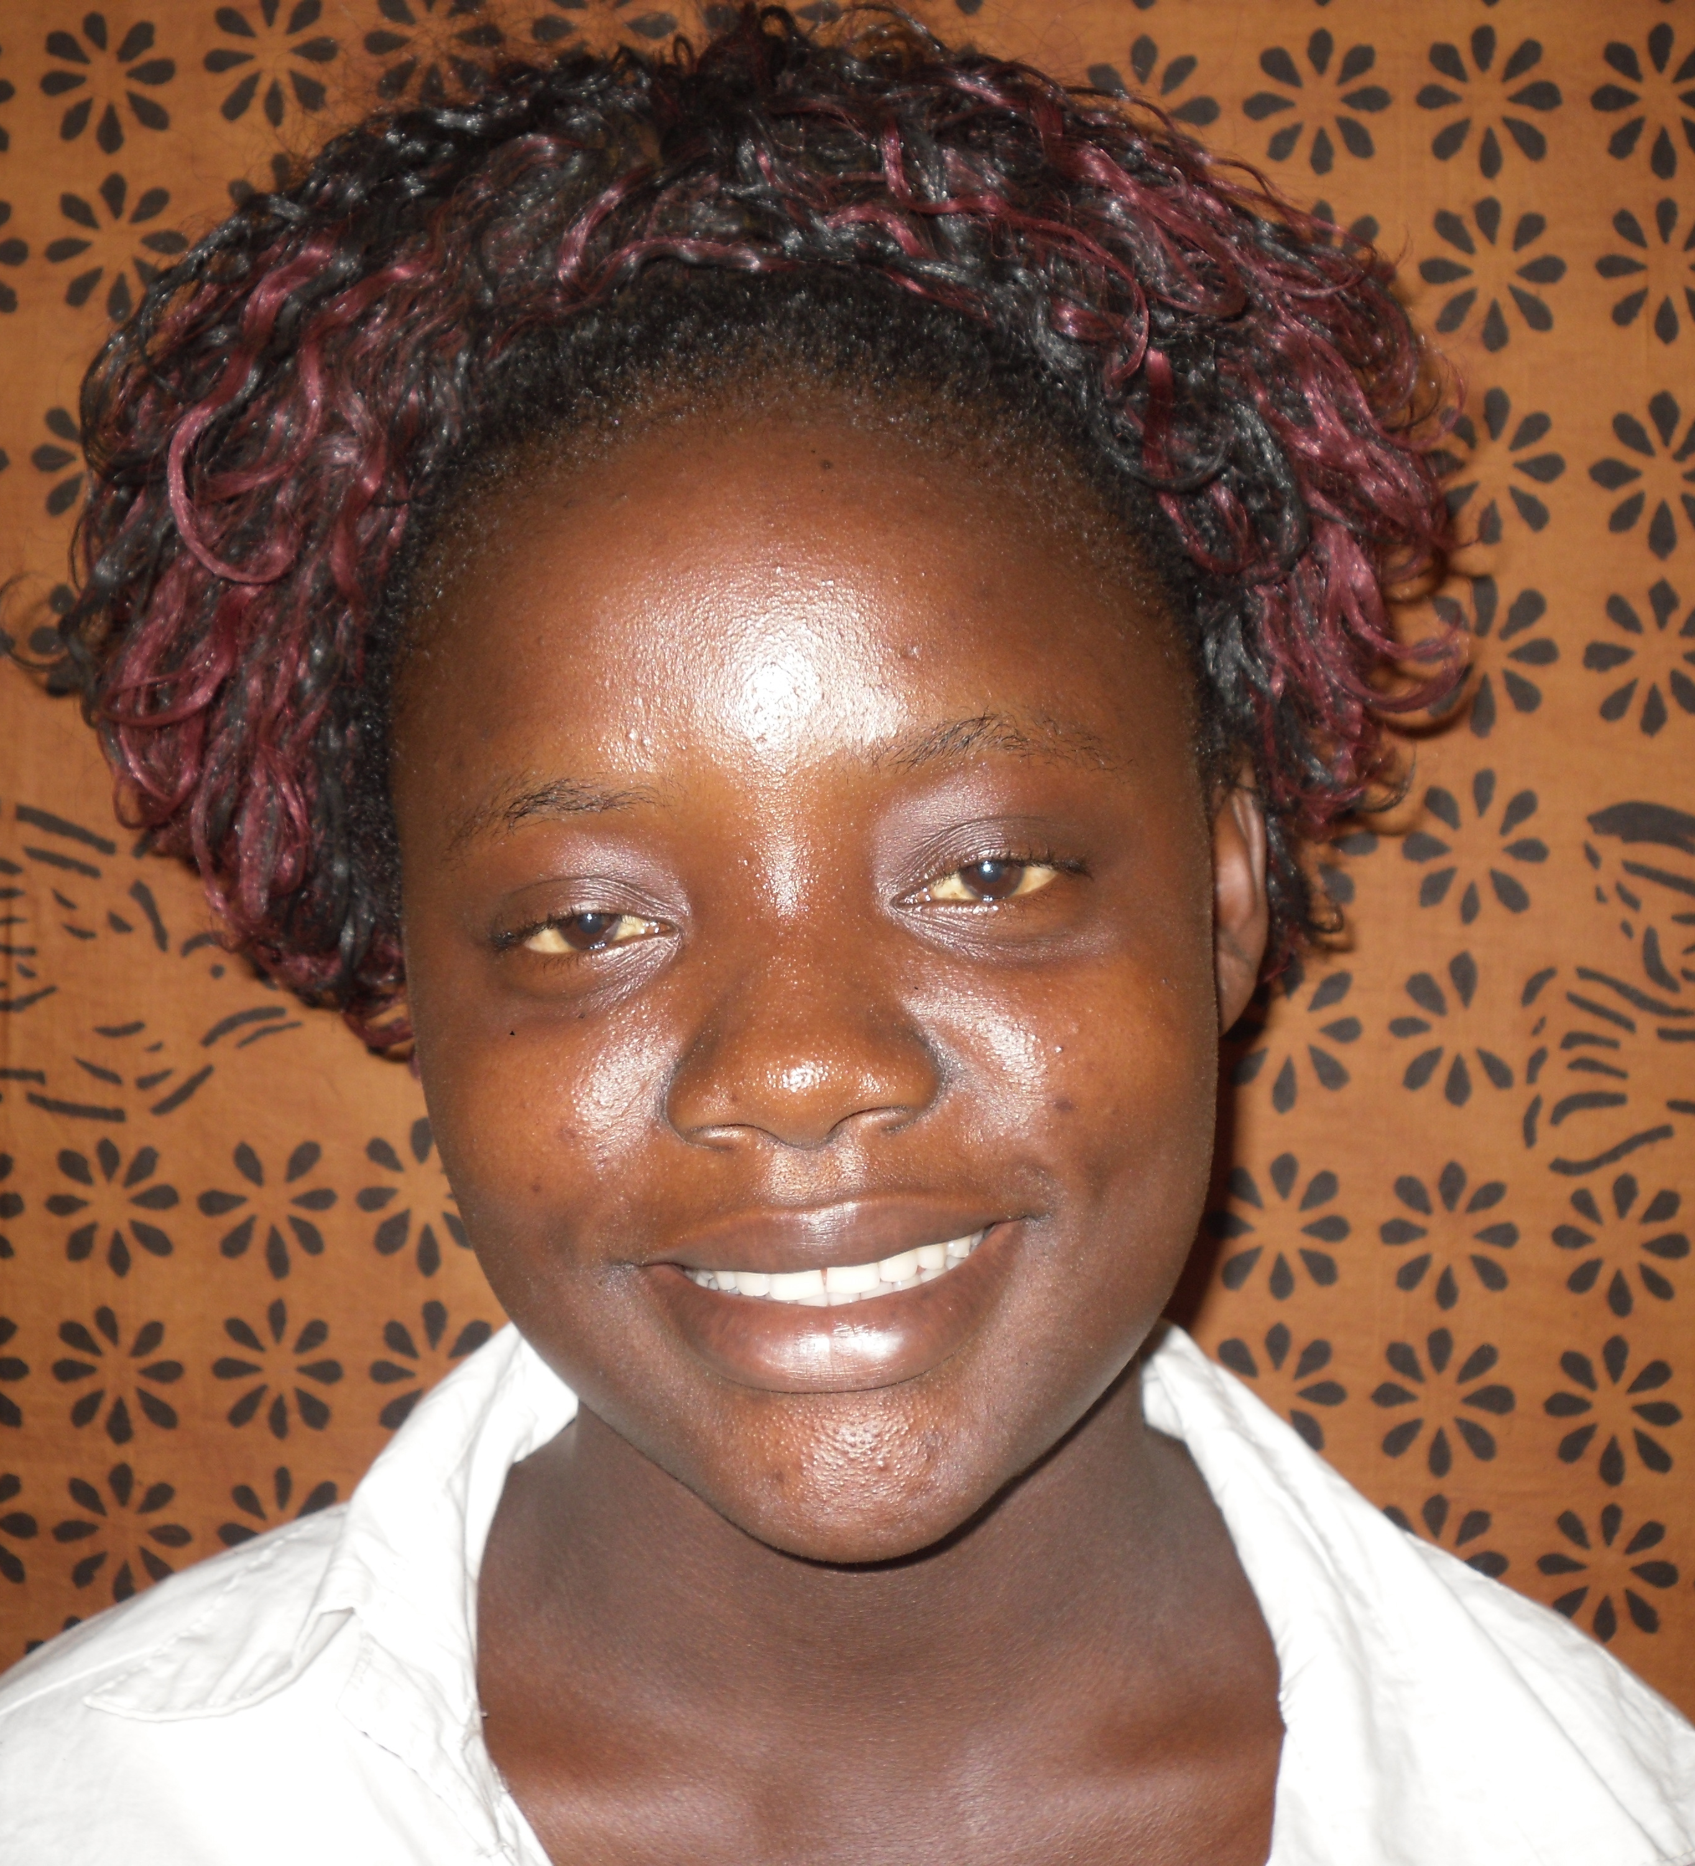
Patience Dobson is 20 years old, and is one of only three girls in Liberia to achieve a Division II score or better in 2010 and 2011. Patience is from Grand Bassa County, which was once a major economic center of activity in Liberia; as a result of the war, the health and education systems in Grand Bassa “remain in very poor shape” according to the Grand Bass County Development Agenda. Patience is the second oldest of seven children, and is
the only person in her family to attend college or university. Her grandfather and mother raised her; her father has not been in her life. Patience is now enrolled at Mother Patern College of Health & Science studying Biology & Chemistry to become a doctor. Patience intends to use her education to “save the lives of my citizens.” Her most immediate goal is using her education to support her family. “The Foundation’s help is my greatest opportunity to help myself, my family and my country.” Patience will now be able to concentrate on her studies with a full scholarship to Mother Patern to complete her studies.
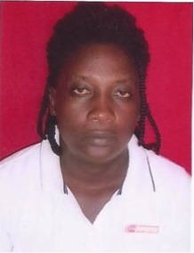
Wanita Kollie is 36 years old, and is the second oldest of seven children in what she describes as a “very poor family” from Gparpulu in Bong County. For Wanita, getting an education has always been a priority. For years, she saved what little money she could, and took one course at a time. As a single mother with four children, she was 33 years old when she graduated high school. “It wasn’t easy,” explained Wanita, “but through determination and focus I was able to get through.” She wants to encourage other girls no matter the situation that it’s never too late for an education. “As a young girl that had given birth to a child at a very early age,
remember that there is still a way that you can go back to school to improve your life.” Wanita is the only person in her family to attend university.
Wanita originated from Gbarpulu in Bong County. She attends at Cuttington University, and studies Agriculture. Wanita intends to use her education to help the government grow more food for Liberia. She is “grateful” for the support Gbowee Peace Foundation Africa provides particularly as “a single mother and [with] the rest of the family depending on me.” As Wanita explains, “there were no means financially [for me] to complete high school and attend college so I am grateful for the great support given me by Gbowee peace Foundation, and pray for it to continue.”

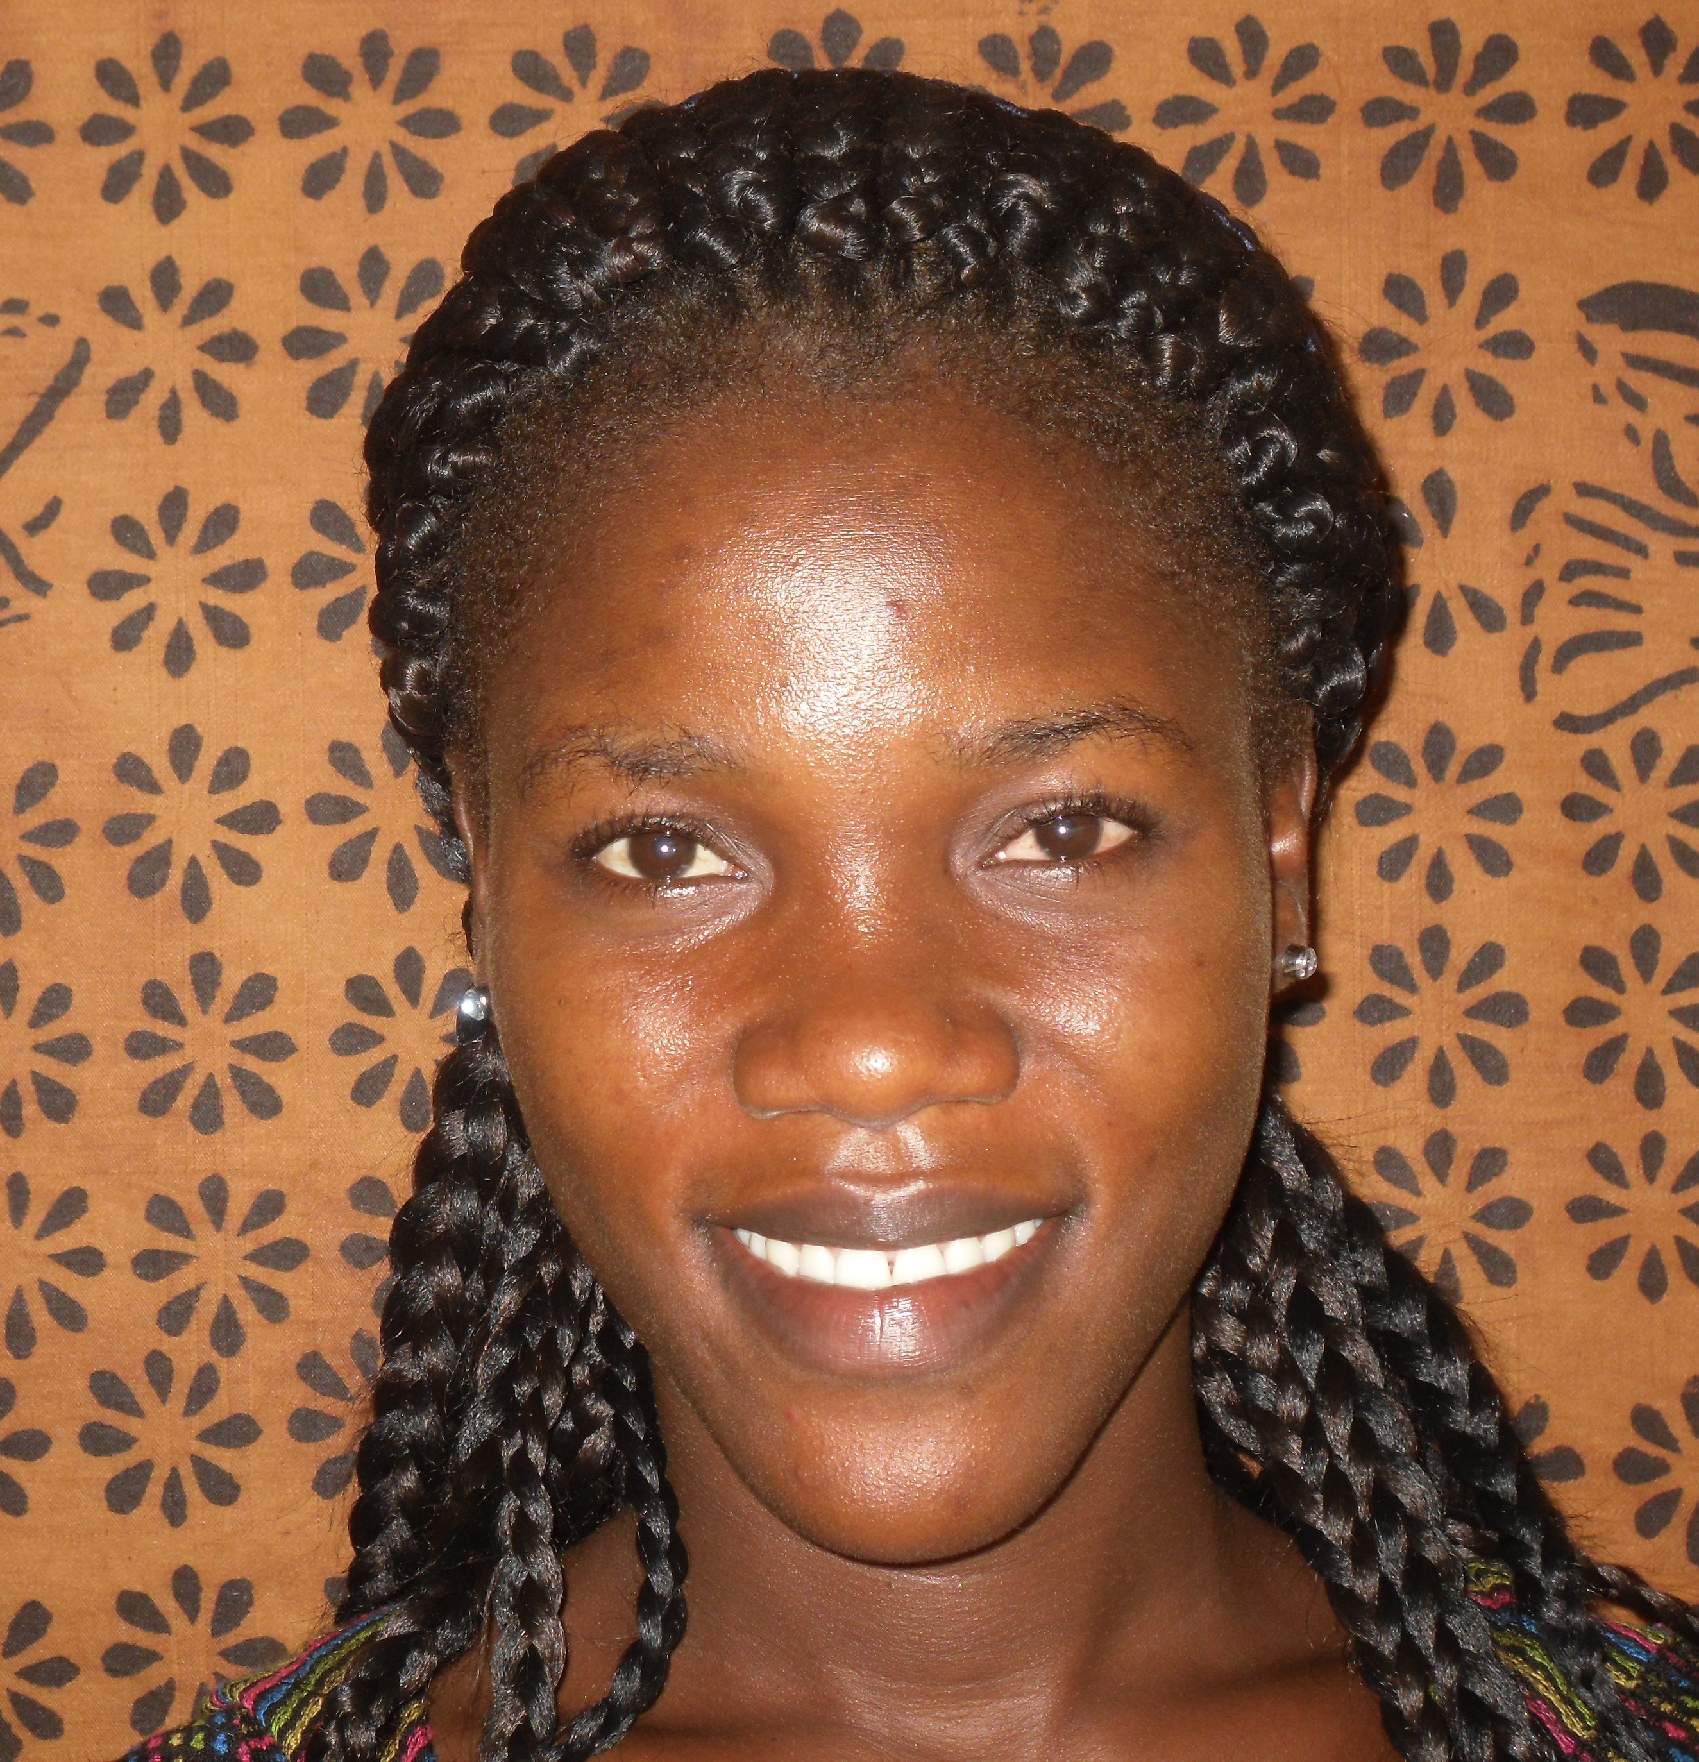
Ruth Nyanti is originally from Grand Kru County. She currently studies Agriculture at Cuttington University. She is the only member of her family to attend university. Ruth was raised by her father and stepmother. Her father is a petty trader, a job in the informal sector consisting of subsistence occupations, and bartered skills. Her home life was difficult; Ruth’s stepmother regularly called her “good for nothing” and predicted she would never make it through college. Ruth’s faith in God and the support from Gbowee Peace Foundation Africa sustains her determination. She intends to “reach the top” and earn her master’s degree. Ruth has never travelled outside the country, and procured her birth certificate and passport with help from GPFA. She is excited about the opportunity to possibly earn her master’s outside of Liberia, but is adamant about returning to Liberia to use her education to “grow more food for Liberia.”
