

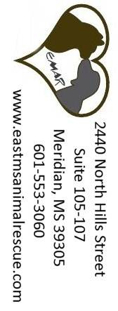


Mailing Address:
2440 North Hills Street
Suite 105-107
Meridian, MS 39305
601-553-3060
www.eastmsanimalrescue.com
EAST MISSISSIPPI ANIMAL RESCUE

All donations to East Mississippi Animal Rescue are tax deductible to the fullest extent allowed by law.

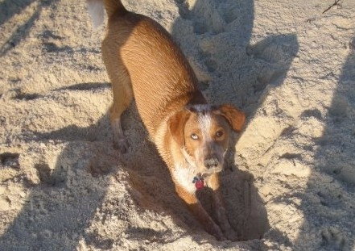

Lizzie, an EMAR rescue, during a trip to the beach with her new family.

Cody, an EMAR rescue, enjoys digging in the sand while vacationing with his new family.

Happy Tails

□ I would like to make a tax deductible donation:
___ $150 ___ $100 ___ $50 ___ $25
$_____ Other Amount – Any donation is helpful!

□ I would like to make a donation in memory/in honor of a person or pet:
$_____ in memory/in honor of (circle one)
Name of person(s) or pet(s):
_____________________________________
Person(s) to notify of your donation:
Name: _____________________________________
Address: _____________________________________
_____________________________________

□ I would like to volunteer for EMAR in some capacity – please contact me!
Name:________________________________
Street: _______________________________
City: _________________________________
State:___________ Zip: _________________
Email: _______________________________
Phone: ____________________________

Please mail this form with your donation to:
EMAR
2440 North Hills Street
Suite 105-107
Meridian, MS 39305

Donate

What You Can Do

There are multiple ways in which you can assist East Mississippi Animal Rescue. Whether you have time, funds, or supplies to donate, your help is greatly appreciated. Listed below are a few ways in which you can help East Mississippi Animal Rescue.
- Apply to adopt a rescued pet
- Volunteer as a foster home
- Volunteer at pet adoption days at Petco
- Wash and groom animals
- Organize fundraisers
- Donate your computer skills
- Make adoption follow-up calls
- Donate funds
- Donate supplies
  - Used or new pet items
    - Leashes
    - Collars
    - Pet beds
    - Pet toys
    - Dog houses/crates (all sizes)
    - Towels/blankets
  - Office supplies
    - Printer paper
    - Printer ink (hp 96 & 97)
  - Gift cards (gas or pet supply stores)
  - Fencing materials
- Use your talents to donate in a creative way
Contact us at 601-553-3060 or email eastmsanimalrescue@comcast.net.

You can also donate online at www.eastmsanimalrescue.com

All photos in this brochure are of animals rescued by East Mississippi Animal Rescue.

East Mississippi Animal Rescue (started in 2001) is an all-volunteer, 501 (c)(3) non-profit organization dedicated to the rescue and re-homing of abandoned animals in East Mississippi.

East Mississippi Animal Rescue is a small group of dedicated volunteers trying to make a difference in our community. EMAR is not a shelter with visiting hours; animals are housed at the homes of volunteers. This means that we can only accept a limited number of animals at a time.

Each animal is given basic medical care, and depending on age, is spayed or neutered. The adoption fee charged for puppies and kittens includes spay/neuter when the animal is old enough for the procedure. Adoption fees also help cover routine veterinary costs.

Rescue expenses are funded by donations and adoption fees. EMAR has never received any assistance from county or city government and is not affiliated with any county-run facility.

Who We Are

