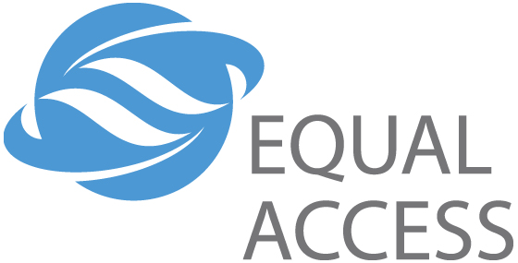
Equal Access Overview
Mission
The Equal Access Mission is to create positive change for millions of people in the developing world by providing critically needed information and education through:
- Locally produced and targeted content
- The use of appropriate and cost-effective technology
- Effective partnerships and community engagement.
Equal Access Approach
Equal Access creates customized communication strategies and outreach solutions that address the most critical problems affecting people in the developing world. By designing and producing compelling local language audio and multi-media programs in-country, we educate and catalyze behavior change in target audiences. We also analyze local infrastructures and use a range of technologies to develop the best dissemination strategy—satellite broadcasting, AM/FM broadcasts, community outreach or a combination. Equal Access partners with international agencies, NGOs and community-based organizations to increase the impact and broaden the reach of existing development efforts.
Our Core Expertise:
- Content Creation—developing innovative ‘needs driven’ programming that is culturally appropriate and incorporates feedback directly from audiences.
- Information Dissemination—implementing scaleable solutions that reach mass audiences, provide training or information resources and are able to reach underserved/remote populations.
- Community Engagement—integrating communications with on-the-ground development initiatives to maximize impact through capacity building, listening/discussion groups, facilitated learning, interactive feedback and evaluation.
Equal Access addresses a broad range of development issues, such as basic education, women’s empowerment, human rights, better health practices, HIV/AIDS, governance and livelihoods training.

Project Example: Nepal
Every day, millions of Nepalese tune into the radio drama, Khura Khasra Mitha, (Let’s Talk Straight), to be entertained by the stories of life in the village of Sundarpur centered on the elder woman, Thuldidi. Issues such as women’s empowerment and HIV/AIDS are raised and examined in the drama. After the broadcasts, these issues are discussed in hundreds of villages through facilitated listening groups. Nepal’s infrastructure is poor, so reaching rural Nepalese is a challenge. For this reason, we use digital satellite radio and local FM radio stations to broadcast Let’s Talk Straight along with more than ten other radio programs covering a variety of development topics. Together, this combined behavior change communications solution works to empower rural women and prevent the spread of HIV/AIDS.
Project Example: Afghanistan
Each week, over 3,500 teachers in Afghanistan tune into the teacher training radio program, Knowledge is Light, to learn new skills and acquire more knowledge. For most teachers, the discussions centered around this radio series are their first training experience and serves as their only information conduit. The devastation wrought by 23 years of war has left virtually no infrastructure intact, the roads are unsafe, the communication systems have to be rebuilt and the schools are destroyed. By teaching teachers how to teach, Equal Access is dramatically increasing the capacity of Afghans to reshape their lives and directly improving the education of over 150,000 students.
Equal Access develops projects around the world to bridge the gap between poverty and opportunity.
www.equalaccess.org.

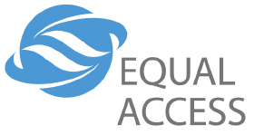 Nepal Report July 2004

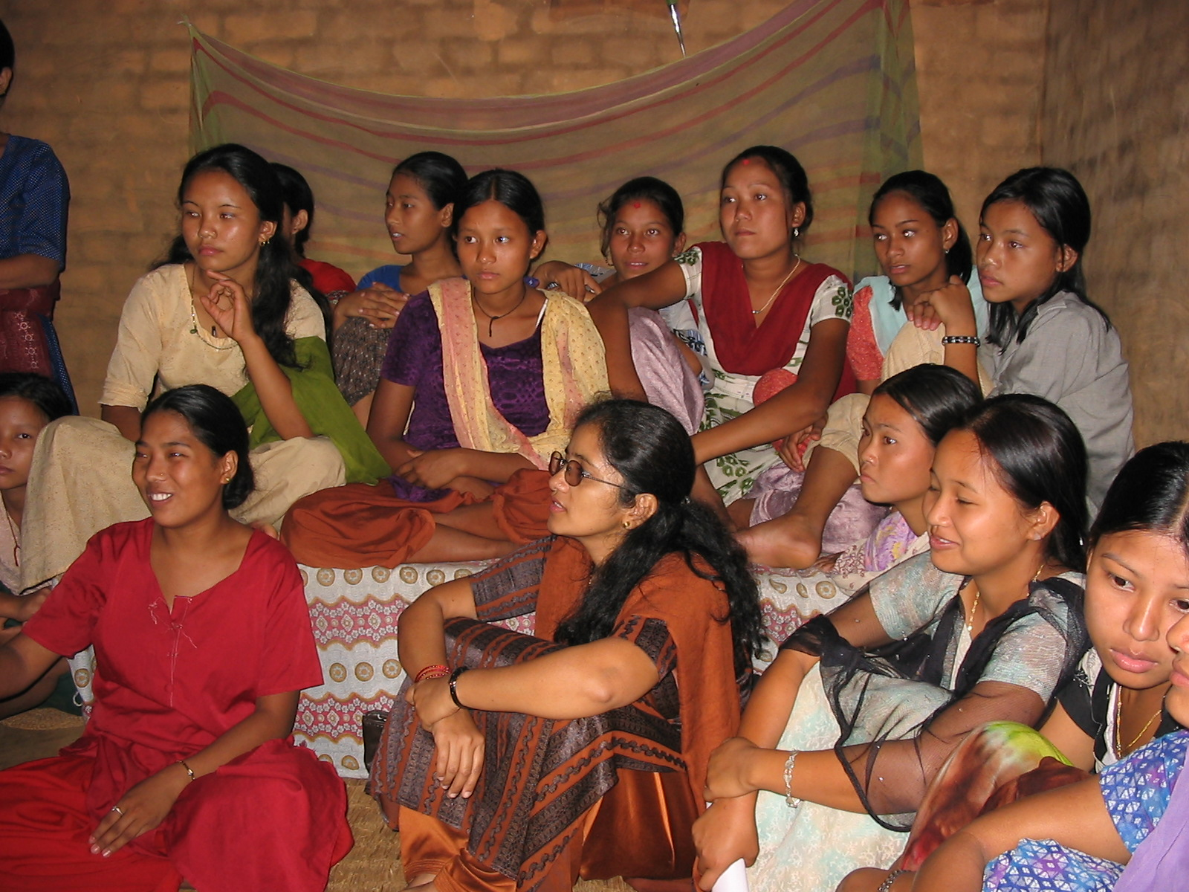
Every day, millions of Nepalese tune into the bi-weekly Equal Access radio drama, Kura Khasra Mitha, or Let’s Talk Straight, to follow the lives and struggles of the people in the village of Sundapur through the interactions and directions of a loveable and gutsy townswoman, Thuldidi. Serving as a foil who highlights the real situations of village life across Nepal, her character stumbles across traffickers trying to buy children for “work” in the city, women beaten by their drunken husbands, men who return home with HIV and women with unwanted pregnancies struggling to make ends meet. With dramatic flourish and panache, Thuldidi provides advice, support and connections for the villagers to adapt and respond appropriately to these difficult situations. Site visits and thousands of letters show the real impact of the program—many of our listeners have appointed a town “Thuldidi,” sent women and girls for empowerment trainings, sought family planning services or refused to send their daughters off with traffickers.

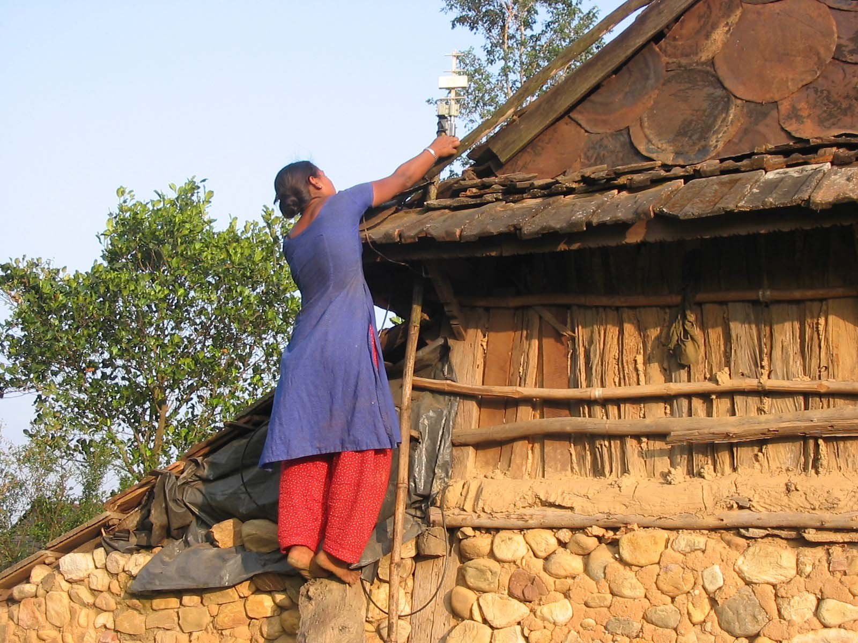
After the broadcasts, these issues are discussed in hundreds of villages through facilitated listening groups. Nepal’s infrastructure is poor, so reaching rural Nepalese is a challenge. For this reason, we use digital satellite radio and local FM radio stations to broadcast our flagship radio program, Let’s Talk Straight, along with more than ten other radio programs covering a variety of development topics. This combined behavior change communications solution empowers rural women and prevents the spread of HIV/AIDS, while providing critical information on sustainable livelihoods, human rights, early childhood development and safe migration. After only a year of broadcasting, documented and anecdotal evidence demonstrate increased knowledge, shifting attitudes and behavior changes in participating communities. These empowered women will make a profound difference in their community.
Nirmala setting up
the satellite antenna

For instance, Ms. Manju Panta, a receiver custodian in a Morang district village, says that the broadcasts have a visible and positive impact on her community. Previously, many people from a group known as ‘Sattar’ used to flock to the cities in search of jobs as house servants. Many people from this group became aware of the hardships faced by house servants and girls being trafficked through Let’s Talk Straight. As a result, they have decided to stay back home and work in the fields as paid workers or sell veggies in the local market.

In the village of Churuamai, a young Dalite girl, Nirmala, is the caretaker of the receiver and all the discussion groups in her village meet in her home. One day, she ran up to Equal Access staff member, Likhit Devkota, to proudly exclaim, “I saved my best friend’s life, I saved her life! You see, I learned what trafficking is because of the broadcasts. I knew my best friend would be a victim because she is very beautiful. I told her about trafficking and warned her to watch out for the men who come to our village to offer jobs in the city, but she wouldn’t listen. One day, I saw a man talking to her and I ran over. I pleaded, ‘Don’t just take her…take me too!’ I knew he wouldn’t take me because I am not very pretty. Sure enough, the man said, ‘I only have money for one girl’s job.’ Then I threw myself at my friend and said, ‘How can you leave me? Don’t leave me here alone; I will never speak to you again if you do.’ Well, my friend stayed. I know I saved her life.”

In Churiamaio, a young woman returned from Mumbai with HIV. The villagers learned from Let’s Talk Straight that you cannot catch AIDS just by touching people and the importance of caring for people living with HIV/AIDS. “She needs our compassion. We used to discriminate against her. However, the thinking in our community has changed because of listening to the programs. Now, we care for her and she is part of our community.” In Ranjani, the women said, “In Let’s Talk Straight, Kaji drinks a lot and is abusive to women, especially his daughter and her friend from the village. Thuldidi finally sent these two teenagers to empowerment training so they would know how to deal with Kaji. Well, we never knew there was such a thing as empowerment training, but we do know that this type of abuse happens often in our village. We made some inquiries with the local NGOs- and now we send our girls for empowerment training too!”

Afghanistan Report July 2004
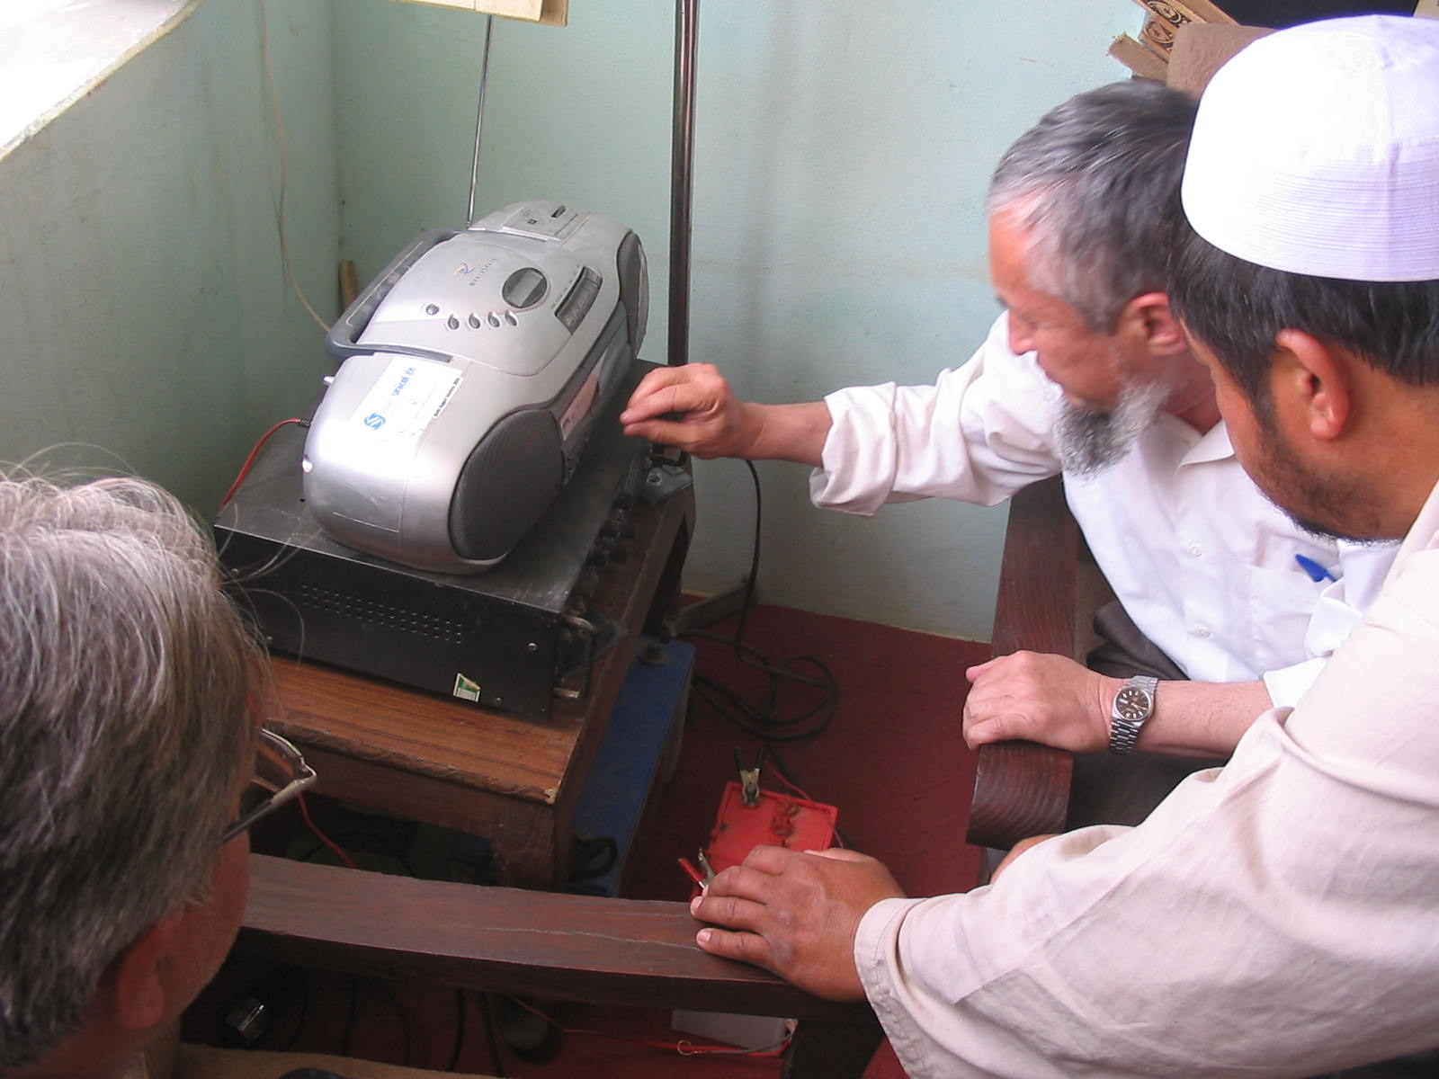
Each week, over 3500 teachers in Afghanistan tune into the Equal Access distance-learning, teacher training radio program, Knowledge is Light, to learn new skills and acquire more knowledge. For most teachers, the discussions centered around this radio series are their first training experience and serve as their only information conduit. The devastation wrought by 23 years of war has left virtually no infrastructure intact—roads are unsafe, communication systems have to be rebuilt and schools are destroyed. By teaching teachers how to teach, we overcome these obstacles by dramatically increasing the capacity of Afghans to reshape their lives and by directly improving the education of over 150,000 students. As soon as funding is available, The Ministry of Education has requested that we provide receivers and orientation training on Knowledge is Light to 150,000 teachers at 7,000 schools in critical need of training support.

At the end of May, Mustafa Shah Babak and Ahmad Shah Rashidi, our field staff in Afghanistan, returned from Kunduz province with several stories on how successfully Knowledge is Light is being integrated into the schools that Equal Access currently serves. At Basoos Secondary School—1,590 students with 142 girl students—the headmaster of the school and the teachers, all listen to the programs once a week and find the programs very useful and effective. Most teachers listen to the broadcasts and those teachers who can’t, listen to the recorded programs later. The headmaster, Mr. Mohammad Eisaq Khan, asked for a loud speaker so others in the community could benefit from the program—he feels the benefits of the program are not only limited to teachers. His school lacks qualified teachers and he has therefore selected his best students to teach primary classes.

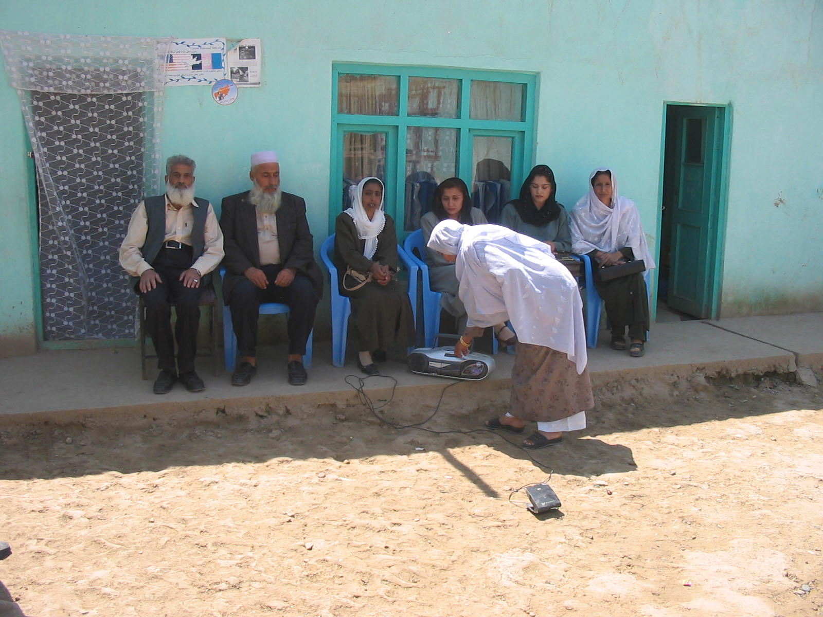
When Mustafa and Ahmad Shah arrived at Zer Dawra Primary School—approximately 1,200 girl students, 100 boy students—all 28 teachers were listening to Knowledge is Light together. As Ms. Gawhar Taj, the principal of the school, said, “This program is a very good teacher trainer for all the teachers. We are finding very good ways of teaching and the programs have really helped us improve the teaching quality.” One teacher, Mr. Afzali, said that the programs talk about child abuse and encourage teachers not to threaten the students. Every teacher may not improve overnight, but simply knowing the options begins the process of changing standards and improving education opportunities.

At Aaq Tapa Primary School, Mr. Rahim Qul, the headmaster of Aaq Tapa High School, works together with his teachers on the contents of Knowledge is Light after every episode to develop better ways of teaching in his school. He uses loud speakers to amplify the programs, because this program is not only for teachers but also for students and families, especially since parents are also teachers of their children. He has an attendance sheet that every teacher signs after listening to each episode every week. He visits each class every week to evaluate the changes in the class, and so far, he is very satisfied with his teachers, saying that they are doing very well.

Ms. Gawhar Taj, listening to
Knowledge is Light with her teachers.

