Multipurpose Safe Space Shelter Project
Hidden in Plain Sight
Many lesbian, gay and bisexual individuals who come out to their family and friends in Kenya live with a genuine fear of repercussions that come with revelation about their sexuality. Some LGBs lack family support and sometimes also lack the opportunity to access an education, formal community groups and social networks.
LGB persons are thrown out of home, schools, estates and even assaulted because the society is generally intolerant of sexual minorities. With nowhere to go, these individuals are sometimes taken in by abusive relatives and the internal and external pressure push some to the streets and some succumb to depression.
In Kenya, homosexuality is criminalized under sections 162(a), 163 and – 165 of the Penal Code. Sexual minorities are constantly exposed to shame and discrimination and abuse by law enforcement agencies, public authorities, and the media.
Old aged gay persons, particularly also face stigma and oftentimes, lack family and social support in their old age. These persons wonder whether they will be denied adequate care by both family and other old aged homes if their orientation is known.
The social old age homes are reluctant to take in aged gay persons while others live in seclusion and are closeted once again to be able to access support. Aged LGBs often find themselves with an isolation that is complete, or almost so, when they enter retirement homes for the general population or taken back by family, relatives or friends, if they have any.
This proposed Multipurpose Shelter will in the long term, cater for old aged gay persons, who may lack a support structure.
GLOBALGIVING FUNDRAISING CHALLENGE
Gay Kenya Trust initiated a $53,000 Multipurpose Safe Space Project which envisions the establishment of not only a safe space for LGBs, for immediate safety evacuation but also for counseling, economic empowerment and where possible, engage with family, seeking reconciliation and reintegration of LGBT persons.
One of the single important factors mentioned by our members as reason for their increased vulnerability to HIV and violence is their inability to have meaningful and sustainable means of earning a living. Entrepreneurial training will address these vulnerabilities.
Gay Kenya joined the GlobalGiving Summer Challenge in December 2011 through which it managed to raise $1,260. The fundraising was not able to meet the $4,000 threshold to guarantee a permanent spot on the website.
Gay Kenya had identified a piece of land in Kajiado County, a little less than a quarter of an acre, but the $1,260 was not enough to purchase the land whose rate was $4705.
In honour of the persons who had made donations towards this project, Gay Kenya members planted 100 indigenous trees at the Wildlife Clubs of Kenya.
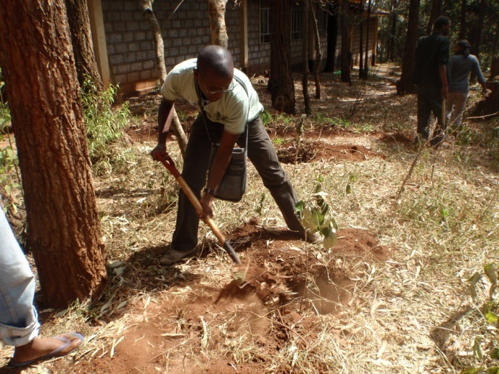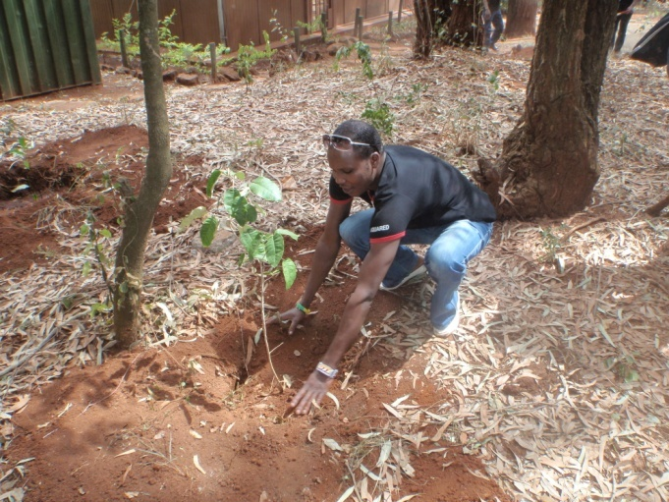
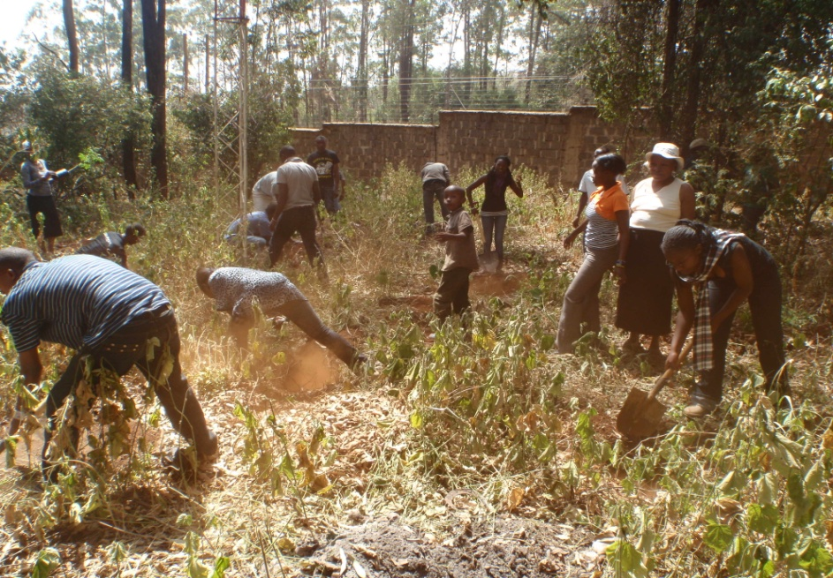

Aged LGBs are profoundly uncertain that family care and social services that are primarily designed to meet heterosexual peoples’ needs will be able to respond to their own specific requirements. As a long term strategy, the shelter will be expanded to also take in aged gay persons who face the prospect of their support family from and social networks falling away.
WAY FORWARD
The $1260 is still in the Gay Kenya bank account. Fundraising for the project is ongoing, and Gay Kenya hopes to implement the project in phases.

