Thanks to the fabulous donations, we’ve been able to help more people with diabetes. We raised the number of people from 58 to 92. Your extra support helps them to pay for their medication every month. Among these 92, three out of four (69) are women. The discounts vary from 50% to 100% depending on the individual situation.

A little bit of support can be critical to improve quality of life. For example, here is Mrs Nhem Samat with her new voucher to buy her medicines for June 2012 from the revolving drug fund. The lower the monthly costs, the better she is able to afford the daily treatment. She has an 80% discount on her monthly bill of USD 9.75 bringing it down to just USD 1.89, a level with which she can cope.
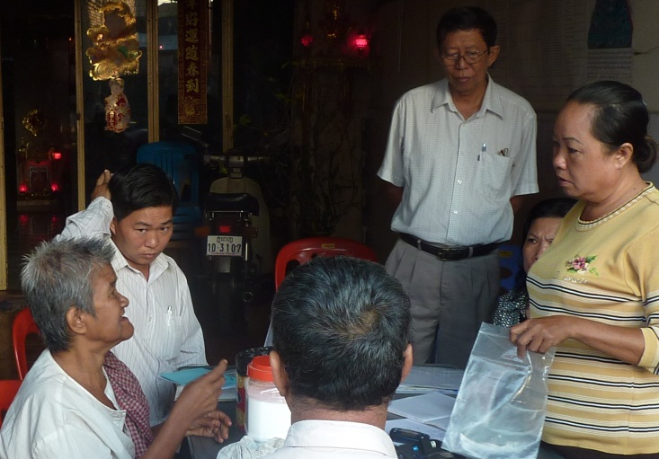
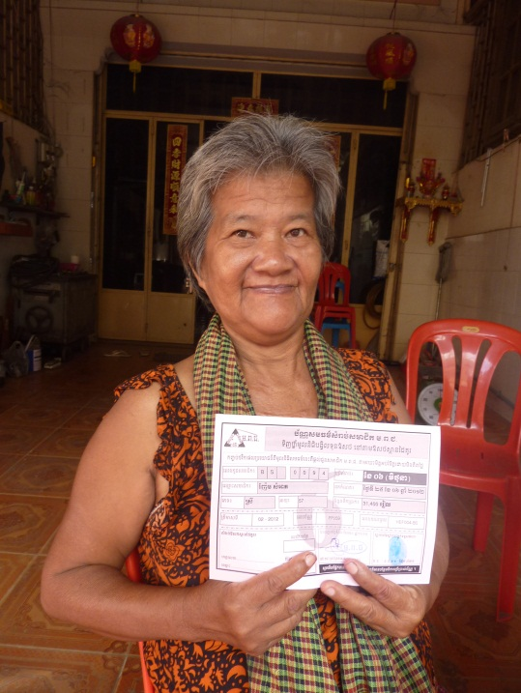
She lives with her husband. They are both old and have very little money to live on so meeting the cost of medicines is a real challenge for them. She likes the routine of joining the Tuesday morning group of diabetics led by the peer educator in area where she lives. That morning also Dr An Prasath from the Public Health Center nearby was making an informal visit.
Our financial goal is USD 20,000 per year for 250 patients. So far we have raised over USD 4,000. The total monthly value of their discounts which these 92 patients receive is USD 456 so we will run short on yearly basis. We hope to raise more in the coming months to continue to help our people with diabetes and …help more people. Your support is more than welcome.

Our Cambodian NGO MoPoTsyo is advocating for the adoption of affordable structural solutions to the problems that we encounter. First we help to find these solutions and when we find them we test them out and we share our knowledge with everyone who wants to know more about it.

For many more news items and detailed project activities, please read our last newsletter called “highlights” by clicking on the weblink here below:
http://www.mopotsyo.org/Highlights_Jan_2012_to_May_2012.html

Maurits van Pelt, 26 June 2012

