

Overcoming Tragedy in the Indian Ocean

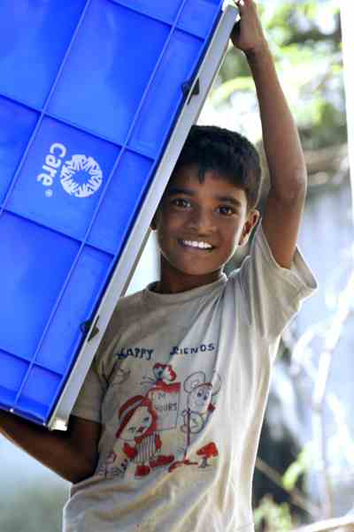
This hopeful Sri Lankan boy shows he is willing and able to pull his weight – or rather to lift it –
to help his family and community begin their road to recovery.

Earthquake and Tsunami Rehabilitation Fund

Goal: $50 Million

Overview

What now? It is a pressing question for an untold number of people – not only the millions of men, women and children whose lives have been torn apart by the December tsunami that claimed more than 250,000 lives, but also generous donors, a concerned public and government leaders, not to mention the aid workers on the frontline of the response. Fortunately, disasters of this magnitude are rare. Unfortunately, there is pressure to fulfill unrealistic expectations of putting broken lives back together in a matter of weeks or months, while it is becoming apparent to experts on the ground that it will take years of concerted commitment and effort for tsunami-affected families and communities to recover from the staggering loss of loved ones, livelihoods, homes, infrastructure and basic social services.

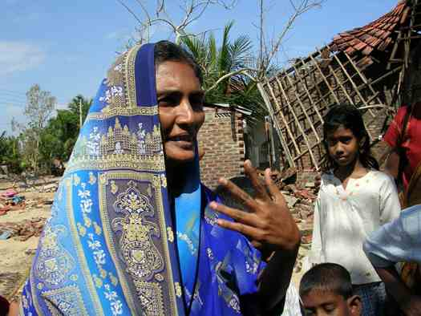
CARE’s first step in responding to the devastation wrought from south Asia to the east coast of Africa is to listen to the needs of the survivors and coordinate with governments and other humanitarian organizations to help meet those needs. As the immediate requirements for food and clean water subside, CARE will work with affected communities to begin the less newsworthy, longer-term work of rebuilding. CARE was working in the affected countries before they captured the media spotlight, and we will remain long after the cameras and journalists move on to cover the next crisis. We value the trust our donors place in us as much as we value the poverty- and disaster-stricken communities with which we work. We will honor that trust by dedicating the time and resources necessary to adapt our response to best meet the evolving needs of vulnerable communities in India, Indonesia, Sri Lanka, Thailand and Somalia.

Rumasalima safely escaped with her children and mother to higher ground when the ocean swelled and ravaged her Sri Lankan community of 40,000 Muslims. She now lives with her family in a tent at a temporary camp where she receives food and basic supplies from CARE. Had her family not been among hundreds of Muslims accused by the militant Liberation Tigers of Tamil Eelam (LTTE) of spying for the government and forced to live in the precarious coastal land years earlier, Rumasalima quite possibly would have been spared the loss of her home and all its contents.

While continuing to help rehabilitate damaged communities, particularly those with vulnerable and marginalized populations, we realize that channeling all our assistance only to those who have lost their homes, boats and other possessions poses a potential threat to neighboring communities, and could create or exacerbate longstanding ethnic, political and status divisions present in these countries. CARE will therefore consider the impact of our response efforts on the larger coastal area and on other vulnerable groups within each country as we refine our long-term strategies. With our solid reputation and long-standing ties to the affected areas, CARE staff can facilitate collaboration between a multitude of local organizations, government agencies and community groups to find solutions to poverty and inequities. For example, this could mean examining ways to improve market access and strengthen the fishing industry as a whole, rather than simply replacing destroyed boats and nets in the most visibly devastated communities.

Our experience in responding to such large-scale, multi-country disasters as 1998’s Hurricane Mitch tells us that long-term commitment and support are required to rebuild communities that have been completely devastated. As our staff in the field learn more about the extent of personal, economic and environmental damage and loss in the tsunami-stricken countries, CARE believes that to help people transition to a state of self-sufficiency will take at least five years. Contributions to our multi-country Rehabilitation Fund allow our staff the flexible funding and other support we need to offer communities sustained assistance to help them regain what losses they can (homes, livelihoods, land and community buildings), cope with the irreplaceable loss of loved ones and find solutions for a more secure and fulfilling future. Thanks to the generosity of individuals, corporations and foundations, we have raised approximately $30 million of our $50 million goal to date.

India

Within hours after the waves struck, CARE’s most experienced disaster response staff in India rushed to the affected coastal areas, where more than 10,000 people were killed and millions of lives were turned upside down. In the worst-hit state of Tamil Nadu, an estimated 800,000 fishermen have lost the means – boats, nets and other supplies – with which they have supported their families all their lives. While the people who lost assets will receive some amount of government compensation, the marginalized dalits – who live further inland, have no place in the recognized caste system and are oppressed – could be left to struggle now that they have no fish to trade or boats to repair or odd fishing-related jobs to do. Reviving this essential sector of the economy will require a replenishment of the labor force, the replacement or repair of boats, nets and other basic equipment, as well as the desalination of the land and clearing of massive sludge deposits carried in by the seismic waves.

CARE helped meet the basic survival needs of 50,000 people by providing water purification materials, clothing, plastic sheeting for temporary shelter, sleeping mats and sheets, soap, cooking utensils and basic medicines. In the ravaged village of Pazhiyar, CARE also provided 500 temporary houses with electricity and nearby water taps and latrines for displaced families. With our kits containing drawing pencils, textbooks, slates and other basic items, children are returning to school and restoring some semblance of normalcy to their lives. Most schools have reopened and telecommunication and transportation infrastructure has been restored. In the 53 villages where CARE identified a lack of clean water and sanitation facilities, water systems are being repaired and latrines are being built. CARE has also set up two market areas where community members have begun selling vegetables, coconuts and flowers, among other basic items. We also moved rapidly to help bereaved and despondent survivors overcome their grief. In partnership with the National Institute of Mental Health and Neurological Sciences and Oxfam, CARE is training 900 health staff to provide trauma counseling in their communities.

Looking Ahead
In coordination with the government, CARE will help tens of thousands of families in Tamil Nadu’s Chennai, Cuddalore, Nagapattinam and Kanniyakumari districts cope with their loss, rebuild their homes and explore new job opportunities. In Andaman and Nicobar Islands we are continuing to provide needed emergency relief before initiating longer-term activities around livelihood support (small business development and micro-finance), HIV prevention and advancement of tribal rights and land entitlements. Our activities are briefly outlined below.

Mid-term: In addition to our ongoing distribution of supplies noted above, we will continue working to ensure better sanitation conditions and clean drinking water, and thus help people reduce their risk of diseases linked to contaminated water. Over the coming months, CARE’s activities will include the provision of latrines in camps for the displaced and in villages where survivors are regrouping, and delivery of clean water as needed. Civil society organizations will be strengthened and supported to carry out community-designed projects to rehabilitate livelihoods, education services and infrastructure, as well as address environmental damage. Moreover, we will ensure that community health workers have the skills and resources not only to help vulnerable children and other survivors begin to overcome the psychological and social trauma they have endured, but also to make these services permanently available.

Long-term: CARE will stay in affected areas and help families and communities rehabilitate water sources (wells, piped systems) and rebuild their homes and livelihoods. We will provide fishing nets and assist in the repair of small to medium-sized fishing boats and help other families build poultry and goat stocks as a means of earning income. To ensure that the rights and interests of poor marginalized people are represented in new housing, water and resource management policies, CARE will closely engage local governments. We will also assist with the development and strengthening of community emergency planning and preparedness to reduce vulnerability to future disasters.

With a focus on women, youth and other vulnerable groups, CARE will work through existing community groups to:

- Develop curricula for vocational and technological training programs and establish livelihoods resource centers to help women and other vulnerable groups learn new ways to earn money;
- Create community savings and loan groups and facilitate access to other financial services;
- Provide business development and management training to female entrepreneurs (vendors, retailers, tailors, etc.) so they can improve their family income and learn how to influence policy issues relevant to their lives.

CARE has worked in India since 1950, and we have more than 700 staff in country. Our programs are active in 11 of India’s 29 states, and in 2003, we partnered with more than 200 local nongovernmental organizations to transform the lives of 6 million poor and vulnerable people through programs in nutrition, health and HIV/AIDS; microfinance services; basic education; disaster preparedness and response; and tribal empowerment.

Indonesia

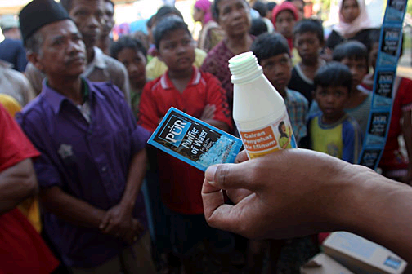
CARE’s staff in Indonesia are providing relief and recovery assistance to Sumatra’s Aceh state and capital city Banda Aceh, which were virtually on top of the earthquake’s epicenter. The need for and difficulty of disaster response in this zone are acute, amid mind-numbing destruction, more than 100,000 people dead and 1 million affected. The tsunami destroyed 100 percent of Aceh’s community health clinics (puskemas), and 70 percent of health care providers lost their lives, remain missing or have left the area.

To prevent the spread of disease, CARE is training displaced people and partner organizations to disinfect water with a locally-produced sodium hypo-chlorit solution and filter it with a product such as PuR. CARE is also distributing jerry cans with a narrow mouth to reduce the risk of contamination.

CARE’s initial response centered on food and clean water supplies: we delivered more than 61,000 safe water kits and distributed food to more than 37,000 people in more than a dozen of the informal camps that have cropped up in the wake of the crisis. To accompany the purification materials, CARE provided buckets with lids and jerrycans in which people can store and safeguard their drinking water. We will continue providing safe water supplies to at least 500,000 people a month for several months. After completing rapid surveys in 94 temporary camps, CARE began training volunteer health workers and midwives and distributing reproductive health kits to aid pregnant women, women in labor and new mothers and their infants. We also treated 271 cases of diarrhea and distributed oral rehydration salts after surveying more than 34 camps for disease outbreaks.

Using helicopters, CARE was one of the first agencies to provide assistance to remote areas along Aceh’s west coast, which had been cut off from all humanitarian aid. CARE staff are also using boats to deliver 30 tons of food, along with safe water supplies and other relief items, to people on the island of Simeulue and other isolated areas. With many ports, boats and roads destroyed, staff are using all available resources to get aid to people in need. Although schools officially reopened at the end of January, only 35 students were enrolled in an area of Aceh Besar that previously had 700 students. Prior to the tsunami, there were 120 schools in Banda Aceh; today, there are only 52.

Looking Ahead
CARE and our peer agencies are planning an integrated response that promotes peace, reconciliation and good governance to help devastated Indonesians survive and recover from this crisis and help mend political rifts. In the short term, that means providing not only clean water but also food and temporary shelter. In the longer term, rebuilding will be a massive undertaking as the earthquake and resulting tsunami wiped out homes, schools and basic infrastructure. CARE’s priorities will include disease prevention, reproductive health services and psychosocial support to meet the health needs of traumatized survivors.

The World Health Organization estimates that as much as 50 percent of the tsunami-affected population may be experiencing significant psychological distress, with up to 10 percent being severe cases. This equates to tens of thousands of people being in need of specialized mental health treatment. We are partnering with Johns Hopkins University through its non-profit affiliate JHPIEGO to provide reproductive and maternal health services to women and children in resettlement sites and re-establish high quality heath care facilities in Aceh.

In the coming months, the CARE/JHPIEGO partnership will provide immediate technical and financial support, training, supplies, equipment, and educational aids to reestablish quality health care services in hospitals, and private and community health facilities. CARE will also train and equip midwives so that they can provide essential (and free) health care services in resettlement sites.
Puskemas will be rebuilt with designated maternity wards and stocked with supplies, equipment and reproductive health kits. In areas where health care staff are not in place, CARE will provide health volunteers with medical kits and a variety of services, including education around birth preparedness and prevention of postpartum hemorrhage and malaria, as well as distribute iron, folate and vitamin A.

CARE has worked in Indonesia since 1967, and our staff there number some 800 people experienced in our program portfolio of agriculture and natural resource management, children’s health and nutrition, microenterprise development, civil society strengthening, and disaster prevention and response.

Sri Lanka

The island nation of Sri Lanka took a direct hit from quake-generated waves, which killed more than 30,000 people and left some 1 million people homeless. In mid-January CARE USA President Peter D. Bell traveled to the country to survey the damage in Batticaloa and other parts of the east coast, offer support to our staff there and meet with Prime Minister Mahinda Rajapakse.

CARE’s established presence all along the affected coastline (including in rebel-held areas in the north) allowed our staff to respond in the earliest moments of crisis. We have provided basic food, clean water, clothes and bedding materials to more than 100,000 people in seven of the hardest-hit areas (Jaffna, Trincomalee, Batticaloa, Ampara, Hambantota, Mullaitivu and Kilinochchi). We also organized teams to dig graves, dispose of dead animals, clear debris, and construct latrines and temporary shelters.

To plan our livelihood rehabilitation program, a CARE team is wrapping up a detailed assessment of long-term needs in stricken communities. In the meantime, we are providing mobile health services in coordination with the main hospital in Jaffna, constructing latrines, delivering clean water, starting up cash-for-work programs to clear debris, and building temporary shelters. We have also helped children return to school by providing textbooks, uniforms, backpacks, drinking bottles and basic classroom supplies.

Looking Ahead
The unemployment rate in this small, conflict-ridden country has climbed to 20 percent since the tsunami struck. Without quick action to revive the job market, there is a risk of increased tension and potential conflict as people compete for scarce employment. Over the next few years, CARE will likely focus on re-establishing livelihoods, safeguarding the environment and rebuilding social services for the benefit of a minimum of 60,000 people. We will play a key role in the following sectors:

- Clean water: CARE will help communities rehabilitate and desalinate wells and other water sources in affected areas;
- Sanitation: To prevent the spread of disease, CARE will construct pit latrines and other temporary sanitation facilities;
- Shelter: CARE will procure local building materials, plan construction sites, identify volunteers to clear land, and oversee the construction of homes and community infrastructure;
- Psychosocial support: With the help of mental health specialists, CARE will establish and train community support networks to offer trauma support services to affected communities, especially children, youth and women; and
- Income generation: We will support the reestablishment of livelihoods by providing agricultural and fishing equipment (seeds, boats, nets, animals) and small loans, while at the same time exploring ways to replenish and/or preserve threatened marine life.

When planning and implementing the above activities, CARE will promote conflict resolution and peace-building by engaging representatives of different ethnic and political backgrounds in constructive dialogue. As needed, CARE will advocate on behalf of marginalized communities’ legal needs, including replacing lost documents (land titles, identity cards), obtaining death certificates and resolving land disputes. We will work with affected communities long after the immediate emergency has ended, and invest in them as they revive their lives and livelihoods.

CARE has worked in Sri Lanka since 1956, and has more than 250 staff in country. Building upon a successful base of programs to improve the health and nutrition of children and women, CARE now offers extensive assistance in agriculture and natural resource management, small economic activities development and savings and credit services. Throughout the country’s war-affected zones, we are heavily invested in helping communities actively build peace as they rebuild livelihoods.

Thailand

CARE joined with peer agencies and the government to provide immediate aid along Thailand’s long western coast, where the tsunami claimed at least 5,000 lives and injured some 8,500 people. We are responding in some 40 fishing villages in Phang Nga, the hardest-hit district, and in Krabi, Ranong and Trang, where almost 2 million Thais and hundreds of thousands of migrants earn a living by fishing and working in the tourist industry. Their simple bamboo huts or shanties stood no chance against the seismic waves.

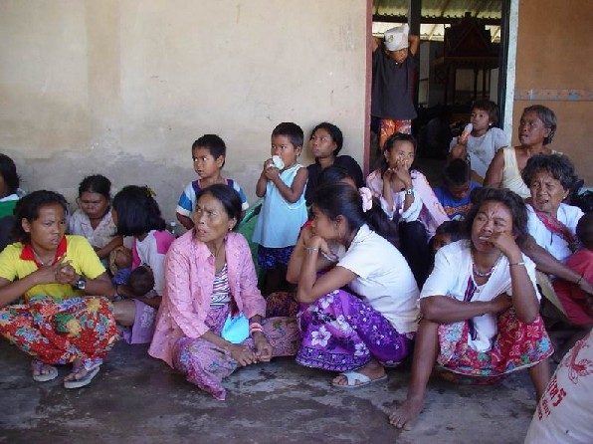
The day after the tsunami, our staff began procuring and distributing basic medicines and equipment to four hospitals struggling to cope with the wounded and ill. With our local partners, we distributed first aid kits, oral rehydration salts, water, clothing, candles and bedding directly to disaster victims, particularly migrant workers in the fishing industry along the coast. Where people have congregated in temporary shelters, CARE has distributed blankets and food, and we are helping 5,000 or so displaced people meet their water, sanitation and health care needs while they wait for financial support from the government to begin rebuilding their homes and livelihoods. Taking into the account the trauma experienced by the survivors, CARE will strengthen the counseling skills of social workers based in the shelters.

Commonly called “sea gypsies” or “Thai Mai,” the Moken are an indigenous ethnic group that is economically and socially estranged from civil society. Possessing a distinct culture and language, the Moken live on islands or along the coast of Thailand, where they rely on traditional fishing methods to earn their living. Many of the Moken on Surin Island detected the impending danger in time to safely escape the island; yet they were unable to save their fishing boats and houses from destruction. In January, CARE coordinated with national park authorities and the district government to facilitate the voluntary return of some 100 Moken to Surin Island. CARE provided local construction materials and tools for the Moken to rebuild their traditional homes. With CARE’s support, they will gradually be able to resume their livelihoods and gain access to education and health services that were previously unavailable to them.

Looking Ahead
In the immediate future, we will facilitate the return of people to their home villages, help them assess the damage to their homes and community buildings, and organize committees to plan and execute the reconstruction and rehabilitation effort. Through partnerships, CARE will assist with designing and rebuilding homes and schools (in some areas, we will repair and re-equip classrooms). CARE is partnering with an architect group to design temporary and permanent houses, school buildings and community centers. The architects donate their skills and time while CARE covers their travel and equipment costs. The architects have finished three designs (for temporary shelters, permanent houses and child centers) and are in the process of designing five additional buildings, including schools and community centers.

To restart their livelihoods, community members will be able to access money from a revolving fund to purchase boats and fishing supplies, as well as materials for other occupations. CARE has already held a series of meetings with the 40 affected villages to introduce and discuss the revolving fund concept. Community groups will be empowered to assume responsibility for carrying forward rebuilding and development efforts that protect the fragile eco-system. We have partnered with the Wildlife Protection Foundation to engage and educate communities on ways to protect marine life and other natural resources in Phra Thong Island. To prevent a repeat of the scale of destruction caused by the tsunami, CARE also will support communities with developing risk preparedness and management plans.

CARE has worked in Thailand since 1979. Now known as CARE Raks Thai, that operation was the first country office with ongoing projects to become a member of the CARE International federation. CARE currently has projects in agroforestry and conservation, children’s education, small-business development, and HIV/AIDS-prevention education and assistance to affected families.

Somalia

The tsunami was powerful enough to impact the coast of Africa, far across the Indian Ocean. In Somalia, nearly 300 people were killed and an estimated 54,000 people are in need of emergency assistance. The exact number of people affected is difficult to determine because it is unknown how many pastoralists came to the coastal areas to collect water and to let their animals drink. All along the coast shallow wells were buried or contaminated with salt and water reservoirs were destroyed. Given the absence of clean water, medicine and accessible health facilities, there is a real chance of disease outbreaks. CARE’s staff have already seen an increase in diarrhea cases and malnutrition in some areas. Having endured years of civil war, three consecutive years of droughts and recent floods and cyclone disasters, the people of Somalia are ill-equipped to deal with this latest shock.

Prior to the tsunami, CARE had been distributing food to poor communities in both southern and northern Somalia. In response to the tsunami, CARE is partnering with the World Food Programme and local agencies to assist approximately 24,000 people in the affected districts of Hafun, Bender Beyla, Eyl and Jariban to meet their basic needs, reduce their vulnerability to future disasters and reclaim their livelihoods. Initial efforts are focused on delivering food, water, medical supplies and other basic relief items to people in hard-to-reach, remote areas that have been cut off from markets by washed-out roads and lost methods of transportation. CARE is training our local partners to assume responsibility for procuring food and other provisions, distributing them equitably and developing financial tracking systems, with our continual support and guidance.

Looking Ahead
CARE is helping lead a multi-agency assessment, and will develop a detailed rehabilitation strategy to be overseen by our newly hired Emergency Response Coordinator for the country. Affected communities will participate in a CARE-led analysis of disaster vulnerability, which will be used to develop mitigation and preparedness strategies and reconstruction plans. With CARE’s support, community members will assess the damage, identify rehabilitation priorities and earn money by rebuilding or repairing roads, communication networks, water systems, health centers and schools. At the same time, CARE will help fishermen and pastoralists to look beyond their traditional livelihoods to consider small businesses, poultry production and home gardening. By establishing revolving funds, people will be able to access loans to restock their animals, fishing boats, nets and other equipment, as well as pursue other livelihoods and pay for vocational training for youth.

In time, CARE will phase out cash-for-work activities while strengthening the management and technical skills of local leaders and community groups so they are able to continue providing quality basic services (health care, water supply and education). Following their own community action plans, tsunami-affected families will have the equipment and skills necessary to earn an income and will be better protected against future disasters.

Thank You

With the flexible resources in our Earthquake and Tsunami Rehabilitation Fund, CARE has been able to rapidly reach those in need with emergency aid, and has begun the long process of helping hundreds of thousands of families rebuild their shattered lives. We thank you for your support of our efforts.

February 15, 2005
Somalia Suffers Same Tsunami Tragedy as other Affected Countries
By Lex Kassenberg

Ardo Sahal, a 53-year old woman from Garacad village in northeastern Somalia, had been up for two nights. A woman in her village had developed complications while in labor. In the absence of doctors, Ardo, who is a traditional birth attendant, was called to help. After successfully delivering the child, Ardo went home early in the morning of December 26, and went to bed – tired, but satisfied that she had been able to put her skills to good use. Her husband and eight children – three boys and five girls – were already up and moving about for the day.

Ardo had not been sleeping long when around 11:00 a.m. she heard the loud honking of car horns, as if signaling imminent danger and warning people to take cover. The first thought to come to her mind was that the small town was under attack from a militia group, not an uncommon occurrence. She immediately jumped out of bed and arranged a car to find and take her children to a safer place. In the rush to get her children to safety, she had not realised that there were no gunshots heard. Why the alarm?

Bewildered, Ardo began hearing people all around her shouting, “The sea is coming, the sea is coming!” She ran to retrieve her youngest son from the nearby school, only to discover that all the students had been evacuated to a town farther inland. By this time, Ardo was very frightened. In her utter confusion, she started running in the direction of the ocean thinking that the end of the world was upon her village. She saw cars submerged in seawater, and boats being swept into town. Spotting a gathering of people on top of a sand hill, Ardo quickly joined them and together, they yelled and cried, watching the boats being swept into town.

A second massive wall of water came ashore and everyone scrambled to get to the hills at the other end of the village. Two of Ardo’s sons joined her after the water resided. Later in the afternoon, many of the villagers were busily at work attempting to salvage their boats and fishing gear when they saw the sea withdraw again at a speed that left fish behind on the dry land. Yet gain, people clambered to escape the rush of water any way they could.

After 12 days, people gradually began returning to the village, where they found spoiled food, damaged houses and scattered debris. Children, out of fear of more waves, initially refused to sleep in the village so the elders slept with them in the jungle during the night. Even the adults had trouble sleeping and are always alert for another disaster. Ardo and her family, like so many others, have been badly traumatized.

Fishermen along the northern coast lost their boats and equipment at the peak of the fishing season, leaving many without any means of earning an income. Nearly all water sources along the coast – mostly shallow, hand-dug wells – have been contaminated by the tsunami. For drinking water, people rely on aid agencies or are forced to consume salty water (as are their animals). Water trucking is not a viable long-term solution, so water systems must be restored as soon as possible.

Ardo’s family lost two boats, all their fishing gear and food stocks. Despite her losses, Ardo thanks God that no one in her family died in the ordeal. Since the tsunami, Ardo has delivered eight children. Normally she would receive money for her services, but the women have nothing left to give.

The psychological scar remains for Ardo and her family, who now survive on the food rations provided by international agencies and local women’s groups who have collected money from other communities. She can provide little comfort to the villagers who come to her for suggestions on how to cure their nightmares and perpetual fear. People are scared and depressed, and disconsolate at finding themselves with no way to earn money and to support their families. Children especially need counseling to recover from the trauma, but psychological services are non-existent in Somalia.

CARE has targeted Garacad and neighboring villages for rehabilitation and reconstruction support. CARE will help Ardo and others reclaim hope and rebuild their lives by distributing food and water to meet their immediate needs and by helping communities develop plans for repairing infrastructure, basic services and livelihoods, and for better protecting themselves against future disasters. With CARE’s sustained support, the people affected by the tsunami will be able to put their lives back together and ensure a more secure future.

A small portion of the monies raised may be used to provide counseling to our staff who are working all hours to assist survivors even while suffering their own trauma.

