Help 1 Million South Africans Save Water & Energy
September 2012 Status Report

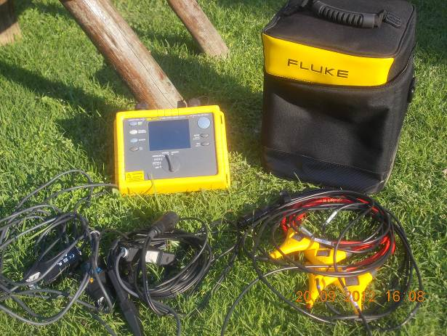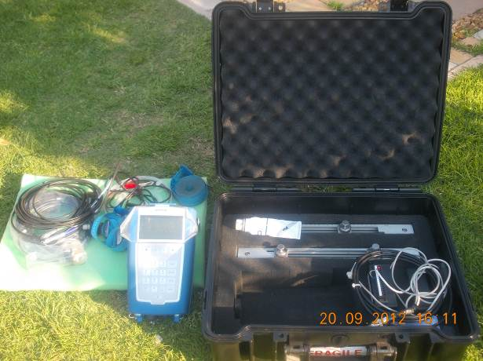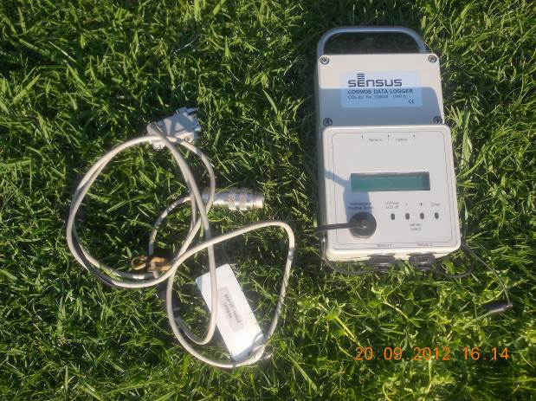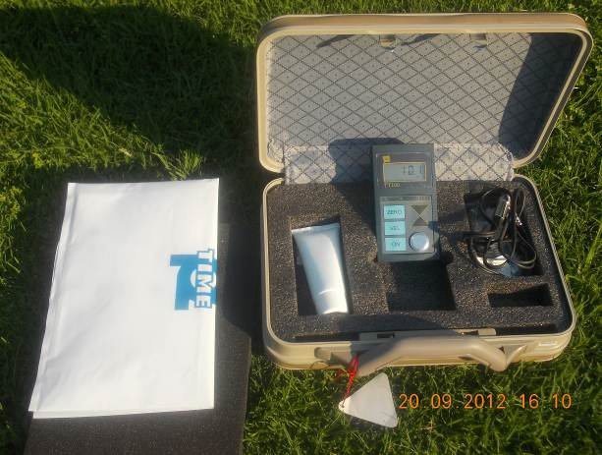
Some of the specialized equipment purchased for determining the efficiency of pumps and motors.

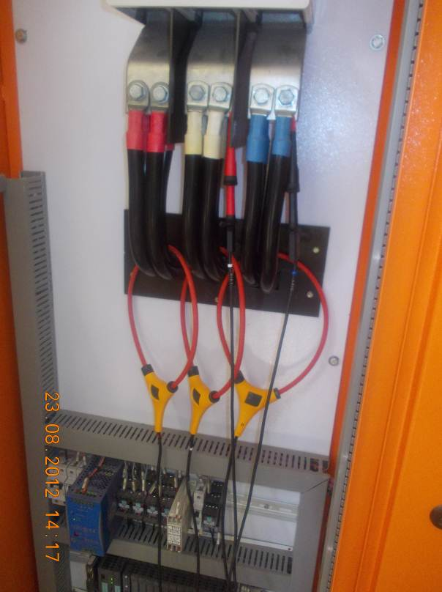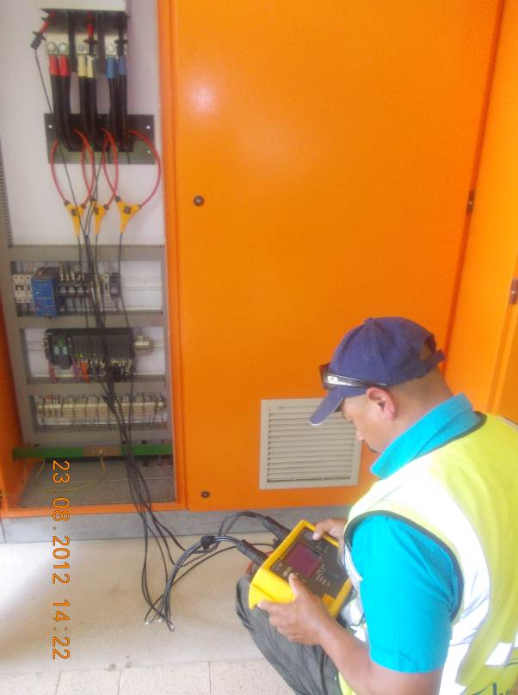
The Alliance team using measuring equipment at some of the water pump stations.

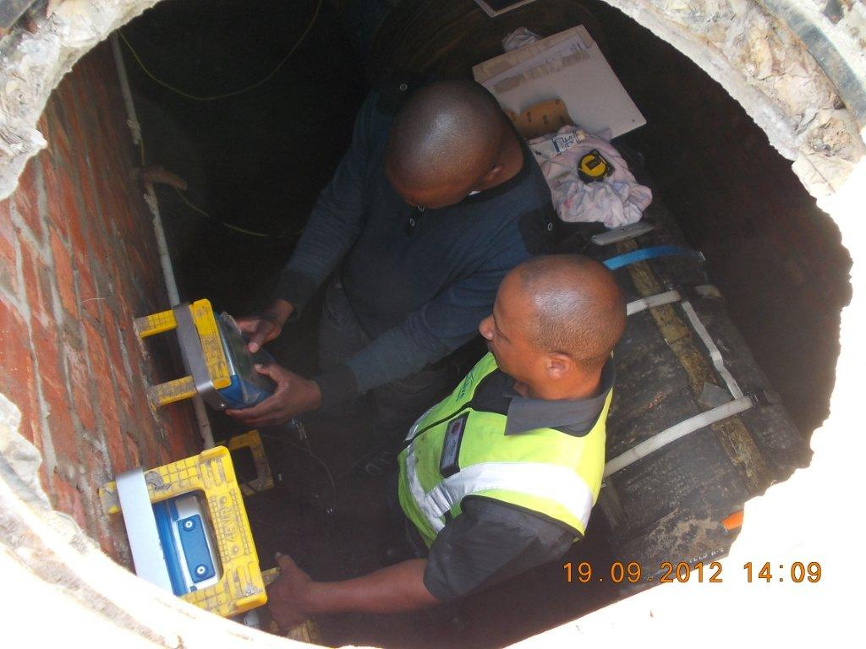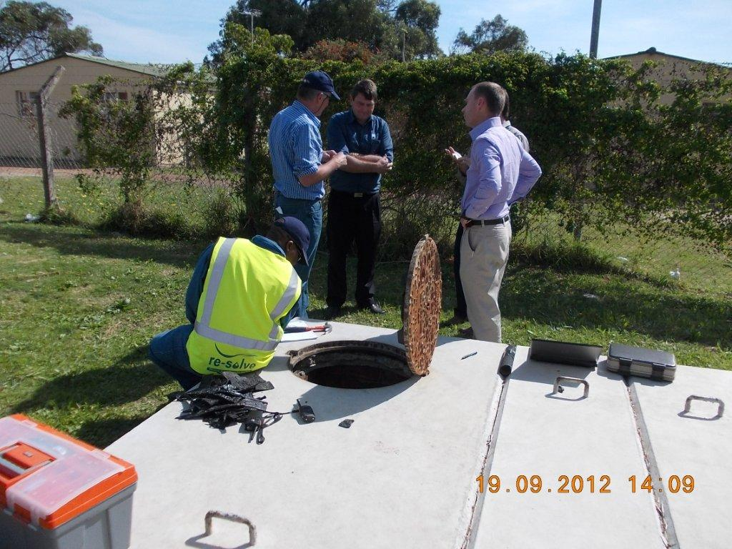
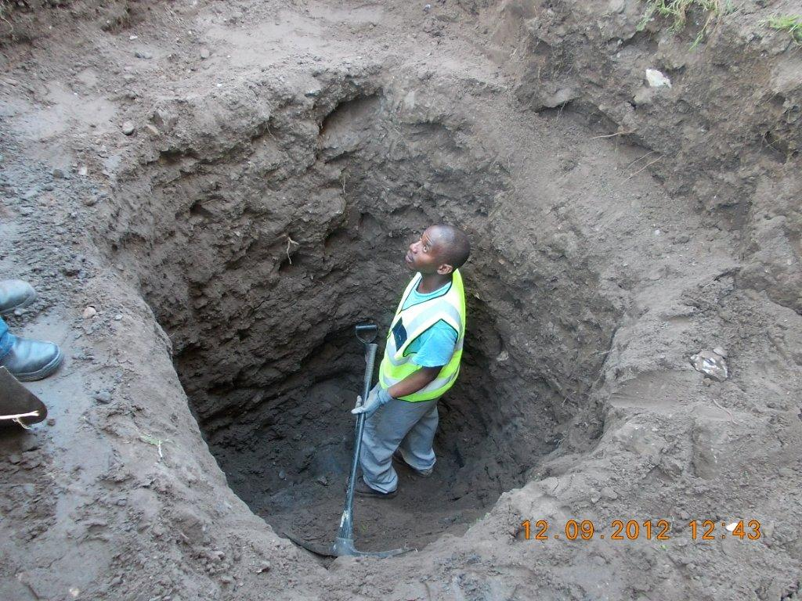
The Alliance team being trained in the use of specialized measuring equipment. (previous page)

Holes being dug to locate the rising main at the one of the pump stations in order to measure flows. (Above)

