M/S RAYLAND RURAL DEVELOPMENT

ORGANISATION

(RARUDO)

AUDITED FINANCIAL STATEMENTS
FOR 2008 AND 2009
ENDED 31ST DECEMBER 2009

Audited By:
ROSS AND COMPANY
AUDITORS & ACCOUNTANTS
P.O. BOX 3690, KAMPALA.

RAYLAND RURAL DEVELOPMENT ORGANISATION

NOTES TO THE ACCOUNTS AS AT 31ST DECEMBER 2008

The Notes are extracted to explain the Principal policies under which the final accounts were prepared and presented.

(i) Principal Accounting Policies
These were in accordance with the historical cost convention and the audit standard so required. The following were considered necessary for the purpose:-

- Depreciation
The principal annual rates used for this purpose
Other Fixed Assets 15 %
Computers 33 %

- Operation Surplus
This is charged after depreciation.

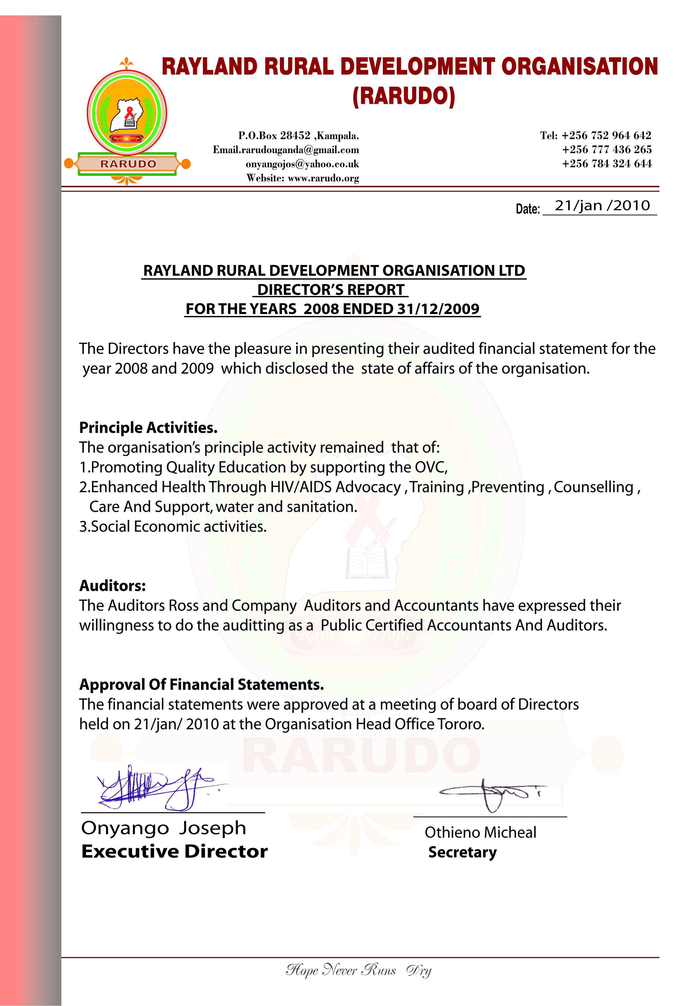

Ross & Company
Auditors and Accountants
P.O. Box 3690, Kampala – Uganda. Tel 0712 925 906

RAYLAND RURAL DEVELOPMENT ORGANISATION

Report of the Auditors
to the Financial Committee of
Rayland Rural Development Organisation.

We have audited the accounts set out on pages 4 & 5. These accounts were prepared under the historical cost convention and are in agreements with the Books of Accounts.
We obtained all the information and explanations which to the best of our knowledge and belief were necessary for the purpose of the audit.

RESPECTIVE RESPONSIBILITIES AND OF THE FINANCIAL COMMITTEE AND AUDITORS:

The financial committee is responsible for the preparation of accounts which give a true and fair view of the Organisation state of affairs and its surplus / deficit. Our responsibility is to express an independent opinion on the accounts based on our audit observations and report opinion to you.

BASIS OF OPINION
We conducted our audit in accordance with the generally accepted auditing standards. These standards require that we plan and perform our audit so as to obtain reasonable assurance that the accounts are free from material misstatements; an audit includes an examination, on a test basis, of evidence supporting the amounts and disclosures in the accounts. It also includes an assessment of the accounting policies used as significant estimates made by the management as well as an evaluation of the overall presentation of the accounts.

OPINION
In our opinion proper books of accounts were kept and the accounts give a true and fair view of the state of affairs of Rayland Rural Development Organisation as at 31st December, 2008 and 31st December, 2009 and of its surplus for the year then ended.


ROSS & COMPANY
AUDITORS AND ACCOUNTANTS
Kampala
Date: 31/12/2009

RAYLAND RURAL DEVELOPMENT ORGANISATION
BALANCE SHEET AS AT 31ST DECEMBER 2008
FIXED ASSETS | UG.SHS | UG.SHS
Building | 14,000,000 | 14,000,000
Furniture | 300,000 | 255,000
Less Depreciation | 45,000 | -
Computers | 1,800,000 | 1,206,000
Less: depreciation | 594,000
Total Fixed Assets |  | 15,461,000
CURRENT ASSETS
Cash in hand | 200,000
Cash at Bank | 96,400
Stock (animals, crops & birds) | 1,835,000
Total Current Assets |  | 2,131,400
Total Assets |  | 17,592,400
CURRENT LIABILITIES
Creditors | 400,000
Net Total Assets
Accumulated Fund B/F | 15,484,200 | 17,592,400
Net Surplus | 2,068,200
Accumulated Fund C/F |  | 17,592,400

RAYLAND RURAL DEVELOPMNT ORGANISATION
RECEIPTS AND PAYMENTS ACCOUNT FROM YEAR 2008 AND
ENDED 31 DECEMBER 2009
RECEIPTS |  | 2008 | 2009
Balance B/F |  | 96,200 | 181,000
River Fund |  | 12,550,000 | 19,495,000
Seeds for Africa |  |  | 1,500,000
World Vision |  | 420,000 | -
Proceed of RARUDO IGA |  | 280,000 | 1,900,000
Subscription fees |  | 490,000 | 510,000
Marci Valeria (USA) |  |  | 250,000
Total |  | 13,836,200 | 23,836,000
PAYMENTS
 | Improved Seeds | 250,000 | 620,000
 | Vet Drugs (oxen and goats) | 336,000 | 412,000
 | Vet. Allowance | 143,000 | 154,000
 | Scholastic Materials | 1,203,300 | 1,612,000
 | Uniform (Orphans) | 1,700,000 | 1,839,000
 | Girl child support | 1,605,000 | 1,624,100
 | Tailoring Trainer’s allowance | 860,000 | 960,000
 | Community outreach ( local networking) | 959,400 | 1,220,600
 | HEALTH Education HIV/AIDS | 607,000 | 1,210,000
 | Office stationery | 158,000 | 215,000
 | Counseling (HIV/AIDS) home to home | 764,000 | 1,198,000
 | Home Visitation (PLWAs & OVC) | 968,000 | 1,235,000
 | Office finishing | 528,500 | -
 | Food security and nutrition | 1,042,000 | 1,640,000
 | Treatment of Opportunistic Disease | 479,500 | 1,117,500
 | Water & Sanitation | 521,000 | 1,218,000
 | Care and support | 804,000 | 1,205,300
 | Audit fees | 540,000 | 600,000
 | Bugiri women group | - | 1,000,000
 | RWEN (Busia) | - | 3,000,000
 | Bank charges | 186,500 | 220,500
Total payments |  | 13,655,200 | 23,536,000
 | Bal C/F | 181,000 | 300,000
Total |  | 13,836,200 | 23,836,000

