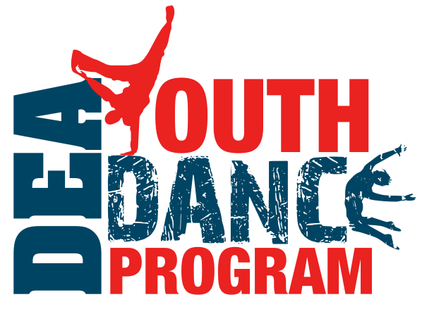
Contact: Jill Roberts
Phone: 202-669-7630
Jill.roberts@deamuseum.org
www.DEAEducationalFoundation.org

May 14,2012
FOR IMMEDIATE RELEASE

DEA Educational Foundation Launches Free After School Program at Payne Elementary
Washington, D.C. … Payne Elementary in Washington, DC was selected as the kick-off location for the DEA Educational Foundation’s nation-wide Youth Dance Program. The free after-school dance program will launch on May 16th at 10am. DEA Administrator Michele Leonhart will be speaking at the event to help celebrate the new program under the DEA Educational Foundation. There will be a dance performance for students, faculty, and invited community guests. Dance company partners include Joy of Motion, CityDance Ensemble, and Culture Shock.
The DEA Youth Dance Program is a free after-school dance program started under the umbrella of D.A.R.E. America in 1999, and moved to the D.E.A. Educational Foundation effective immediately. The alignment with the DEA Educational Foundation will allow the dance program to maintain current programming in 25 cities for thousands of at-risk students across the United States, as well as grow to support its extensive waitlist.
“This is an incredible opportunity and I’m thrilled that the DEA Educational Foundation voted to acquire the Youth Dance Program,” said Jill Roberts, National Director of the DEA Youth Dance Program. “D.A.R.E. America was a tremendous place for us to be for over 12 years, however, now being aligned with the DEA Educational Foundation and its very powerful name and mission, will allow us to reach even more kids, educating them about drug abuse prevention through the healthy outlet of dance.”
The after-school dance program created and managed by Roberts has grown to be the most successful after-school dance program in the United States positively influencing thousands of students each year by providing the healthy outlet of dance. Roberts, a former professional dancer, authority in after-school programs and drug education won the President’s Volunteer Service Award from President Obama in 2009, in part, because of the dance program and her commitment to kids.
“The mission, brand, and long-term goals of the DEA Educational Foundation are in alignment with the dance program,” said Bill Alden, Chairman and CEO of the DEA Educational Foundation. “The board is enthusiastic about providing a quality dance program as an alternative to drugs and negative behaviors for at-risk children in 25 cities in the United States.”
The Youth Dance Program will maintain its partnerships with many of the same foundations, sponsors, and dance companies from the past.

About the DEA Youth Dance Program (DEA YDP) Curriculum:

The DEA YDP services grade-levels that are selected by the school’s administration. Students attend in-school assemblies where they participate in a program led by a professional dance company. The dance company combines their art with a drug abuse and violence prevention theme, demonstrates different styles of dance, speaks to the students as role models, and asks student volunteers to join them on stage and participate in movement during the assembly. Interested students are then permitted to register for free ten-week after-school programs each semester including a variety of hip-hop, jazz, tap, ballet, modern and other world dance forms led by the dance company. Students continue to receive drug abuse prevention materials and engage with their peers and role models in prevention discussions. At the end of the program, students perform in a community or school performance setting, bringing family and other students together. Finally, scholarship opportunities in dance are available to students with an acute interest and dedication to the DEA YDP. Scholarship programs are offered locally so that students are able to participate easily.
Ten programs are launching in Los Angeles and Washington D.C. in the spring of 2012.

Anticipated cities for programs in 2013 include: Aurora, IL; Annapolis, MD; Arlington, VA; Atlanta, GA; Baltimore, MD; Boston, MA; Chicago, IL; Chula Vista, CA; Cicero, IL; Fairfax, VA; Falls Church, VA; Gardena, CA; Houston, TX; Jersey City, NJ; Los Angeles, CA; Long Beach, CA; Monterey, CA; New Orleans, LA; New York, NY; Newark, NJ; Northridge, CA; Oaklawn, IL; Pacific Grove, CA; Philadelphia, PA; Port Huron, MI; San Antonio, TX; San Francisco, CA; San Diego, CA; Seattle, WA; Shepardstown, WV; Silver Spring, MD; Tampa, FL; Van Nuys, CA; Venice, CA; and Washington, D.C.

For more information, visit www.deaeducationalfoundation.org

