Support for 150 Sexually Exploited Women in Nepal
Summary Raksha Nepal is dedicated to protecting women who were sexually exploited by the vulnerability of their employment. Raksha Nepal going to helps at least 200 women and girls who are working in so-called entertainment sector through skill trainings i.e. Swing Cutting, Beauty Parlor, Driving, Cookeries and farming etc. Raksha aiming escape to women and girls from this dangerous and abusive industry and helps establish a safe and secure future through training and counseling. Prevention, Rehabilitation and Reintegration of women and girls who have landed knowingly and unknowingly in painful and life-threatening prostitution.
What is the issue, Problem or challenges?
Women and girls from different remote areas of Nepal enter every year into capital city in search of better life and better earning opportunities. Various data and research shows that around 50,000 women and girls are working in cabin, restaurants and bar with in the valley, this is in growing pattern since for this they do not need any additional qualification and is the only way in which they can rely to earn their and their family’s life. This project will support and protect a huge number of innocent women and girls who are victimized by sexual exploitation and trafficking.
How will this project solve this problem?
Raksha Nepal is running vocational trainings program for women & girls working in places with high risk of sexual exploitation and trafficking. It conducts awareness and to empower women with leadership development and skill enhancement. Beside this it is running Raksha Shree cooperative, rehabilitation and reintegration program, psycho- social and trauma counseling, women’s school and educational support for the women and girls who are at high risk and are victims of sexual exploitation.
Potential Long term impact
RN has already starting working with those women and girls who are working by force in so called entertainment sector. We will enable women and girl who are exploited or at high risk of exploitation to be economically independent. We have targeted 150 women and girls as our direct beneficiaries to whom we will be providing skill enhancement trainings (beautician, Driving, swing/cutting, handicraft, Cooking) and after the completion of training they will be assisted by organization to set-up their business in the beginning, through seed money and necessary orientation sessions needed to start their business. By this we will be benefiting 250-300 indirect beneficiaries as the family members and friend circle of the direct one who will also be the role model for other women and girls who are involved in this sector for their earning.
Project Message
“Women empowerment is our campaign”
The only way to protect and escape women and girls from the trap of sexual exploitation and trafficking is by making their hand full of skills so that they can earn their living independently.
Total Budget of the project
SN | Budget Head |  | Unit | Duration | Unit Rate | Amount  (USD $)
1 | Admin Cost
a. | HR Cost
 | Programme Manager |  | 1 | 12 | 200 | 2,400
 | Accountant |  | 1 | 12 | 150 | 1,800
 | Super Visor |  | 1 | 12 | 150 | 1,800
 | Field Motivator |  | 1 | 12 | 100 | 1,200
 | Total HR Cost |  |  |  |  | 7,200
b. | Local Transportation |  |  | Lump sum |  | 1,200
c. | Miscellaneous |  |  | Lump sum |  | 1,200
 | Total Admin Cost(a+b+c) |  |  |  |  | 9,600
2 | Training Cost
 | a. Tailoring |  | 55
 | 1 | Training and Provide Machine | 20 | Advance course up to 6 months | 253.16 | 5063.29
 | 2 | Training | 35 | Advance course up to 6 months | 126.58 | 4430.38
 | b. Beauty Parlor |  | 25 | Advance course up to 6 months | 126.58 | 31.56
 | c. Driving |  | 15 | Up to 3 months | 253.16 | 3797.46
 | d. Cookeries |  | 12 | Advance course up to 6 months | 126.58 | 1518.98
 | e. Handicraft |  | 45 | Advance course up to 6 months | 126.58 | 5696.20
 | Total Training Cost |  |  |  |  | 23670.87
 | Total Budget(1+2) |  |  |  |  | 33270.87

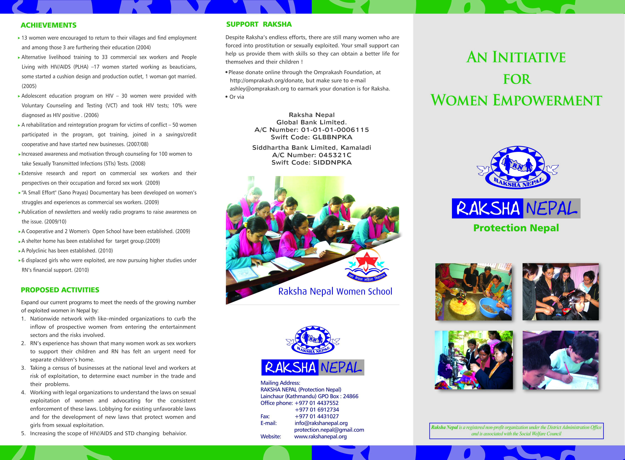

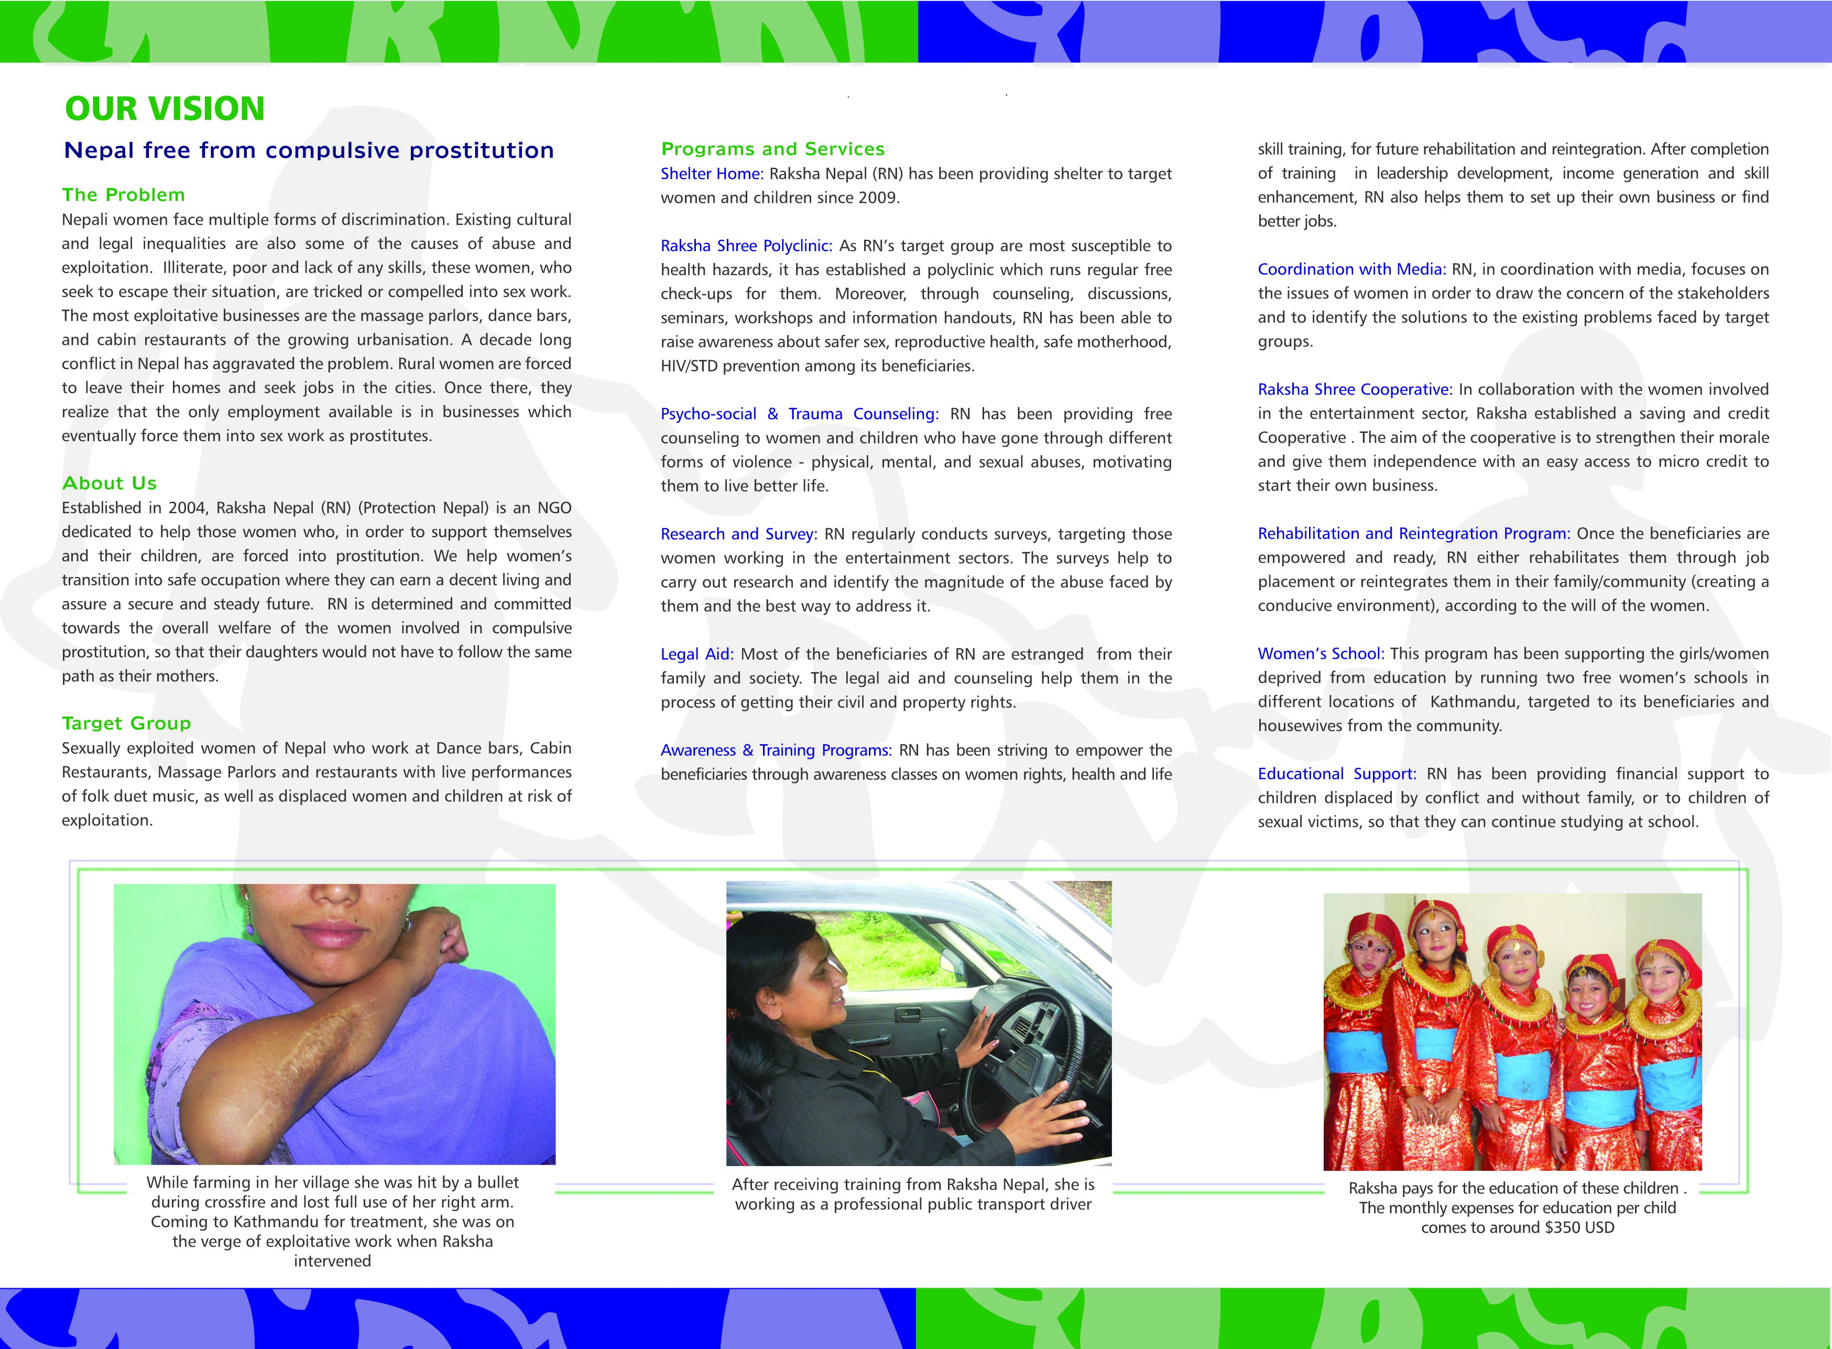

''Solidarity to Stop Forced Sex work and Girls Trafficking''
Raksha Nepal
Introduction
Raksha Nepal (RN) is an NGO established in 2004, is an initiative for women empowerment. RN is run by women and girls who have been sexually exploited. Therefore, the organization is dedicated to those women and girls who have landed knowingly and unknowingly in painful and life-threatening prostitution. RN is committed to making these women and girls aware of how to protect themselves in their current roles, and build their capacity to identify alternative livelihood opportunities to start a safe and respected life. Raksha Nepal believes that if women are confident and educated the entire family becomes educated. This is one of the reasons that the organization is determined and committed to work towards the overall welfare of women and girls who are sexually exploited.

Vision: Nepal free of Compulsive Prostitution
Mission: Women and young girls free of Sexual Exploitation
Nepali women face multiple forms of discrimination. Existing culture and legal inequalities are also some of the cases of abuse and exploitation. Illiterate, poor and lack of skills, these women who seek to escape their situation, are tricked or compelled to sex work. The most exploitative businesses are massage parlors, dance bars and cabin restaurants of growing urbanization.

Objectives:
- Create awareness about self-protection from sexual exploitation
- Rehabilitate and reintegrate women and girls into society by providing alternative employment opportunities through skills training
- Research and advocate against compulsive sex work, especially with cases involving minors
- Lobby for effective implementation of national/international laws involving Child Labor, Child Right Convention (CRC), Convention on Elimination of All Kinds of Discrimination against Women (CEDAW) and the modification of other unequal laws currently in practice
- Rescue, rehabilitation, and reintegration of sexually exploited women
- Provide economic empowerment programs
- Psychosocial and trauma counseling
- Provide health education programs
- Provide Legal support
- Provide shelter to survivors
Major Activities/Programs
Shelter Home: Raksha Nepal has been providing shelter to women, girls and children.

STD Prevention: Through counseling, discussions, seminars, workshops and informational handouts, Raksha raises awareness about safe sex, HIV/STD prevention, and the legal rights of women.

Raksha Shree Polyclinic: As RN's target group is most susceptible to health hazards, it has established a polyclinic which runs regular free check-ups for them. Moreover, through counseling, discussion, seminars, workshop and information handouts, RN has been able to raise awareness about safer sex, reproductive health, safe motherhood, HIV/STD prevention among its beneficiaries.

Research and Survey: Raksha conducts surveys for women from our target group around Kathmandu, with a focus on those working in Thamel. These surveys are helpful in identifying the magnitude of abuse and the best way to address it.

Coordination with Media: Raksha, in coordination with the media, focuses on issues of women in order gain attention of all the stakeholders. Such coordination also helps in identifying solutions to the existing problems faced by women and girls working in places with high risk of sexual exploitation.
Awareness and Training Programs: Raksha offers different trainings to empower the women. The trainings include leadership development, income generation and skill enhancement. After completion of the trainings, Raksha provides some seed money to the trainees to set up their own business.

Raksha Shree Cooperative: In collaboration with women and girls who has faced sexual abuse, Raksha has established a saving and credit cooperative named Raksha Shree Cooperative. The aim of the cooperative is to strengthen their moral and make them independent with an easy access to micro-credit to start their own business.

Rehabilitation and Reintegration Program: Once the beneficiaries are empowered and ready, RN either rehabilitates them through job placements of reintegrates in their families / communities (creating a conducive environment), according to the will of the women and girls

Psycho-social and Trauma Counseling: Raksha Nepal has been providing free counseling to the women, girls and children who have gone through different forms of violence ; physical, mental, sexual abuse, motivating them to live better life.

Women’s School: Raksha has been supporting the women and girls deprived from education by running two women’s schools in different locations of Kathmandu.

Educational Support: Raksha has been providing financial support for education to children displaced by conflict and without families, or to children of sexual victims.

Legal Aid: Most of the beneficiaries of RN are estranged from their family and society. The legal aid and counseling help them in the process of getting their civil and property rights.

Achievements
- Research on commercial sex workers and their perspectives on their occupation and forced sex work
- Initiation of business like beauty parlors, tailoring, production outlets, café, by women and girls who were victims of sexual exploitation. Few have also started working as van drivers.
- Establishment of women's school
- 1600 women and girls rehabilitated and reintegrated in their families and communities till 2011
- Establishment of Saving and Credit Cooperative by 3500 women and girls who have faced some kind of sexual exploitation in their lifetime.
- Empowered Women and girls who have started safe sex.
- Recognition from Ministry of Women, Children and Social Welfare, Nepal Government

Learning
Economic empowerment is the major component which will help the women and girls to come out from sexual exploitation.
Shelter needs to be equipped with new information technologies to enhance the capacity of women and girls in IT sector.
Partners of Raksha Nepal
- Canadian Co-operation Office.
- Global Fund for Women. USA
- World Education (Technical Support).
- Norwegian Refugee Council (NRC) (Technical Support).
- BONO Direkthilfe e.V. Germany
- Planete Enfants.
- Partnership with parliamentarians.
- Partnership with Asia Pacific Leadership Forum on HIV/AIDS (APLF), which has been partnered with UNAIDS
- DKA Austria /KFB Austria
- Joan B. Kroc University of Peace and Justice, United States of America
- Omprakash Foundation, United States of America
- Brown University, United States of America
- Women for Peace and Democracy -Nepal
- The Advocacy Project, United States of America
- Aus Nepal News.com
- Social Welfare Council of Nepal
- Nepal Woman Commission
- Ministry of Education

Working Area: Raksha Nepal has been working in 13 districts (Kathmandu, Kavre, Sindhupalchowk, Dhading, Rasuwa, Nuwakot, Makwanpur, Sindhuli, Nepalgunj, Ramechap, Achham, Gorkha , Bhaktapur and Lalitpur) of Nepal
Office: Raksha Nepal has one central office in Kathmandu and one regional office in Nepalgunj, Midwestern Development Region of Nepal

What do you aspire for?
- Solidarity towards gender equality and women rights
- Prevention, care and counseling for sexually transmitted diseases
- Family free of domestic violence
- Secure and dignified future
- Legal counseling services
- Public awareness
- Health and Education
- Skill development Training with job placement
- Participation in campaign against human trafficking
- Rehabilitation and Social reintegration of internally displaced people
- Co-ordination and partnership for conflict free society.
- Research

We are with you, come let us collectively move forward

Contact Person

Menuka Thapa Rabin Malla
Chairperson Program Manager
menuka@rakshanepal.org.np rabin@rakshanepal.org.np
menuka31@gmail.com

Raksha Nepal (Protection Nepal)
Lainchaur, Kathmandu, Nepal
P.O. Box: 24866
Ph: 977- 016912734,
977 -1- 4437552
Fax: 977-1-4024100
E-mail: info@rakshanepal.org.np
Web: www.rakshanepal.org.np

