Communities across America are struggling to overcome pressing social problems in education, health, and poverty alleviation. Demand continues to grow while charitable resources have become even more limited.

Increasingly, donors are seeking greater assurances that their charitable giving will have a measurable impact. A recent study, Markets for Good II, found that donors want third-party information about nonprofits’ impact, financials, and legitimacy, yet they do not always have the time or specific expertise to do the research.

That is where the Social Impact Exchange and the S&I 100 come in so donors have confidence that they are contributing to organizations that consistently deliver impact.

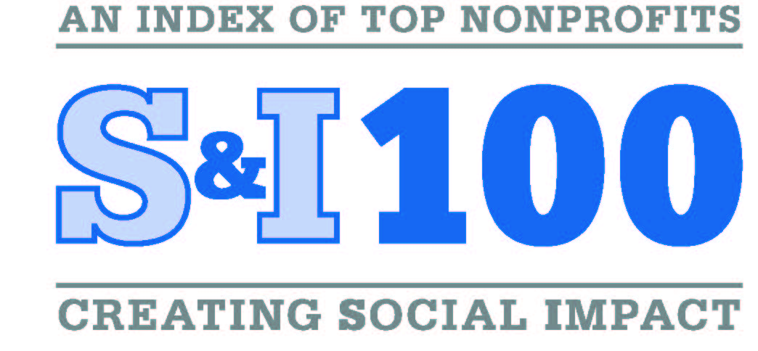
The S&I 100 is the first-ever, broad index of U.S. nonprofits with proof of results and readiness to grow! This web-based platform shows donors which nonprofits consistently deliver impact – featuring 100 top-performing nonprofits and nearly 16,000 local affiliates that are implementing their solutions. The resource allows donors to learn from and leverage the knowledge and practices of leading philanthropic experts.

A Wealth of Expertise, at Your Fingertips
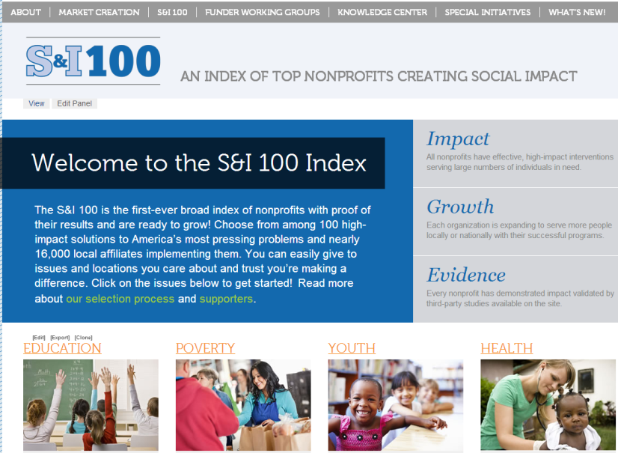
- Nonprofits in education, health, poverty and youth located across the U.S.
- Rigorous selection process developed and conducted by a sector-wide collaboration
- Proof of impact with evidence studies and ability to expand reach
- Key information for decision-making including evaluation studies, financials, lists of funders, and more
- Ability to support the local communities and issues donors care about with one easy online resource: www.SI100.org

For the first time, donors can learn how to increase the impact of their charitable giving
and deliver solutions that work where they are needed most.

