

Access to knowledge through Computer Education

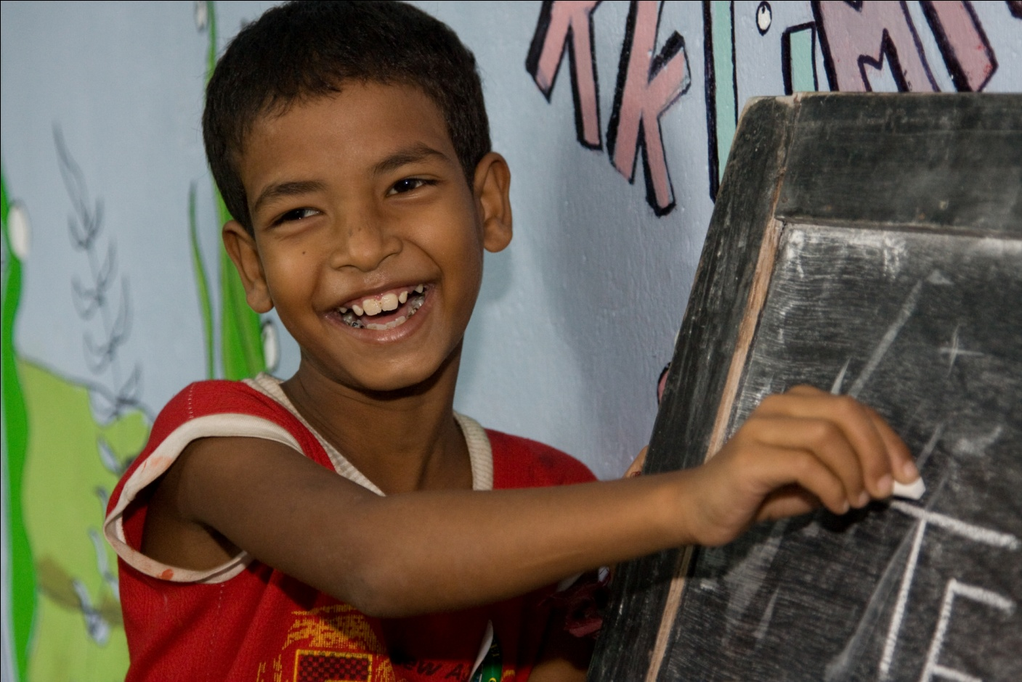

Introduction

1.1 Organisation Details

Organisation Name | Sabuj Sangha
Address | Registered Office:  Vill & P.O.: Nandakumarpur, P.S.: Raidighi, Dist: South 24 Parganas,  Pin: 743349  Central Office (for correspondence):  30/9, Rajdanga Main Road (East), Kolkata – 7000107
Contact Details | Phone | +91 33 2441 4357
Contact Details | Fax | +91 33 2441 4357,
Contact Details | Email | director@sabujsangha.org
Contact Details | Website | www.sabujsangha.org
Chief Functionary | Ansuman Das
Organisation Type | Society
Registration Details | Registered under the West Bengal Societies Registration Act, 1961, Registration No. is S/16979 of 1975-1976 dated December 12, 1975  Registered under Foreign Contribution(Regulation) Act 1976  Registration No.: 147110293
Exemption | Section U/S 80G (5) (VI) of the Income-tax Act, 1961  Section 12A income Tax Act1961  Empanelled with Planning Commission, Govt. of India  Empanelled with National CSR Hub
Turnover (Rs.) | 2014-15
Turnover (Rs.) | 2013-14 | 33,992,136.00
Turnover (Rs.) | 2012-13 | 39,533,750.00

1.2 About the Organisation

Sabuj Sangha is a non-profit, non-government development organisation working in West Bengal, India. It was established in 1975 in the Sundarban region of West Bengal. From its humble beginnings, Sabuj Sangha has grown into a vibrant organisation working with a range of people across multiple sectors. Sabuj Sangha implements programmes in a range of sectors, catering to the needs of vulnerable communities.

Sabuj Sangha seeks to improve the lives of people less fortunate through participation and empowerment. We believe that partnership is the key to breaking the cycle of poverty and ensuring that all people are given a fair and equal chance.

Aside from direct programme implementation, Sabuj Sangha is involved in research, documentation, advocacy and networking. It also works with Government to enact change and ensure people have access to their most basic human rights.

1.3 Organisation Structure

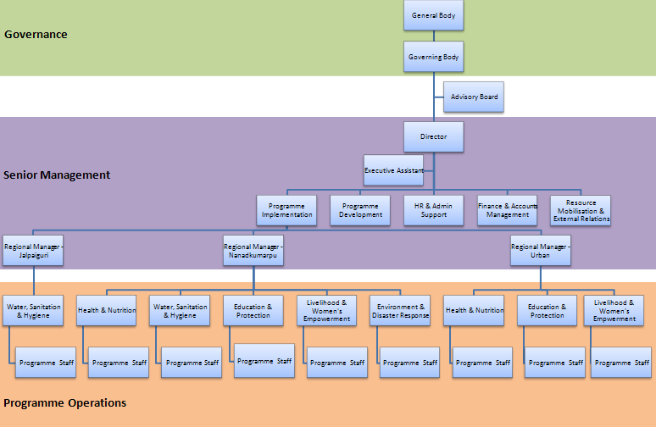

1.4 Our Model - Integrated Sustainable Development

Sabuj Sangha believes that there is no simple solution to poverty. In order to overcome poverty, it is necessary to address the range of issues that poor people face on a daily basis. For this reason, Sabuj Sangha adopts an Integrated Sustainable Development Model. It works in five main operational areas:

- Health and Nutrition
- Water, Sanitation and Hygiene
- Education and Protection
- Livelihood and Women’s Empowerment
- Environment and Disaster Response

By tackling all of the issues in an integrated, sustainable manner, Sabuj Sangha seeks to improve quality of life for some of the most vulnerable people in the world.

2.0 Background

2.1 Geographical Location

Sundarban is famous for its’ scenic beauty, vast openness, thick mangrove forests, tigers and crocodiles. Located at the southernmost part of West Bengal, it is a popular tourist destination. However, despite its obvious beauty, the region is extremely vulnerable with many people living in poverty.

The inhabited islands always are prone to flooding and other natural disasters, causing the river embankments to burst, covering the region in saline water. This saline water damages the soil, limiting agriculture activity for years. There is a lack of basic infrastructure such as roads, bridges, public transport, and electricity. A lack of job opportunities, absence of industry and a reliance on mono-crop cultivation, results in the region being extremely vulnerable, with few sources of income.

There are a total of 19 Blocks in Sundarban. Six of these blocks (Gosaba, Hingalgunj, Patharpratima, Sandeshkhali II, Namkhana, Kultali) are extremely inaccessible and lack even the most basic facilities. Eight Blocks (Sagar, Jaynagar II, Canning II, Basanti, Minakhan, Kakdwip, Mathurapur II, Sandeshkhali I) are remote and severely underdeveloped. The remaining 5 Blocks (Hasnabad, Canning I, Joynagar I, Mathurapur I and Haroa) are main land’s, with greater accessibility and somewhat better living conditions.

In such a scenario, people are often forced to migrate to Kolkata or other cities in India in search of work. This forced migration deteriorates the community and also puts families at risk, as they settle in temporary living conditions in unsafe environments. Children are particularly at risk, and find themselves victims of child labour and trafficking.

2.2 Education

Literacy is one of the single most important factors in an individual’s well being. Without it, they are unable to access basic goods and services. Similarly it is a globally accepted indicator for education, as set out in the Millennium Development Goal 2, which seeks to ensure that by 2015, children everywhere, girls and boys alike, will be able to complete a full course of primary schooling. However, for many children in rural communities, education is not a right but rather a privilege. Literacy rates are still alarmingly low, with an estimated 77% of the population literate. Among women, the number is even lower, with just 71% of the population literate.

Education access, retention and quality are factors that influence literacy. In rural India, many children are unable to access education. Those who are able to access it, often drop out due to a range of factors including financial constraints, lack of support, child labour, child marriage and family commitments. The quality of education is sub-standard with large class sizes, unqualified teachers, inadequate teaching materials and poor sanitation facilities.

The children of Sundarbans are no different. They are deprived of schooling and a quality education due to abject poverty. The majority of students are fist generation learners, with their parents never having been to school. As a result, they are unaware of the importance of education and are unable to see its long term benefits, for both their child and themselves. Those children, who do get the opportunity to go to school, often are unable to continue to the desired level due to costs of books and other educational materials.

These factors, as well as various under social and economic factors result in children not completing a full course of primary schooling and hence, growing up uneducated and illiterate.

Sabuj Sangha intended to ensure quality education of the underprivileged children in Sundarbans; . The school is affiliated by the Government of West Bengal, but un-aided. Total 167 children are presently reading in pre-primary to upper primary & 300 in the teachers training programme and the students are taught by qualified teachers. Proper teacher pupil ratio, Use of technology is aiming at provide facility of computer education that is imperative of modern scientific approach of joyful learning.

2.3 The Need for Quality Education

A key concern of any formal educational system is that of the quality of education offered. It is a focus of all stakeholders, both direct and indirect, and generates much debate. Parents and guardians, irrespective of their socio-economic status, want to educate their children to the highest possible standards. However, there is no universally accepted definition of ‘quality education’. Very often, the perception of quality is based around student performance, such as attendance, examination results and learning achievements. For some, quality education refers to the added valued of education, those things that can’t be tested or measured, such as responsibility, confidence, a quest for knowledge and the ability to apply learned knowledge in practical life. Whatever the definition or perception, there are some basic requirements that must be met. At the most basic levels, the ability to read and write are indicators of student learning. It is expected that after the completion of a course of primary level education, a pupil should be able to read, write and solve simple arithmetic. Excellence and value are further desired indicators of education
The National Knowledge Commission has been emphasizing ‘quality primary education’ to build India as a knowledge society. The quality of education mainly refers to physical infrastructure, qualified and competent teachers, curriculum and instructional materials, support materials and equipments, teaching learning strategies, comprehensive and continuous evaluation, and effective management. However, in India, where 90% per cent of primary schools are run by government and the majority of them situated in rural areas, these criteria are lacking. Some of the reasons for this include:
- Many primary schools have no shelter and schools with buildings have insufficient accommodation.
- No classroom furniture with students mostly sitting on mats.
- High pupil-teacher ratio with teachers teaching students with varying abilities and needs.
- Textbooks for teachers, which contain methods for teaching each unit of the curriculum, are not provided in time.
- Teaching aids are very old. Information and Communication Technology (ICT), despite being recognized as an effective teaching-learning methodology is still not used.
- Teacher appointments are often politically motivated, leading to unqualified teachers and hence a poor quality of education.
- Resource materials are not provided on time or in adequate quantity.
- Extra-curricular activities are not undertaken and are viewed as a waste of time.

In this scenario, the teaching–learning environment and quality of education is unsatisfactory. If possible and affordable, parents prefer for their children to go to private schools. However, marginal groups of society, as found throughout rural India, are not in an economical position to enrol their children in private school. As a result, they are forced to rely on the public school system which is inadequate and ill-equipped. The stakeholders of these public schools are unable to ensure accountability of the system for quality education. Therefore, a situation is created where those students, that are most need of a quality education that will create opportunities for them allowing them to alleviate themselves from poverty, are deprived of such an education.

In order to ensure quality education for all, there is a need to re-think the idea, structure and system of primary education. There should be a greater emphasis on quality, providing students with an education, not just for school but for life. The added value of education should be taken into account and addressed. Basic requirements are as follows:

- Ensure every child receives early childhood education ( enrolled in preparatory education in Integrated Child Development Scheme centres at three years of age and enrolled in Class 1 of primary school at six years of age) is extremely important and must be universalized.
- Accurate assessment of learning outcomes by Village Education Committees (VEC) to analyze the student’s performances.
- Ensure use of modern teaching methodologies that are effective and positive, creating an enjoyable learning environment.
- Using information and communications technology in teaching learning process.
- Regular teacher training to ensure quality is maintained.
- Introduce participatory management of education systems in which the VEC board members are involved in decision making, creating an opportunity for teachers and students to voice their opinions in a safe environment
- Ensure greater access to schools for children from vulnerable segments of society such as Scheduled Castes (SC), Scheduled Tribes (ST) and Other Backward Castes (OBC).
- Community participation in monitoring of primary education
- Functional parent teacher association and the power of decision making authority
- Reduced teacher-student ratio, maximum one teacher for every 25 students.
- Appointment of female teachers with preference to local qualified applicants.

2.4 KSSN (Model School)

KSSN is a model school in Nandakumarpur, providing quality education to 140 students from prep-primary to Class V. The school promotes a quality holistic approach to education, using the standard school syllabus.

Established in the year 2000, the goal of KSSN is to not only provide quality education but also improve education standards throughout the region. The focus is on providing a fun learning environment for students using alternative teaching methods that are engaging. The school maintains small class sizes, ensuring teachers student ratio of 1:20. Outside of the standard curriculum, students also take part in extracurricular activities such as sports, music, dance and drama. Transportation is provided to those students living far away from the school. This approach is promoted among nearby Government school with a view to improving the standard of education in the surrounding communities. New teaching techniques and methodologies are shared with teachers and field visits to KSSN are conducted.

KSSN currently caters to students up to Class V. However, over the next 3 years, it is planned to extend this to Class VIII which would allow the school to be recognised by the Government as a Higher Primary school.

3.0 Project Details

3.1 Objectives

Aim

Increase number of students completing Class X by improving the quality of primary education in Mathurapur II block of Sundarbans

Objective

Increased number of students completing quality primary education through KSSN, demonstrate model and the adoption of new teaching practices in nearby schools

3.2 Project Beneficiaries

The target beneficiaries for the project will be vulnerable children aged between 6 – 12 years of age of Nandakumarpur block in the Sundarbans. 130 students per year will receive quality education through KSSN. There will be focus on providing education to girls, with a minimum enrolment rate of 50% female. Indirect beneficiaries will include families of those students receiving primary education.

- Direct Beneficiaries: 130 students per year (Male 65, Female 65)
- Indirect Beneficiaries: 650 family members per year (Male , Female)

3.3 Activities

3.3.1 Primary Education

Primary education will be provided to approximately 130 students (Male 65, Female 65) from Class Pre-Primary to Class VI. Subjects include Bengali, Mathematics, English, History, Geography, Life Sciences and General Knowledge. Subjects are taught using modern teaching methodologies and teaching learning materials. There is an emphasis on making learning fun, creating a positive classroom environment and that conducive to learning.

3.3.2 Extra Curricular activities

Extracurricular activities will also be undertaken, providing students with skills, knowledge and confidence that are essential in later life. At present, activities include art and crafts, sports, music and dance.

It is also proposed to stranthen a Computer Training Centre for students. Students will be taught basic computer skills, empowering them on the use of technology and providing them with skills that are essential in today’s modern world. It will increase their confidence and also ensure that they are better placed to undertake employment upon graduation from school. A computer network with internet facility will also be established.

3.3.3 Child Friendly classrooms

Creating a positive fun classroom environment is a critical part of quality education. With this in mind, we propose equipping all classrooms with Teaching Learning Materials (TLMs). TLMs be will placed around the walls of all classrooms and can also be used for teaching. The technique, although simple, creates a bright positive classroom atmosphere and enhances students learning and understanding of subjects.

3.3.4 Teacher Training

Ongoing teacher training will be provided to all teachers of KSSN. This will ensure that teaching methods are kept up to date and that students are receiving the best possible quality of education available. Workshops will be conducted with teachers to identify challenges that they face and areas where they would like to build their capacity with respect to teaching.

3.3.5 Awareness Programmes

Awareness programmes will be conducted in the community. These programmes are aimed at celebrating certain cultural events and also increasing awareness in the community of educational and social issues. Engaging communities on such activities ensures that children are better protected with regard to their rights as children and also creates a sense of community and ownership of KSSN within the community. It increases the likelihood of students staying in school longer and completing their full course of education, thus ensuring that they have better employment opportunities in the future.

3.3.6 Model School

Kishalaya Sishu Siksha Niketan (KSSN) was established as a model school, designed to promote modern teaching methodologies in Government schools and improve the quality of education in the region. In order to this, exposure visits of Government teachers to KSSN will be conducted. These visits will give teachers the opportunity to see teaching techniques in practice and replicate them in their own schools. They will also have access to resources such teaching learning materials and manuals that are used in KSSN with a view to adopting the use of these in public Government schools.

Similarly, Sabuj Sangha will work with existing Village Education Committees (VECs) and local and district Government with a view to improving education systems in the region. Ongoing meetings and communication with key stakeholders will be undertaken with a view to building capacity of these stakeholders and promoting the adoption of best practices with respect to education in Government schools.

3.3.7 WHY KISHALAYA SISHU SIKSHA NIKETAN(kssN) IS NEEDED FOR THE CHILDREN

OF SUNDARBANS…..

The Kishalaya Sishu Siksha Niketan (KSSN) is a model school in Nandakumarpur Gram Panchayat under Mathurapur II Block of South 24 Parganas district running since 2000. The education centre is recognized by the School Education Department, Government of West Bengal; vide order No. 525-SE (EE10M-93/2013) dated 29.05.2013 as an un-aided private school run by Sabuj Sangha.
Usually, the Government schools can’t always focus the need of a particular group of children living in different situation. The areas of Sundarban region are extremely vulnerable in many aspects. Since the areas are mostly with number of islands, the communities are isolated from the main land. There is absence of basic infrastructure, electricity, proper communication arrangement, health facilities and other civic amenities. People are mostly economically poor, living in small mud-made tiles roofing houses (only a few are semi-pucca houses) and always bear the threat of natural calamities like cyclone, flood, tidal surge etc. Since there are limited livelihood options except agriculture extreme poverty is very much prevalent, and in most cases both the parents of the families has to go outside home earning daily bread. The children are left uncared, unsafe and alone in the home; and are possible victim of trafficking also child labor. In such environment the children, in many cases are deprived of basic care in their child hood. So, the children of this area need basic care and extra support for their development and one such effort is the KSSN.
The Government schools can’t change their curriculum just for the needs of children from certain section of any place like Sundarbans. Therefore; Sabuj Sangha steps in as a humanitarian aid-related organization to support the children of Sundarbans for their development through education.
For the children who are deprived due to various reasons (lack of area development is one such component) need additional inputs besides the main curriculum that taught at the Government schools, and the areas are: -

An emphasis of teaching in the mode of joyful learning methods of teaching
- Using subject related TLM (teaching and learning materials): worksheets, pedagogical toys, etc.
- Using songs, rhymes, games, story-telling with the children
- Providing trainings to the teachers about child friendly mode of teaching so that they can understand the needs of deprived children
- Additionally providing books that will help the children to expand their horizons
This educational intervention of Sabuj Sangha through KSSN with cited components is needed to bridge the gap faced by the children of this area. They are mostly the first generation learners and without an external effort like KSSN the development of these children is not possible. KSSN is the tool which gives these children that extra edge that they miss out because of lack of education in their families.
Sabuj Sangha desires to make KSSN a model of educational development of the deprived children of Sundarbans, to establish the need of developing the Government schools to assist deprived children regarding their development through education related interventions.
At the Block level, there is forum constituted with the representatives of different Government and private schools and school authorities in the Block Mathurapur II, which has expertise conducting “Merit and Talent Tests” of the school children. The KSSN children always ranked 1 – 10 in the tests done by the forum and proceed to other schools for further education.
Sabuj Sangha, as future plan is going to introduce one ‘Computer Lab’ for the children of KSSN. This will create an added interest to children and will learn computer operating from the childhood. They will in the next step access the internet and gradually know the outer world to expand their knowledge to a large extent. This will be an additional quality of children going for further education in other schools. The parents will also be encouraged observing and feeling that; their children are computer literate.
However; the organization has realized the need of such successful school in Sundarbans.

3.4 Outputs

As a result of project activities, the following outputs will be achieved:

- Establish Equipped computer lab
- 467 vulnerable students receive quality education
- All teachers receive training and support for increasing their capacity to provide quality education
- 467 vulnerable students receive computer education
- KSSN & Teachers training Institute seen as a model for education among local schools in the community and functions as a resource for local teachers
- Awareness of communities on education and importance about computer in the present context
- Increase interaction with local/district Government (especially Village Education Committee) with a view to form a model high school

4.0 Project Finances

The complete project budget is given below.

No | Heading | Duration | Unit | Unit Price | Total (INR)
1 | Computer Project
1.1 | Computer | 1 | 13 | 22,000.00 | 2,86,000.00
1.2 | Instructor | 12 | 1 | 18,500.00 | 2,22,000.00
1.3 | Assistant | 12 | 1 | 11,000.00 | 1,32,000.00
Total (INR) |  |  |  |  | 6,40,000.00
 |  |  |  | $ | 9846.15

Census of India, 20111

