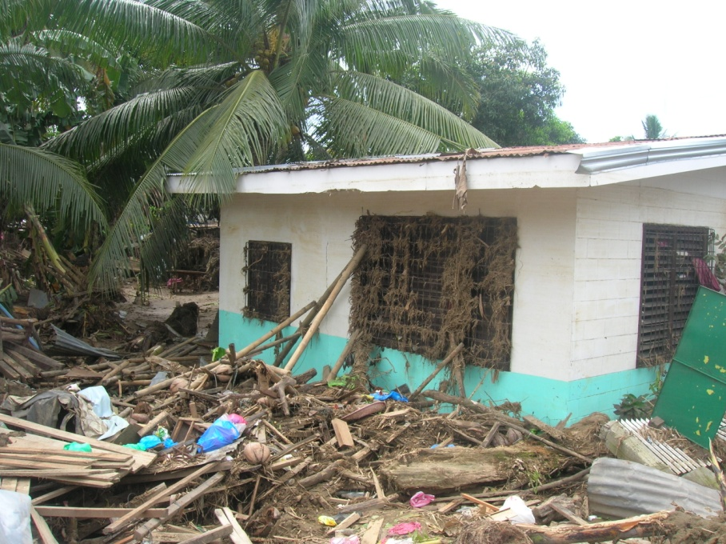

Upper Hlnaplanon Health Center, Iligan