

Greeting from the Executive Director:  The charitable movement that was the root for the charitable Foundation “Constellation of Hearts” began in 2006 with a group of like minded people helping children who were abandoned in Novosibirsk hospitals.  Subsequently these activists registered the charitable foundation that would provide “smart charity”. This is the approach we recommend to our supporters and sponsors.  Our principles and values are the same as before when we created our movement “Effectiveness. Concern. Honesty.” | 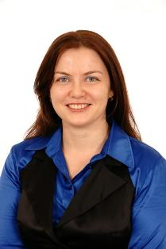
During the last 5 years we have provided help to those in need, children and families.
The results of our efforts speak for themselves:
In recognition of our contribution to disabled and seriously ill children our Foundation was the only one from Siberia or the Far East to be invited to the May 2011 meeting with President Medvedev as one of the top 20 funds in the country. Thus, we were included among such famous Russian organizations as Chylpan Khamatov’s “Give Life”, “Life Line” and “AdVita”.

It is worth mentioning that these results were possible thanks to help from “Supporters of Fund Constellation of Hearts” that includes many individuals and business representatives in our community.

“Hospital Children” Program

We help abandoned babies who are being temporarily housed in hospitals located in Novosibirsk Oblast (Berdsk, Iskitim, Lenova)
We give these babies certainty that they will receive the most essential items – food, medicine, diapers and access to medical equipment.

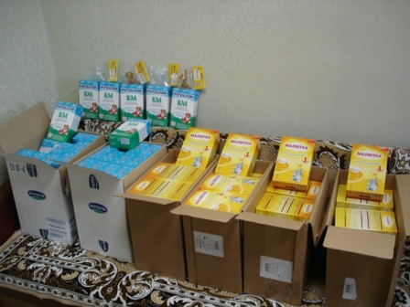  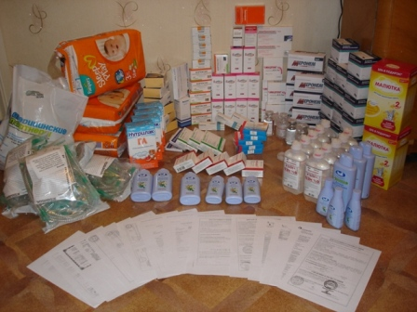 | 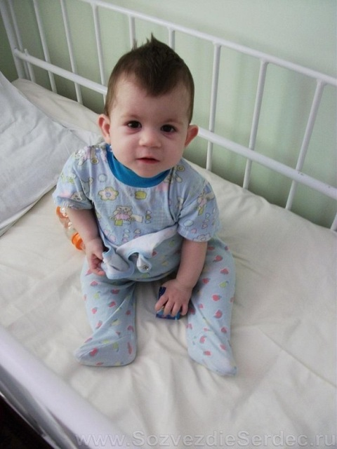 |  |  | 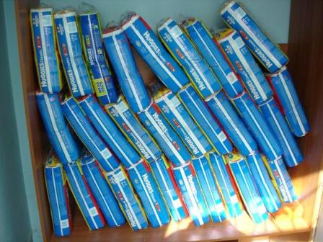  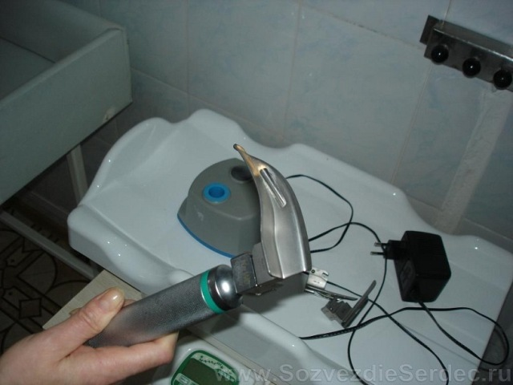
We establish and repair separate rooms for abandoned children living in hospitals so they do not come in contact with sick children.
These pictures show the rooms “before” and “after” the repairs.

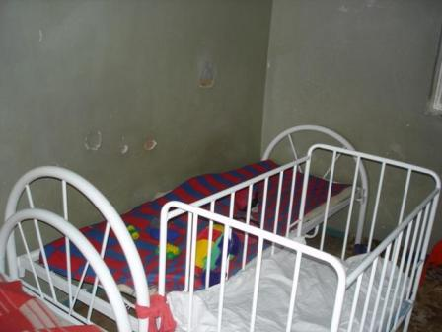 |  | 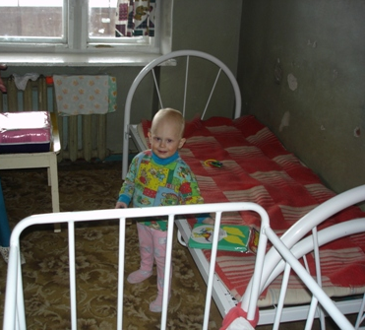 | 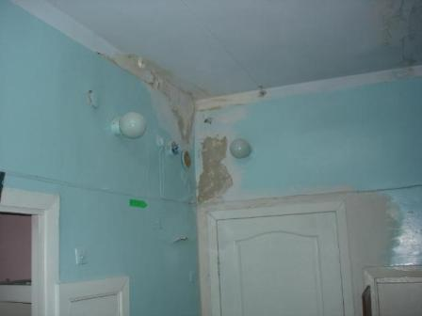
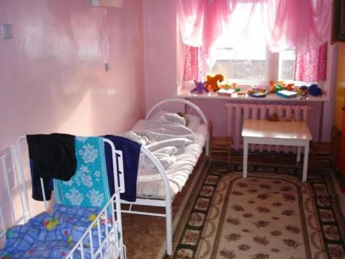 |  | 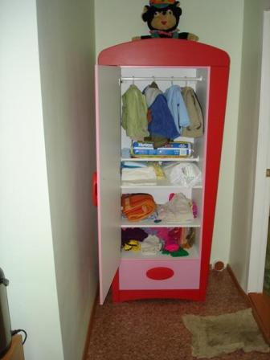 | 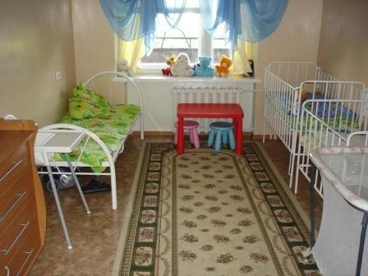

“World of Limitless Opportunities” and “Save a Child’s Health-Save a Child’s Life” Programs
- We do everything possible to save seriously ill children regardless of whether or not they have parents, their nationality, gender or citizenship (children in orphanages as well as tose from poor families, Russian as well as children from other former Soviet countries);

- We have taken responsibility for taking care of the most disadvantaged children those are abandoned and disabled who have practically no chance for a new family.

Before Oleg and Sergey did nothing but lie in a crib, they were considered hopeless. Now, they can old their heads up, they try to crawl with their hands, stand and chat.

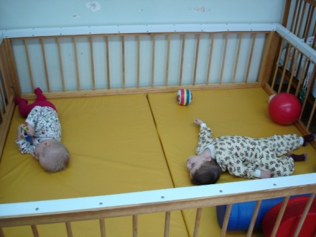 | 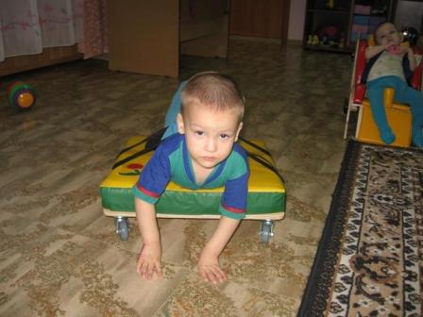 | 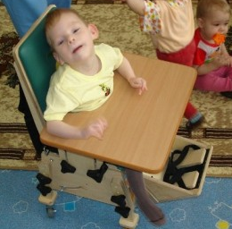

“Prevention of Child Abandonment” Program
We provide the following people help:
- To poor families in crisis situation (for example the loss of the primary breadwinner or those who have lost their home in a fire);
- Babies whose mothers are HIV positive, we provide food so there is no risk of transmitting the virus to their child through breastfeeding;
- Young mothers who find themselves in an oppressive living condition (unable to find a job, emotionally or physically abused, homeless, without food for their children etc.), “lost and desperate” so they have agreed to give up their child;
- Lonely older people who do not have any close relatives, or they have them but they forget about the elderly.

For 1.5 years we supported Masha, a young mother whose husband left her after she gave birth to triplets. Now Masha is standly strongly on her own two feet, she works and lives together with Asiya, Igor and Genya who are attending kindergarten.

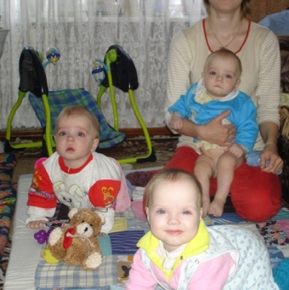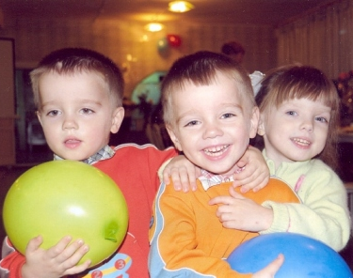

Some words about our results:
“Hospital Children” Program:
- Repaired and fully equipped 3 separate hospital rooms for orphans and children whose parents have lost their parental rights in the children’s wing of Lenova Hospital:
- Number of abandoned children receiving medical help:
2007 – more than 30 children,
2008 – more than 61,
2009 - 97 children,
2010 - 86 children.

“Prevention of Child Abandonment” Program:
- We support more than 200 families that are in critical situations living in the Siberian Federal Okrug and other regions;
- Several children in these families, thanks to this support, were able to remain with their nuclear families rather then being placed in an orphanage;
- In 2012 we successfully got the Municipal budget to include funding to provide food for children born to HIV positive mothers to eliminate the risk of transmission through breast feeding.

Programs “World of Endless Opportunities” and “Save a Child’s Health, Save a Child’s Life”
- Purchased and provided rehabilitation and medical equipment for disabled children in all 5 Children’s Homes in Novosibirsk Oblast;
- Provided the rooms for psychologists and speech therapists in Children’s Homes with equipment and computers and other technical equipment to support interactive lessons with children;
- Provide medical and/or rehabilitation support to more than 200 children in the Siberian Federal Okrug and other regions.

More detailed results are available on our site: www.Consrellationofhearts.com

Thank you for your attention to our presentation!
We would be happy to answer any questions and look forward to mutually beneficial cooperation.
Contact:
Charitable Foundation “Constellation of Hearts”
Pisareva St. 102, Novosibirsk;
Mailing address: 630034, Russia, Novosibirsk, а/я 100
Tel.: +7 (383) 263-88-22; Tel/fax: +7 (383)343-25-36
Executive Director
Margarita Semikova
E-mail: Info@SozvezdieSerdec.ru

