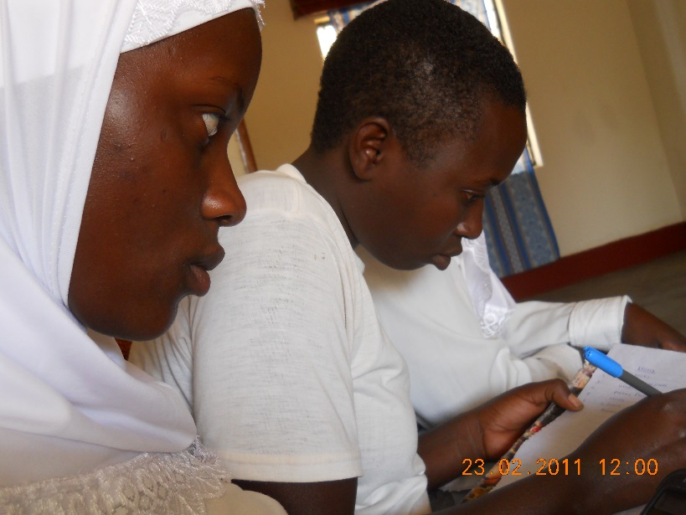
By Joseph Munyambaza, COBURWAS Education Director.
Dear our friends and supporters,
We say, special Thank you for supporting COBURWAS to provide education, leadership and entrepreneurship to refugees and underprivileged youth in Uganda.
We are glad to inform you that our students have continued to do well in the national exams, this year we have got 8 students that have qualified to join university.
COBURWAS is preparing for a new school year and we are now supporting 300 students’ education. In addition to supporting students’ housing so they can attend secondary school and tutoring and COBURWAS Primary School, COBURWAS has also established an anti-violence young women’s empowerment initiative, an agricultural/collective farming initiative which leverages micro-finance, and a small business development and vocational training programming for widows and girls who never got the opportunity to go to school.
By supporting the COBURWAS students, you are making an investment in not only an individual life, but also a community, and a continent. You are giving an education that empowers and enables a young person to be an agent for positive change in his or her community. By educating young refugee girls and boys you give them hope that will sustain them in building their communities when they return to their home countries.
How can your support help?
Is a day of learning worth 67 cents? Just 67 cents covers accommodation, medication, clean water and electricity for one high school student for one day. But to unlock the potential in all youth, we have to make every day count!
Can you help give the chance for a better future for a child for a day, a month, or even a year?
 | Cost per day | Cost per month | Cost per academic year (11 months)
1 student | 67 cents | $20.10 | $221.10
100 students | $67 | $2,010 | $22,110

