IBHABHATHANE COMMUNITY CENTRE
Where we welcome the changes that will assist us in realizing our potential
P.O.Box85, Riebeeck East 5805, Cell: 0746131054, www.riebeeckeast.co.za
NPO 077808

Madiba Magic Reaching Across Generations – July 2012

South Africa’s favourite grandfather, Nelson Mandela celebrated yet another victorious birthday on July 18th. The staff and children of the Ibhabhathane Community Centre committed their 67 minutes of good, which is an initiative that shares Madiba’s wish for spreading happiness and good will through out our country, to visiting the Senior Citizens Home in Riebeeck East. The staff made a huge pot of delicious chicken soup while the children helped baked and iced a birthday cake, which was all taken with on our visit to the eldest of our community. Once there- a birthday banner – was rolled out and our Gogos painted the words Happy Birthday - then the handprints – the grandpa’s and grandma’s painted the hands of the little ones and visa versa and printed on the banner. Old and young inserted candles in the cake. Auntie Katie lit them for us and after a thousand birthday wishes were made, they were blown out with one puff! Happy Birthday Dearest Madiba, cheered through out Riebeeck in Xhosa, Afrikaans and English.

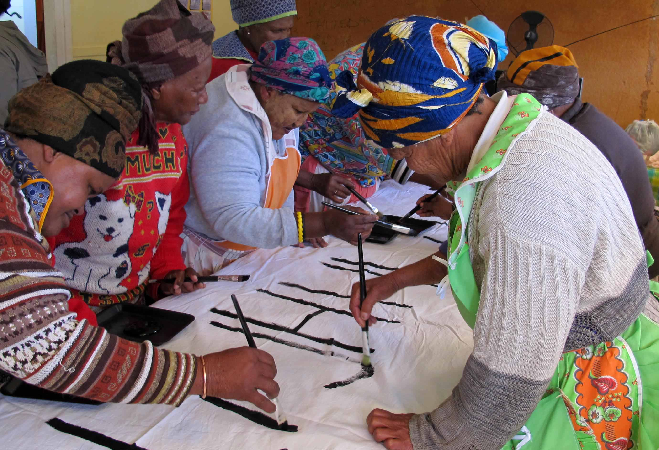

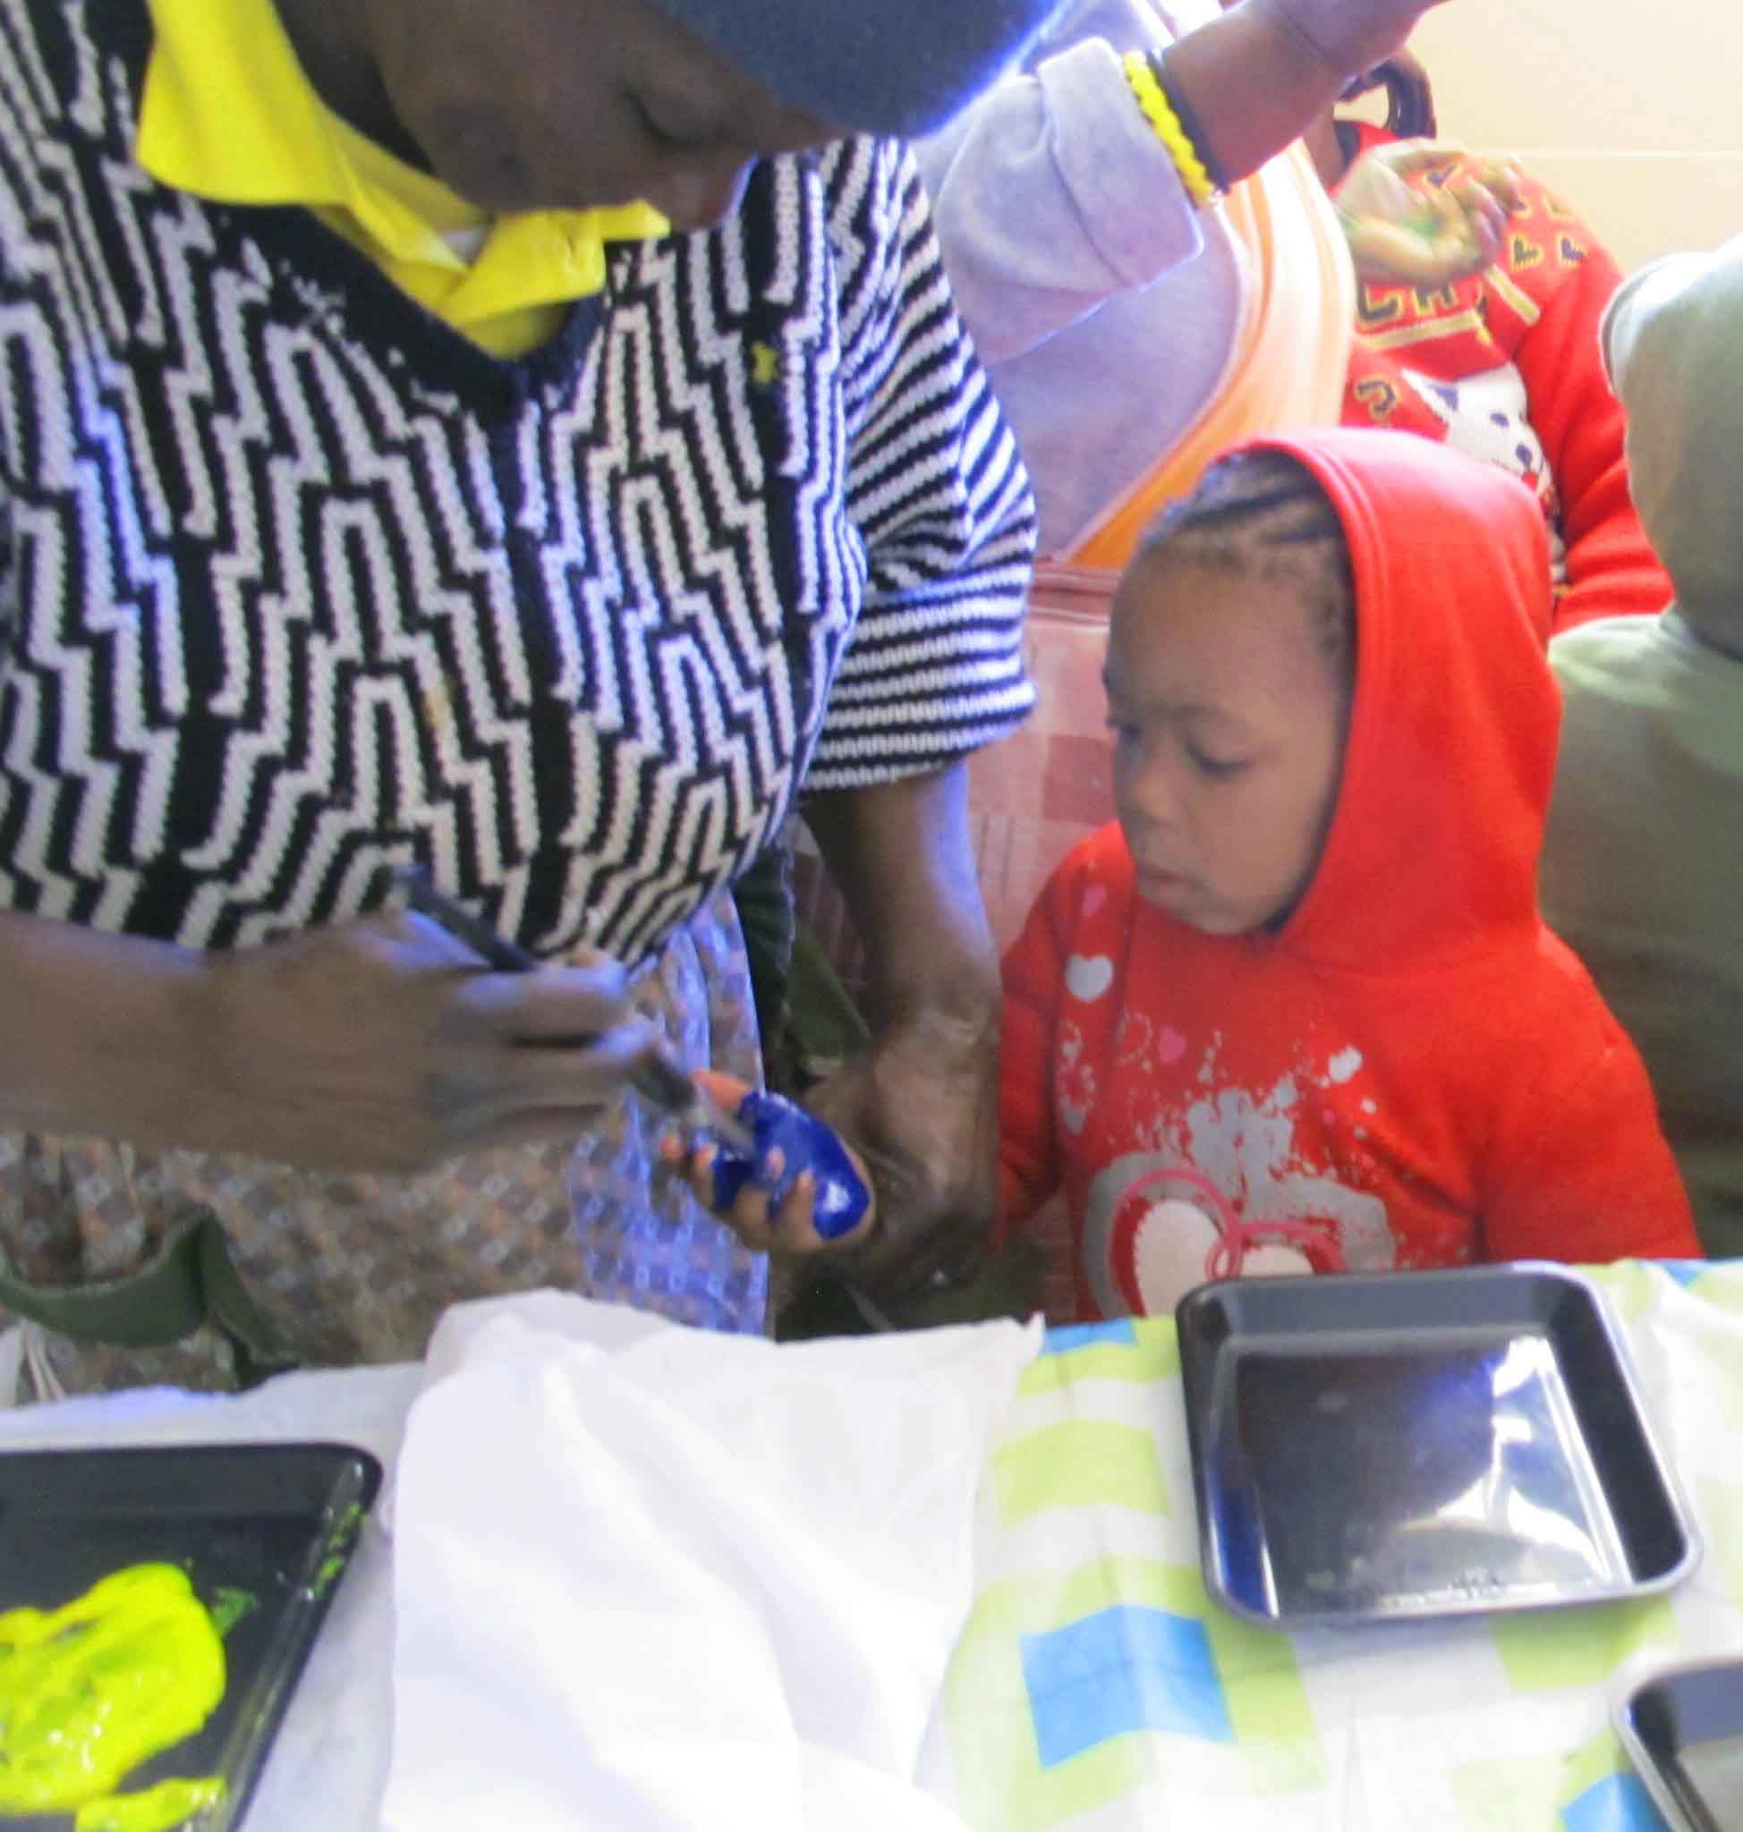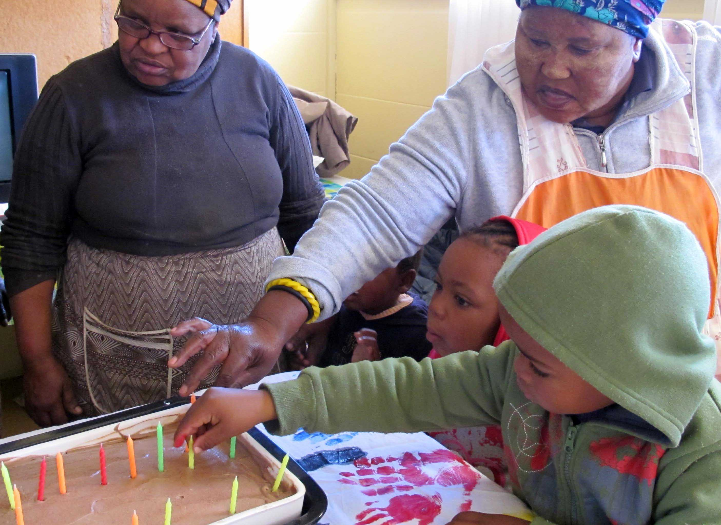

Sharing Nelson Madiba’s birthday was a superb start to our X-Generational learning program. Once a week the oldest and youngest of our community get together and engage in traditional Xhosa singing, story telling, and fast forgotten crafts like beading and pottery.

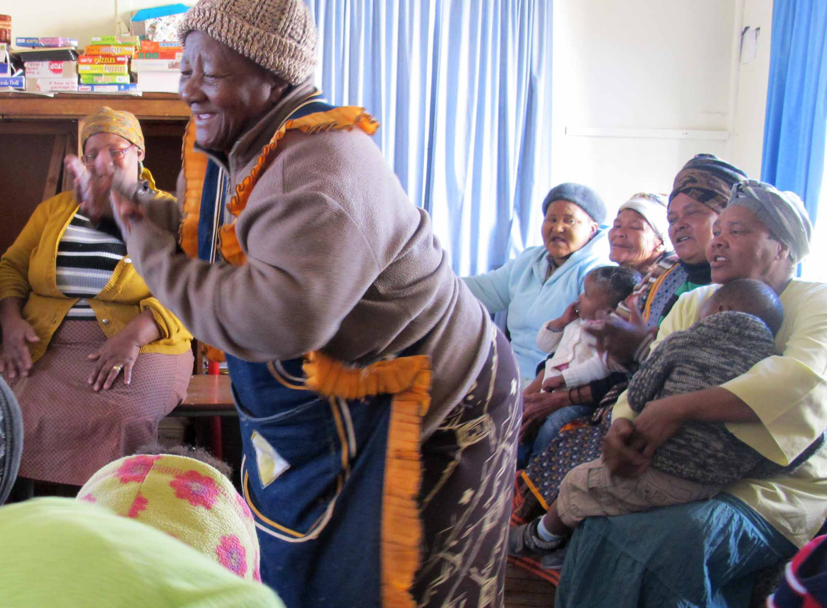

Through the Generational learning program we attempt to bring the importance of Early Years Education to the attention of our elders and for the children to experience their cultural identity and hopefully build strong relationships that will offer a sense of belonging as they travel through their life’s journey.

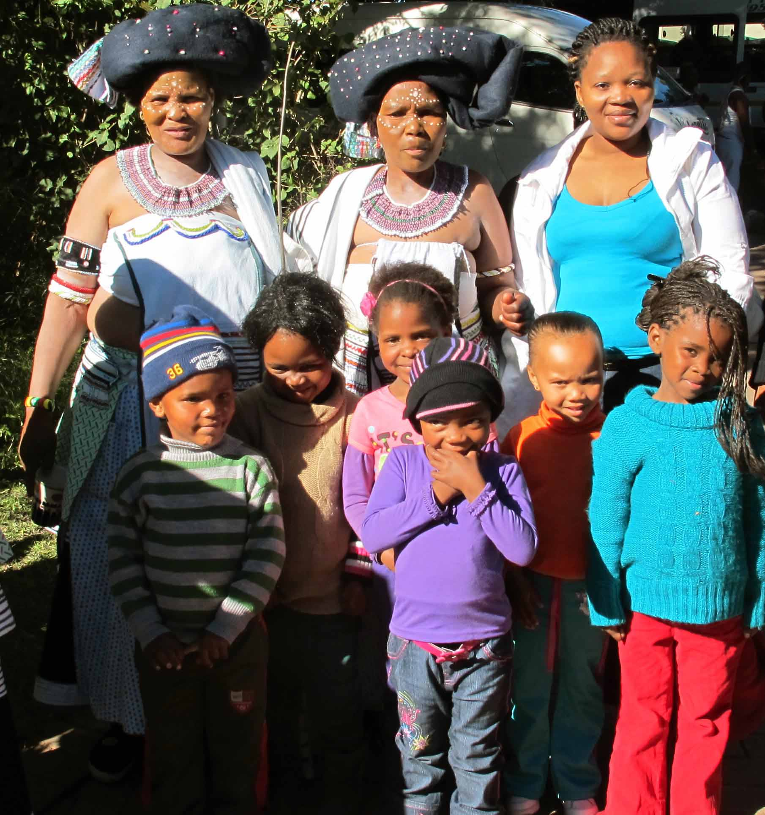

We were very fortunate to take a few of our children on an excursion to the world’s second largest festival, the Grahamstown Arts Festival. The AmaThembu tribe was performing their traditional dancing. The Children were captivated and totally enthralled. The performers’ outfits were discussed as well as the color and bead decorations which blended in very well with our x-generational learning.

We are very privileged to have had these experiences first hand which provide such a meaningful learning experience for our children. We thank our sponsors, donors and the powers to be who have made this possible

Our sincere appreciation
The Ibhabhathane Community Centre

