Report: Training in Able Ladies CIG Maumu 11/08/14-12/08/14

Introduction
The goal of these two days was to train the Able Ladies CIG in Maumu on nutrition basics. The training focuses on achieving a balanced diet, and understanding the relationship between diet and health. On the second day, FORUDEF held a practical workshop to show how to cook cheap and healthy meals. The goal was also to create awareness of the importance of eating well and being healthy using the locally available resources in their communities. Four staff members of FORUDEF facilitated this training:
Tabe Susan
Aschenbrenner Paula
Castang Estelle
Caryn

- Activities carried out
Some materials have been used for this training: the posters “Food Pyramid”, “Be Clean - Be Healthy”, “Nutrition House”, “Body with a Balanced Diet and Body with no Balanced Diet”; a stool to show the relationship between nutrition and health; posters with markers. The posters were drawn in the office before this training.
We began the first day of this training at 11:00 AM with a prayer.
We then introduced the training by explaining the importance of a balanced diet, and the adverse health impacts of malnutrition. In addition, we asked the women their expectations and fears about this training. Their expectations were:
- To learn new ways of cooking
- To learn new ways to keep the house clean
- To learn how to prepare a balanced diet
- To learn more about hygiene
- To learn new ways to prepare food for children to get a balanced diet
- To learn how to meal plan for children and the whole family
The participants were concerned that somebody would get sick and couldn’t attend the training, and that rain or farm work would stop some people from attending this training the following day.
Then we began a presentation of the three groups of foods. We first asked women if they knew them. The participants could identify carbohydrates and proteins, but FORUDEF facilitators had to identify “vitamins and minerals”. Participants then listed various foods available in their village that could be grouped into each category.
The facilitators then presented the importance of these three groups: each group has an important role in maintaining our body’s physical health. Carbohydrates give us energy, proteins allow our body to grow and our muscles and brain to develop. Vitamins and minerals protect our health by improving each part of our body: eyes, skin, and teeth for example.
Using comparisons, FORUDEF staff then explained that we can’t be healthy without eating of all of these three groups. The first comparison was with a plant: a plant can’t grow well if water or sun or good soil is missing. It absolutely needs these three conditions to grow well. The second comparison was with a stool. A stool has three legs and it can’t stand if one leg is missing. So each leg represents a group of food that we need for our body. Facilitators continued to explain this point with a poster that shows two bodies: one is healthy because it has a balanced diet and the other is not because it has an unbalanced diet. On this poster we had written the consequences of a balanced and unbalanced diet. This was followed by a discussion on various illnesses that the women have experienced within their families, and their possible relationship to nutrition.
This portion of the training was followed by a little break by singing a song.
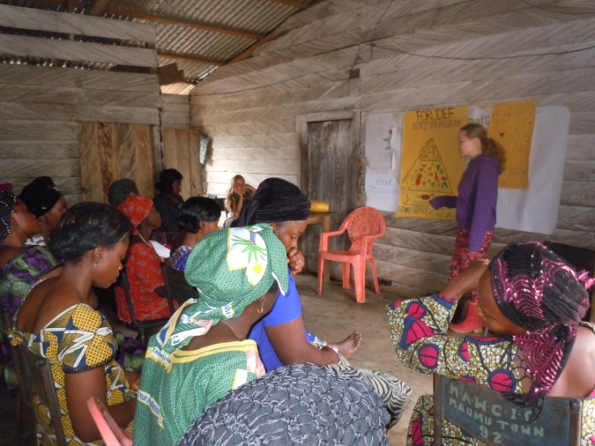
The second half of the training began with a breakdown of consumption. For this point, we have used the pyramid food that summarizes the three groups of foods and their proportions in the same picture.
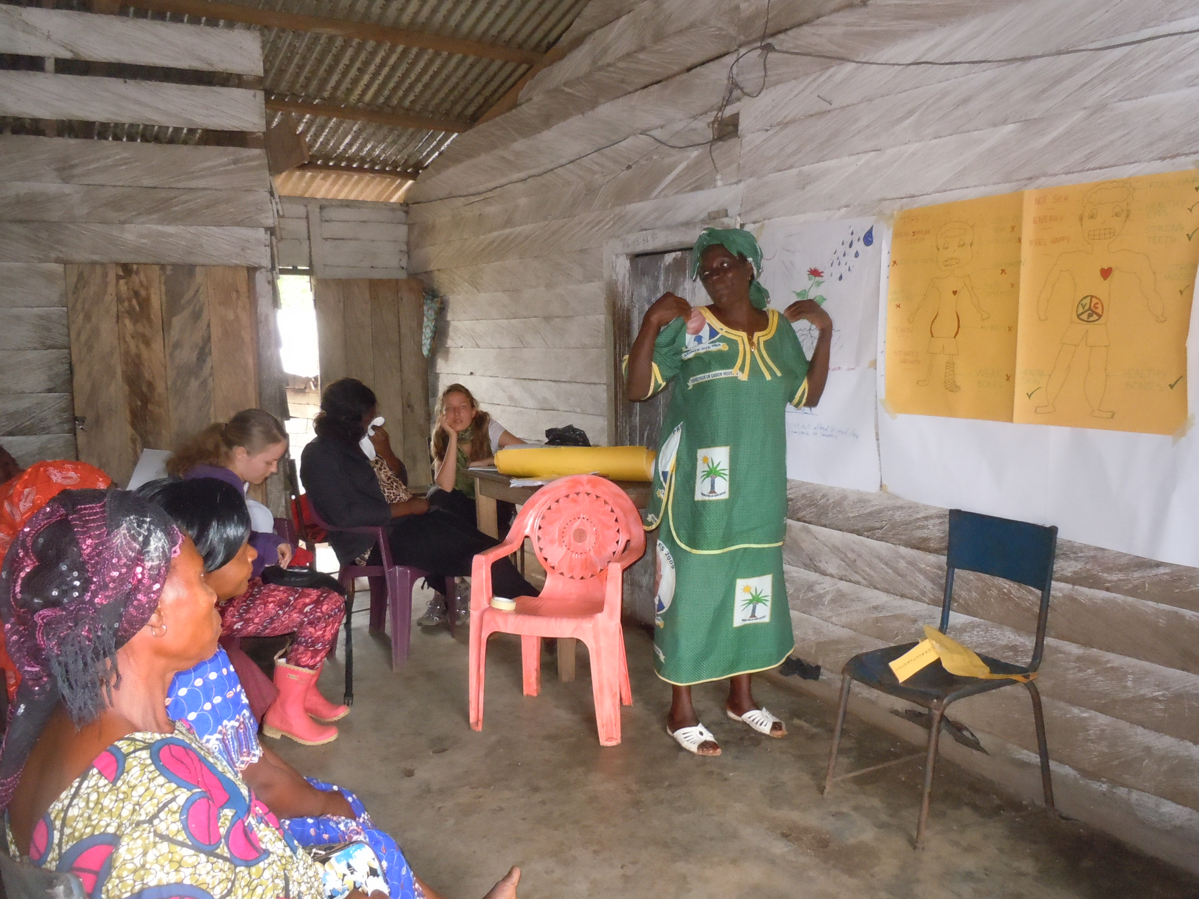
We also displayed the poster “Nutrition House” and used this as a last comparison between the body and a house to explain how important it is to have a balanced diet. Carbohydrates are the foundation of the house, proteins the walls and vitamins and minerals the roof. To reinforce this information, FORUDEF staff led an activity where each participant was given a card with a food labeled on it, and had to put it on the “Food Pyramid” poster under the correct food category. Most of the women found out to which group their food belongs.
The first day of training concluded with a brief evaluation of the participants’ feelings on the workshop thus far. Each participant anonymously marked that they were very happy with this training and that they learned a lot of things. At this time, FORUDEF facilitators also read again the expectations for this training and explained any additional points that had not been yet said, and answered last questions.
In addition to learning about nutrition, the women wanted to learn more about hygiene. As a result, FORUDEF presented the poster “Be Clean - Be Healthy” and discussed the importance of washing our hands, teeth and body to be healthy. The facilitators also highlighted the importance of using hygienic practices when cooking so that food isn’t contaminated.
Throughout the day, the women were very interested the content of the workshop, and showed eagerness to learn new things. This first day of training was finished at 2:30 PM.
The second day of training began at 10:00am. The facilitators began to prepare the food, and as the women arrived, the facilitators and participants began to cook together. To demonstrate a balanced, nutritious meal, FORUDEF prepared beans with crayfish, groundnut paste, n’dolé, rice, and plantain. We have seasoned the different dishes with salt, garlic, onions, maggi and pepper. The goal was to cook balanced meals with local and cheap resources. All the dishes were affordable, healthy and locally available. Only a small amount of oil was used, which seemed to be quite unusual for most of the women. While preparing the food Susan Tabe explained how to prepare this food and how it constituted a balanced meal. We emphasized the point that it is not necessarily the quantity, but the quality of food that is most important.
Afterwards, facilitators summarized the knowledge that was learned during these two days. The women had many questions that were answered by the staff. Finally, all participants and facilitators ate together what had been cooked, and it was a nice atmosphere in which everyone seemed to be very happy with this day. The women liked the food and seemed to be willing to change their way of cooking.

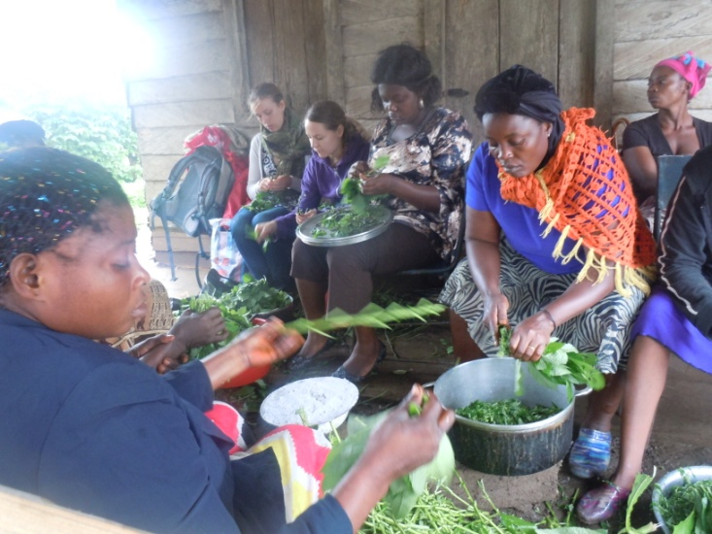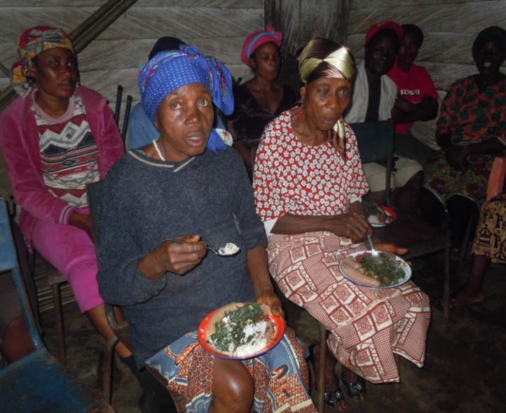

- What was Learned
Participants noted that they had learned a lot during the practical workshop. In addition to the classroom knowledge from the first day, the women could observe Susan Tabe to understand how to incorporate this knowledge into their diets on a daily basis.
The women also shared with the facilitators about some experiences of malnutrition and their way of living. This was valuable for FORUDEF staff to better understand how malnutrition has manifested itself in Maumu, and the specific health concerns that have resulted.

- Difficulties
FORUDEF staff encountered some difficulties during this training:
The training was planned to begin at 10:00 AM and it begun at 11:00 AM. We had to wait for people who were on the farm.
English had to be translated into Pidgin so that the women could understand us. Therefore the training took more time.
Another difficulty was the varying knowledge base of the participants. It was difficult to identify if all women understood the system of the three groups of foods or only those who actively took part in the discussion.
- Recommendations
To make sure that all women understand the importance of a balanced diet, we could divide the women into smaller groups to tell each other what they have learned. Furthermore, they could create in these groups a balanced meal that they could then cook at home (with ingredients that are very cheap or available on their farms). Each group could present their meal to the larger group so that everyone can discuss if it contains a good balance between the three groups of food. With this method, the women can gather ideas about how to apply what they have learned at home, and how they can create a balanced diet for the whole family.
Another recommendation is that the women could repeat what they have learned in their regular meetings. They could tell each other how they have applied what they have learned and talk about difficulties they had.
Finally, because the participants are now aware of the value of nutrition, they can now be trainers and pass their knowledge on to others in their families and community. We should advise and support them to do so.
Conclusion
These two days of training are considered to have been a success; the participants expressed their enjoyment of the workshop’s content, and throughout the course of the training, demonstrated their general comprehension of its main tenets. The women seemed to be very interested and eager to both learn and apply their new knowledge. Furthermore, they expressed their commitment to adapting new methods of cooking. As such, although there are alterations that FORUDEF will implement before the next nutrition training workshop, the staff facilitators feel that this workshop in Maumu has catalyzed a change in the women’s nutritional understanding that will result in a healthier, more vibrant community.
