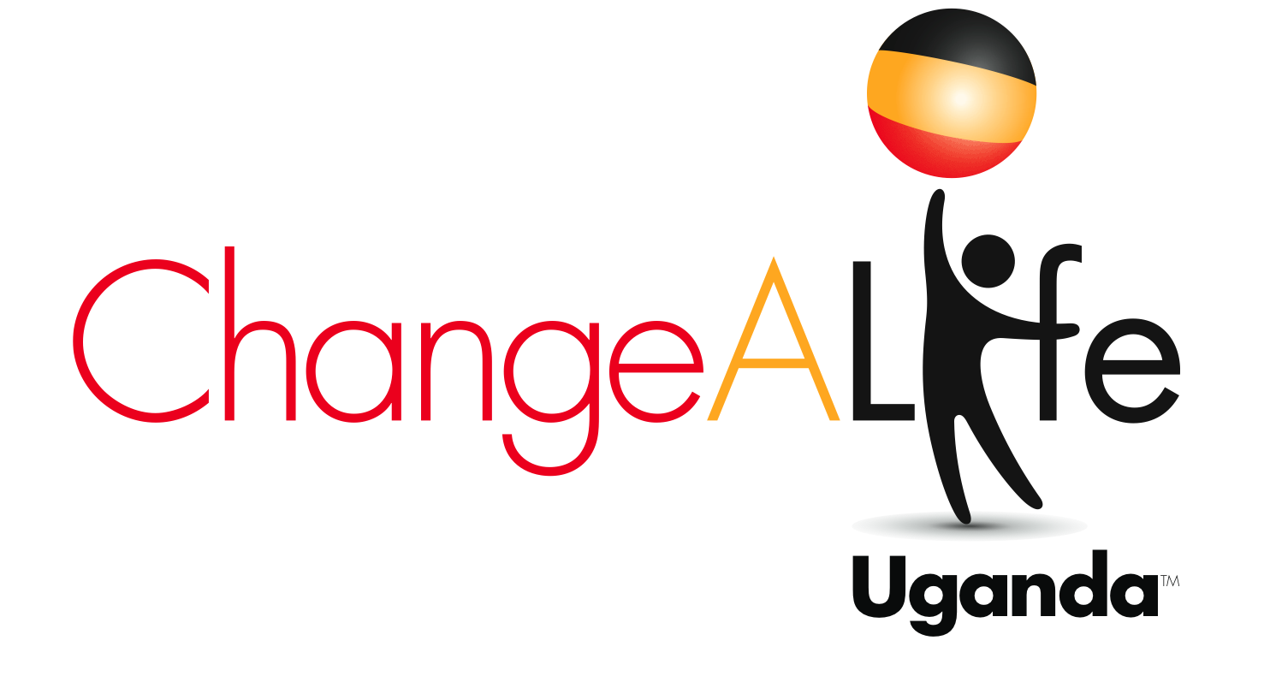
CASE STATEMENT

BACKGROUND
Meet 14-year old Scovia. She used to leave her home before daybreak at 6 am everyday so that she could arrive at school by 8 am. While other students around the world take school buses, carpool and use public transportation, Scovia walks miles down a treacherous path of multi-lane highways and deserted dirt roads just to have access to education. She is a high risk to be propositioned by truck drivers and workers who illegally burn charcoal in the woods near her school. Wild animals are also of concern. And when school lets out at 4 pm, she has to retrace her steps all over again in the dark, to arrive home nearly two hours later where she lives with her mother and three siblings. She is immediately confronted with her reality, a makeshift hut on land they do not own with barbed wire acting as their sole source of security. She and her three siblings sleep in one hut six feet in diameter. Her mother is in a relationship with a man who is an illegal charcoal burner. The little money earned from selling charcoal must support the family because they are without land on which to farm crops or raise animals.

Scovia is no exception. In fact, she is one of millions of children around the globe that live in poverty with little hope of getting out. But luckily for Scovia, two years ago she became part of ChangeALife Uganda, a nonprofit organization working to give children hope through sponsorships and other educational, health and economic interventions. Scovia’s sponsor changed her life forever by providing her with new housing on school property, covered tuition and school fees, new school supplies and textbooks, and most important, someone really cares about her well being. Even after her mother passed away suddenly due to AIDS, her sponsor was there to act as her mother in absentia, paying for her additional dormitory fees and sending her to secondary school next year.

ChangeALife Uganda envisions this for all Ugandan children. We believe it is possible as a result of its inspiration, Father Lawrence Kizito Kimbowa, whose personal and professional experience in educational sponsorship was the catalyst for ChangeALife’s work. His story and the inception of ChangeALife Uganda are amazing proof that a happenstance meeting between two retired American professionals, who agreed to house a Ugandan priest during his visit to the US, can result in global life-changing work.

MISSION
ChangeALife Uganda, founded in 2007, is a nonprofit 501(c)(3) tax-exempt organization dedicated to improving the lives of orphaned and disadvantaged children and their families in Migyera and Nabbingo, Uganda through a multi-sectoral approach of education, health and sanitation, and business development. ChangeALife Uganda places a primary focus on educating children, the hope of the future. The child and the child's family receive health care and assistance with income development projects including training, micro-financing and market development. ChangeALife Uganda’s goal is to provide first for one child and its family, then 100, then 500 to alleviate the level of poverty and improve the overall quality of life in the village. The ChangeALife Uganda’s model focuses on the child as the catalyst for change.

THE CHANGEALIFE UGANDA DIFFERENCE
Uganda’s population is 32.4 million with 88% living in rural areas. Household economic status is inextricably linked to health and educational status. For this reason, ChangeALife Uganda understands the importance of treating the whole family. It works on a small scale to become a key player in the lives of the children, families, and communities by providing income generating activities for unskilled parents and creating health centers and access to water for the entire village. This complements the core focus of providing children with access to knowledge and learning.

ChangeALife Uganda is committed to working directly with the individuals and communities it serves. It does so by employing local people who become part of the communities and aligning itself with partner organizations and religious institutions to further its mission. ChangeALife Uganda works in two locations in rural Uganda:

- Migyera is located 86 miles northwest of Kampala, the capital of Uganda, in the district of Nakasongola. Sponsored children attend St. Lawrence Primary School, a non-denominational, public school.
- Nabbingo is situated 9 miles from Kampala in a semi-urban area. Sponsored children come from homes scattered throughout Nabbingo and surrounding areas, and attend various day or boarding schools that are pre-selected for the highest quality education.

THE CHANGEALIFE UGANDA MODEL

Education
ChangeALife Uganda’s education programs aim to increase primary, secondary and university school attendance and graduation rates by creating learning environments with improved student/teacher ratios, safe sleeping arrangements for overnight students, and covered tuition and schools fees for disadvantaged students. The organization also partners with Colleges, High Schools, Elementary Schools, and other schools across the country to provide students in the US and Uganda an opportunity to learn hands-on about the lives of school children in each other's country. The school partnership arm seeks to enrich student learning in Uganda and the US by focusing on the interdisciplinary connections between the US and Uganda core curriculum. In addition, professional collaboration assures a continuous enhancement of teaching methods and classroom quality.

The goals are achieved through the following fundraising programs:
- Tuition For Tots-To-Teens: a child sponsorship program that gives the gift of quality education to disadvantaged children who lack the means to attend school. Child sponsorship provides educational support, medical care, nutritious food and counseling. A sponsor-child relationship develops through letter writing and photo exchanges.

- Sponsors For Teacher: a teacher sponsorship program to increase the number of teachers at St. Lawrence School and to lower the student teacher ratio of 70 to one.

- Bucks For Beds provides a dormitory for students who live miles from school or have challenging family situations. Accommodations provide the students with a safe place to sleep, three meals a day, clean water and ongoing support of their academic achievement.

Health
Uganda has the third highest population growth rate in the world, as the average woman has seven children in her lifetime. Unfortunately, due to lack of access to proper healthcare and nutrition, 14 out of 100 mothers die during childbirth, in addition to the same number of infants. But it is the children who survive childbirth that are undoubtedly hit the hardest by poverty, as a staggering 22.9% of children under 5 are deemed as underweight for their age.

HIV: Uganda has a reputation for its successful HIV preventive measures. Prevalence rates dropped from 18% in the mid-80s to 6% nationwide. In spite of this, it is estimated that there were 130,000 new infections in Uganda in 2009. One third of individuals requiring antiretroviral therapy are receiving treatment: 115,000 of 350,000. An estimated 77,000 died in 2007. Many Ugandan grandmothers are raising grandchildren due to the death of their own children from AIDS. There are 1 million orphans because of AIDS.

What are the specific health challenges in the Nakasangola district, where Migyera is located? Malaria is the number one cause of mortality. Only 17.1% of women receive antenatal care and trained staff delivers 10.7% of infants. Just 38.6% of the population has access to clean water. The prevalence of HIV in the Nakasangola district is 15.7%, which is significantly higher than the general population of Uganda, due to its location on a truck route between Kampala and Sudan, where spread of communicable disease is common. In fact, Migyera is listed as an “HIV Hotspot” in a report from Makerere University. In Nabbingo ,as in Migyera, poverty has a major impact on maternal and infant mortality and morbidity and Nabbingo has the third highest rate of infection in the country at 7.4%.

The HIV/AIDS epidemic compounded by TB and malaria has had far reaching social and economic consequences for families and communities. ChangeALife Uganda’s health intervention programs hopes to address many health issues affecting our children and their parents such as HIV/AIDS, tuberculosis, malaria, diarrhea, and various respiratory diseases. Our goal is to provide access to healthcare giving a better quality of life to the people of Nabbingo and Migyera by:
- Upgrading the healthcare center,
- Improving staffing,
- Providing medicine, equipment and supplies,
- Constructing clean drinking water systems
- Providing access to HIV counseling, testing, antiretrovirals, disease management and palliative care services;
- Teaching students how to create sanitary living conditions for themselves and their families;
- Instructing them how to prevent infectious diseases as part of their educational curriculum.
- In addition, providing a stable food supply at school to contribute to maintaining their health and well-being.

Nabbingo Health Center is a Level III health center supported by the Catholic Diocese of Kampala. It provides primary care, medications, limited laboratory testing, antenatal care and a delivery room services. The facility has two small buildings, with one exam room for primary care of adults and children, two rooms with beds where intravenous therapy is administered for treatment of malaria and other diseases, an extremely small space where microscopy is performed, and a closet size pharmacy that dispenses formulary medications. One small picnic cooler with water for hand washing is located in between the two buildings. While there is a sizeable population of patients with HIV, antiviral therapy is not offered at the clinic. It only offers HIV screening, pre and post-test counseling, limited health education and pastoral visits to infected patients.
Our wish is to provide our clients a holistic approach to the management of their HIV condition. This includes diagnostic equipment and supplies including viral load and CD4 testing, antiretroviral medication, adherence programs, nutritional support, physiotherapy, general medical and psychological health care management, orphan and vulnerable children support, financial interventions and HIV prevention programs in schools and community.
In Migyera the health center has been standing partially completed for the last few years. In 2004, an Austrian NGO began construction of the clinic, which was about 2/3s constructed when funding stopped. The building remained unfinished until construction resumed in August 2010. The facility was initially planned as a level III health center, but the only services provided presently is the dispensing of anti-malarial drugs and some antibiotics by a nursing assistant who lives in one of the unfinished rooms in the 20 room clinic. To open the clinic it will cost an estimated $20,000 to complete construction, $40,000 for medical and administrative supplies, and to hire a medical officer, 2 midwives, laboratory technician and other attendant staff. To become fully operational the total cost will be $162,000.
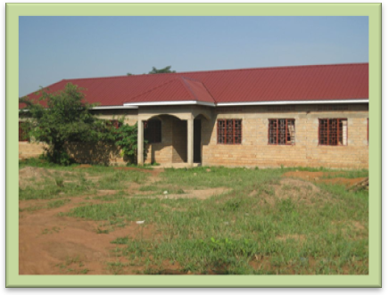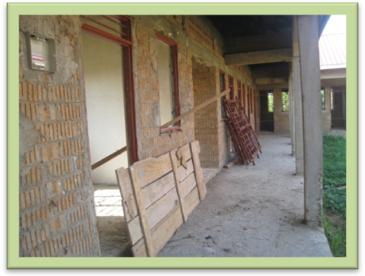
BUDGET PROPOSAL FOR ST FRANCIS MIGYERA HEALTH CENTRE FOR 1 YEAR.
 | NO | AMOUNT  Ugandan  Shillings | TOTAL PER YEAR | Modified to Basic Needs | Amount  US $$ | Total
1. Visiting Physician | 1 | 750,000 | 9,000,000 | 1 | 3471
1 Clinical officer | 1 | 500,000 | 6,000,000 | 1 | 2334
2 Counsellors | 2 | 300,000 | 7,200,000 | 1 | 1400
Laboratory Techinician | 1 | 400,000 | 4,800,000 | 1 | 1867
1 Laboratory Assistant | 1 | 300,000 | 3,600,000
Enrolled Nurse | 1 | 350,000 | 4,200,000 | 1 | 1634
1 midwives | 1 | 400,000 | 4,800,000 | 1 | 1867
1 Comprehessive Nurse | 1 | 350,000 | 4,200,000 | 1 | 1634
1 Account's Assistant | 1 | 200,000 | 2,400,000
1Nursing Aid | 1 | 150000 | 1,800,000 | 1 | 700
Security officer | 1 | 150,000 | 1,800,000 | 1 | 700
1 Cleaner | 1 | 120,000 | 1,440,000 | 1 | 560
Sub-total |  |  | 42,240,000 |  | 16167 | 16167
Window curtens | 4 Rolls | 500,000 | 2,000,000 | 1 | 193
Bed Covers | 4 Rolls | 500,000 | 2,000,000 | 1 | 193
Screens | 4 | 200,000 | 800,000 | 2 | 154
Adult beds | 40 | 500,000 | 20,000,000 | 5 | 965
Children' beds | 15 | 250,000 | 3,750,000 | 5 | 483
Blankets ordinary | 40 | 60,000 | 2,400,000 | 10 | 232
Matresses with Pvc cover Adult | 40 | 100,000 | 4,000,000 | 5 | 193
Bed Sheets | 40 | 30,000 | 1,200,000 | 10 | 117
Sub-total |  |  | 31,350,000 |  | 2530 | 2530
Diagnostic Sets | 2 | 850,000 | 1,700,000 |  | 656
Drugs |  |  | 48,000,000 | 24M | 9266
Sets for normal delivary
Cold boxes | 2 | 50,000 | 100,000
Mama Kits for mothers | 400 | 20000 | 8,000,000 | 50 | 386
Laboratory Reagents |  | 500,000 | 6,000,000 | 6 | 1163
2 Delivery beds |  | 1,000,000 | 2,000,000 | 2 | 386
B.P Machines | 2 | 274,000 | 548,000 | 2 | 211
Weighing scales | 3 | 200,000 | 600,000 | 1 | 77
Baby Weighing scales | 2 | 370,000 | 740,000 | 1 | 143
Drip stands | 10 | 50,000 | 500,000 | 4 | 78
3 Trollies | 3 | 24,000 | 72,000 | 2 | 10
5 stop Watches | 3 | 50,000 | 250,000 | 2 | 39
1Microscopes,binocular electric with mirror, novex | 1 | 1,064,163 | 1,064,163 | 1 | 414
Examination coaches | 4 | 500,000 | 2,000,000 | 2 | 386
Sterilisers | 2 | 1,500,000 | 3,000,000 | 1 | 583
3 Wheel chairs |  | 300,000 | 900,000 | 1 | 117
Autoclave | 1 | 5,100,000 | 5,100,000 | 1 | 1980
1 Refrigerator for Reagents storage |  | 1,000,000 | 1,000,000 | 1 | 386
Suction pump | 1 | 1,261,247 | 1,261,247 | 1 | 490
Resuscilater for baby1 |  | 358,000 | 358,000 | 1 | 139
Resuscilater for Adult | 1 | 382,722 | 382,722 | 1 | 149
Oxygen Concentrator | 1 | 2,367,500 | 2,367,500 | 1 | 920
 |  |  | 36,243,632 |  | 17979 | 17979
Stationeries, paper etc.. |  | 200,000 | 1,000,000 |  | 39
Computer/ Printer/ Photocopier Machine |  | - | 3,000,000 |  | 1166
Coordination E mail /Airtime/Modem |  | 100,000/= per month | 1,200,000 |  | 466
Office Desks | 10 | 200,000 | 2,000,000 | 4 | 310
Office Chairs | 15 | 50,000 | 750,000 | 8 | 155
Shelves | 5 |  | 1,000,000 | 2 | 80
Filling Cabinets | 5 |  | 1,000,000 | 2 | 80
Fuel ( support suppervision) |  | 3,000,000 | 36,000,000
Fuel for motorcycle and Ambulance. |  | 3,000,000 | 36,000,000
Motor Cycle | 1 |  | 6,000,000
 |  |  | 362,117,264 |  | 2296 | 2296
Grand total amount |  |  | $139,813.62 USD |  |  | $38,972
 |  |  | 1 USD = 2,593.00 UGX

Our vision is to make sure that both centers are fully equipped with enough basic medical equipment to enable the medics to perform their jobs efficiently to the benefit of the rural poor.
The goals are achieved through the following fundraising programs:
- The Money For Medicine program to fund general pediatric and adult health care, desperately needed HIV, TB and malaria treatment and building and staffing of medical facilities.

- The Quarters For Water program is now supported by U.S. schools and in the future individuals and corporations and will together provide clean on-site drinking water for students of St. Lawrence school and their rural village of Migyera by building wells and boreholes, purchasing tanks and cisterns, and using existing pipeline to reach nearby large water sources.

Business Development
The economy of Uganda is primarily based on the agricultural sector, with over 80% of the working population employed by this sector. Unfortunately, due to two dry seasons that deplete water storage and impede irrigation, families who rely on agriculture for their livelihood earn very little. In fact, fifty-two percent of the population live below the poverty line and earn less than $1 per day. Two-parent households currently earn $75 dollars per year, while single-parent households, which make up 53% of the population, earn just $37.

ChangeALife Uganda works to empower families with marketable skills to further their financial independence and reduce poverty through profitable and self-sustaining occupations, such as raising farm animals, native craft production, retail stores, sewing and tailoring, and food preparation. The goals are achieved through the following fundraising programs:

- Cash For Crafts is a sales initiative wherein purchasers of crafts handmade, such as jewelry, baskets, masks and artwork by Migyera and Nabbingo artisans are sold in the U.S., with all money earned cycled directly back to the artists and schools.

- Funds For Farming is a beneficially cooperative effort between local crop and livestock farmers with our schools and students, providing needed healthy produce as well as markets for local growth.

- Financing for Families is a microfinance program to fund small business opportunities for the women and families of our sponsored children. Examples are selling gee, making chapatti, and sewing clothes, weaving baskets, making jewelry, brewing beer and owning a grocery or retail shop.

These programs distribute loans, develop markets to sell products, assist clients in the planning and implementation of their projects and include micro savings for future needs. Donations for income-generating programs will fund microloans and provide resources needed for families to start their own self-sufficient small businesses.

ACCOMPLISHMENTS

Education
- The number of sponsored children in our Tuition for Tots to Teens program has increased to 276 (165 in Migyera and 111 in Nabbingo) all are in good schools and received scholastic materials to facilitate their studies.
- The St. Lawrence School has progressed from an unranked, rural, substandard school in 2007 to a grade two school, approaching grade one in 2010. It is now a model school in the district of Nagasangola and is headed to becoming a model school countrywide.
- St. Lawrence Primary School student population increased from 90 students in 2007 to 505 students in 2010. Sixty students were turned away in 2011 because of lack of classroom space.
- Two additional acres of land were purchased to accommodate future expansion.
- The school was repainted, the compound remodeled, a boys latrine built and a new fence constructed around the school compound, electricity installed, a new kitchen with an energy efficient stove was built, sports equipment, sports, music, dance, and drama equipment were purchased and a new computerized mimeograph machine, a computer, photocopier and printer supports the administrative duties of the school secretary.
- Our students now have a fully stocked library resulting in a great improvement in the student’s literacy levels. Monitor Newspaper Publishers ranked the school number one in the district for literacy.
- In the 2011 school year, a new computer room with one central processing unit and seven monitors was constructed. The computers combined with internet service allows teachers to access information for lesson preparation.
- The school’s first football field was constructed, team uniforms were purchased and the students participated in athletic competitions.
- A new art and performing art program was added to the curriculum with students receiving a trophy in music competitions and selling products they are producing.
- In 2009 a new dormitory was constructed. It opened its doors in 2010 with 55 students which increased to 70 in 2011.
- A model organic garden for our students and the entire community to provide “hands on learning” was developed in 2008 and expanded in 2010. With the application of manure and ash, it has become more productive and supplies the school with cassava, maize and matooke bananas to supplement the children’s diet.
- All children wear full uniforms and shoes to school.
- ChangeALife Uganda funds a new school secretary position and twelve of the school’s twenty teachers’ salaries, some of which was funded by our Sponsors for Teachers program. We provide extra teaching allowances for the numbers of lessons conducted and extra curricular activities. All teachers receive housing allowances and four teachers are housed at the school.
- Professional development workshops have been introduced for our teaching staff.
- Our school disseminates information to our students, parents and staff on peace building, justice and conflict resolution.
- Education classes for parents to learn to write and keep records are conducted on weekends.
- School dropouts have reduced creating a consistent enrolment.
- Student performance in national exams is improving. In 2009 all 27 Primary seven students passed the national exam with 22 performing in Division 1 and Division 2. In 2010 all 24 students passed the national exam with 4 performing in Division 1 and 19 in Division 2.
- Twenty-one sponsored children from St. Lawrence School are attending secondary school (high school). Twelve new students will be starting secondary school in 2012.
- Two students completed vocational school, one nursing school and two graduated from the university; all are employed.

Health
- All students and teachers receive one meal per school day at the St. Lawrence School regardless of sponsorship.
- All ChangeALife sponsored students have access to health services.
- Forty parents were screened for HIV/AIDS in 2009
- ChangeALife Uganda donated four C.U.R.E kits from Project Cure to our health centers in Migyera and Nabbingo
- A US health team conducted a needs assessment and planning meetings in 2010 with our team in Uganda.
- Money for Medicine funded a pilot HIV/AIDS sponsorship program that was launched in 2011 for sixteen of our parents to receive testing, antiretrovirals and nutritional support.
- Other parents have received health care services through funding from ChangeALife Uganda because of the seriousness of their illness – HIV, TB, and malaria.
- In 2010 our Quarters for Water project funded the purchase and installation of four tanks to collect water from the school’s roof, one at the health center and the purchase of land 1.5 miles from the school as the future sight for a deep well to provide clean water to our school students.

Business Development
- St. Lawrence Primary School children and members of the Migyera community were taught methods of cultivation through their demonstration gardens
- Cash For Crafts program was initiated in 2009 with the profits from handmade crafts sold in the U.S. benefiting the women and the school. The program raised $10,000 in 2009 and $20,000 in 2010.
- A Microfinance Pilot Program was initiated in 2010 with 5 clients in Migyera and 5 in Nabbingo. Compared to other microfinance programs, ChangeALife Uganda offers lower interest rates, a grace period before repayment, market development and training and support to ensure a successful outcome.
- The pilot program was restructured in late 2010. With funding of $10,000 four microfinance groups of parents in Migyera and one in Nabbingo received project funding. This was expanded in 2011.
- Through a partnership and grant from Rumson Country Day School (RCDS), 30 children are participating in a microfinance program for children. Students are repaying their loans and learning how to raise goats, chickens, rabbits, pigs. RCDS students sell the crafts made by a student craft group,

A LOOK INTO THE FUTURE

2011 Activities
- Students will learn computer skills at the new computer center.
- Students will learn vocational skills using cyclostyling (mimeograph) machine, a computer and printer as an income-generating activity for the school to print extra exams for other schools in the region.
- Expand the student small loans project to more students to start small businesses, for example, raising chickens, eggs, goats, pigs to sell in the market.
- Extend the microloan program to the families by consolidating the existing distributed fund, and increase distribution by at least $10,000 every 4 months, for the period of 3 years during the pilot phase.
- 100 students to sleep in the new dormitory on 50 new bunk beds, mattresses and bedding.

Goals
Education
- Expand from 235 to 300 sponsored students in 2011.
- Decrease student ratio at St. Lawrence to below seventy to one.
- Fund boarding costs from 30 to 75 students.
- Build a dinning hall to provide shelter during meals.
- Purchase textbooks matching the Ugandan primary school curriculum.
- Increase communication between students in Uganda with counterparts in US partner schools and sponsors via the internet.
- Install satellite dish for wireless internet.
- Construct a three classroom block to decrease class size from 100 to 50.
Microfinance:
- Expand microloan program to 100 families including small loans to 20 students.
- Increase handcrafted jewelry, basket and crafts sales to $25,000 up from $20,000.
- Develop Uganda and US market for craft items.
Healthcare:
- Expand health care initiative including HIV testing, counseling and antiretrovirals for 50 parents.
- Remodel existing Nabbingo Health Center and upgrade equipment.
- Start Phase 2 of our water project to dig a deep well, install a pump and pipes and a holding tank for the St. Lawrence School and village.
- Expand educational and health partnership programs to universities, corporations and churches.

Other: develop strategic partnerships with universities, NGOs and corporations.

FINANCIALS

2007: $37,963

2008: $100,248

2009: $208,672
Professional Services:
- Design of promotional resources: Davidoff Associates
- Accounting Services: Robinson & Company
- Website development: Quinn Fable Advertising
- Website hosting: Shield Fire Protection, Inc.
- Attorney services: Gluck & Allen LLC

2010: $238,584
- Corporations: $39,648
- Jewelry and Crafts: $20,000
- Individuals: $178,936

For further information, please contact:

Jean Semler

President

ChangeALife Uganda

58 Fairview

Brick, NJ 08724

(732) 899-8483

jsemler@changealifeuganda.org

www.changealifeuganda.org

