Land details:

Distance from the landfill entrance = 528.2 ft

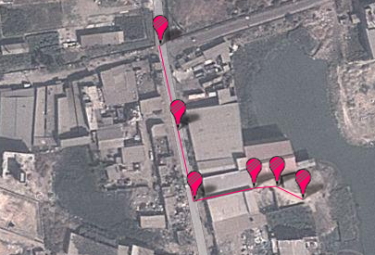

Distance from the school = 1249.08 ft

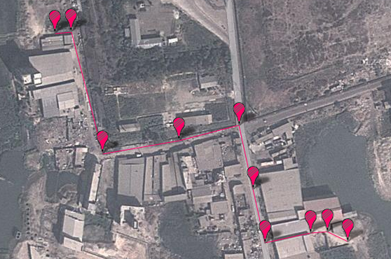

Area = 3050 sq. ft

