GENERAL INFORMATION
1. Date of Application |  |  | 11 November 2011
2. Location of Project  (Village/LGA/State) |  |  | Aaye community/Ifedore LGA/Ondo State
3. Type of Project |  |  | Cassava Food Processing Factory
4. Total dollar Amount Requested |  |  | Fourty-eight thousand dollars
5. Project Leader  Full Name (underline surname): |  |  |  | Adodo Friday
Mailing Address |  |  |  |  |  | Street Address
Liberty Spirit Foundation |  |  |  |  |  | 1, Oluwatuyi Road,
P. O. Box 477 |  |  |  |  |  | 2nd Floor Olukayode House
Akure, Ondo State. |  |  |  |  |  | Akure, Ondo State.
Telephone: | +234 803 532 6432 OR +234 808 880 6774 |  |  |  |  |  | Fax:
Address: |  | - Email libertyspiritfoundation@yahoo.co.uk  - Project Committee Members (use attached list if necessary):Name (underline surname)
Full Name |  |  |  |  | Address
Oni Tope |  |  |  |  | Project Site Officer (Builder) 1, oluwatuyi Rd, 2nd Floor, Olukayode House, Akure, Ondo State.
Aje Niyi |  |  |  |  | Project Officer/Cost manager 1, oluwatuyi Rd, 2nd Floor, Olukayode House, Akure, Ondo State.
Alabi Oladapo |  |  |  |  | Builder/Site Officer.  King Konsult Associates,1, oluwatuyi Rd, 2nd Floor, Olukayode House, Akure, Ondo State.
Iwueke Chinonye J |  |  |  |  | Architect/Studio Officer.  King Konsult Associates,1, oluwatuyi Rd, 2nd Floor, Olukayode House, Akure, Ondo State.
8. Name and address of organization or community sponsoring the project: Liberty Spirit Foundation, 1, oluwatuyi Rd, 2nd Floor, Olukayode House, Akure, Ondo State.

Project Information
9. What is the purpose of the project?
The purpose of this project is to contribute to the Millenium Development Goal Poverty Nos. 1 & 4- reducing extreme poverty and hunger among community dwellers, especially women in Aaye Community and reducing maternal mortality among them by promoting income generating activities through the establishment of a gari processing plant in the community, provide job opportunity for unemployed youths in the community and create well-know marketing avenue for their products.Cassava is in large production in Aaye and they get spoilt due to lack of access to processing facilities. Gari production is a major occupation of the women in the community. Cooperative cassava production and processing will be a boost among the women and youths folk who become idle after corn and cocoa harvesting seasons.

10. Briefly describe the project. Include a description of how the project will be managed and who will be responsible for the management. Where will the project get any technical advice or assistance it may require? Who will volunteer to assist in the project, and what are their qualifications? (Attach an additional sheet if necessary.)
Women in Ondo state, and indeed Aaye community are gravely bearing the brunt of poverty as many of them are marginalized educationally, socially and politically. Also, few have capacity to access loans because they do not have well-organized cooperative unions. These very industrious women find it very difficult to feed themselves and their children or access basic health facilities because many do not have a good means of livelihood, but are good farmers and gari producers. Moreover, they are feeble politically and slighted in decision making as a result of this menace. Liberty spirit Foundation (LISFO) has identified Income Generation Activity as a possible solution to the financial challenges of these women through small scale industrial works on available raw material, cassava.
Towards the reduction of poverty among women in Aaye, Ifedore LGA of Ondo State and the improvement of the economy of families, LISFO would help promote farming in this community by providing a cassava processing plant, an income generating project that would provide sustainable livelihood and alleviate poverty and wastage of cassava. Through this project, large-scale cassava farming and gari production would be encouraged leading to a stable family economy with which children can have access to education and better health care. This project will also ameliorate gender equality and women empowerment which will improved access of children to education,improved health status of the family especially children and consequently reduction in Maternal and child mortality.
Because women are closest to their family (both nuclear and extended), it is hoped that the success of this project would cut across extended family members, especially in women-headed homes. The intervention involves these major activities:
Advocacy visits: Advocacy visits would be paid to the community leaders (including political, religious) to implore them make gender-sensitive decisions aimed at improving the lives of women in the community.
Community mobilization: A community awareness/sensitization will follow the advocacy visits to create a need for the project intervention and raise more volunteers to actively participate in contruction work.
Construction of cassava processing plant: a cassava processing plant will be constructed to boost gari production, a major fermented food consumed in Nigeria, and the South-western part in particular.Gari Production is very promising in this geographical zone as competition is low due to the fact that there is large market always ready to consume it. Gari is eaten locally in a multi-dimensional form. For example, it can be soaked in water and eaten with cocoanuts, peanuts etc; malted with boiled water for swallow; and malted with cooked proteins such as beans and starches etc. Every Social classes enjoys gari.
The project would be managed by a committee comprising 4 LISFO staffs and the community members.
Technical assistane would be provided by King Konsult Associates, a very good friend of our organization also based in Akure, Ondo state. Already, we have about five volunteers in Aaye community who are willing to work on this project. They are also part of the Project Management committee.
11. What are the social and economic benefits of this project to the community?
The project will:
Ensure self-reliance and create job opportunities to the women in the community
Create self-employment for their sustainable livelihood and reduce vulnerable employment among women.
Provide the women groups with a cassava grinding machines to facilitate gari production
Improve the quality of gari produced in the community by making them free of stones or sands
Provide technical support in marketing their products and creating cooperative groups among the women
Develop gender relation and reduce home violence against women
Contribute to the Millenium Development Goals 4 and 5-improving the health of women and children and the reduction of maternal and infant mortality.
12. How many people will benefit from this project?
An estimate of 3500 people in Aaye community will be a major beneficiaries.
Over 100,000 people in Ondo State will benefit from the project.
13. What are the primary economic and social activities of the community?
Small scale farming such as cassava, yam, cocoa and corn farming
Petty trading
Artisans
Palm wine tapping
14. Describe all local contributions to the project, including those of other sponsoring organizations. Do not forget to include contributions of land, labor, materials, cash, or expertise.
The community will provide land to facilitate the project implementation.
15. Has any work been completed on the project? If so, what work has been done?
Advocacy visit was conducted
Feasibility study of the area was done
Comprehensive NEEDS analysis by involving the beneficiaries
Land survey layout (enclosed)
Market survey to have an estaimate of the cost of materials
16. Will weather or other activities in the community, such as holidays, harvesting, or religious ceremonies, affect the project timeline? How?
No, this proposed project would not be affected by holidays or harvesting or
religious ceremonies because the holidays/harvesting/ceremonies celebrated in
this community do not stop development activities.
17. How will the project be sustained once the small grants funding stops?
We hope to ensure community ownership of the project and ensure that the
beneficiaries of the project pay very little monthly maintenance fees out of the
Profit they make. Out of this monthly contribution, we shall encourage the expansion of
project by building more cassava processing plants in other parts of the community.
BUDGET SUMMARY $

- Construction of Factory site 20,000
- Processing Machines 18,500
- Consultancy 1,500
- Training of 4 Operators 1,000
- Commissioning Ceremony 1,000
- Admin and Personnel costs 5,200
- Generator 600
- Monitoring & Evaluation 200
TOTAL 48,000

ARCHITECTURAL DRAWING OF AAYE CASSAVA PROCESSING FACTORY
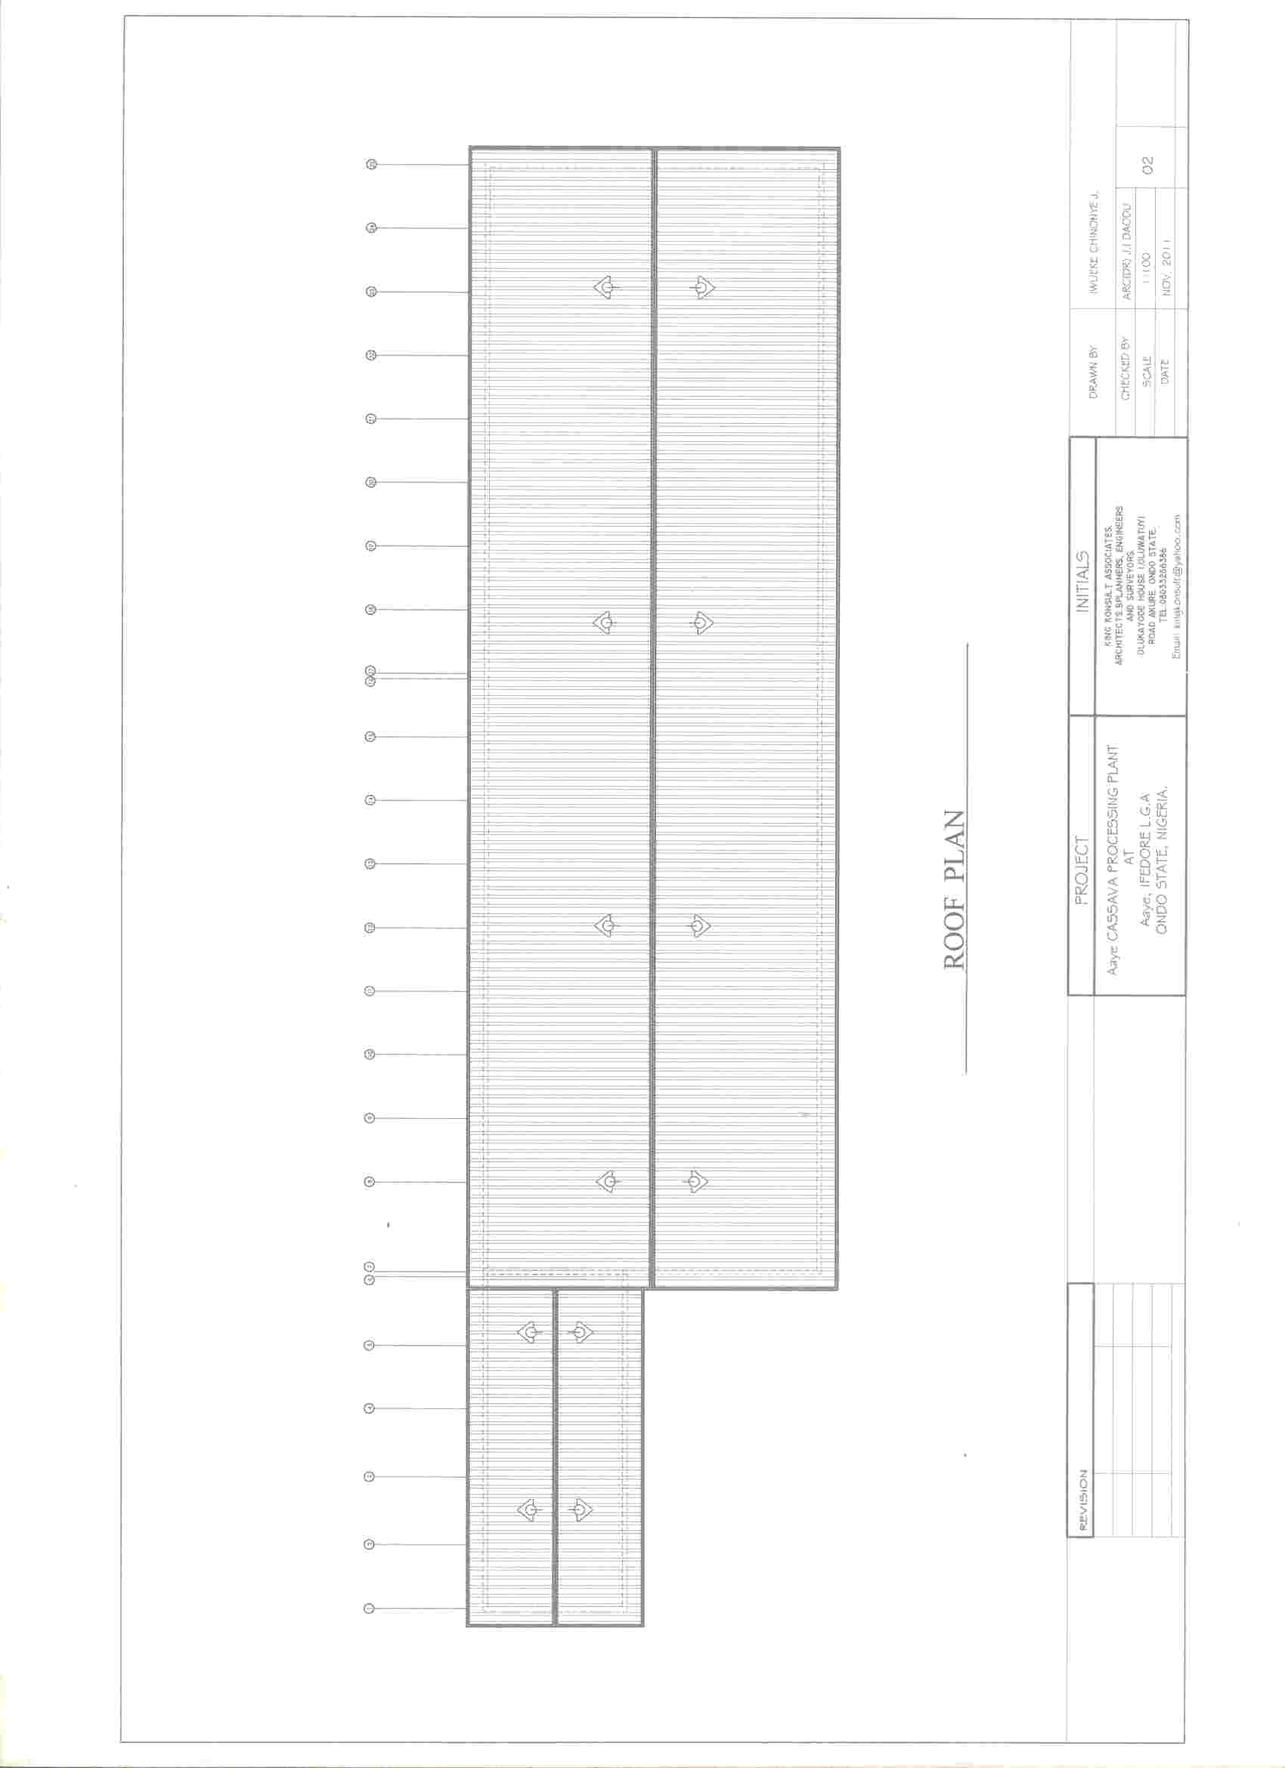
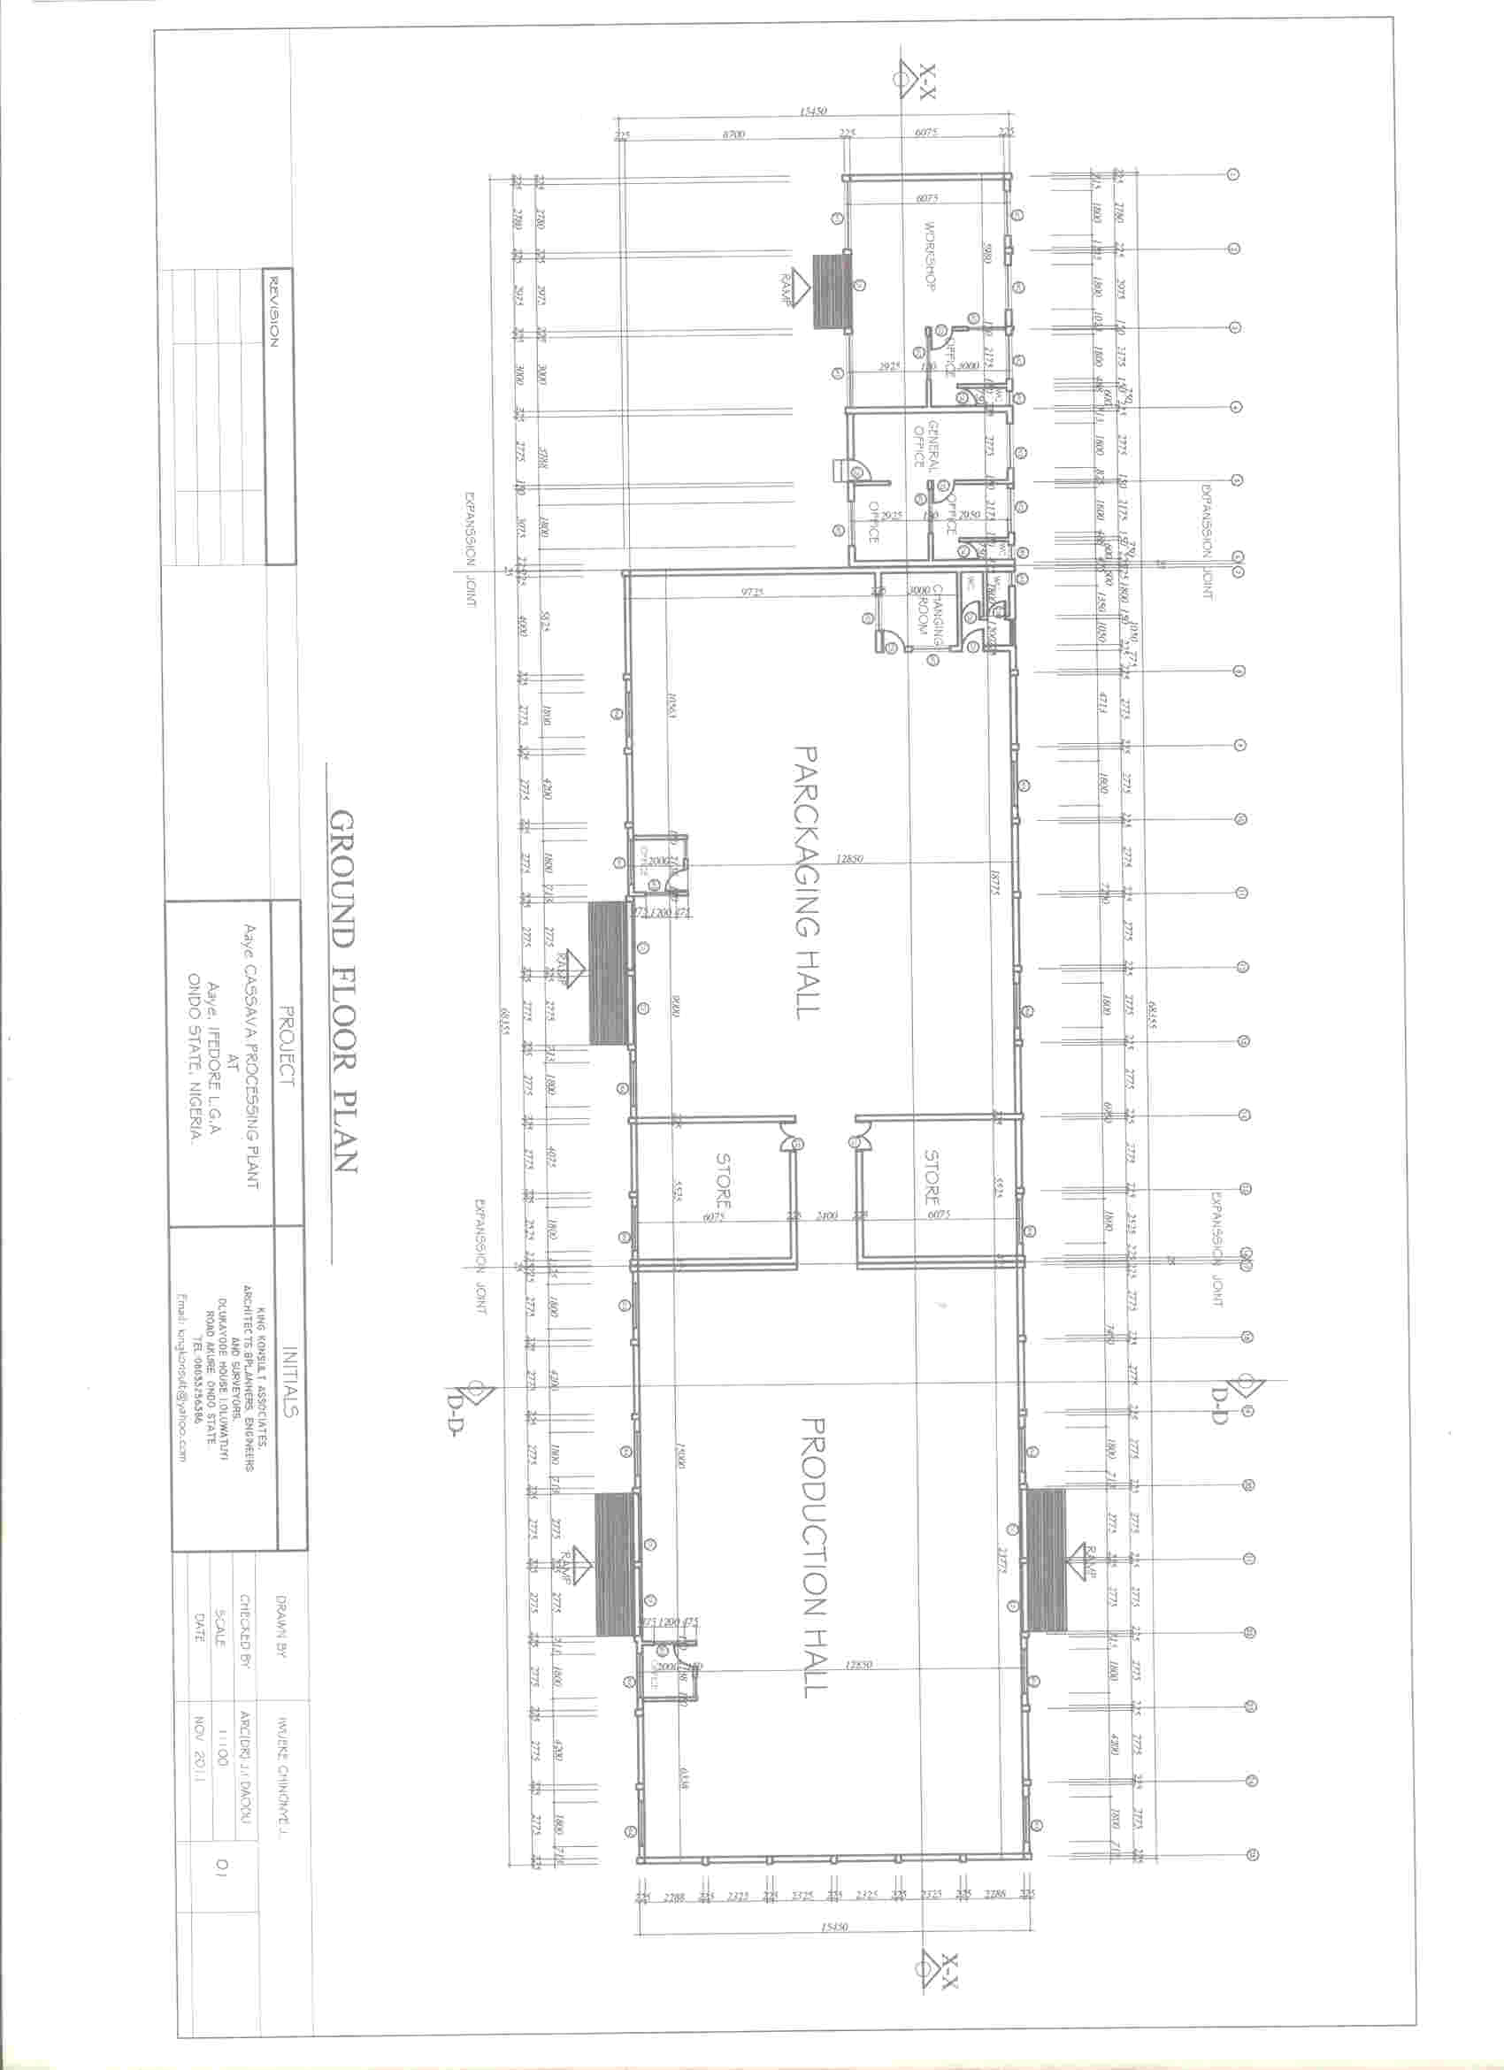
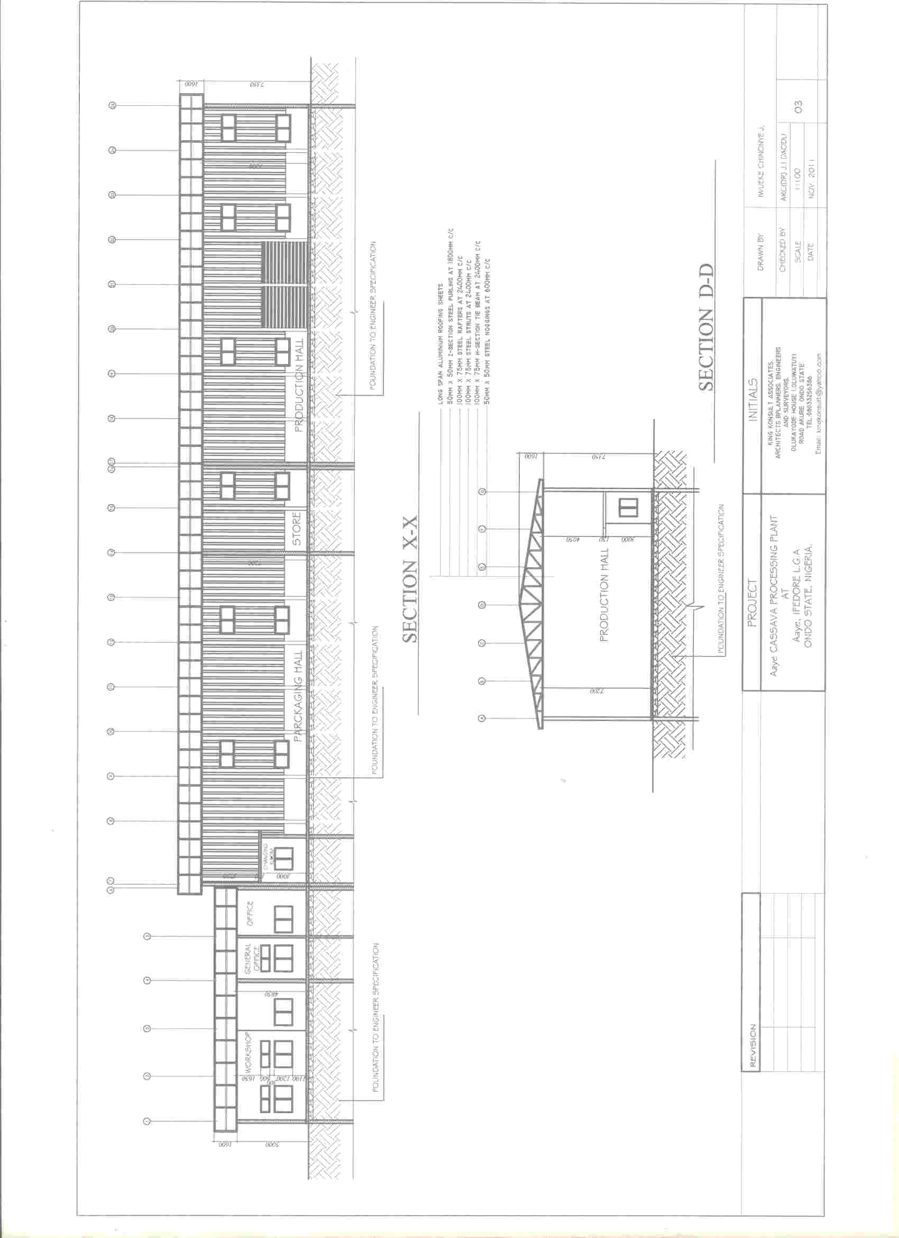
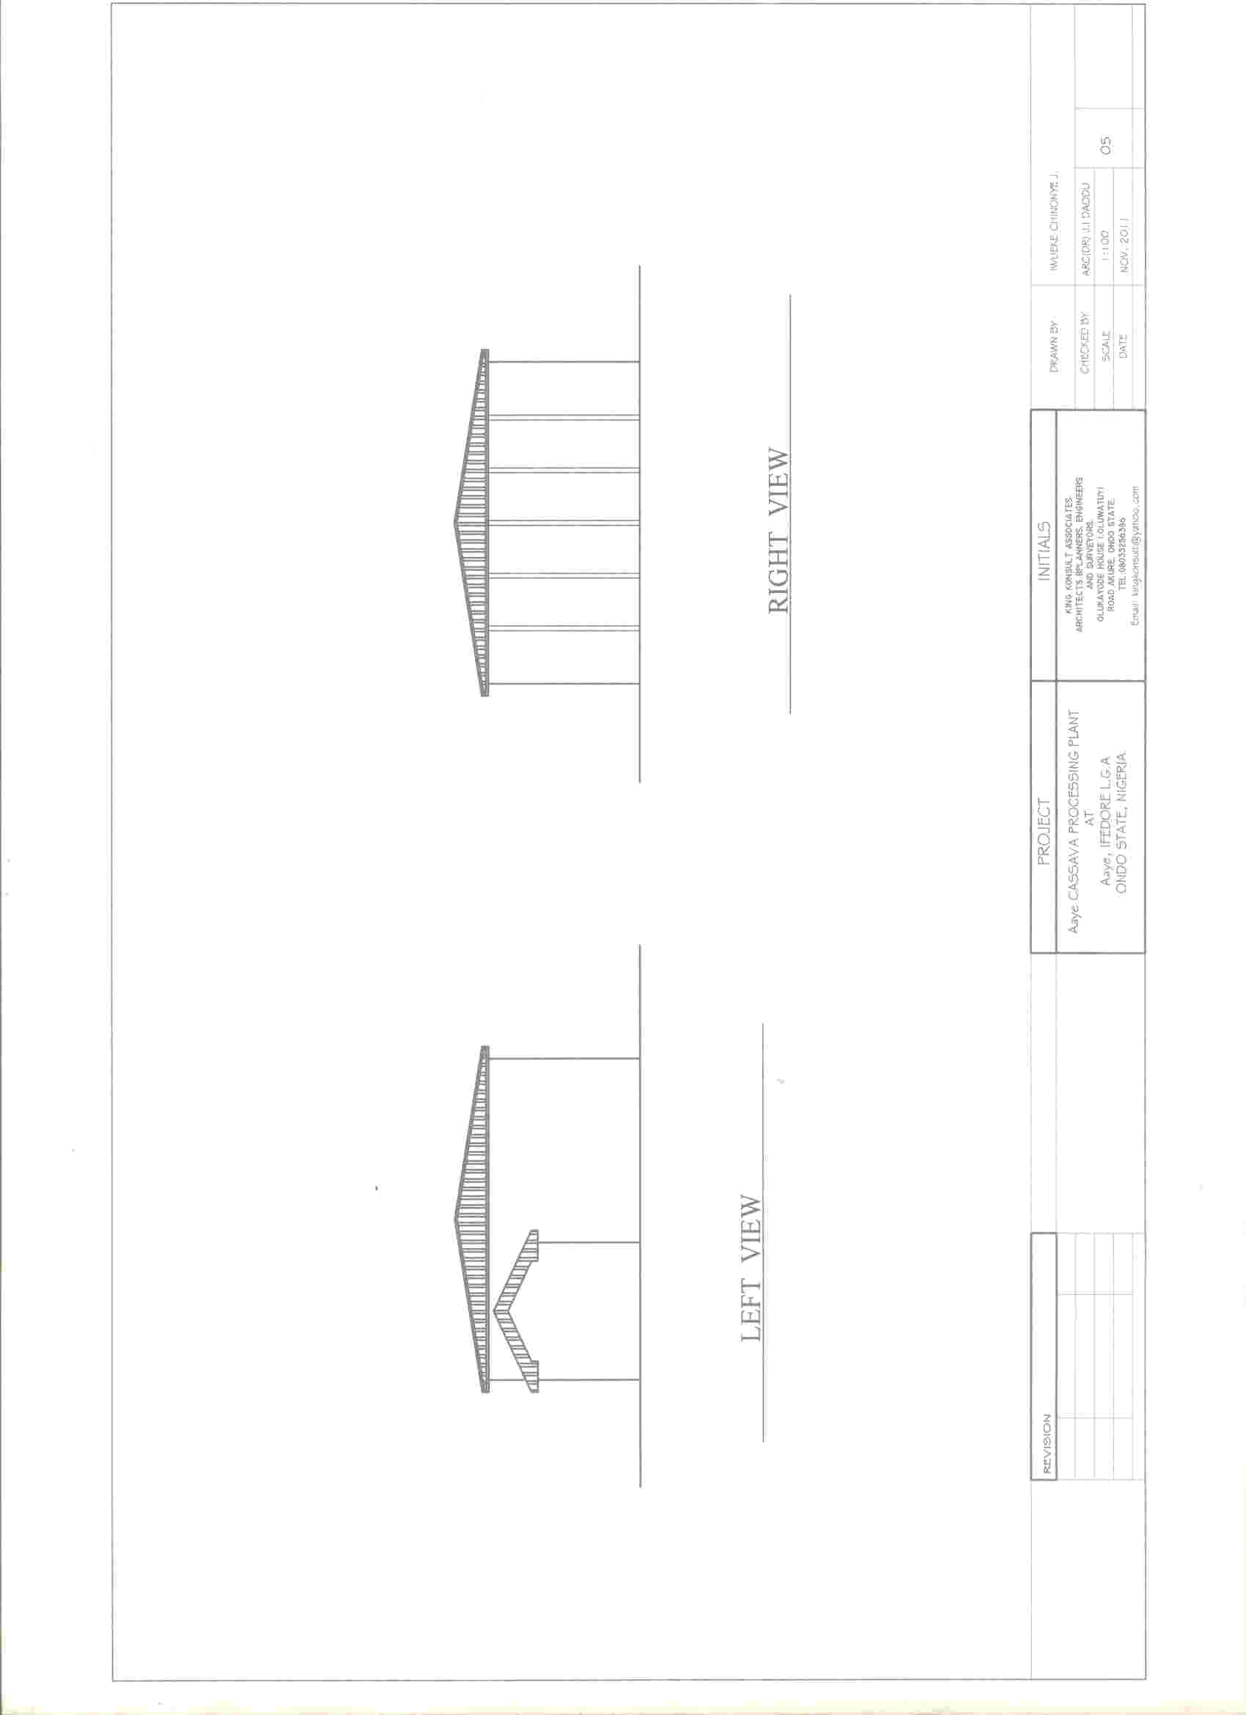
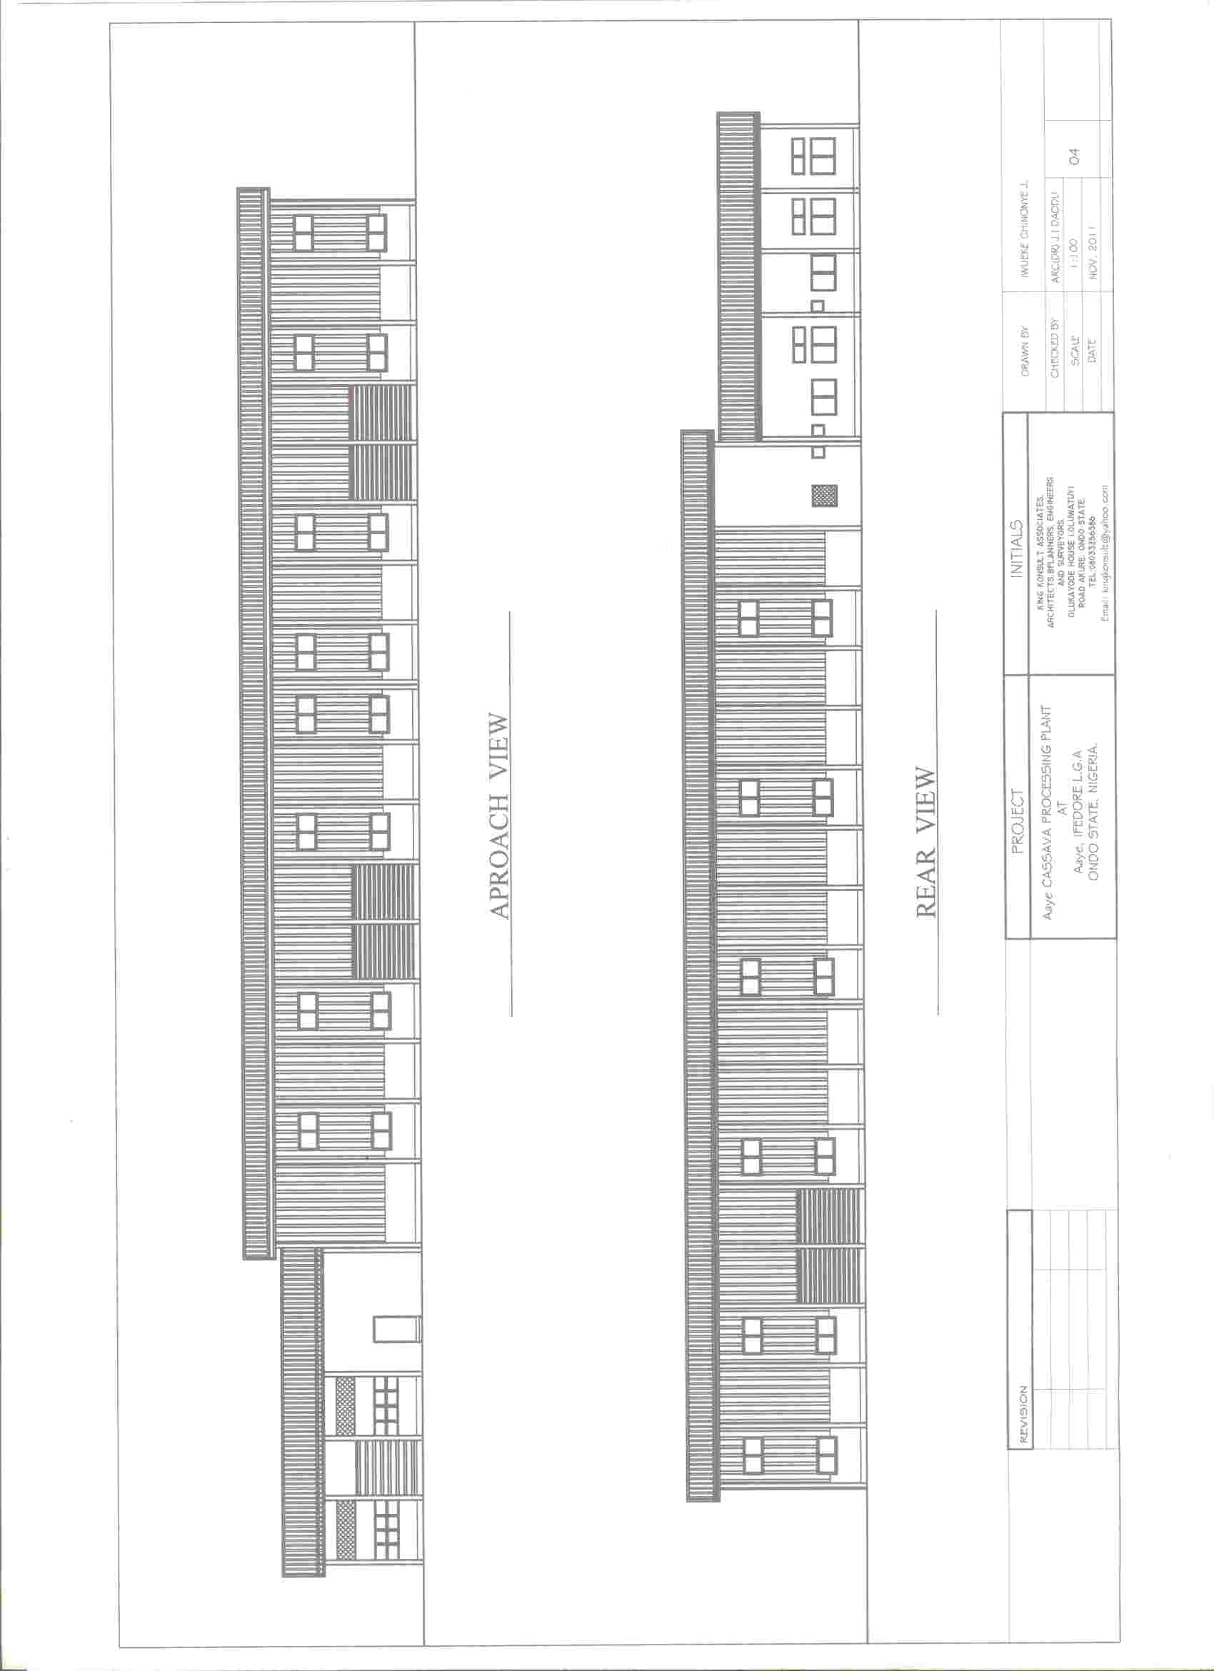
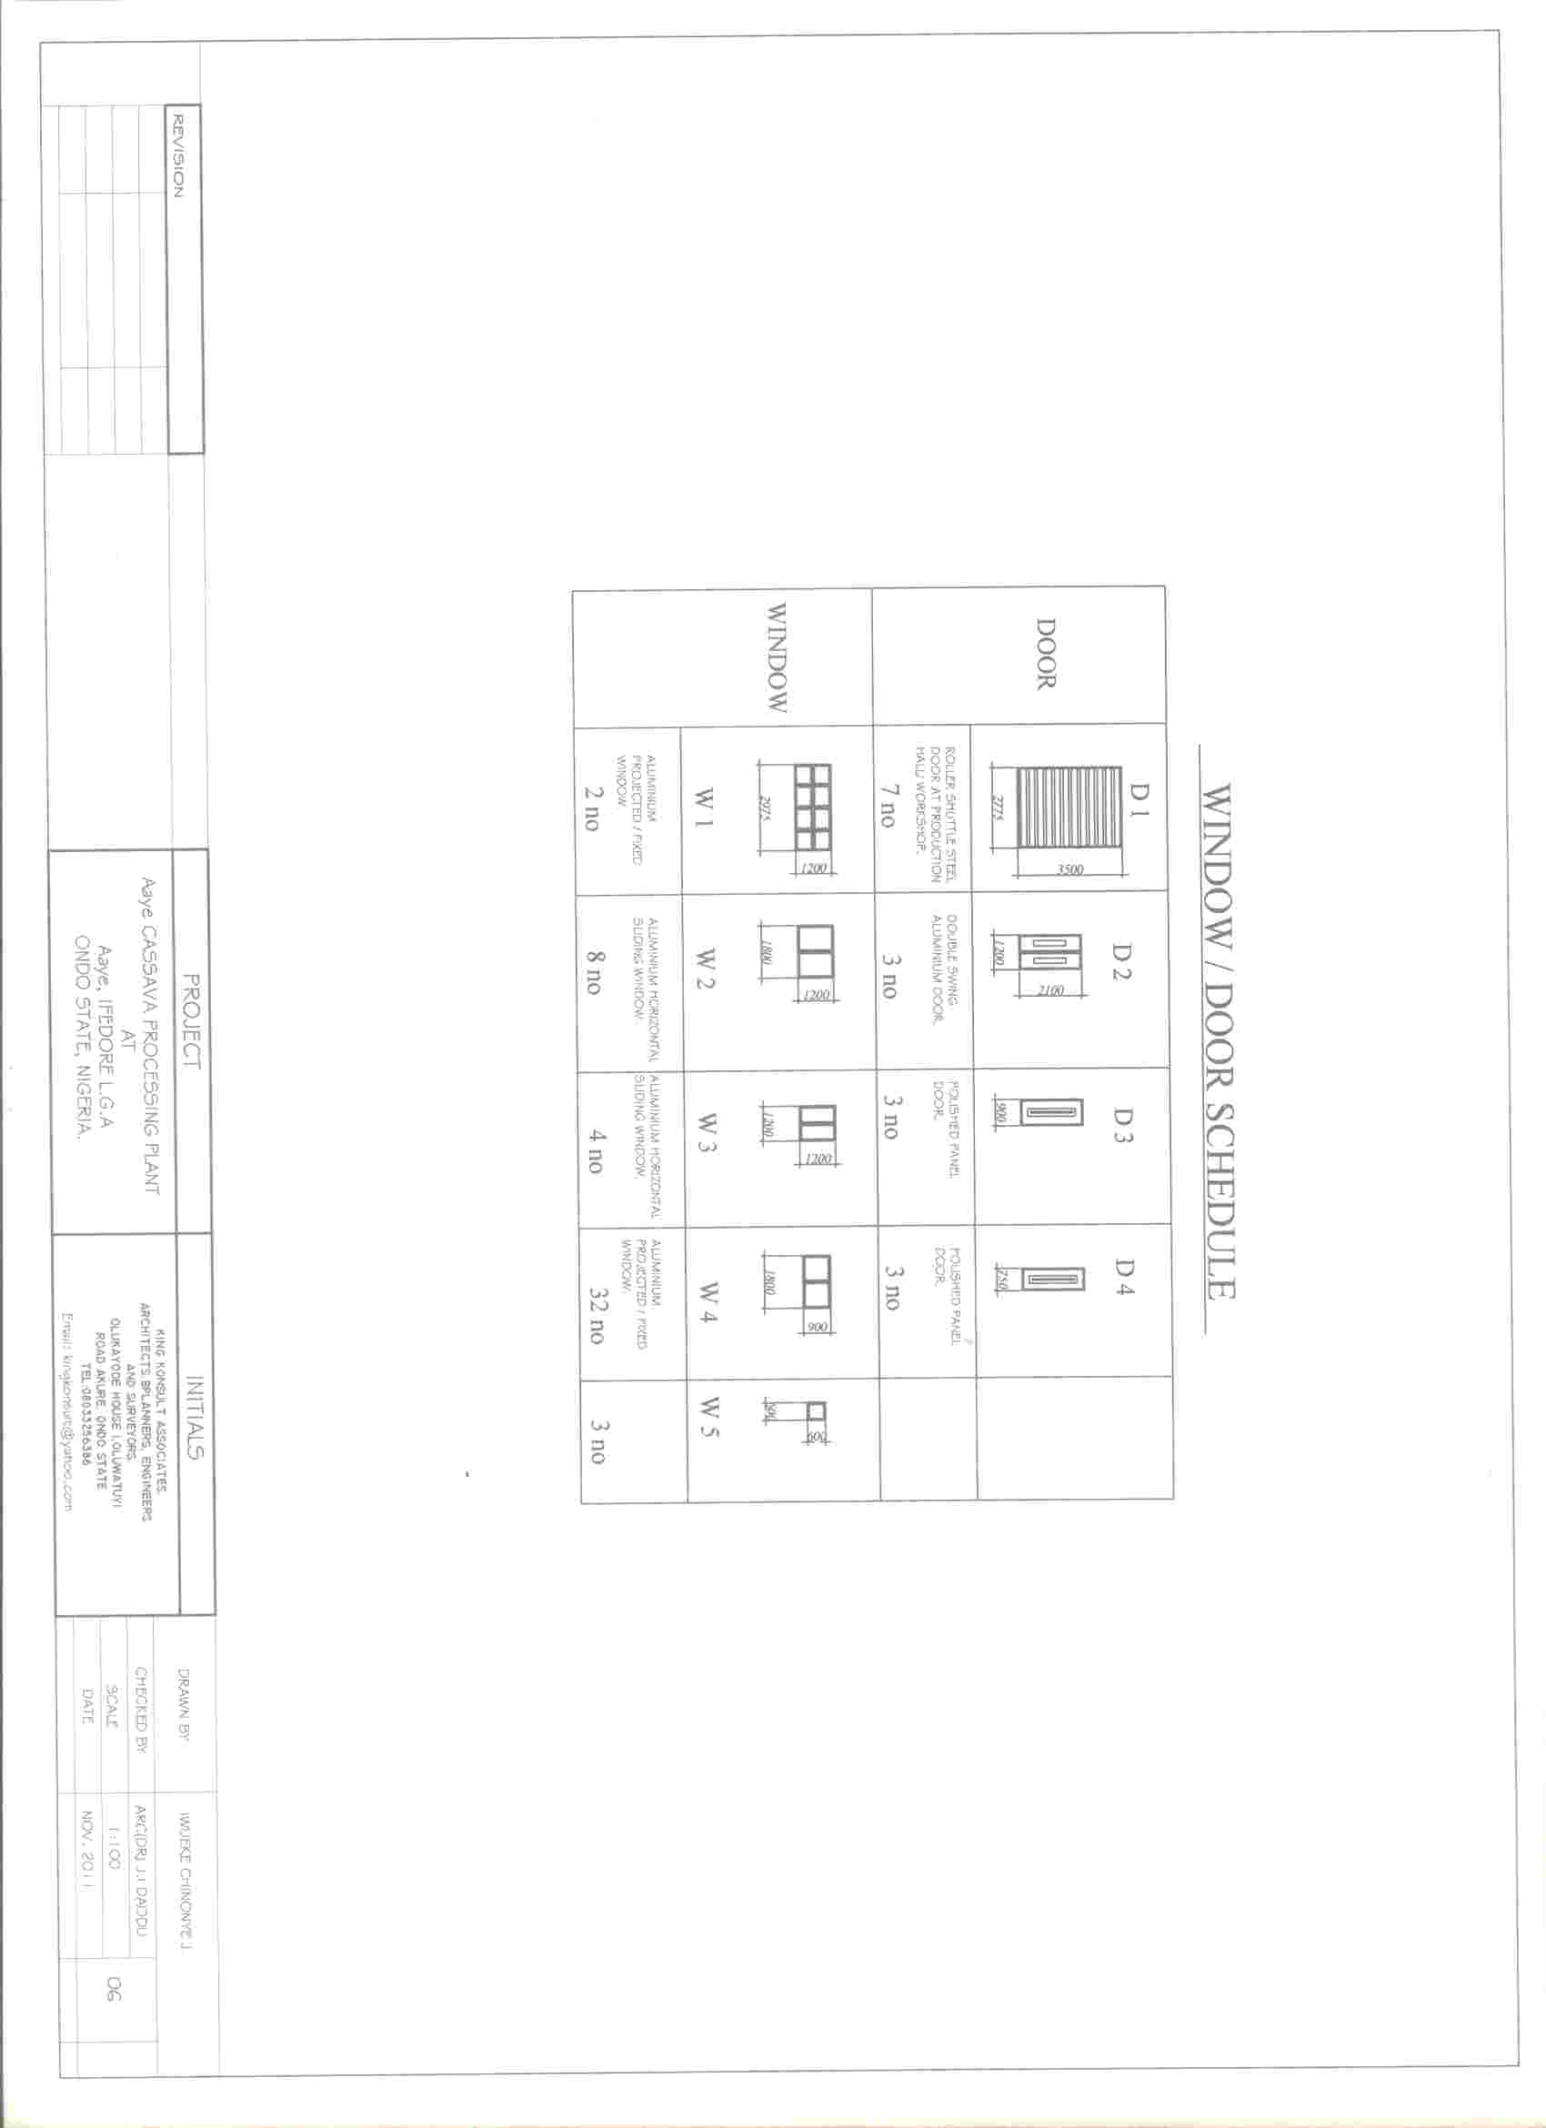

SCHEDULE OF FINISHES FOR CASSAVA FACTORY AND OFFICE BLOCK AT AAYE COMMUNITY, ONDO STATE.
 |  | FLOOR |  |  |  |  | EXTERNAL WALL |  | INTERNAL WALL |  |  | CEILING/SOFFIT |  |  | ROOFING
 | ROOM FUNCTION | 20mm insitu polished terrazzo paving Brown | 300x300mm PVC 1.6mm Nigerite Floorflex Tiles | 30mm Screeded Bed | Vitrified Tiles | 250x250mm Ceramic Tiles | Vinyl mat Emulsion(Sandtex) | Aluminium Cladding Wall | Vinyl Mat Emulsion (Sandtex) | Sandtex Gloss | 150x6mm Approved White ceramic Wall tiles | 600x600x12mm White Decoceil insulated board | Vinyl Emulsion Paint White (Sandtex) | Suspended ceiling | 0.55Aluminium Long Span Roofing Sheets
A | Office Block
 | Admin Offices
 | Reception
 | Entrance
 | Toilet
 | Workshop
B | Main factory
 | Supervisory Office
 | Store
 | Packaging Hall
 | Production Hall
 | Changing Room
 | Toilet
C | Roofing

