PROJECT PRGRESS REPORT
First and foremost, I want to take this opportunity to sincerely thank all our donors who participated during the December 2011 to support our project. Being our first time to do online fund rising we were not able to attain a permanent spot. Several many other challenges also contributed to our low performance.
Despite all these, the money that was raised has helped us to know some steps forward towards attaining our/objectives. We have managed to make some milestone steps incremental progresses we continue to make are driving us towards our goals. We believe as a group in the Kaizen principle. I wish to register with you our achievements as follows:
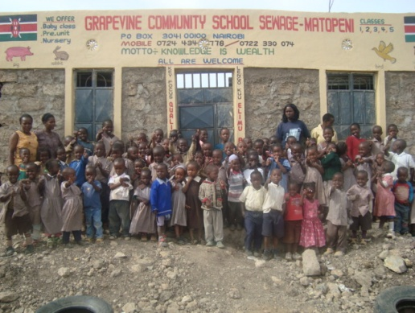
First, we were able to plaster and paint well the first wall (entrance) and make our school attractive. This new look has our parents, pupils, teachers and the community at large to be happy. They are now proud with the school and the progress that we are making.
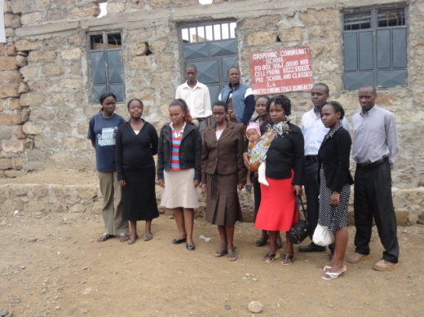
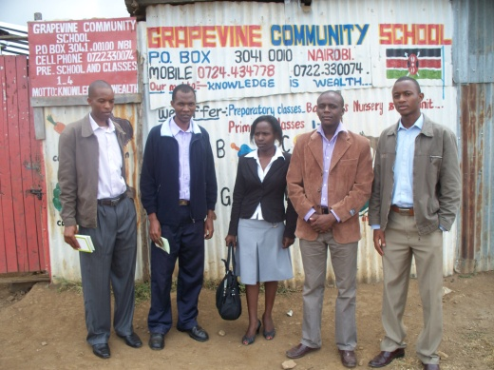

Front Wall before Front Wall after Front Wall Now
We were also able to buy desks for use by our children. This has since reduced the pupils squeezing in one desk and eased their work-especially when writing
Sections of Pupils, Now comfortable in their class
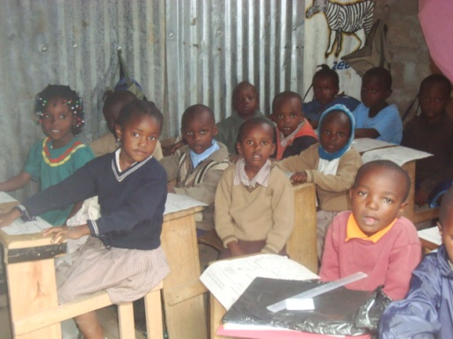
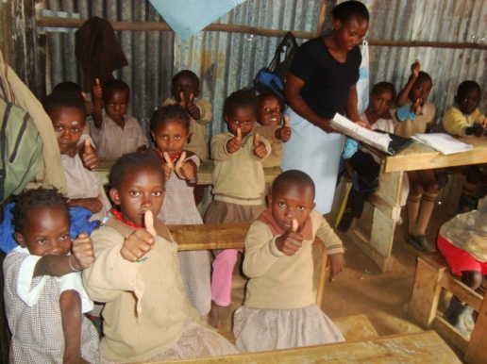
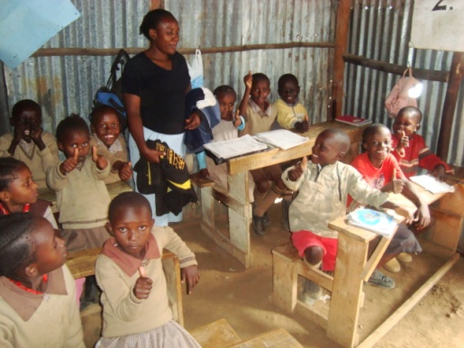

We held a meeting with the parents & members of the community in mid-Feb, after receiving the funds and we made some recommendation. We agreed to support party for the whole of these year the best girl and boy from pre-unit to class four. We based this on the last year performance. We agreed that we shall support performance and not pupils for the years to come. Parents appreciated this idea us will promote hard work among the pupils and motivate our supporters.
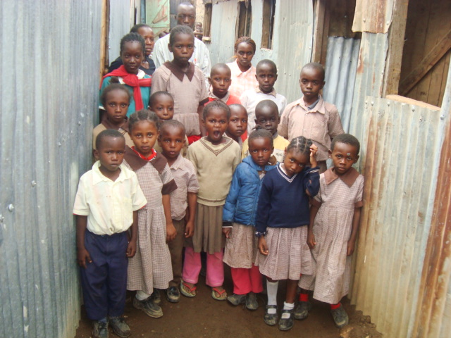
We however agreed to retain the support the very poor children we have been supporting. Most of them cannot be able to perform well due to the poor foundation from their previous institutions and many challenges at their homes. In general, we now have ten (10) pupils we support based on their performance (from last Year) and twenty (20) others due to high levels of poverty. We support all of them partially.

We plan to support five (5) pupils from each class as from next year. We shall give support to the three (3) best girls and two (2) best boys from class one onwards. Out of 157 pupils who attended school from January only 125 of them sat for the end of the Examination and here are their results (Attached)
I have put a star against the names of the pupils that we are currently supporting based on their performance from last years’ performance.
I shall be very happy to extend this help to very many other needy pupils. I hope that we shall achieve all this in the due course. It is my sincere hope that our donors in the last function and others will invite their friends relative’s workmates sand others in our next online fund raising in September this year (2012).
It is my sincere desire that we shall together make our society a safe place now and in future by educating the children and instilling in them good values.
Thank You
With Kind Regards
Josephat Nyagwaya Marwanga
Project Leader

