Hello Dear Donors,
The past three months has being a time for the beneficiaries of the KGA project to put the knowledge acquired during the six months of both practical and theoretical training into practice. In their various communities with separate focus, it has not being all about just what was identified by the girls to have potential in their communities but improvising on other initiatives to complement the activity established.
On the part of Reach Out Cameroon, it was time to continuously carry out monitoring and evaluation to ensure that girls use the micro credit established to improve on their wellbeing and that of their family and community as a whole.
A remarkable good practice that the beneficiaries projected during the past three months was that of a group spirit and willingness to continuously work as a team for the common good of the group. Noticing that some beneficiaries wanted to be recalcitrant in the team, the team leader for the beneficiaries of Tole reported a situation to Reach Out Cameroon and they were called up and coached on group dynamics by the Executive Director of Reach Out Cameroon, while encouraging them to get more girls to the group, give it a name so that Reach Out could help in its legalization and enable them benefit from government sponsored projects like the INTERGRATED SUPPORT PROGRAMME FOR INFORMAL SECTOR ACTORS- PIAASI put in place by government to move youth out of poverty, as well as the European Union Civil Society Programme- PASC of which Reach Out Cameroon is the Relay Organization for the South West Region.
In addition to the call shop business that was established for Nji Edaoune, she now roasts fresh corn and sells to complement the call box business.
The Story of Cythia Meh whose petit business was reinforced thanks to the KGA project is another visible success story of the KGA project. Situated at a very popular joint in Buea, Cythia has grown today from being a small retailer, to a supplier of doughnuts to other persons at a discount amount who also sale to make some profit for their households. Apart from this, she complements this activity with the sale of other fruits like Banana, watermelon, pineapples and oranges, employing the service of her loving mother to help her in her growing business.
The success story of the KGA project was an inspiration to yet another partner represented by Chantelle and Dylan from the Caerlon Comprehensive college in the UK who came visiting to find out how they could come in to extend and scale up the initiative so that it could benefit other underprivileged girls, widows and single mothers who could not benefit from the KGA project. The introduction of the project to the partners inspired them to support Reach Out Cameroon in producing the 2013 Calendar basically with stories of the KGA project.
We will keep you posted on the progress of our project
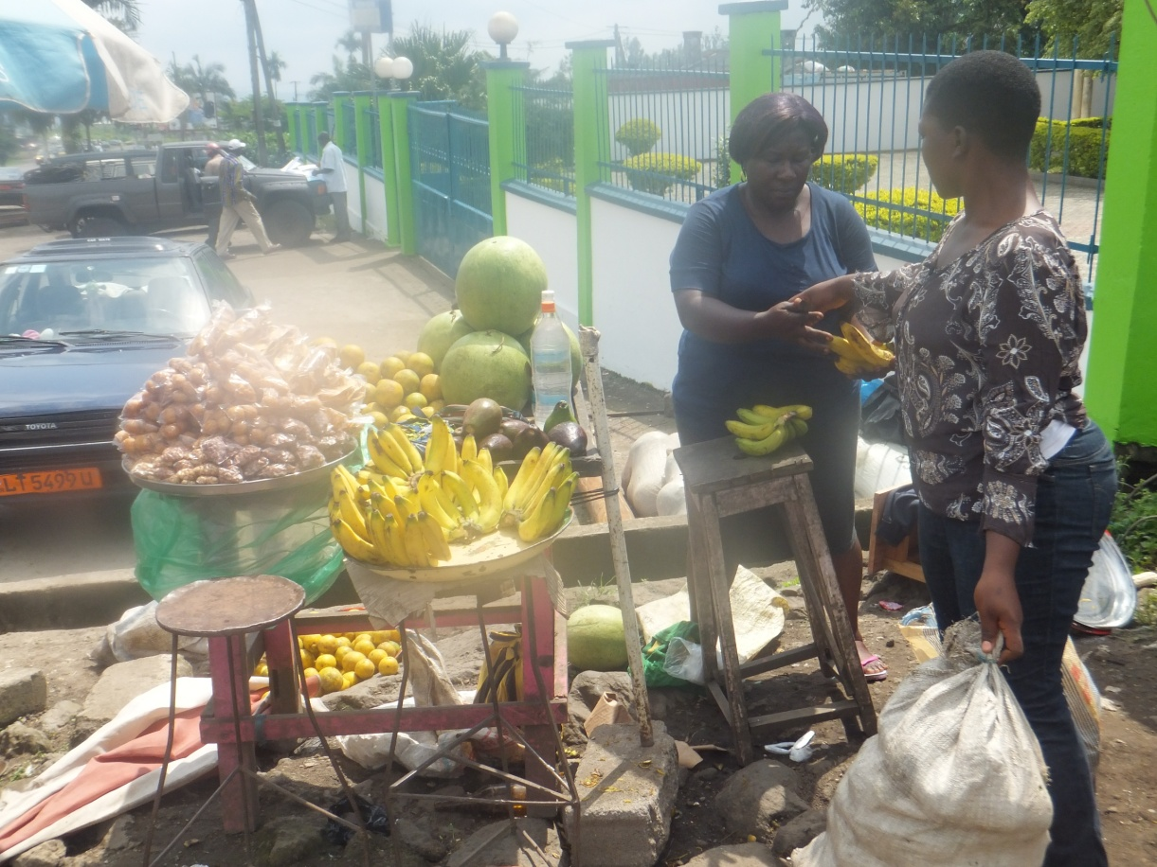
Cythia and mother at her business place (Clerks quarter Buea)

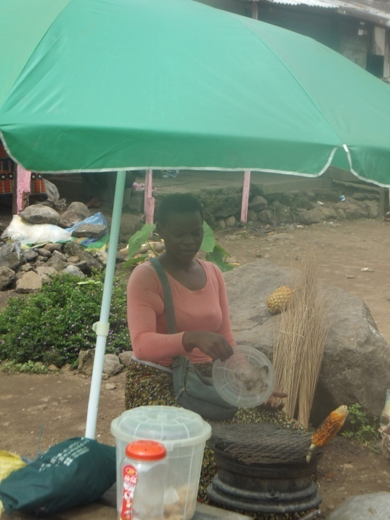
Nji Edaoaune complementing her calls box business with the roasting of fresh maize
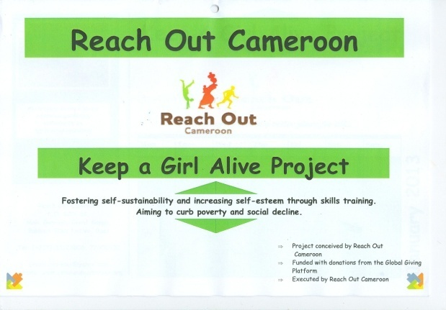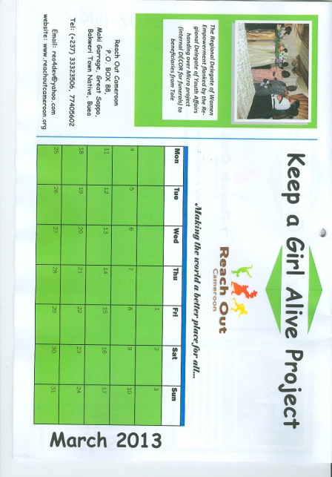
Reach Out Cameroon 2013 Calendar produced by the Caerlon Comprehensive College in the UK with the KGA story
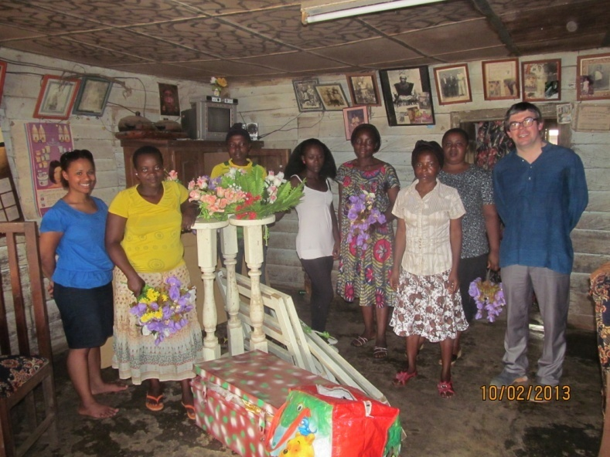
KGA beneficiaries of Tole with their micro project of internal Deco for funerals and Reach Out partners from the UK( Chantelle and Dylan

