GlobalGiving Report – December 2013

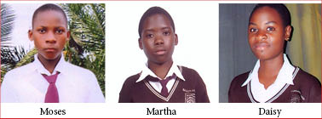

9,000 Miles to School

We hope that students from St Andrews Secondary School in Matale, Uganda will soon be making the 9,000 mile trip to visit their Sister School, Southridge High School in Beaverton, Oregon. Martha (10th grade), Daisy (10th grade), and Moses (9th grade) along with Head Teacher Sajjabbi Andrew are working steadfastly to make the visit to Beaverton a reality, and the Harambee Centre looks forward to welcoming the students to Oregon in 2014. They will live with Southridge host families during their 3-week stay and attend classes with their Southridge counterparts. As Ambassadors from St Andrews they will share news and pictures about the status of the girls’ dormitory and discuss the impact that this new building will have on the school environment.

Southridge has hosted visitors from St Andrews since 2009, and many students there have expressed how the experience of having students on campus from Uganda has forever changed them. One former Southridge student named Jessica Harn wrote about this for our recent newsletter.

Giving Back
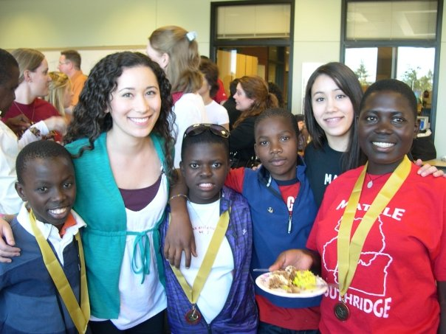
Meet Jessica Harn
Harambee Centre Intern

I first became interested in Africa when I was in elementary school, watching documentaries I could barely understand and listening to music from sub-Saharan Africa. In high school, a friend and I decided to get involved with the cultural exchange between my high school, Southridge, and St. Andrews school in Matale, Uganda (2009). We became wrapped up in the enormous task of bringing four students and a teacher from Uganda to Beaverton, succeeding with bridging the gap between two seemingly different cultures, and learning more than I will probably ever be able to describe fully. Seeing my world from their eyes and learning about a culture so physically far from what I had ever known steered me towards a life of traveling and learning about different peoples across the globe. Since graduating high school, I have studied abroad in three different countries and am now living and studying in the United Arab Emirates in the Middle East with a focus on International Relations. Being involved with the Harambee Centre changed my life in not only being connected with a different culture and people, but it also gave me a deep insight into how small but powerful organizations operate and change the community around it. The Harambee Centre changed my life and opened up dreams and possibilities, and through my internship with them this summer I hope I can give back a tiny portion of what they had given and are giving me. --
Jessica Harn

Harambee Centre & ZoomUganda

