Employment training – progress report – January 2013
Hospitality
We are in the midst of another cohort of trainees for the Hospitality course, which started 22nd October. We had 9 out of 10 students completed the months classroom training. One dropped out due to a health issue. The course leaders were very impressed with the dedication and effort of the trainees who learnt quickly and showed real interest in what they were doing.
The trainees are now on placements at various Hotels, all have been offered work. Although for some this is on a ‘’daily rate’’ of Rs800 plus food (which actually isn’t that bad) , never the less this work would not have been available to them before the training so we are thrilled that they have improved their skills and now have the confidence to seek employment.
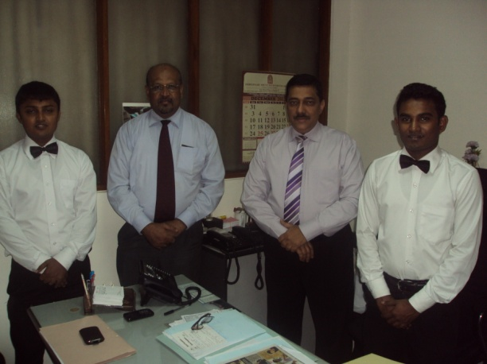
Two of the trainees, Sanjeevan and Budeema, have been working at the Shappire Hotel in Colombo for four months, they stated that they were happy in their roles and had learnt a lot. This is the first time that either have worked full-time. Sanjeevan, aged 23, has not had a job since finishing his O levels at 16. Budeema, aged 22, had only ever worker temporarily before in a shop that sells plastic items. Both appeared confident in their surroundings and proud of their achievements. They were a delight to meet!
Sanjeevan and Buddeema with Asoka (trainer)
and Ronald Perera (CEO of hotel group)

Hair and Beauty
There is also another group of 15 young women engaged in the Hair and Beauty course, which started in November. Two dropped out early on but have been replaced with others who were keen to start. All the students appeared committed and confident, and the training team have remained extremely dedicated to the programme and the students.
The trainees have completed the first month of the course at the centre in Athidiya prior to Christmas break. They came to the training salon in Colombo for the first time in December where a Christmas party was held for them by Cheryl, the proprietor of the training academy. The trainees will start attending training sessions in the academy from January. The training team are pleased with the trainees progress and commitment. They are enthusiastic and keen to learn and have developed good relationships amongst themselves and with the trainers.
Nishanthi completed the course in September she has now set up a salon in her home. She has signs up the local area which look very professional and has dressed several people for weddings. She even buys in extra help employing a fellow trainee when necessary. Her plan is to build a proper salon on land near her house once she gets approval from the local government. Prior to the course she was a housewife and had never worked.

Nishanthi‘s sign

Learning Lessons and Assessing Impact
We continue to monitor the progress of trainees and offer support where we can, although a high number of students initially got work a number have dropped out. For many regular work is a new phenomenon and rather a culture shock. Travelling into the city, the long hours, having to wait to the end of the month to receive a salary, are just some of the aspects which have taken some of the trainees by surprise.
However it is clear from having monitored the progress of those who have completed or currently undergoing employment training that although some are not in full-time work or working in other industries not directly related to the course they took, the training has had multiple benefits to those involved. For example, there has been a dramatic transformation in the hair and beauty trainees who were part of the fist cohort. The training is of course not a ‘magic solution’ to finding permanent work but has given them all a new found confidence and pride that they were able to develop a skill. In addition it has opened their eyes to a world outside their immediate community and helped them develop their own aspirations and hope for the future. This is highlighted by one of the young women who took part in the course who gave an impromptu thank you speech at the graduation ceremony. Not only would she never have dreamed of being able to speak in front of a room full of people but she was able to articulate well about how the course had opened her eyes to a life beyond what she had been living up to them. She had also felt supported by the trainers and this has clearly done wonders for her self esteem and confidence. We continue to monitor those who have taken part in the training course to look at the long-term impact of the training and how we can learn lessons for the future.
To All Our Supporters.
Lastly, Thanks to you for your donations and support. Without ordinary people like you joining in, none of this would have been possible. You really did make a difference!!

Katherine de Kretser & Stephen Bynon
January 2013

