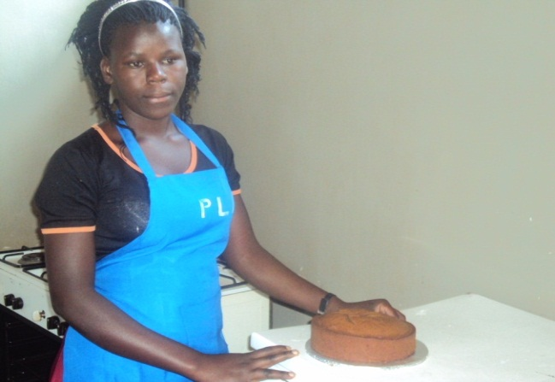
Minisa at school at Kyebando Vocation Training Centre after removing the cake from the oven she had baked

