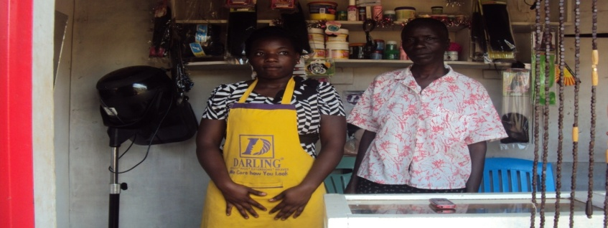
DEBORAH NAMANYI’S PHOTO

