PLATFORM FOR LABOUR ACTION
EMPOWERING COMMUNITIES TO STOP CHILD DOMESTIC WORKERS
This quarter has been very exciting for PLA and especially for the 99 former child domestic workers now in school. Identifying appropriate children required many weeks of door-to-door house visits, hours of interviews, several community awareness sessions and ongoing mediation. Ultimately, in October and November 99 vulnerable child domestic workers were withdrawn from exploitative conditions and placed at Nile Vocational Institute. Popular courses are motor vehicle mechanics with 30 children, catering with 9 children and hair dressing with 38 children, Tailoring 19 children computer 2 and Plumbing 1 child.
PLA staff members have periodically visited the students to monitor their progress, address issues and provide counseling. During these visits, a one on one interview is carried out where children are asked about their experiences at school during a private counseling session. During the identification, PLA staff came across one of the Child Domestic Worker and the following below is her story.
ATINO DOREEN DURING THE COUNSELING SESSION
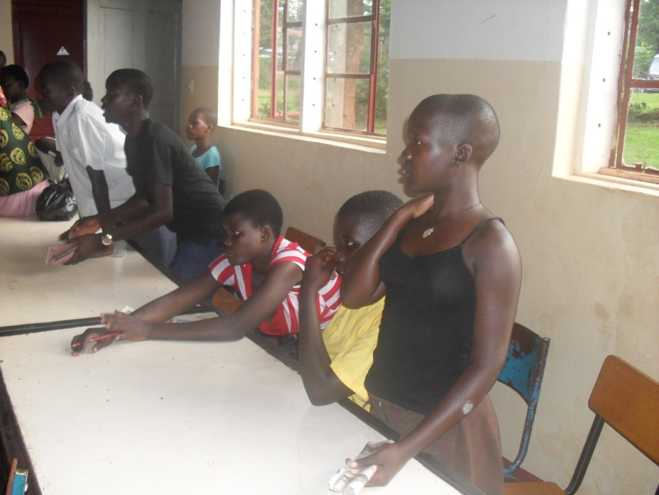

Doreen Atino is 14 years currently staying with Ms. Achen Scovia in Nsambya police barracks B coy near main road separating A and B coy next to a big tree. Initially I lived with my parents in Lira where they were paying my school fees at Amokoge primary school in P.3 although dad kept on telling me money is not enough for me to finish up school.
In 2009 Ms. Achen Scovia commonly known as maama Walter came to our home and convinced my parents to hand me to her so that I help her taking care of her young children but on condition that she will take me to school and pay school fees in Kampala because village standard was poor. This was to be a compensation of my work done at her home. Because I wanted to have better standard s of living and hearing of Kampala I was excited so i requested my parents to let me go. They later accepted me to go, that’s how I got to Nsambya police barracks. Reaching her home, I started doing work like taking care of children, washing clothes & utensils, cooking, mopping and other domestic work were all my duty. I had to accept because nothing I could do after all I came to work and my work was my school fees. But ever since I came to maama Walter, Nsambya police barracks in 2009 I have never received either formal or informal education as agreed. On top of that I have never contacted with my parents so I don’t know whether they are aware of this condition, how are they currently and I don’t know any relative this side to discuss my situation and contact my parents. My day starts at 7:00am with preparing breakfast for school going children, after I was utensils have some breakfast. At 11am, I mop the house and prepare lunch at mid day from that I pick children from school give them lunch and then bathe them. Rest a bit then wash utensils and prepare supper so that when maama Walter come back from work everything is ready. When she comes back she assigns me other domestic work up to the time I go to bed. I am the last person to go to bed because I have to ensure that everything is done and in its right position then go to bed at 11pm.
Atino Doreen was identified, withdrawn and placed at Nile Vocational by PLA and she now offering tailoring course. Doreen says she is happy with what she is now because she has time to rest and associate with fellow peers. She thanks PLA for supporting her at school because she had lost hope completely.
Right; Doreen in a black and white top preparing for netball and left, Doreen
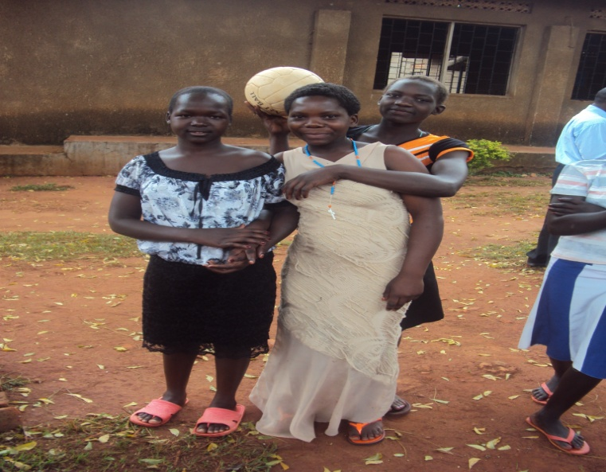
during the tour at River Nile
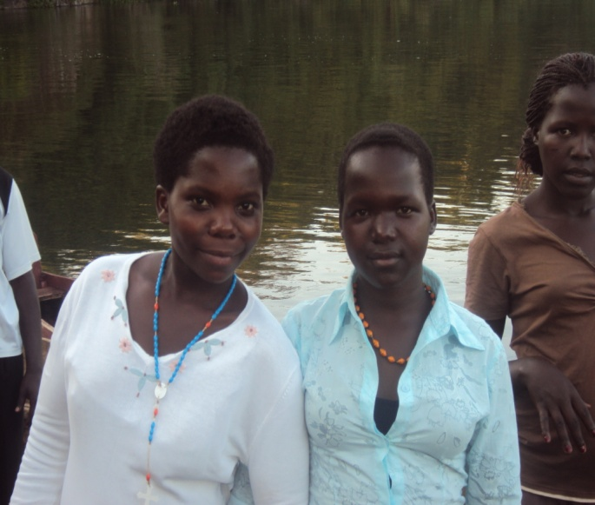

Doreen has plans of opening up a big tailoring workshop after the end of the course and to advocate for the rights of fellow Child domestic workers because she was once a victim of Child Domestic Worker.
Testimonials
“I love school because I have so much knowledge that I otherwise would not have had. The teachers are great. They really care about us.”
“When I finish school I will now be able to get a good job and help my family. I have learnt to be disciplined and to be a more productive member of society.”
“I like school because I feel secure here. I know that I will eat.”
Thank you so much PLA

