AKINGOL BETTY – A FORMER DOMESTIC WORKER AND NOW A HAIR DRESSER WHO GRADUATED FROM NILE VOCATIONAL INSTITUTE

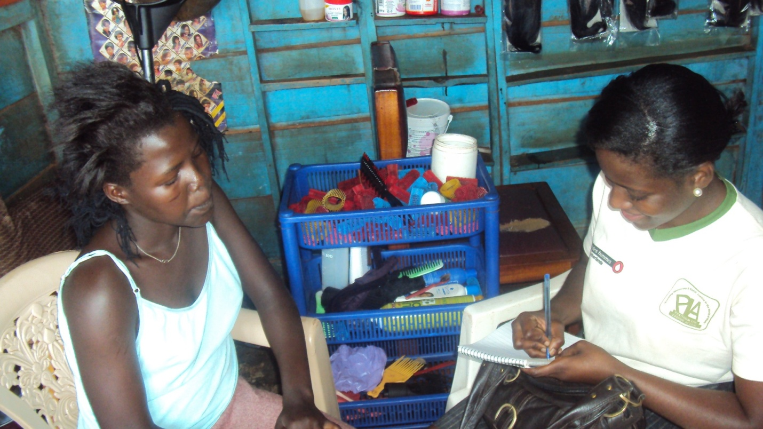

Ms.Betty Akingol aged 15 years old is a former graduate from Nile Vocational Institute Jinja who was identified in 2011 by PLA working as a domestic worker at Nsambya police barracks. Betty a former child domestic worker has three siblings with both parents but separated. Her mother is a farmer / peasant staying in Karamoja while her father stays in Jinja and works as a policeman. Betty attended school up to Primary two but since her mother could not afford supporting her, she was brought to work at Nsambya police barracks as a child domestic worker.
Fortunately, during the mapping of the child domestic workers in the area, Betty was one of the identified children who needed PLA’s support. With the help of a task force member, Betty was withdrawn and placed at Nile Vocational Institute where she took a six months course in hair dressing. After completion, Betty got a job at a task force member’s saloon in Nsambya police barracks where she is currently gainfully employed. On a good day she earns 2 USD and when the saloon is not so busy she is paid around 1 USD. During one of the recent monitoring visits done by PLA team, Betty was found busy and happy at her work place and extended her sincere thanks to PLA – (I thank PLA for with drawing me from Child domestic work, from the skills that I gained, I am now employed and in position to cater for my living materials like pads, cosmetics and clothing’s.)
Currently Betty is faced with the challenge of the saloon where she is employed not being so busy , and if a day goes by without her attending to a customer then she will not get paid since she is paid on Commission, which is calculated per customer worked on.
Betty is looking for a better job that can pay her better so that she can be able to help out her siblings in the village as well. The one dollar she earns helps her in catering for her living materials as a young girl like buying pads, cosmetics and clothing’s which she was not able to do before acquiring the hair dressing skills.

