From unpaid domestic work to a fulfilling hairdressing job
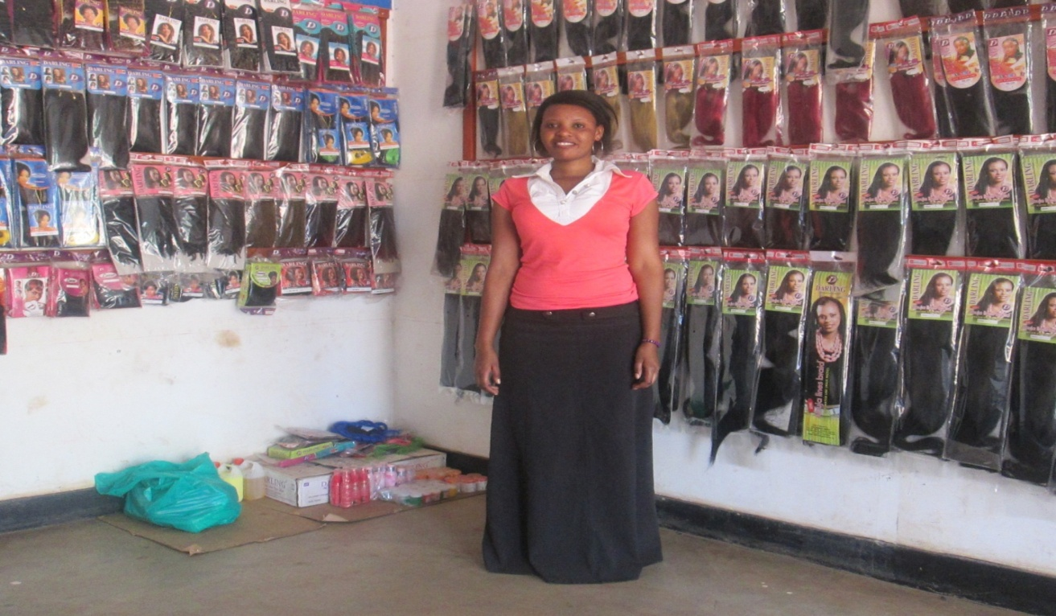
Nakintu is 17 year old girl who graduated in hair dressing from Nile Vocational Institute Jinja in March 2013. She is a former child domestic worker at Nsambya police barracks who was identified by PLA during the 2012 door to door annual mapping exercise. Nakintu has five siblings and her mother was widowed and she struggled bring up her seven children single handed.
Her mother a peasant farmer could not afford supporting her since her father passed away during her P.7. After completing primary school, she could not continue with her secondary education. In 2009, her elder sister got her a domestic work job in Kazo - Bwaise a Kampala suburb, where she was promised a monthly payment of UGX 20,000/=(Twenty Thousand) Ugandan shillings equivalent to 8 dollars, she worked there for two years and received payment for only three months. In 2011 she left her job and joined her brother who was working in Nsambya barracks. At her brother’s place she was doing housework and was paid in kind where beddings, food and clothing were availed to her. According to Nakintu working for a stranger without pay was better off working for a relative (her brother) who was giving her better treatment.
With the help of a task force member, PLA rescued her and placed her at Nile Vocational Institute Jinja in July 2012 where she took a six months course in hair dressing. After completion, In May 2013 Nakintu got a job as whole sale seller of women’s hair pieces. At her place of work she also plaits ladies’ hair, she further says that she rates the customer depending on the hair style ranging from (10,000/= to 20,000/= UGX) equivalent to 4 to 8 USD and the money got out of this is shared together with her employer. She is paid on a weekly basis between (20,000/= - 30,000/= UGX) equivalent to 8 to 12 dollars), depending on the profit gained. She also gets a working benefit of housing where her employer pays for her accommodation.
During our two Monitoring visits, we realized that she has a decent work place as well as good accommodation. Nakintu expresses her sincere appreciation to PLA- (I thank PLA for giving me a future; I am now in position to stand as a woman and support my poor mother , before acquiring the hair dressing skill, I was not able to do so)
Nakintu is currently faced with the challenge of a few customers since she is still new in the area, she further defends it by saying that through the entrepreneurship skills that she acquired, she says that she plaits customers at a reduced cost so as to attract more and with such a strategy she believes more customers will come up. She commends her boss for allowing her to plait ladies to add on her take home and with this she has been able to save something and send to her mother, who uses some and saves the rest for her.
In future Nakintu believes that her working station will turn into a big saloon since her employer promised to buy the necessary hair dressing tools to improve her workplace and she believes that this will attract more customers, which will expand her services thus increasing on what With this she will be able to cater for her own accommodation by paying rent elsewhere unlike to date where she stays at her workplace.

