Photographs
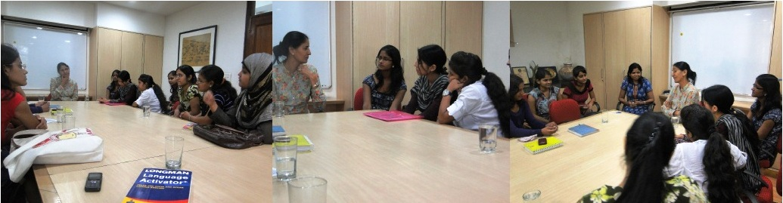
Meet With Fellows in Udayan Care’s Office
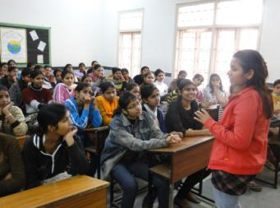
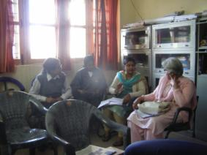
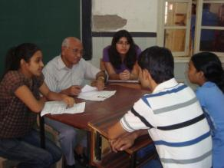
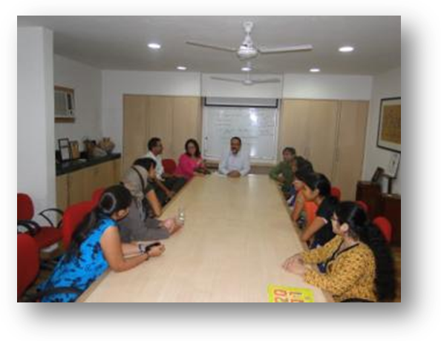
Workshop With Fellows Mentor Didi & Mentor Meet in Progress
Final Interview of Short Listed Fellows Mentees’ meets with Mentor

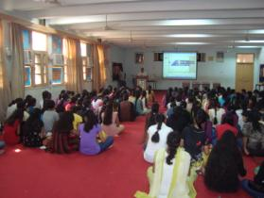
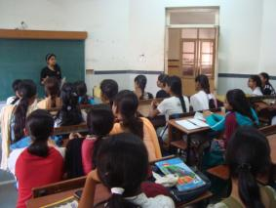
Small Group Workshop is in Progress A Glimpse of Quarterly Workshop
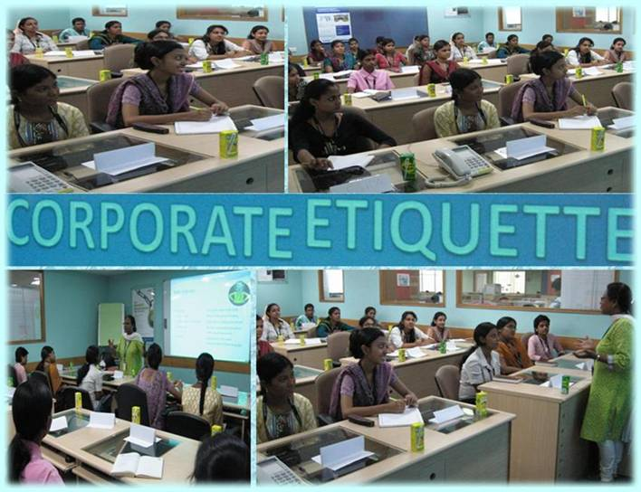
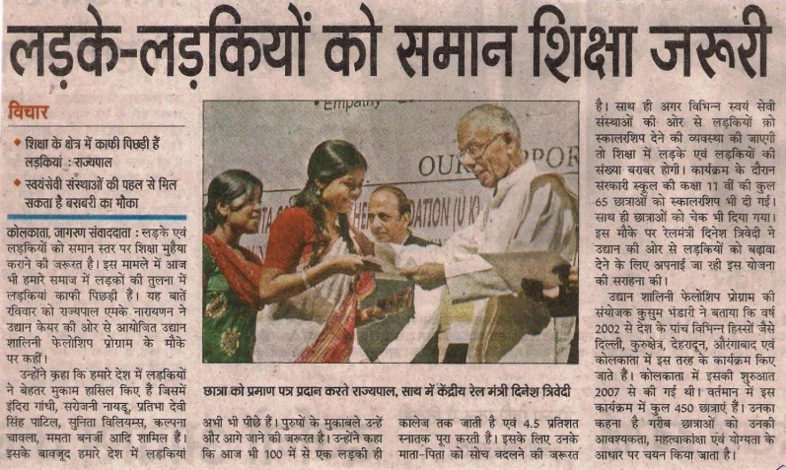

Small Group Workshop in Progress at
Genpact Office Kolkata
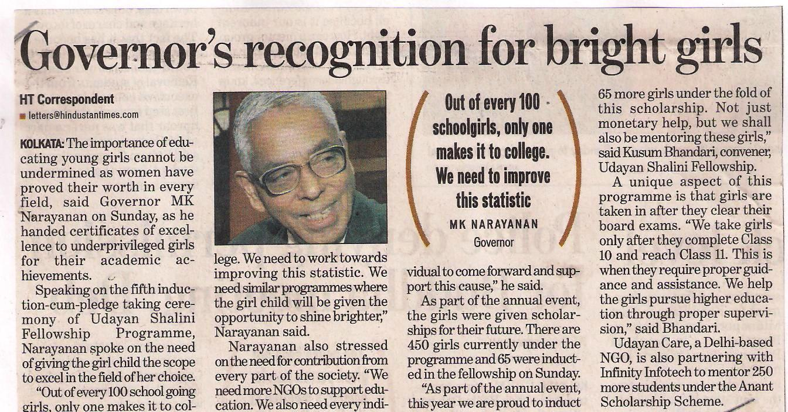

New Induction in Kolkata 2012

