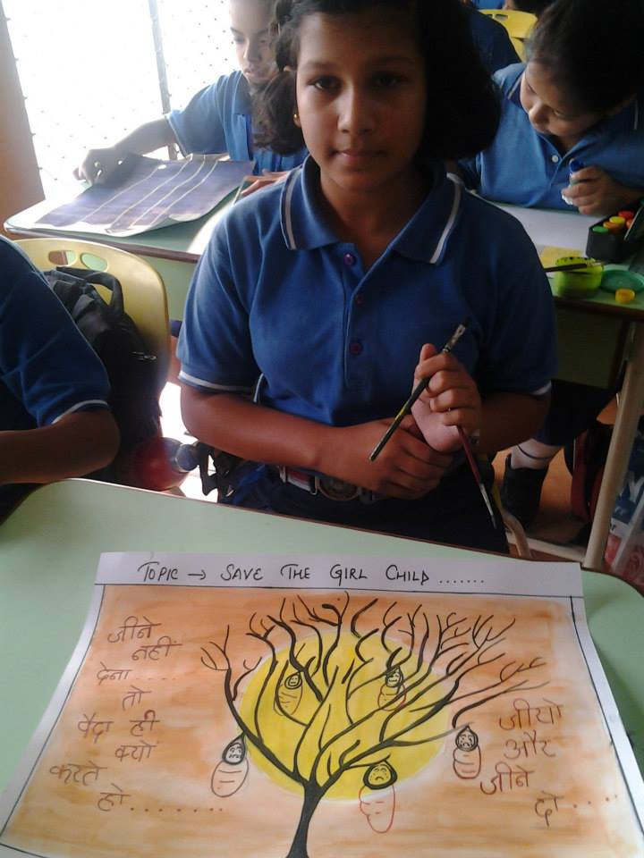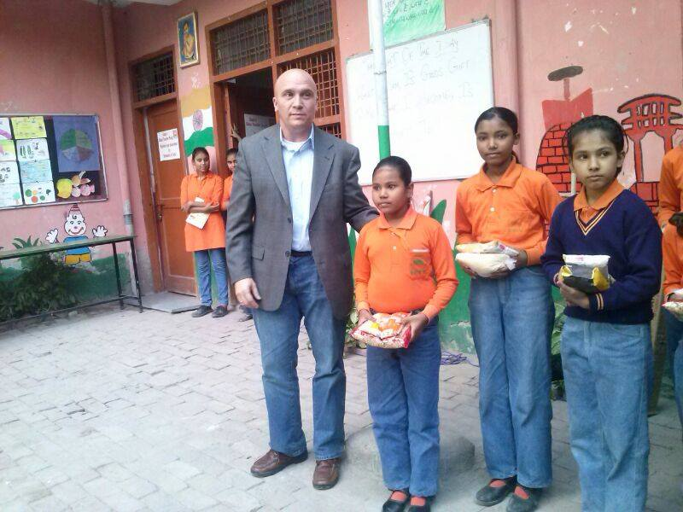

A beautiful drawing by a girl at Mayoor School Noida

Mr. Russell giving awards to our students.

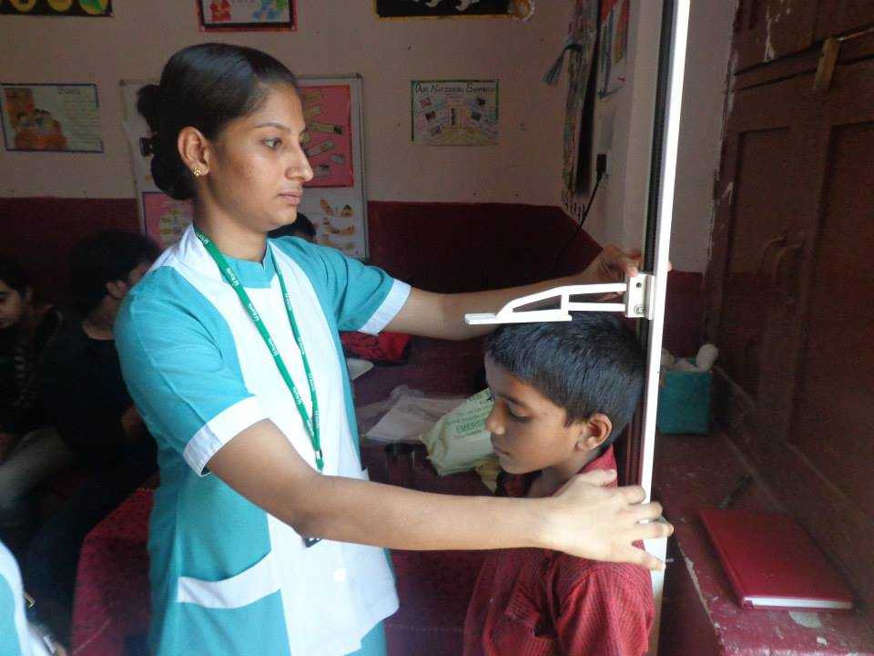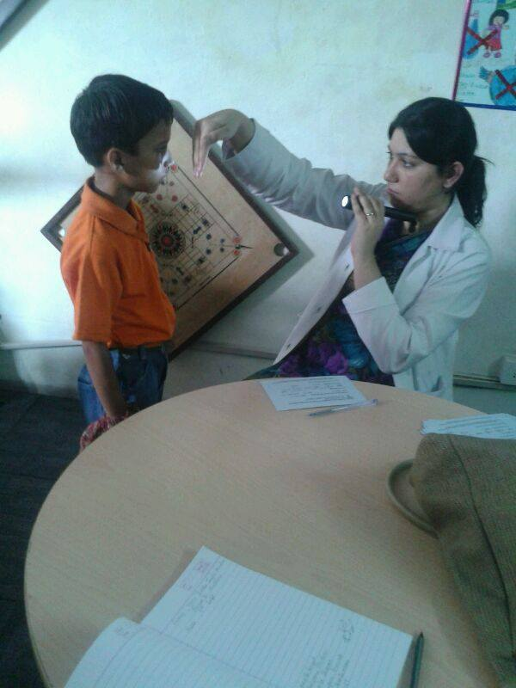

Healthy Life Happy Life

Eye Check up Camp at SETU