Global Giving
Progress Report9 for the Period Jan to Mar'2014.
Narratives :
The Right of Children to Free and Compulsory Education (RTE) Act, 2009, which represents the consequential legislation envisaged under Article 21-A, means that every child has a right to full time elementary education of satisfactory and equitable quality in a formal school which satisfies certain essential norms and standards. Ruchika also believes that the most basic education instills a sense of confidence, purpose and insight that is necessary for successful and productive participation in any society without which the children and adult lack the ability to adequately support themselves in a legitimate profession or trade and thus often fall prey to all forms of exploitation, corruption and abuse.

In response to the growing and apparently formidable challenges faced by the children on the street and of the city slums, Ruchika started an innovative fun school program viz. “Platform school” in April 1985. Presently the organization reaches out to over 7,000 children and their indigent families in about 150 slums of Bhubaneswar and 11 major railway hubs of Odisha with multifarious programs. Through a diverse and large variety of educational innovations, the organization has dedicated itself to the ideal that: “If the child cannot come to the school, then the school must go to the child”.
In response to the growing rate of drop outs from the formal school system Ruchika started Remedial Education program in 2009. Presently it reaches out to 4000 children with 105 primary and 67 elementary remedial education centers spread across 105 slums of Bhubaneswar.
- Accomplishments, Challenges & Learning on the Project:
Accomplishments | Challenges | Learning
- Describe key tasks and project activities completed and provide supporting information, | - Outline any challenges you are facing that may limit the expected impact of the project. | - Identify any “best practice” methodologies that have been developed from this project, especially those that may be used for other projects.  - Lessons learned on administrative systems and project activities should be included.  - Describe efforts to continue project activities after grant is complete.
- Enrolled over 90 % into the government school as per the mandate in RTE Act  - Conducted Common Assessment Test- end line test by Education initiative , Bangalore  - Conducted all competency tests of all the classes.  - Continuing medical Program.  - A series of teachers training program was conducted (20 days) In addition monthly meeting with the teachers were conducted separately.  - Adopted worksheet method in the schools.  - Inducted new methods in the classrooms like – creating stories, clay work, paper work, science work.  - Continued Education with friendship methods  - Continued nature observation and analysis with inter action.  - A total number of 68 community meetings have been conducted.  - Meetings organized at all Basti Education Committee.  - 7 Balak Mandols, 7 Balika Mandols, 2 Youth groups, 3 Library Committees and 7 Mahila Sikshya Mandols have been formed in the community. They are trained and educated on RTE to demand quality education for the children.  - A special meeting was conducted with 50 government officials including District Project Coordinator (SSA), DI of Schools, Block Resource Persons and Cluster Resource Persons. Plan made for future action for collaboration.  - Cultural meet was conducted at 7 places. Children from 30 remedial centres participated in the meet. This talent search programs were done in collaboration with the community. | 1. There were some reservations in the community and in the school for enrollment of students into the schools. We had to continuously counsel the parents, students and school teachers to overcome it.  3. We have only one doctor conducts health check ups. Due to scarcity of allopathic practitioners we do not find the second doctor. We have started monthly medical checkup for the students.  4. Govt. has followed our porgaramme. In month of July- August -2013, All the Govt. Primary School have imparted special remedial coaching (Named: SAHAJA). In fact it was not a successful programme but it dialed the regular teaching plan which started in Sept. 2013.  6. It has been noticed that some non-starters and late starters have been admitted into the school in their age appropriate classes. They require intensive and special coaching to make up and be at par with their counter parts. This is not followed in the regular schools.  7. Govt. officials have got stereotype mind set. Difficult for them to collaborate with NGOs. However there are some good education officers who are found very cooperative.  8. Difficult to retain the street children and children of nomadic tribes in the school.  9. Govt. officials have no experience in rescue operation and counseling the children. As a result there was a huge drop out of children after rescue operation of marginalized children. | - Every child has to go to the school as it is their rights. But school teachers need to be sensitized to educate the children in a right based approach not in a welfare approach.  - Friendship education strategy facilitates learning at a faster rate, creates interest and develop creativity among students. Training has been imparted to all the teachers on the same  - Learning through nature observation makes the life of the students interesting and facilitates the children to establish their contact with the environment. It also helps them to imagine and be creative.  - Teaching through competencies gives a better result. The work-sheets assessment helps the teacher to understand the level of academic proficiency of the students and plan for improvement.  - Different programs like Science Exhibitions, Inter school sports & Cultural Programme give the students opportunities to express their latent talents.  - Necessary to collaborate with District SSA to bring a change in the education system in the district.  - Govt. officials need support to conduct rescue operation.

Rajashree a distinguished little scientist:
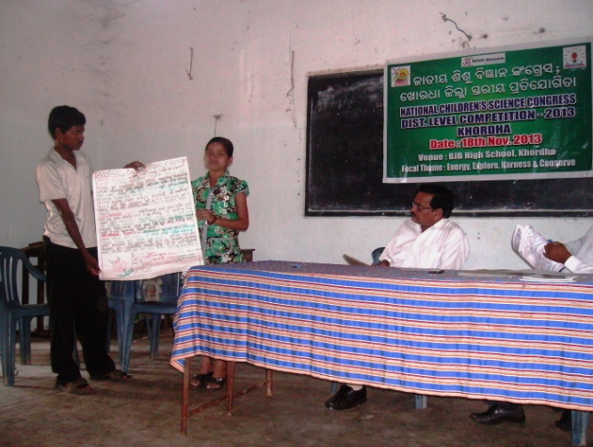
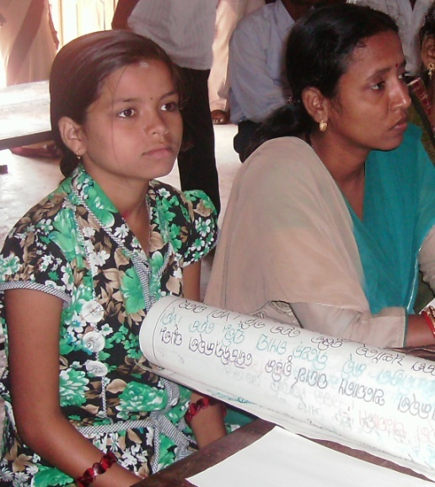
In the word of Rajashree a girl studying in class 7th “I live in a slum of Bhubaneswar established in the base of urban waste, dumping yards and always feel suffocated & have a dream to build an eco-friendly environment by proper utilization of wastages. This promotes me to see a dream to become an Environmental scientist in my life. When I got a inspiration to demonstrate my project while studying in Ruchika Remedial Education Centre. I had prepared a model on proper utilization of waste output of urban community, and my project was exhibited in the Ruchika Science Exhibition program and was selected as one of the best model by the jury of National Children’s Science Congress, Govt. of Odisha. I am so glad to present my model in the 21st National Children’s Science Congress, Khordha Dist. Level competition and would like to thank Ruchika & its supporters for building the first ladder of my dream in the future- to be an Environmental Scientist”
Rajashree with her guide
Visual: Miss. Rajashree presenting her model in front of the Juries of 21st National Children’s Science Congress
Thanks:
We sincerely express our heartfelt gratitude to our supporters for their magnanimous gesture towards the children living in oppressed and deprived of their minimum basic rights to go to school .

