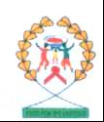
BREAD without BORDER ORPHANS SUPPORT PROJECT
Kick Building, 1st Floor, Door 2, Opposite Winam Court
P.O. BOX 7060-40100 KISUMU - KENYA TEL: +254 733959031 / +254 721414826.
E-mail: bodalessbread@yahoo.com

BACKGROUND INFORMATION:
Bread without Borders Orphans Support Project is anon profit community based organization
Registered with the ministry of Gender, Sports, Culture and Social Services in the Kisumu East District bearing certificate number S/H no 13407. The project was founded in the year 2002 and was officially registered in May 2007.

Bread is currently based at Kick building, 2nd block 1st floor, door 2, opposite Winam Court along Ramogi Road.

FORMATION BACKGROUND:

Kisumu City is rated as one of the large cities in Kenya with a population of over 800,000 people. Located along the shows of Lake Victoria; Kisumu is strategically based in east Africa, and is the Headquarters of East African Community. High prevalence of HIV/AIDS and Malaria has resulted to many early deaths of energetic age and young parents leaving thousands of Orphans living miserable lives mostly in the sprawling slums.
Young children are left with no option but to drop out of school to join unskilled labour market in their quest to provide for their siblings and their aging grandparents. This has resulted to immense poverty, child prostitution; child labour and high school drop out. The worse affected areas are the slums where over 75% of the residents live below poverty line.

Even though the Government introduced free and compulsory Primary education eight years ago, this has not effectively addressed the plight of the poor children in the slums as other basic learning materials are also needed to facilitate this program. Many orphans in the slums can not afford school uniforms, shoes, school bags and supplementary reading material which are required in schools. More so the biting hunger in the slums is also contributing to high school dropout because no child can attend school on an empty stomach. Bread has been in the forefront in addressing many of the above problems, the project currently works with orphans and vulnerable children in Manyatta slums and many other identified vulnerable children.

WHAT BREAD DOES;
With the support of both local and international partners, BREAD is currently running the following programs in the slums;
- Feeding program targeting the most vulnerable orphans.
- Provision of blankets and shoes
- Provision of books and learning materials
- Provision of basic non-formal education targeting the girl child
- Provision of basic training on carpentry, tailoring and dressmaking.
- Adult basic education targeting teenage mothers and young widows.

PROBLEM STATEMENT;

Due to the high number of orphans and vulnerable children in the slums, Bread can not cope with request of support due to limited finances and resources. Many orphans still lack and are NOT accessing basic human needs. The Girl child is the most affected due to gender disparity, cultural beliefs which puts boys at an advantageous position than girls. This has led to high number of school drop out among girls. The project is therefore striving to support the education of girl child, teenage mothers and young widows who can benefit from our basic adult education center.

Many orphans hardly get a meal a day and malnutrition is rife among many children, continuous support is needed to help sustain this project to meet its objectives.
The following have been identified as some of the most challenges the project is facing which needs timely attention;
- Lack of enough school uniforms for the orphan and vulnerable children.
- Lack of enough food for the orphans and vulnerable children.
- Inadequate learning materials and equipments for vocational training.
- Failure by the project to sustain bright orphans beyond primary education is a very big challenge, many bright orphans drop out of school because the project can not support their secondary education, this area needs urgent attention.

REQUEST INFORMATION;

Bread is making an appeal to well-wishers, volunteers, Donors and partners all over the world to help support this project. The project has done and is doing a lot for the orphans and vulnerable children in the slums of Kisumu. Continuity and sustainability of this project remains a challenge and a joint effort is needed to help the many needy beneficiaries of this project.
The following are needed to help the project move;
- Material resources and support not limited to blankets, shoes, mosquito nets, books and other learning materials.
- Education sponsor for the girl child both at primary and secondary level
- Provision of educational materials and other school requirements
- Food and food supplements.
- Individual and or community volunteers to volunteer with the project (both local and International volunteers).
- Volunteer fund raisers who can volunteer to raise funds for the project both locally and internationally.

SUMMERY;
The plight of these children needs a joint effort; Bread is dedicated and is willing to work with any willing partner to help change for better the lives of these children. Bread will transparently account for any donation or support given to help the orphans, regular reports and financial accountability will be practiced to the later, Bread books of account will be made accessible to all partners, supporters, volunteers and donors.

We urge both local and international volunteer, partners and donors to consider working with and supporting bread.

APPEAL TO PARTNERS, DONORS AND WELL-WISHERS.

Any kind/material donation can be dropped at:
BREAD offices at Kic-k building, Ramogi road, opposite Winam Law court, 2nd block, 1st floor, 2nd door.
Financial donation can be deposited at:
The cooperative Bank of Kenya as detailed below;
Bread without Borders Orphans Support Project.
Acc. No. 0110012726600
Kisumu Branch.
SWIFT CODE: KCOOKENA (for international deposits only).
This appeal is made by:
George Okanga
Founder/ Director
BREAD without BORDERS ORPHANS SUPPORT PROJECT.
KISUMU- KENYA.
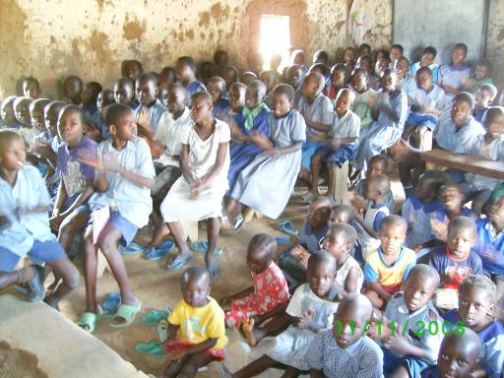
Some of the orphans and vulnerable children during learning in their non-formal school.

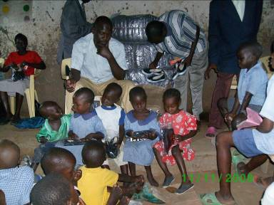
Little orphans admire shoes donated to them at the center.

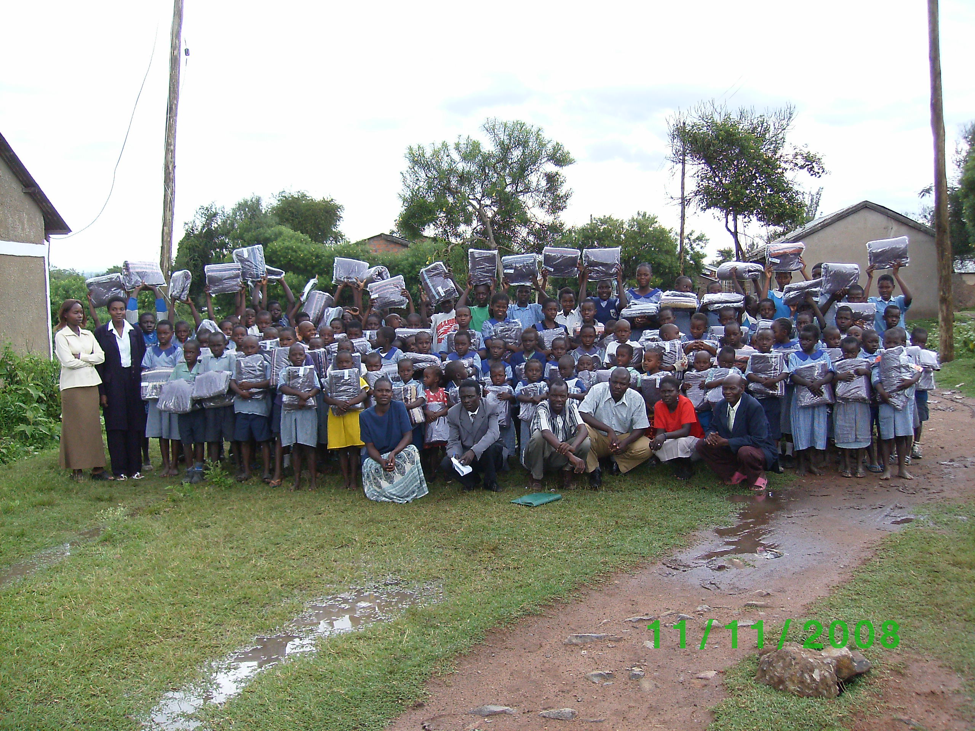
Orphans and staff in a group photo after receiving donation of blankets.

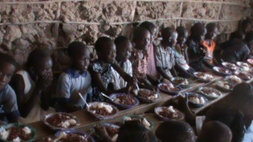
Children enjoying their meal during Christmas day. December 2010.

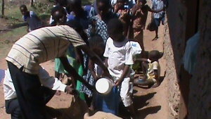
Children lining up to receive donation of dry maize (for maize meal) during last Christmas, December 2010.

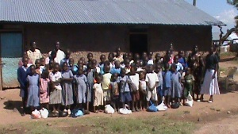
Children in a group photo after receiving Christmas donation.
A section of children receiving maize donation during Christmas of 2010.
