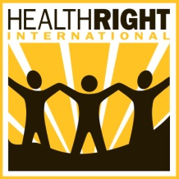

Global Giving Campaign Improves Diagnosis of Malaria in Rural Kenya
Report for November 2012

Malaria is the number one cause of illness in children in Kenya. In the fight against malaria in rural Kenya, the needs are great but the solutions are simple. With inexpensive resources such as test kits, microscopes, and mosquito nets, HealthRight’s project saves hundreds of children’s lives every year.

In July 2012, with generous support from Global Giving donors, HealthRight provided over 5,000 Rapid Diagnostic Test (RDT) kits for malaria to five rural health facilities in the North Rift Valley. RDTs are a simpler and faster way of testing for malaria, requiring only 20 minutes for a final result. Therefore, when RDTs are available, nurses and clinical officers can test and confirm malaria cases faster, leading to faster treatment for sick patients. And this saves lives.

HealthRight delivered the test kits during the peak malaria season (May – August), when the risk of death due to malaria is the highest for pregnant women and young children. In July alone, over 8,400 malaria tests were performed in the five districts where HealthRight works with over 2,500 positive cases. Forty percent of these sick patients were children under five years of age, all of whom received life saving medications.

Below is a photo of one of HealthRight’s busiest clinics in Central Pokot District.

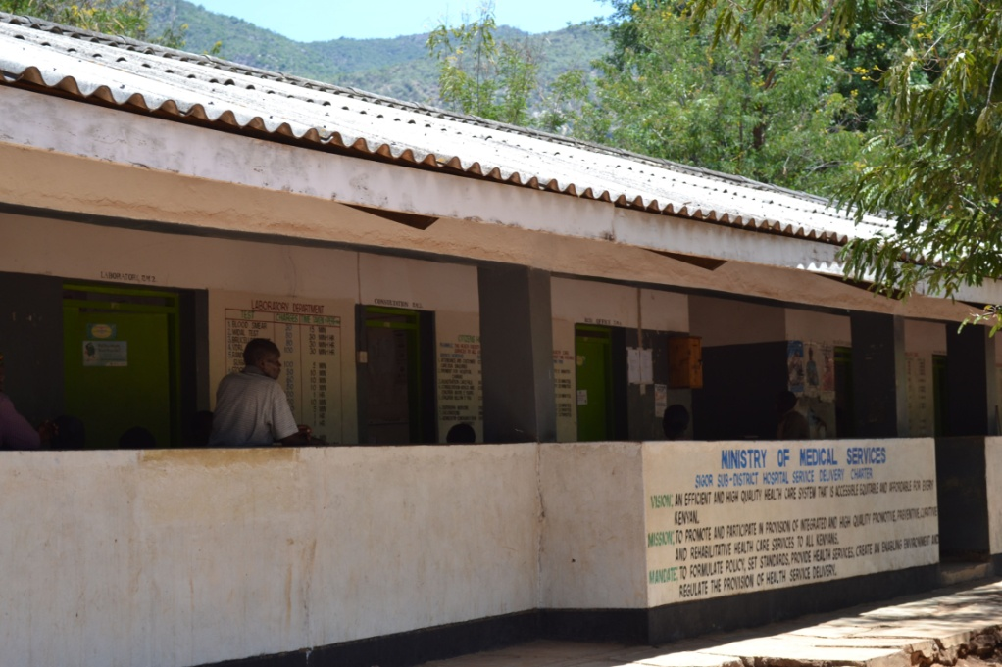

And a photo of a mother and baby after receiving care at one of the facilities.

