

Tragedy in the Indian Ocean

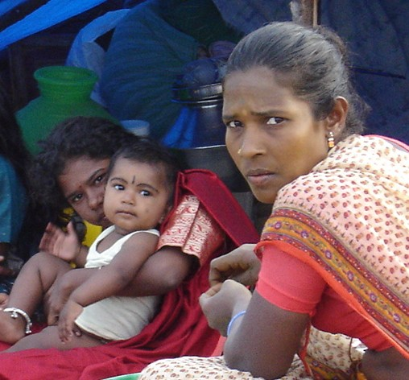
Near Chennai (Madras), India, survivors face recreating their
lives and livelihoods from a nearly unfathomable wreckage

Earthquake and Tsunami Relief and Rehabilitation Fund

Goal: $25 Million

Overview

Sunday morning, December 26, dawned clear and bright over the Indian Ocean, but the weekend calm was soon shattered by a powerful earthquake off the western edge of Sumatra, Indonesia. Shortly afterward came the eerie sight of the ocean taking a deep breath – from India to Thailand to Indonesia, people watched the water recede hundreds of yards from the shore in a matter of moments – followed by towering tsunamis that crashed into coastlines all around the region. The death toll has surpassed 150,000 and is still rising.

CARE’s long-term presence in India, Indonesia, Sri Lanka and Thailand, means that we were on the ground when the crisis struck, and we are responding to people in need as rapidly as possible. We join the governments of the stricken countries and the international humanitarian community to reach those in need in the most efficient and effective manner possible. In addition to the funds we are receiving from the American, Canadian, Australian and British governments and the European Union, CARE seeks $25 million from generous donors in the United States for our multi-country Earthquake and Tsunami Relief and Rehabilitation Fund. These resources will allow our staff the flexible funding and other support we need to ensure that crisis-affected communities not only can survive the immediate crisis but can rebuild their lives and livelihoods in the coming two years.

India

The destructive waves took the lives of more than 13,600 people along the eastern and southern coasts of India, according to best government estimates, and affected the lives and livelihoods of well over 1.2 million more. CARE’s most experienced disaster response staff in India rushed to the disaster zone within hours after the waves struck.

Since our initial assessments in the two states, we have locally procured and are distributing large volumes of relief supplies to flood-affected people in hard-hit coastal areas. Foremost among these items are water purification materials and oral rehydration salts to stave off the worst effects of water-borne diseases; we are also distributing clothing, plastic sheeting to be used for temporary shelter, sleeping mats and sheets, hygiene materials, cooking utensils and basic medicines. CARE has reached roughly 50,000 people with these emergency supplies.

Our current distribution to displaced families in Tamil Nadu includes:

- 10,000 water tanks (100 liter capacity each)
- 20,000 clothing kits (1 dhoti, 2 lungis, 1 sari, 1 petticoat, 2 towels)
- 20,000 family hygiene kits (bath soap, laundry soap, disinfectant, cotton, comb, sanitary pads, mirror)
- 30,000 packets oral rehydration salts
- 650,000 water purification tablets
- 10,000 cooking kits (2 cook pots, 2 plates, l ladle, 2 metal tumblers)

At the same time, we are mapping out our mid-term strategy to help tens of thousands of families begin to stabilize, return to the routines of school and work, and rehabilitate their means of securing a livelihood. As an initial action plan, we are aiming to reach a minimum of 20,000 households – at least 100,000 people – who are among the most acutely affected and who have the fewest familial, social and economic means to recover. Our plans, which we will carry out in Tamil Nadu’s Chennai, Cuddalore, Nagapattinam and Kanniyakumari districts, are briefly outlined below.

Mid-term: January to February 2005: In addition to our ongoing distribution of the type of supplies noted above, we continue our push to ensure basic sanitation conditions and clean drinking water, and thus help people reduce their risk of diseases linked to contaminated water. CARE’s work will include provision of latrines in camps for the displaced and in villages where survivors are regrouping, and to deliver clean water as needed. Moreover, we will offer programs to help people begin to overcome the psychological and social trauma they have endured.

Long-term: March 2005 Onward: CARE will stay in affected areas and help families and communities rehabilitate water sources (wells, piped systems) and rebuild their homes. We will provide fishing nets and assist in the repair of small to medium-sized fishing boats – most of those affected in coastal Tamil Nadu are fishers by trade – and help other families build poultry and goat stocks as a means of earning income. Most importantly, we will stay to help affected families reweave the social fabric of their lives after such tremendous loss.

CARE has worked in India since 1950, and we have more than 700 staff in country. Our programs are active in 11 of India’s 29 states, and in 2003, we partnered with more than 200 local nongovernmental organizations to transform the lives of 6 million poor and vulnerable people through programs in nutrition, health and HIV/AIDS; microfinance services; basic education; disaster preparedness and response; and tribal empowerment.

Indonesia

CARE’s staff in Indonesia are delivering emergency assistance to Sumatra’s Aceh state and capital city Banda Aceh, which were virtually on top of the earthquake’s epicenter. Reports of mind-numbing destruction including an estimated death toll of more than 90,000 people attest to the need for and difficulty of disaster response in this zone. CARE’s chief emergency operations officer, speaking from Banda Aceh, says, “It is absolute chaos.”

Our initial response centers on clean water supplies: CARE is delivering and distributing 200,000 safe water kits in more than a dozen of the spontaneous camps that have cropped up in the wake of the crisis. To accompany the purification materials, CARE is distributing buckets with lids and jerrycans in which people can store and safeguard their drinking water. We intend to continue providing safe water supplies to at least 500,000 people a month through the first part of the new year.

At the same time, CARE and our peer agencies are planning an integrated approach to helping devastated people survive and recover from this crisis. In the short term, that means not only clean water but food and temporary shelter. In the longer term, rebuilding will be a massive undertaking in this land that bore the brunt of the earthquake and the resultant tsunami.

CARE has worked in Indonesia since 1967, and our staff there number some 700 people experienced in our program portfolio of agriculture and natural resource management, children’s health and nutrition, microenterprise development, civil society strengthening, and disaster prevention and response.

Sri Lanka

The island nation of Sri Lanka took a direct hit from quake-generated waves. More than 29,000 lives were cut short by the tsunami, according to the national disaster center, and at least 750,000 people – but perhaps as many as 1.5 million – are homeless. Survivors beyond count are traumatized by the horror that surrounds them.

CARE’s long-term presence all along the affected coastline (including in rebel-held areas in the north) means our staff responded in the earliest moments of crisis. We are providing basic food, clean water, clothes and bedding materials in the hardest hit districts. Although the situation on the ground remains fluid, our work includes aid to more than 55,000 survivors so far:

Jaffna: Distribute clothing, bedding and basic medicines to survivors; organize work teams to dig graves, dispose of dead animals; and clean out hospitals and other vital infrastructure.
Trincomalee: Distribute relief packs (water bottles, mats, utensils, bedding, clothing and toiletries) to 4,800 families.
Batticaloa and Ampara: Distribute clothing, bedding, toiletries, bottled water and dry ration packs (rice, tea, lentils, tinned food) to 6,500 families.
Hambantota: Distribute dry food, bedding, oral rehydration salts and utensils (plates, cups, candles, matches) to 5,000 families.
Mullaitivu and Kilinochchi: Ensure basic sanitation and distribute food, water, clothing, basic medicines to 5,000 families.

We are rapidly developing plans to help Sri Lankans recover from the unprecedented disaster that has befallen them. CARE’s current plans are to target a minimum of 60,000 people and – over at least an 18-month-period – achieve the following:

- Work with affected communities to clearly identify and prioritize needs.
- Continue clean-up operations of debris and waste.
- Rehabilitate/build housing for affected families.
- Provide water and sanitation facilities, including clean up and desalination of existing water sources.
- Support the rehabilitation of community infrastructure, such as rural schools, hospitals, clinics and religious places.
- Support the reestablishment of livelihood strategies by providing agricultural and fishing equipment, including boats, and small loans.
- With qualified experts, identify trauma support services and strategies to deal with the long-term psychological and social well being of affected communities, especially children, youth and women.
- As needed, facilitate or advocate on behalf of affected communities’ legal needs, including replacing lost documents (land titles, identity cards) and obtaining death certificates.

CARE is relieved that those of our colleagues who were unaccounted for in the early hours of crisis have been found alive, and we are aiding our own coworkers who lost family and homes in Sri Lanka. We will stay with affected communities long after the immediate emergency has ended, and invest in them as they revive their lives and livelihoods.

CARE has worked in Sri Lanka since 1956, and has more than 250 staff in country. Building upon a successful base of programs to improve the health and nutrition of children and women, CARE now offers extensive assistance in agriculture and natural resource management, small economic activities development and savings and credit services. Throughout the country’s war-affected zones, we are heavily invested in helping communities actively build peace as they rebuild livelihoods.

Thailand

CARE has joined hands with peer agencies to provide immediate aid along Thailand’s long western coast, where the tsunami claimed at least 1,500 lives and caused injury to some 8,500 people. We are active in Phang Nga, the hardest-hit district, and in Krabi, Ranong and Trang.

Our staff are providing locally procured basic medicines and equipment to the health care workers struggling to cope with the wounded and ill. We and our local partners are distributing first aid kits, oral rehydration salts, water, clothing, candles and bedding directly to disaster victims. In one location, we are helping homeless people develop and manage a shelter in an open field where they spontaneously gathered after the waves receded.

CARE is planning its next steps in assisting disaster victims survive and recover. In the longer term, we will focus on helping fishing villages, on the mainland and on islands, rehabilitate their livelihoods and rebuild their communities.

CARE has worked in Thailand since 1979. Now known as CARE Raks Thai, that office was the first to become a member of the CARE International federation and a country office with ongoing projects. CARE currently has projects in agroforestry and conservation, children’s education, small-business development, and HIV/AIDS-prevention education and assistance to affected families.

Thank You

With the flexible resources in our Earthquake and Tsunami Relief and Rehabilitation Fund, CARE is rapidly reaching those in need with emergency aid, and we will help hundreds of thousands of families rebuild their shattered lives in the two years to come. We thank you for your gift to CARE.

January 3, 2005

A Dark New Year

Madhuri Dass, CARE India

January, 1, 2005. Chennai, India.

It is now exactly one week after the terrible tsunami that claimed tens of thousands of lives in south Asia. You would think that the mood in Chennai, capital of one of the worst affected areas in India, would be decidedly somber. Yet somehow, stores in downtown are not only open but are buzzing with holiday shoppers. Has the horror of the disaster not touched the lives of the people in this city?

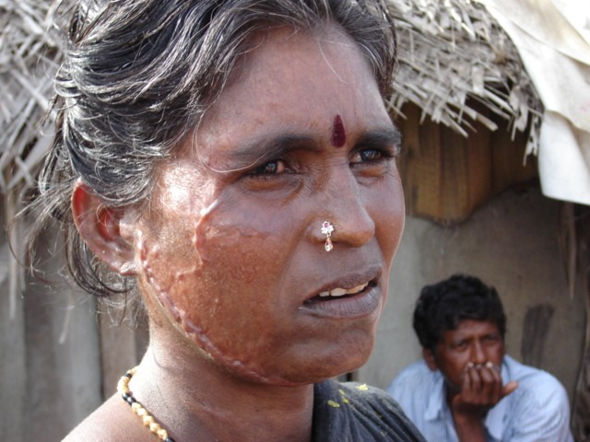
A quick trip to nearby Marina Beach, one of the largest city beaches in the world, is more telling. The killer waves primarily hit fishing communities like Marina Beach along the coast, and largely missed downtown Chennai. The mood in these hardest hit communities is very, very different. Most of the families living here, at the edge of the beach, had no disposable income before the disaster. And now that the tsunami has destroyed their means of livelihood, they have plenty to worry about. The tsunami has affected these poorest of poor much more that the rich.

Like other residents of Marina Beach, Kanagga was cleaning a catch of fish on the beach when the tsunami struck. Crouched on a stretch of sand in front of her home, she looked up when she heard a terrible noise to see the enormous waves approaching. Quickly running to safety with her family, Kanagga is lucky even to be alive. Her home, though damaged, still stands. However, many of her families’ possessions were washed away or severely damaged. What’s worse, her families’ fishing boat – their sole means of livelihood – ran aground and is now in need of much repair. Unlike nearby city dwellers, there will be no holiday celebrations this year in Kanagga’s home. Although the family went to church to offer prayers, they could simply not afford a meal to celebrate the occasion at home.
Survivors along the coast of Chennai are facing the sober realities of life after the disaster.

Kanagga’s was one of the first communities to receive relief in the form of food, owing primarily to its proximity to the city. But she worries about getting a new engine to power her families’ boat. “It is not easy for us to recover our loss,” says Kanagga. “We have to get back to earning a regular income again very soon, or we will not be able to eat.” None of the other fishermen in the community have gone out to sea either. Some say they have lost their nerve. Others believe that they will not be able to sell their catch because people fear contamination. They say they want to wait until the sea gives back all the dead. Hundreds of people are still missing in the state of Tamil Nadu.

The eastern coast road hugs the sea for some distance after we pass Chennai’s city limits. Dotted along the highway, quickly built camps house the newly displaced, who are now completely dependent on emergency relief for survival. Living conditions here are cramped and unhygienic. Some children play a ball game, while others just sit and stare. The men are huddled together figuring out what to do next, and the women are doing their best to set up home in makeshift conditions. CARE’s relief workers have already surveyed many such scenes. They are carrying out measures to make camp life a little easier for about 50,000 displaced families. Their task at the moment is to make sure that there are no gaps and no duplications in the distribution of items like clothing, cooking utensils, sleeping mats, blankets, and water.
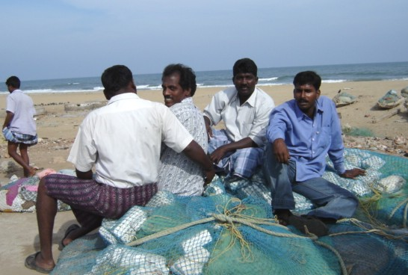
New Year’s Day at the emergency outpost in Chennai began with a quick team briefing for the experienced relief workers, deployed from CARE’s programs from around India, to take charge of operations in Tamil Nadu. They dispersed quickly to execute the plans for the day. They have been listening closely to the local survivors to ensure that their point of view is included in the relief efforts, and that the long-term rehabilitation effort – already being planned – is based on real need.
Fishermen along Marina Beach face the loss of their livelihood.

Godspeed to the CARE team, and to all those in the largest coordinated relief effort in recent history.

