Burundi Program

Main website: http://www.ibj.org/where-we-work/africa/burundi/

Burundi Country Background
En Français
Burundi is a small landlocked country in Africa’s Great Lakes Region striving to overcome the legacy of over a decade of civil war. The government of national unity, led by President Pierre Nkurunziza since 2005, has embarked on the process of rebuilding virtually all of the country’s institutions, strengthening the rule of law and improving the quality of life for its people. In April 2009, the last rebel group in Burundi, the FNL, laid downs arms, creating a reasonably stable peace throughout the country. With widespread involvement in the unity government by former rebel groups, the situation looks promising.
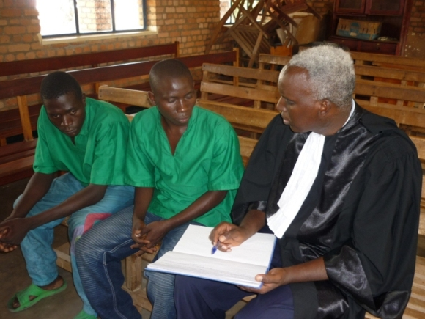

IBJ Lawyer Herman NDAYISHIMIYE interviewing his clients to prepare their case before the Bubanza Court. (Photo by Claire Habimana)
Since the end of its 12 year civil war, Burundi has made great strides towards true societal normalization and an open political space. While the justice system works poorly, both law enforcement and judicial officials openly acknowledge the problems, and have expressed a willingness to work to resolve them. Major progress has been made by the adoption in April 2009 of a revised penal code and clearly criminalizes the use of torture.
More than half the population of Burundi lives below the poverty line and the end of the civil conflict has left a legacy of unskilled young men trained only to be soldiers. This means that true societal reconciliation remains a distant, though achievable goal. Profound institutional weaknesses, poorly trained personnel and a lack of resources are hampering the effective implementation of new laws and access to justice for millions of people.
According to the Burundi Bar Association, the country has only 106 practicing lawyers in the entire country of 8.1 million people or one lawyer for every 76,000 people. The prison population has recently reached a peak of 11,000, alarming the national authorities and urging them to take action. Out of this prison population, more than 64.5% are pre-trial detainees. Most of the accused are unable to afford legal representation. There is no State-sponsored structured public defender/legal aid system. The lack of a juvenile justice system means that over 400 child detainees are held in communal cells with convicted adults, making them vulnerable to abuse. There is a real sense of urgency to consolidate rule of law in Burundi.
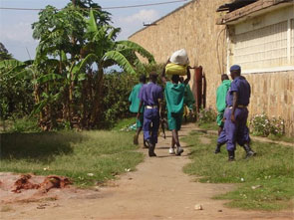 |  | 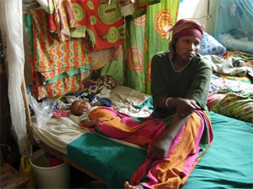
Prison life in Burundi |  | Woman detainee with child

IBJ Programming in Burundi
In November 2006, IBJ sent a mission to conduct a preliminary legal needs assessment and initiate relationships with local partners. Since then, IBJ has signed a Memorandum of Understanding (MOU) with the Bar Association of Burundi (l’Ordre des Avocats du Burundi) and forged a strong working partnership with the Association for the Protection of Human Rights and Detained Persons (APRODH).
During the 2006 trip, IBJ also visited Mpimba Central Prison in Bujumbura, the nation’s capital, and met with prison officials; these officials acknowledged the need to strengthen the criminal justice system in Burundi in the aftermath of civil war. In 2007 IBJ began preparations for legal training seminars which would bring together 20 legal aid lawyers, 12 prosecutors and magistrates, 4 police officers and 29 civil society members.
To learn more about IBJ’s 2008 and 2009 training workshops in Burundi, please refer to the section below on building a culture of public defenders/legal aid.
2007 also saw IBJ’s first legal rights awareness campaign in Burundi, aimed at the general population of the country. Posters illustrating legal rights were designed in conjunction with IBJ’s local partners APRODH and the Burundi Bar Association. 3,000 posters were distributed nationally, sparking an overwhelming demand for legal assistance.
Together with APRODH and the Bar Association, IBJ has produced another 10,000 “Know Your Rights” posters that have been distributed in prisons, police stations, local government offices and other public centers. These posters educate ordinary citizens, detainees and law enforcement agents on the right of accused persons to be free from torture, the right to legal counsel and the right to a fair trial.

Building the in-country leadership of the criminal justice movement
The foundations for IBJ to help build a working criminal legal aid system have been laid in Burundi. In 2009 IBJ has hired its first Burundi Fellow to spearhead IBJ’s work in the country, and has opened a Public Defender/Legal Aid Resource Center (DRC) in the capital of Bujumbura. With the recruitment of a dynamic legal aid expert Astère Muyango – as IBJ Fellow and Country Manager, IBJ has begun to provide resources and support to the criminal justice system. Relying on his local knowledge, tenacity, and organizing community involvement, Astère is a leader in the Burundi criminal justice movement.
Ultimately, the DRC will provide a space where lawyers access IBJ’s online legal training curriculum, printed legal resources and the Internet. It is also a place where lawyers meet and discuss cases, find out about resources (like available grants from IBJ and others) and share the best legal practices.
Finally, it will become a shelter where lawyers can meet with their clients and their families, and prepare their cases for court. Efforts are ongoing to make more resources like law books, research papers, and other legal materials available for the use of defence attorneys. More and more lawyers come to the office for copies of the newly enacted penal code and for IBJ’s public defender criminal defense manual.
In October 2009 IBJ hired Mr. Herman Ndayishimiye, a seasoned lawyer with over fifteen years of legal experience. Herman’s many years of experience, in combination with his participation in both of IBJ’s Burundi public defender criminal defense training seminars, ensures that the defendants he represents will be provided with effective, efficient and committed counsel. Herman is also responsible for organizing and leading a core group of volunteer lawyers, each taking at least two pro bono/no fee cases per month across the country.
Finally, Herman will be responsible for developing a Burundi-specific public defender/legal aid/criminal defense training curriculum, including elements of the adversarial system, with the support of other criminal justice experts. Burundi has recently joined the East Africa Law Society, an organization promoting the practice of adversarial law and it is essential that Burundian lawyers be able to access the legal resources and training materials required to keep abreast of these innovations.

Building a culture of Public Defenders/Legal Aid/Criminal Defense through training and dialogue
In May 2008, IBJ, along with APRODH and the Bar Association of Burundi, co-sponsored a two-part training session over the course of four days for everyone in the Burundi criminal justice system: lawyers, magistrates, Supreme Court judges and police officers in Bujumbura.
Participants identified areas within the justice system that could be improved and created workable solutions. The use of torture was identified by all participants as a major concern that needed immediate attention. The objective of the first training session was to provide an opportunity for dialogue among participants by exposing them to each other’s understanding of criminal and social justice.
This allows them to grasp the nature of each others’ roles, and to address the challenges facing the country’s justice system, including the use of torture collectively. They also examined the options available under Burundi legislation, identifying possible changes that could be made within the current legal framework. Through such discussions, IBJ started a change in the attitudes among everyone in the legal community who could effectively implement the already existing legal due process rights and in that way help to prevent torture.
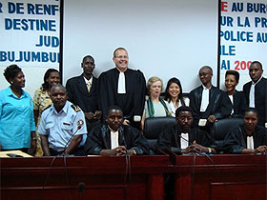 |  | 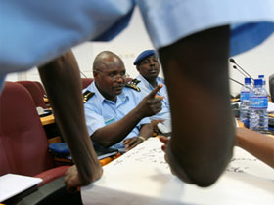
The training team and participants |  | Commissioner general Bernard Sekaganda engaging other participants of the 2008 Burundi Legal Rights Training Seminar in discussions about ensuring early access to legal counsel in Burundi. (Photos by Miranda Harple)
In addition to the training seminar, IBJ solidified its commitment to a long-term plan to building a functional justice system. By meeting with Burundi’s Justice Minister Jean-Bosco Ndikumana, IBJ demonstrated its long standing commitment to work with governments for systematic legal change.Minister Ndikumana stated that one of his biggest priorities is to eliminate the use of torture in Burundi and he recognized the need to lay a strong legal foundation to protect his country as it emerges from civil war. He expressed a desire for IBJ to work with prisoners to increase access to counsel and with judges and magistrates to make the system more effective.
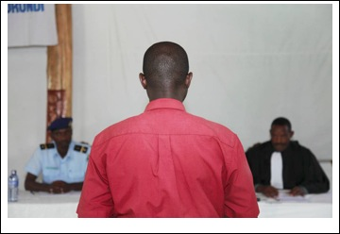

Above: Modeling an unchecked system: the accused with no lawyer, Mock-trial of the Burundi Public Defender/Legal Aid/Criminal Defense Training, July 2009 (Photo by Nathalie Mohadjer)
IBJ’s second Burundi Public Defender/Legal Aid/Criminal Defense Training Seminar, held in conjunction with the Burundi Bar Association and APRODH, in June-July 2009 built on the foundations laid in 2008. Over the course of the four days, lawyers, prosecutors, magistrates, police officers and prison directors gathered to attend workshops on all aspects of the legal process, from the initial arrest through to the trial and judgements. There were also numerous opportunities for the participants to both practice their new skills through trial simulations and to put forward their own ideas on how to improve Burundi’s Justice system in round table discussions on juvenile criminal justice and on legal aid.IBJ was able to provide participants in the training workshops, lawyers and non-lawyers alike, with copies of the newly enacted penal code. Before the workshop, even high-ranking police officials had not received a copy of the new legislation. The document created a sensation.
Though the 100 copies were nearly double the number of participants in attendance, the IBJ team quickly ran out as defenders, magistrates, police and prison officials sought the code on behalf of their colleagues in the provinces. New copies have been printed since then, and there is still a huge demand for these at the DRC. (Click http://blog.ibj.org/2009/07/14/ibj-delivers-black-letter-law-to-burundians-entrusted-to-uphold-it/ to read more about it).
By the end of the training seminar participants had a new awareness of the legal tools available to prevent systematic abuse. Defense attorneys were inspired by their newly discovered legal tools to provide legal rights for the accused. Each group of justice system workers learned their specific role in the criminal justice system while understanding the roles and responsibilities of those in other sectors and the need for collaboration to eradicate abuses in the justice system.
Inspiring co-ordinated answers to common challenges
The training workshop also demonstrated that these events can become catalysts for real change, with effects far beyond their immediate aims. The training workshop environment encouraged the lawyers to come up with their own initiatives. As a result of the 3rd round table, held at Bubanza, they committed to spending a part of their August vacation visiting Bubanza Prison and working to expedite the trials of prisoners who have remained in pre-trial detention long-term. This initiative is being undertaken with the support of the Prison Director and the President of the Court in Bubanza Province. To date, 45 pre-trial detainees, including 15 juveniles, have been released. Prosecutors were equally inspired and ordered, on their own initiative, the immediate release of additional detainees. Cooperation among lawyers, police officers, prison and justice officials was also the credo of the Gitega round table discussion held in October 2009, which resulted in the release of 28 detainees. The success of the Cibitoke roundtable conducted in December is equally resounding: the trial of Mpimba’s 15 juvenile prisoners is in the process of being expedited with the active support of prison officials and magistrates. With IBJ’s impetus, co-ordinated answers to common challenges have started to emerge within the Burundian legal community.
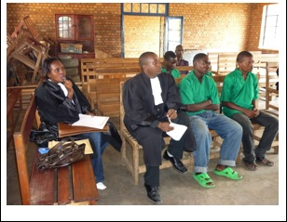

Above: Lawyers Sonia NDIKUMASABO and Patrick-Didier NUKURI requesting the immediate release of their pre-trial clients in Bubanza court. (Photo by Claire Habimana).
Raising the awareness of the general population and public officials about Legal RightsIn the spring of 2008, 3000 advisement of legal rights posters were distributed. They were highly-engaging, and – positioned at police stations, government buildings, etc. – they were a pragmatic mechanism for curbing torture and other instances of legal abuse. But IBJ lacked the resources to distribute them. A year later, IBJ has recruited a qualified lawyer. New advisement of legal rights campaigns have been conducted. On June 26th 2009, IBJ collaborated with its partner, the Association Burundaise pour la Protection des Droits Humains et des Personnes Détenues (APRODH), on a legal rights awareness campaign conceived to mark International Week in Support of Victims of Torture, which involved distributing ‘Know Your Rights’ posters throughout the North Burundian province of Ngozi. (Click on http://blog.ibj.org/2009/07/14/rights-posters-bring-legal-awareness-to-burundians-nationwide/ to read more about it).
Another successful rights awareness campaign held at Gitega on September 22nd, 23rd – where more than 1450 people have been reached – shows that posters are making their way to the walls of police stations, prisons and courts across the country. On Human Rights Day -the 10th of December – IBJ educated 700 people about their legal rights in the remote province of Cibitoke. To date, more than 2350 people have been sensitized about their basic legal rights across the country.
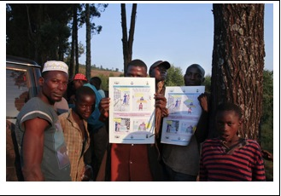

Above: Recent recipients of IBJ’s Legal Rights Poster in the Ngozi province. (Photo by Nathalie Mohadjer)
IBJ also actively works at prioritizing the issue of the legal rights of the accused on the agenda of domestic authorities. On July 23rd 2009, just three weeks after the training and series of round tables, the Minister of Justice issued a circular, to the attention of the President of the Supreme Court, the Director General of the Penitentiary Administration and the Prosecutor General, reacting to the unacceptable prison overcrowding and pre-trial detention rate, and asking them to immediately proceed with the release of juveniles under 15. The next category of prisoners whose release will be prioritized is detainees who have remained in pre-trial prison detention for 12 months while they face less than 5 years imprisonment for the alleged offence.There is no doubt that the continuous lobbying of IBJ Fellow, Astère Muyango, the series of meetings conducted with top officials in June 2009 and the momentum created by the widely publicized legal training workshop and round table events contributed to this decision.
Moving forward: Creating a Functioning Legal Aid System
IBJ will consolidate the progress made in Burundi and create national, as well as regional, projects with the aim of assisting the government to create a functioning legal aid policy. Prioritizing systematic access to legal counsel, IBJ is planning the co-implementation of a legal aid pilot project with the Burundi Bar Association. A new Memorandum of Understanding outlining the essence of the project has just been ratified by both parties.Through this project, IBJ is looking to continue its training workshop capacity in ways which reinforce its hands-on workshops, through the development of public defender/legal aid/criminal defense manuals and other training materials, to institutionalize public defender practices throughout the country, and foster skills exchange with members of the wider international legal community, in particular with defense attorneys worldwide. The increased availability of IBJ training materials online and the development of an international online support community will allow improved access to such resources. A pilot legal aid center in one of Burundi’s 17 provinces is also sought to promote timely and effective legal counsel to indigents accused of a crime.
Added to the ongoing workshops and other outreach initiatives, this project will help identify a core group of public defenders who will push forward the legal aid agenda in Burundi both through their own actions in legal practice, and through advocacy work. These public defenders will receive intensive legal training in order to equip them with the necessary skills to provide free legal counsel; in addition, IBJ will encourage a core team of lawyers to commit to taking on a minimum of pro-bono/no fee cases in addition to their personal practice.
Through these initiatives IBJ fosters the creation of a culture of public defender criminal defense in the country, ensuring that the best legal service is made available by decentralising legal aid, making it available in the provinces and deprived areas, insisting on the highest degree of nationally standardised quality of counsel, to facilitate Burundi’s transition to a true rule of law legal system.
- eLearning Burundi program: Click here to access.
- Burundi Criminal Defense Manual: Click here to access.

IBJ’s Burundi Program is funded by the the European Union.

“The European Union is made up of 25 Member States who have decided to gradually link together their know-how, resources and destinies. Together, during a period of enlargement of 50 years, they have built a zone of stability, democracy and sustainable development whilst maintaining cultural diversity, tolerance and individual freedoms. The European Union is committed to sharing its achievements and its values with countries and peoples beyond its borders.”
The European Commission is the EU’s executive body.
http://ibj.org/uploads/eubanner_small.jpg

