A step-by-step progress toward a new age of juvenile justice in Burundi
The ratification of the Convention on the Right of the Child by Burundi in 1990 brought a hope for change in the system of administrating juvenile justice. However, the civil war which lasted 15 years from 1993 slammed the brakes on these changes. In 2005, the Constitution of Burundi integrated the CRC through its 19th section and enacted some key principle rules on the treatment of children accused of a crime. It stipulates that the detention of a child must be prevented as much as possible (section 46 of Burundian Constitution). In 2009, a new penal code was adopted and brought meaningful changes including raising the age of penal responsibility to 15 years and introducing alternative sentences in order to avoid detention of the child. By this only reform, Burundi remains far from reaching the minimum standards of acceptable treatment of the child in conflict with the law. IBJ as well as other organizations working for the welfare of the child accused of a crime seek a more specific text to protect the child in Burundi.
Following this, a bill of code of criminal procedure and a bill of code of the protection of the child in Burundi are being discussed. These two texts will recognize the right of the child to legal counsel, the right to be judged in front of specialized chambers of the courts as well as other innovations. IBJ gave the opportunity to ordinary citizens to discuss the content of these bills of law through the radio programs organized by IBJ.
Awaiting the adoption of these legal provisions, International Bridges to Justice continue to bring out impetus for changes as far as possible using the existing provisions. IBJ combines three methods: building and tightening collaboration with courts and prosecutions, sensitizing criminal actors to hear children in special in-camera sessions and providing direct legal counsel to children.
From September 2012, after a successful legal assistance of children accused of crimes in the province of Muramvya, where all the 15 cases of children which were fixed at the court were closed by October 2012 and 6 acquittals obtained. In this perspective, IBJ went on spreading the technique of organizing special in-camera sessions in the province of Gitega. There, a legal need assessment done throughout an IBJ mission conducted in November showed that 21 children are in pre-trial detention. With the judicial authorities of Gitega court, it has convened the regular in-camera sessions organization. The first session was then held on December 12, 2012 and 5 cases were brought in front the court. The IBJ legal fellow Aline NIJIMBERE assisted the children. 3 cases have been closed and the decisions of the court accordingly are to be pronounced in January.
Organizing special sessions for children accused of crime helps judges and prosecutors to implement laws related to trials concerning children. This is why all judges who attended the roundtable organized by IBJ on November 23, 2012 around the “updates of implementation of special procedures of juvenile justice in Burundi” committed themselves to building a strong collaboration with IBJ and then became open to holding such sessions.
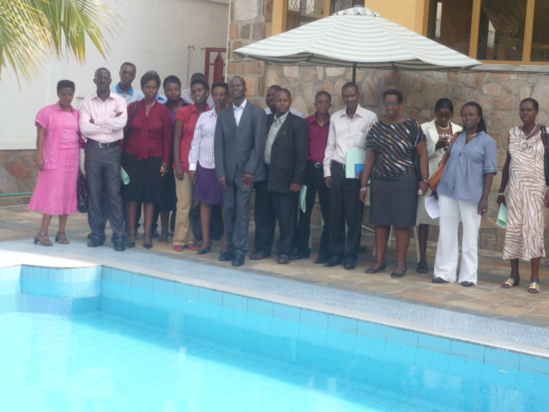
Judges, prosecutors and court clerks from Bujumbura, Bururi and Muramvya courts

That roundtable was held with the initial purpose of pushing the juvenile justice actors working in the area where IBJ provides legal assistance to children, to catch the right meaning or have a common understanding of the key articles of the Convention on the Right of the Child especially the section 3, 37 and 40.
Also, this roundtable had to bring juvenile justice actors together for them to renew commitments that had been taken through a similar roundtable organized on 23rd September 2011. In this way, this roundtable intended to lay the first steps towards the implementation of the administration of juvenile justice guidance of the Ministry of Justice.
Another purpose was to strengthen collaboration with Juvenile Justice Stakeholders to render more successful IBJ legal assistance in benefit of children accused of crime.
Participants including courts clerks, secretaries, judges and prosecutors took feasible and concrete commitments going from tightening their professional collaboration to treating the child’s case more rapidly.
Apart of these two events, IBJ lawyers went on providing legal assistance to children in Bujumbura Township and Bujumbura rural areas. Among the cases of children handled, NDIKUMANA, a child of 14 years old has been assisted by Aline NIJIMBERE. He was accused of rape. Regardless whether this was true or not, Aline emphasized the age of the accused since the penal code enacted that children under 15 years old can not be responsible of a crime (article 28). In the trial of November 12, 2012, after she had showed to the court that the child was 14 years old at the time of arrest, the court of Bujumbura rural decide to immediate release the child.
It is a continuous process and IBJ will not give-up until a new age of juvenile justice becomes a reality in Burundi.

