A Reason for HOPE – City Year Washington DC’s HIV/AIDS Outreach Prevention Education Program

The HIV/AIDS Epidemic in the DC Community
Washington, DC children live with the highest rate of HIV/AIDS infection in the country. A 2001, CDC report calculated that DC has 166.2 AIDS cases per 100,000 people (compared to the second highest rate of 32.4 cases per 100,000). The premier provider of services to adults and children suffering from HIV, the Whitman-Walker Clinic, estimates that one in 20 adults in DC is infected with HIV. According to the CDC, “HIV-related death has the greatest impact on young and middle-aged adults, particularly racial and ethnic minorities…Many [HIV positive] adults were likely infected in their teens and twenties…[A]t least half of all new HIV infections in the United States are among people under 25…” DC’s Metro Teen AIDS estimates that between 2,500 and 3,500 infected young people live in the Washington, DC area, yet only a fraction of them know they are HIV positive and only 100 of them are receiving medical care.
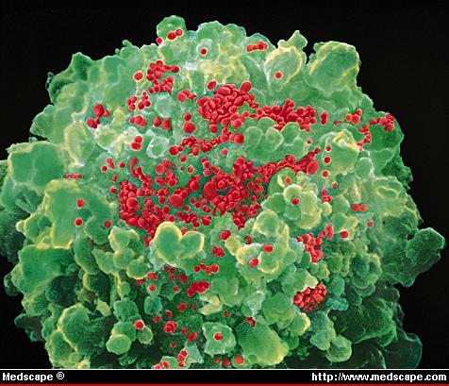
T4 Cell with HIV Virus

Our community is in desperate need of programs where strong, motivated role models deliver positive youth development activities and empower children with the information to make healthy and life-long decisions about their well-being. Without early intervention to counter negative forces and misleading stereotypes about HIV/AIDS an entire generation of Washington, DC young people is at-risk.

The HIV/AIDS Outreach Prevention Education (HOPE) program is one of City Year Washington, DC’s (CYDC) five flagship service initiatives dedicated to helping build a stronger DC community (Examples of other flagship service initiatives include Child Literacy, Substance Abuse Prevention, Youth Leadership Development, and Community Volunteer Engagement).

The HOPE program was developed in partnership with Metro Teen AIDS (MTA) to address the stark realities of the HIV/AIDS epidemic in Washington, DC. The mission of the HOPE program is to prevent HIV/AIDS infection among young people by educating them about the dangers of HIV/AIDS and how the infection is spread.

City Year Washington, DC
Founded in Boston in 1988, City Year is an innovative youth service program to serve as a model for national service, civic engagement, and leadership development. Now in 15 communities across the nation, City Year recruits a diverse “corps” of young leaders, ages 17 to 24, who dedicate a year to full-time citizen service. Our program taps into young Americans’ desire to give back to their community and country with tangible and effective programs that directly strengthen communities with a special emphasis on helping low-income children in need achieve academic and life success.

Launched in 2000, City Year Washington, DC (CYDC) recruits a corps that represents and reflects the tremendous diversity of Greater Washington, DC – inner city and suburban; African-American, Asian-American, Caucasian, and Latino; low, middle, and upper income. These young idealists include college graduates, high school graduates, and young people working to complete their GED. Our model of service brings together diverse young people from all over Greater Washington, DC, united by their desire to build a stronger community and by an ethic of service.

CYDC is a flexible service program guided by the needs of the Greater DC community and the strengths of our corps members. CYDC partners with public schools and community-based organizations to provide structured literacy tutoring programs and substance abuse and HIV/AIDS prevention education curriculums to children from low-income backgrounds. CYDC also helps create safe, learning environments and provides quality mentorship experiences for children during out-of-school time.
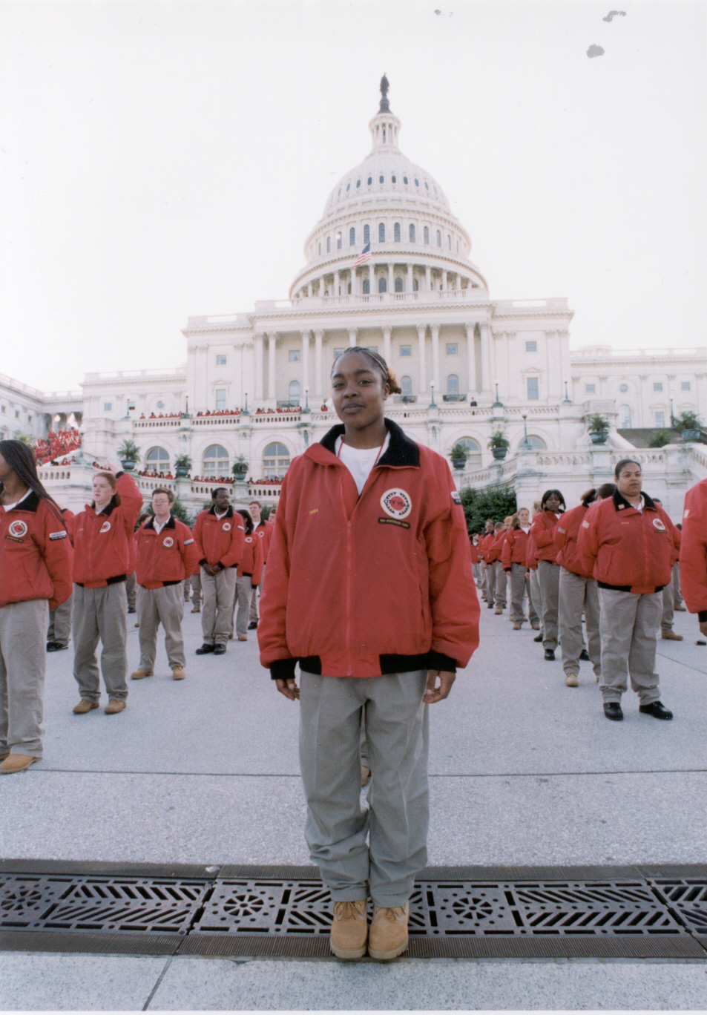
CYDC is a powerful force for good in the DC community, providing more than 300,000 hours of service and working with more than 16,000 DC children since our founding four years ago. Simultaneously, we have developed more than 150 young leaders who are assuming leadership roles at community-based organizations around Washington, DC. And we have developed more than 100 service partnerships with some of DC’s most respected, well-known, and dynamic non-profit organizations, institutions, schools, and after school programs to help them deliver more and higher quality services to children in-need.

Spreading HOPE in the DC Community
The newly launched HIV/AIDS Outreach Prevention Education (HOPE) program is implemented in the DC community by a team of 9 City Year corps members and led by a full-time City Year Program Manager. The “HOPE Team” educates youth by facilitating the Making Proud Choices curriculum: a CDC-approved approach to preventing HIV, sexually transmitted diseases and teen pregnancy. Developed in the early 1990’s by Dr. John B. Jemmott, Loretta Sweet Jemmott, and Konstance A. McCaffree, the Making Proud Choices curriculum is designed to increase the knowledge of young people – especially young people of color – about HIV/AIDS, to prevent infection, and to develop positive attitudes about safe sex. Participants build confidence in their ability to negotiate no sex or safe sex by going through eight modules of interactive educational activities that include role playing, brainstorming, small group discussion, and video presentations.

Targeting 7th-12th grade students in DC public and charter schools, the HOPE Team delivers three cycles of the Making Proud Choices curriculum over the course of the school year. In each cycle, the HOPE Team, with corps members working in pairs, delivers the curriculum at four middle, junior high or high schools. By year’s end, the HOPE team will reach at least 480 DC young people.

Building on the momentum created by the curriculum, the HOPE Team corps members will launch a recruitment campaign to engage students from each school to begin an after-school club focused on promoting healthy choices called “Visionary Youth Becoming Empowered” (VYBE). Working with a school faculty club advisor, the HOPE Team will help interested students form and launch their own club to continue their understanding of the dangers of HIV/AIDS and engage their peers in making healthy decisions about their lives. After providing direct on-site support to help create a school’s VYBE Club, corps members will provide continued support throughout the year while moving on to their next Making Proud Choices cycle. Each of these clubs will become part of a greater, connected youth community, educated about the HIV/AIDS epidemic, on-call to help support large citywide HIV/AIDS awareness and prevention projects such as the AIDS Walk or the HIV Candlelight Vigil.

With the support of the DC Public School (DCPS) In-school HIV/AIDS Education Coordinator, the HOPE Team began its outreach to the DC community in September 2004. However, the Team anticipated a degree of reluctance from individual schools upon being presented with a new program dealing with a sensitive topic. Instead, the HOPE Team has been met with open arms and is being asked in several schools not to teach one or two classrooms of students, but the entire tenth grade class. The Team enables each school to satisfy their DCPS requirement to provide HIV/AIDS education – a requirement that was previously unmet. The HOPE Team has secured commitments to deliver the curriculum through at least January 2005 in the following schools (with the estimated number of participating students).

- Wilson High School (200 students)
- Coolidge High School (150 students)
- School Without Walls (25 students)
- Ballou High School (150 students)
- Eastern High School (150 students)

Discussions with several other middle, junior high, and high schools are underway to identify the partnerships needed to complete the second and third cycles of the program.

The demand for the HOPE Team within the DCPS system is encouraging, but the program is also in its pilot year. The student engagement initiative of the HOPE program through after school-clubs (VYBE) will not launch until early January. At least three cycles of student evaluation of the curriculum are needed to do the initial mapping of the effectiveness and impact of the HOPE Team’s work. Once we are able to assess the effectiveness of the program, planning for HOPE to grow to scale will begin.

Evaluation
The program will be evaluated using two well-established City Year evaluation mechanisms. To track whether the curriculum is being delivered to the planned number of students, City Year DC will utilize its existing Research and Systematic Learning (RASL) tracking systems which include Team Activity Trackers (reports on the teams’ service on a weekly basis) and quarterly reviews of goal achievement. In addition, pre- and post-surveys have been developed to evaluate the impact on the student’s behavior and attitudes towards HIV/AIDS and his or her ability to make healthy life choices. Surveys are administered and collected by City Year corps members. The data collected from these evaluations will allow City Year and Metro TeenAIDS to measure program impact and retention of information by the students.

