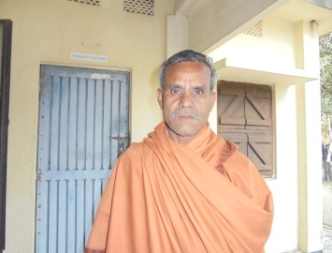
Picture of Moinul (Not his real name)

