Updates on Support high school students in Tohoku
As of December 2014

AMDA has been supporting high school students in Tohoku Region of Japan that had received a massive destruction from the earthquake and tsunami of March 11th, 2011. We would like to thank all the donors and supporters from around the world who have shown their compassion and given support by sending donation through Global Giving.

Charity Concerts

In the past, AMDA have organized Kizuna Concerts connecting Otsuchi High School Brass Band in Iwate Prefecture, with Shujitsu High School in Okayama Prefecture (home to AMDA).

Recently, we have received a letter that was composed by Otsuchi High School Brass Band members, and would like to share their heartfelt appreciation with our donors.
Dear Everyone at AMDA,
On behalf of Otsuchi High School Brass Band, we would like to thank you for your continuing support. We are overflowing with happiness that so many opportunities were given to us to perform in different parts of Japan throughout the year.
Words cannot express how grateful we are for all the support and applause we received from you at the past Kizuna Concerts that was sponsored by AMDA. At this point, we are unable to repay you the kindness, but we will continue to play the music which is the least we can do to thank you.
We wish you all the best for your good health and continued success.

With warmest regards,
Students of Otsuchi High School Brass Band

Letter from Otsuchi High School Brass Band

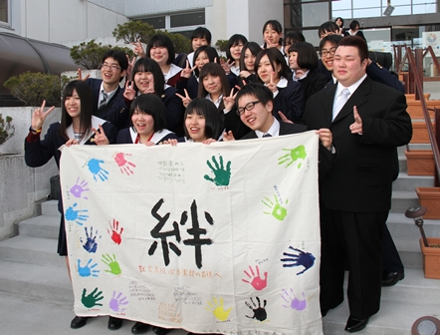
International Scholarship Program

Thanks to the warm support from our donors, we are able to continue to support high school students in Tohoku Region. In Japanese fiscal year 2014, 28 students of 4 high schools are receiving a scholarship through AMDA International Scholarship Program.

 | Name | Prefecture | No. of Students
1 | Kesennuma High School | Miyagi | 9
2 | Shizugawa High School | Miyagi | 8
3 | Kamaishi High School | Iwate | 1
4 | Otsuchi High School | Iwate | 11
 |  | Total | 28

Students aim to be a medical professional such as a doctor, a nurse, or a physical therapist in the future. Each student receives 15,000yen (about 126 USD) per month until she/he graduates high school.

AMDA has been supporting to the high school students living in Tohoku region, where the number of lives has been impacted by the Great East Japan Earthquake and Tsunami on 11 March 2011. AMDA International Scholarship Program has started in March 2011 and 274 students of 8 schools have received the scholarship in the past 3 years.

Breakdown of Scholarship Recipients:
Year | Number of students
2011 | 86
2012 | 101
2013 | 66
2014 | 28
Total | 281

Thank you so much for your warm support to our project. Your continuous support will be highly appreciated.

